1. 1. Select Your Operating System (OS): Choose an operating system that best suits your preferences and project requirements. Download and Install Windows 11. <https://www.microsoft.com/software-download/windows11>

>>I have windows 11 installed and using it as the default operating system.

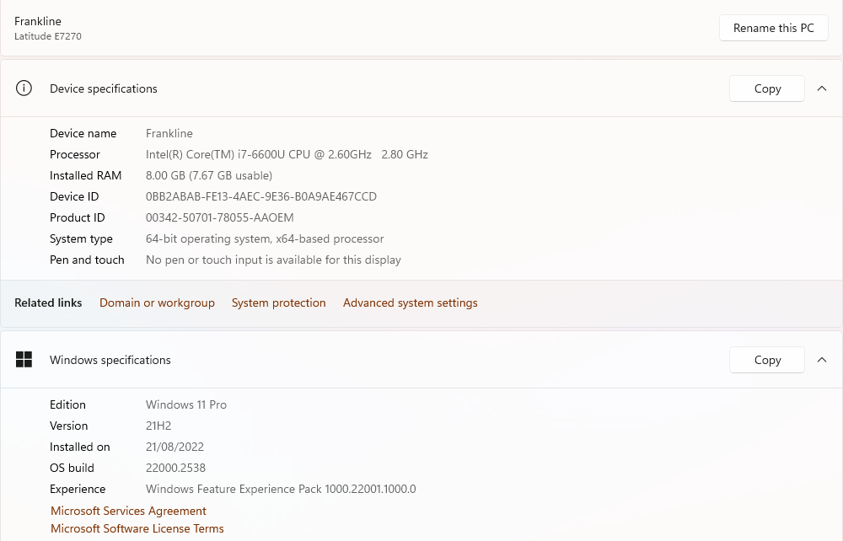

1. Install a Text Editor or Integrated Development Environment (IDE): Select and install a text editor or IDE suitable for your programming languages and workflow. Download and Install Visual Studio Code. <https://code.visualstudio.com/Download>

>>Vs code is already downloaded and configured

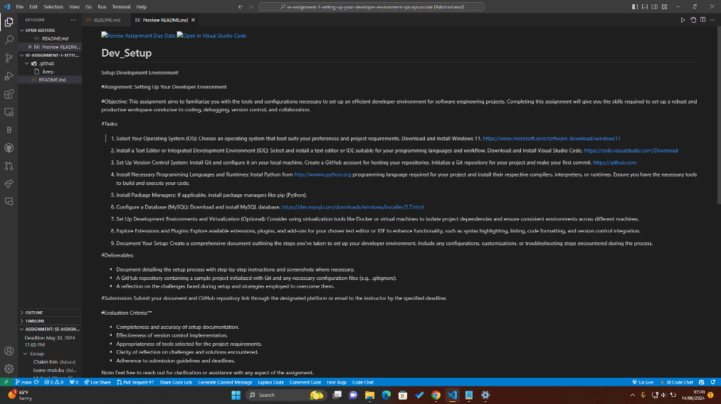

1. Set Up Version Control System: Install Git and configure it on your local machine. Create a GitHub account for hosting your repositories. Initialize a Git repository for your project and make your first commit. [https://github.com](https://github.com/)

>> downloaded and install git in my local machine

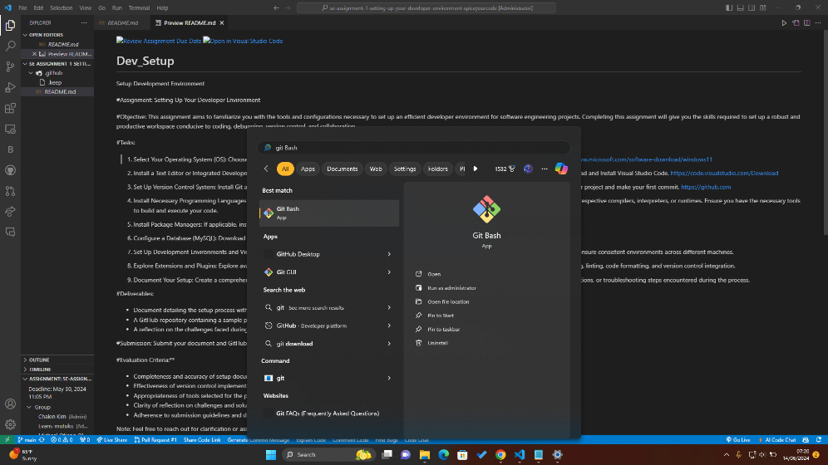

>> making the first commit

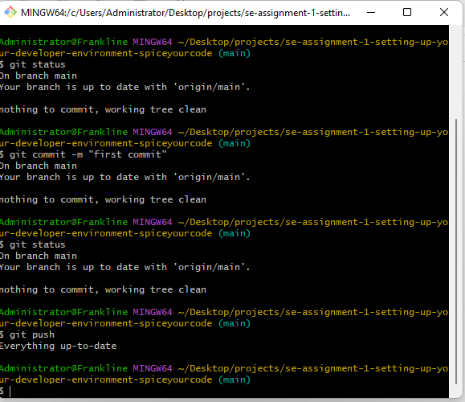

1. Install Necessary Programming Languages and Runtimes: Instal Python from [http://wwww.python.org](http://wwww.python.org/) programming language required for your project and install their respective compilers, interpreters, or runtimes. Ensure you have the necessary tools to build and execute your code.

>>> installed python

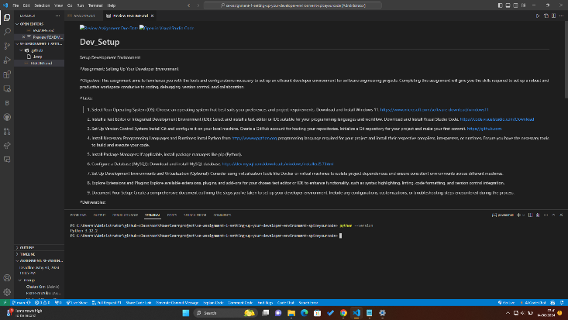

1. Install Package Managers: If applicable, install package managers like pip (Python).
2. Configure a Database (MySQL): Download and install MySQL database. <https://dev.mysql.com/downloads/windows/installer/5.7.html>

>>

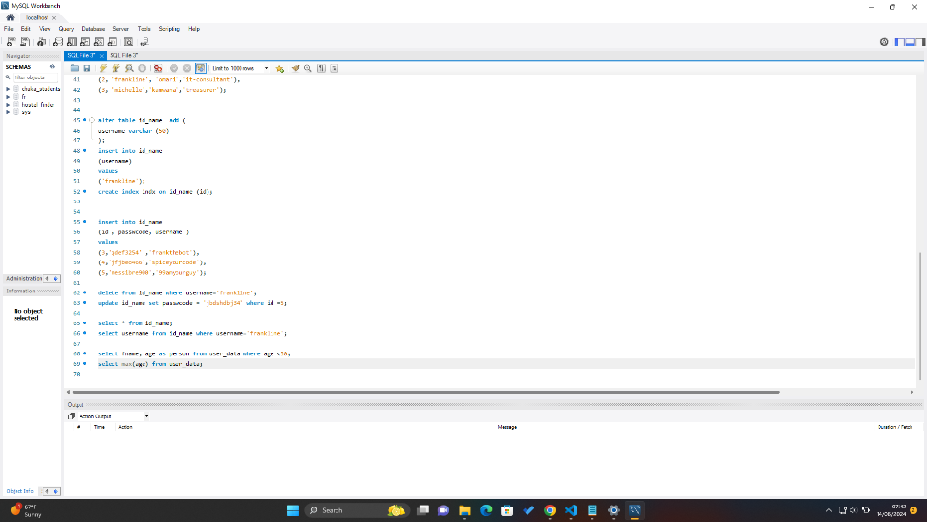

1. Set Up Development Environments and Virtualization (Optional): Consider using virtualization tools like Docker or virtual machines to isolate project dependencies and ensure consistent environments across different machines.

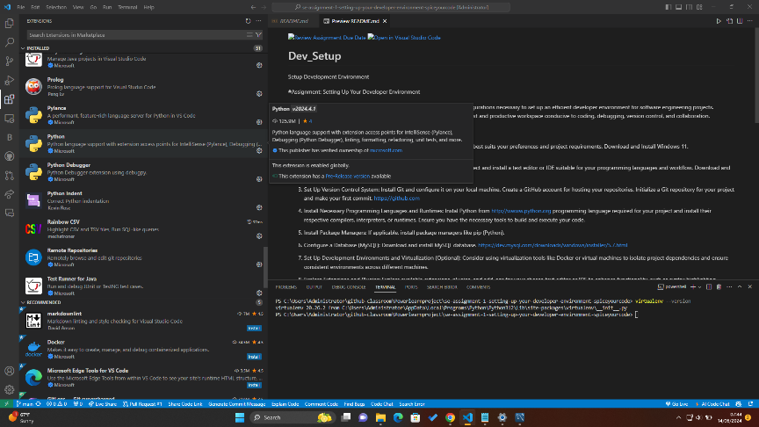

1. Explore Extensions and Plugins: Explore available extensions, plugins, and add-ons for your chosen text editor or IDE to enhance functionality, such as syntax highlighting, linting, code formatting, and version control integration.
2. Document Your Setup: Create a comprehensive document outlining the steps you've taken to set up your developer environment. Include any configurations, customizations, or troubleshooting steps encountered during the process.