Note:  
As I use office laptop it doesn’t allow USB connection of any external devices, hence I preferred to use emulator for this automation project. Herewith placed screenshots of each steps which can be referenced for others.

Pic1: Created a Virtual Devices and started its service as shown below

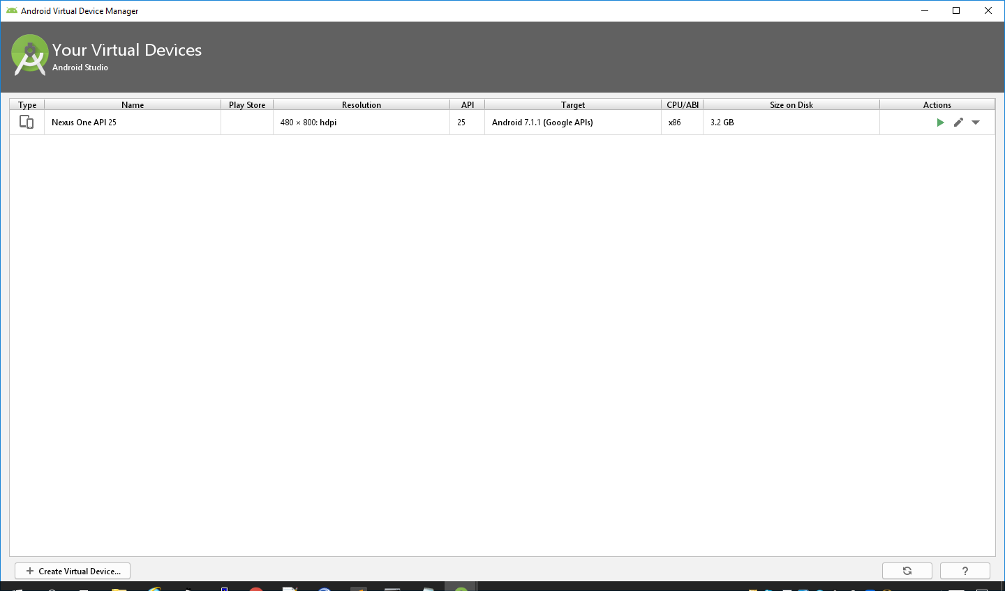

Pic2: Emulator is launched

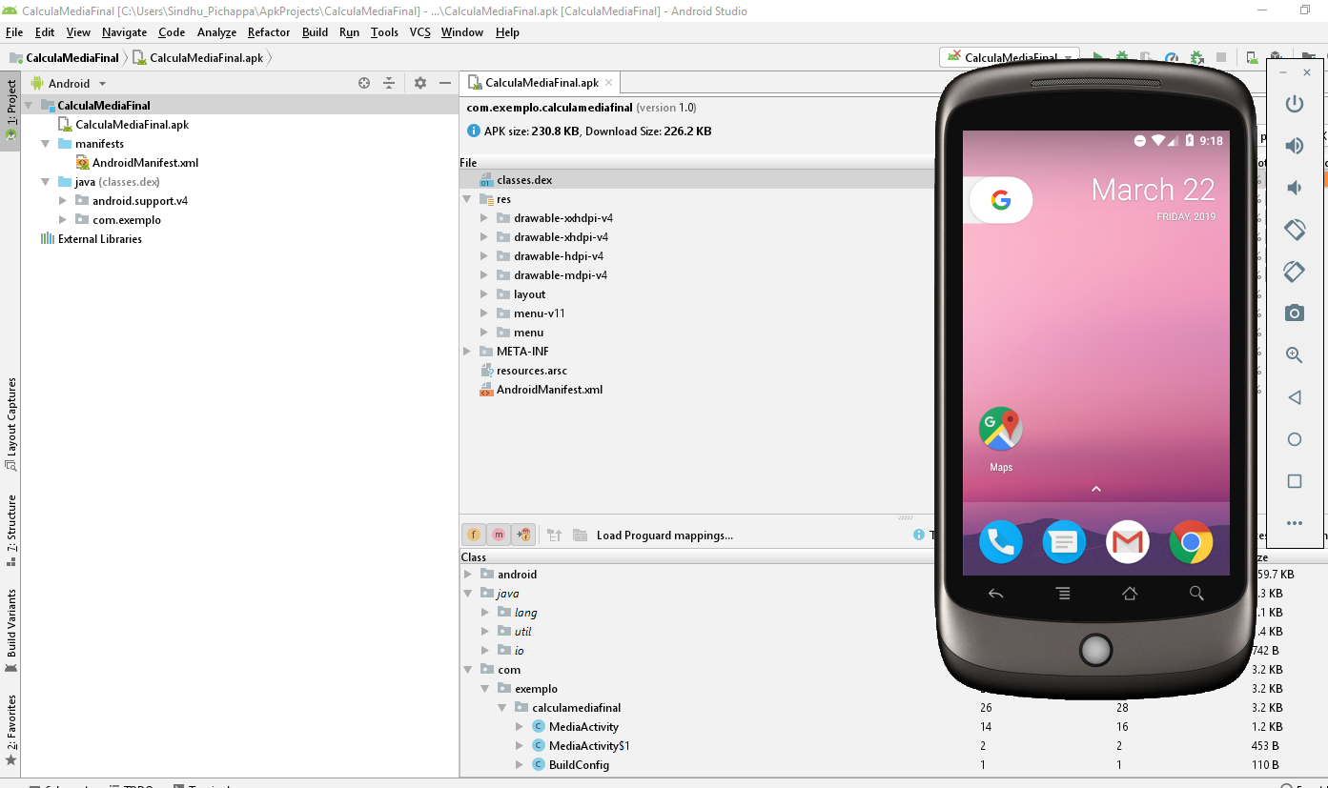

Pic3: Start the Appium server in the cmd prompt now:

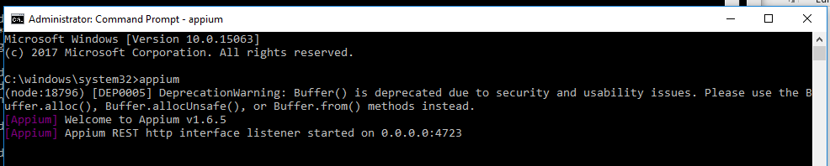

Pic4: Started the automation test suite execution in one window where the suite is placed and beneath cmd window showing the progress of the Appium server.

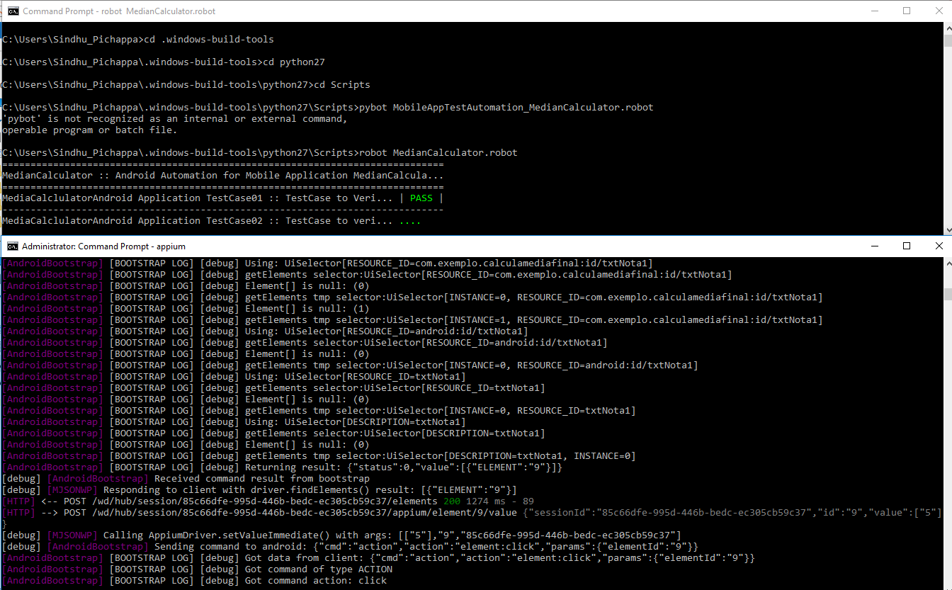

Pic5: cmd window having the test suite execution completed:

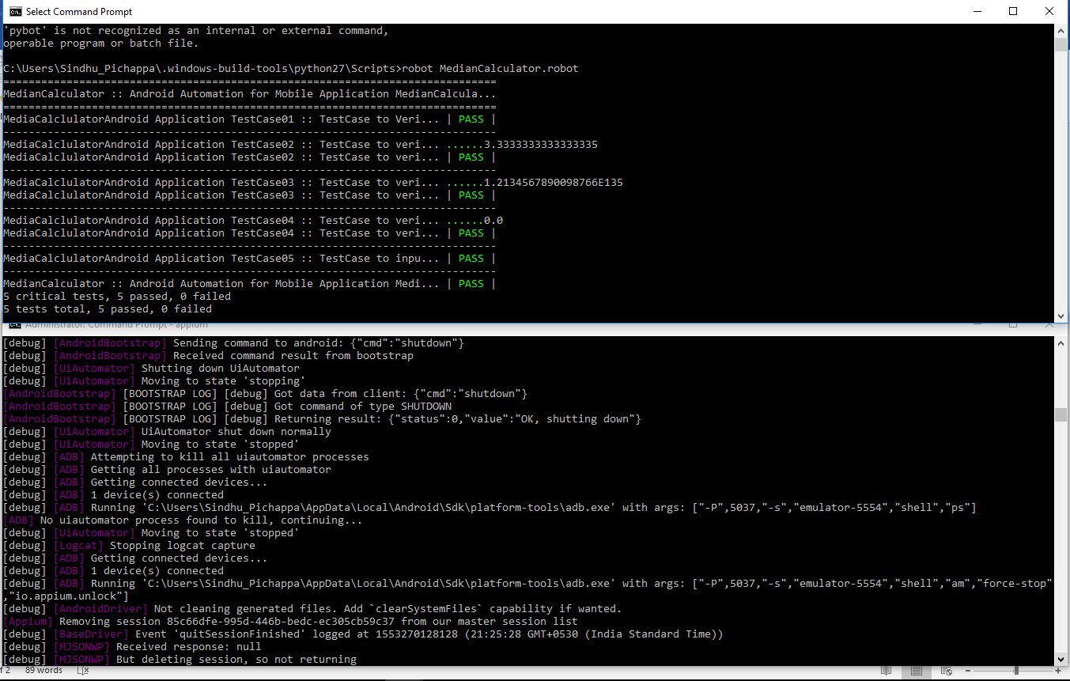

Pic6: AutomationTestLog Result Snippet for quick reference:

