

AMERICAN INTERNATIONAL UNIVERSITY-BANGLADESH

COMPUTER GRAPHICS – PROJECT DOCUMENTATION

|  |  |
| --- | --- |
| **Course Name** | Computer Graphics |
| **Section** | C |
| **Course Tutor** | MD MASUM BILLAH |

**Group Members Information:**

|  |  |
| --- | --- |
| **Name** | **ID** |
| MD. RAHAT ANJUM | 20-42786-1 |
| ASMAUL HOSSAIN AKASH | 20-44209-3 |
| NAZMUL HOSSAIN ARNOB | 20-44240-3 |
| MD ABID HOSSAIN | 21-44375-1 |

**Table of Content:**

|  |  |
| --- | --- |
| **Content List** | **Page No** |
| Introduction | 3 |
| Proposal | 3 |
| Schematic Diagram | 4 |
| List of Objects | 5 |
| Functions to Represent the Objects | 6 |
| Task Assignment and Codes of Functions | 7 |
| Output | 8 |
| Conclusion | 9 |

**Introduction**

In the proposal, a racetrack with cars will be shown in a simplistic manner. A moving car in a hilly location was the scenario we used. Pressing a button will activate the speed-up feature in all perspectives. For each unique scene, there will be a sound effect. It would result in a racetrack scene that is appealing to the sight. The depiction of the items by our program is quick and precise. Furthermore, a setting that mimics a racetrack.

**Proposal**

The project about a scenario type. There will be a real-life scenario about a “Need for speed most wanted view”. There will be mountain, cars, sun, cactus tree, road/racing track. There will be some keyboard connection which will be created.

**Schematic Diagram**

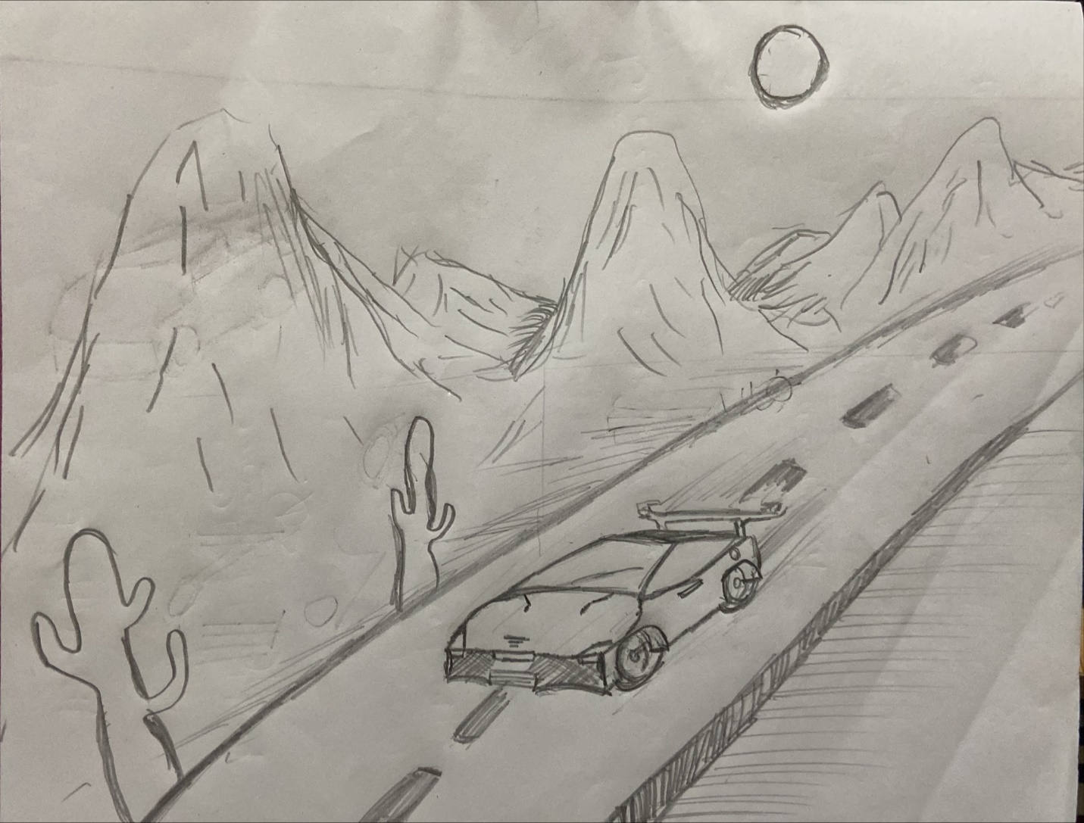

**List of Objects**

1. CAR
2. ROAD
3. CACTUS TREE
4. HILL
5. cloud
6. stoppage

**Funtions to Represent The Objects**

|  |  |  |
| --- | --- | --- |
| **Object** | **Function** | **ID** |
| Car | Void car | **21-44375-1** |
| hill | Void hill | 21-44375-1 |
| Moving object | Void Run | 21-44375-1 |
| Lamp | Void Lamp | 20-44209-3 |
| Sand | Void Sand | 20-44209-3 |
| stop | Void stop | 20-44209-3 |
| cactus | Void cactus | 20-44209-3 |
| Road | Void drawRoad | 20-44240-3 |
| sky | Void sky | 20-42786-1 |
| cloud | Void cloud | 20-42786-1 |

**Task Assignment and Codes of Funchtions**

**Contribution Table:**

|  |  |  |  |  |
| --- | --- | --- | --- | --- |
| **Member-1**  MD RAHAT ANJUM  20-42786-1 | **Member-2**  ASMAUL HOSSAIN AKASH  20-44209-3 | **Member-3**  NAJMUL HOSSAIN ARNOB  20-44240-3 | **Member-4**  MD ABID HOSSAIN  21-44375-1 | **TOTAL** |
| 25% | 25% | 25% | 25% | 100% |

|  |  |
| --- | --- |
| **Name**  **ID** | **Contribution in Project** |
| MD RAHAT ANJUM  20-42786-1 | 1. Sky and cloud |
| ASMAUL HOSSAIN AKASH  20-44209-3 | 1. Cactus, Sand, Lamp and stop |
| NAJMUL HOSSAIN ARNOB  20-44240-3 | 1. Road |
| MD ABID HOSSAIN  21-44375-1 | 1. Car, Hills and moving object |

**OUTPUT**

**Conclusion**

Our project for just showing a car moving in the hill side area like a racing track.. We face so many difficulties in creating this object. Our project purpose is to show an animation type car in real life view. We are here to show some new and hope some new.

Thank you

Developed by  
HOSSAIN, MD ABID

ASMAUL HOSSAIN AKASH

MD. RAHAT ANJUM

NAZMUL HOSSAIN ARNOB