**CPSC 323-06 | PROJECT 1 | Programming Assignment 1 | 2 April 2023**

**Daniel Currey**

**Malka Lazerson**

**Regular Expressions**

<Function Definition> ::= <Function> | <Function> <Function Definitions>

<Parameter List> ::= <Parameter> | <Parameter> , <Parameter List>

<Parameter> ::= <IDs > <Keyword>

<Keyword> ::= integer | boolean | double | float | char | string

<Declaration> ::= <Keyword > <ID>

<ID> ::= <Identifier> | <Identifier>, <ID>

<Assign> ::= <Identifier> = <Expression> ;

<If> ::= if ( <Condition> ) <Statement>

| if ( <Condition> ) <Statement> else <Statement>

<Return> ::= return ; | return <Expression> ;

<Print> ::= put ( <Expression>);

<Scan> ::= get ( <IDs> );

<While> ::= while ( <Condition> ) <Statement>

<Condition> ::= <Expression> <Operation> <Expression>

<Operation> ::= == | != | > | < | <= | =>

<Arithmetic> ::= <Arithmetic> + <Ratio> | <Arithmetic> - <Ratio> | <Ratio>

<Ratio> ::= <Ratio> * <Number> | <Ratio> / <Number> | <Number>

<Number> ::= - <Digit> | <Digit>

**FSA for Identifiers and Integers**

Regular Expression: L(L|D|_)*

Expression must start with at least one L = letter and be followed by at least one D = digit or underscore. “File_2” is accepted while “6_file” is not accepted. “Var1_” is accepted but “_var3” is not accepted.

NFSM

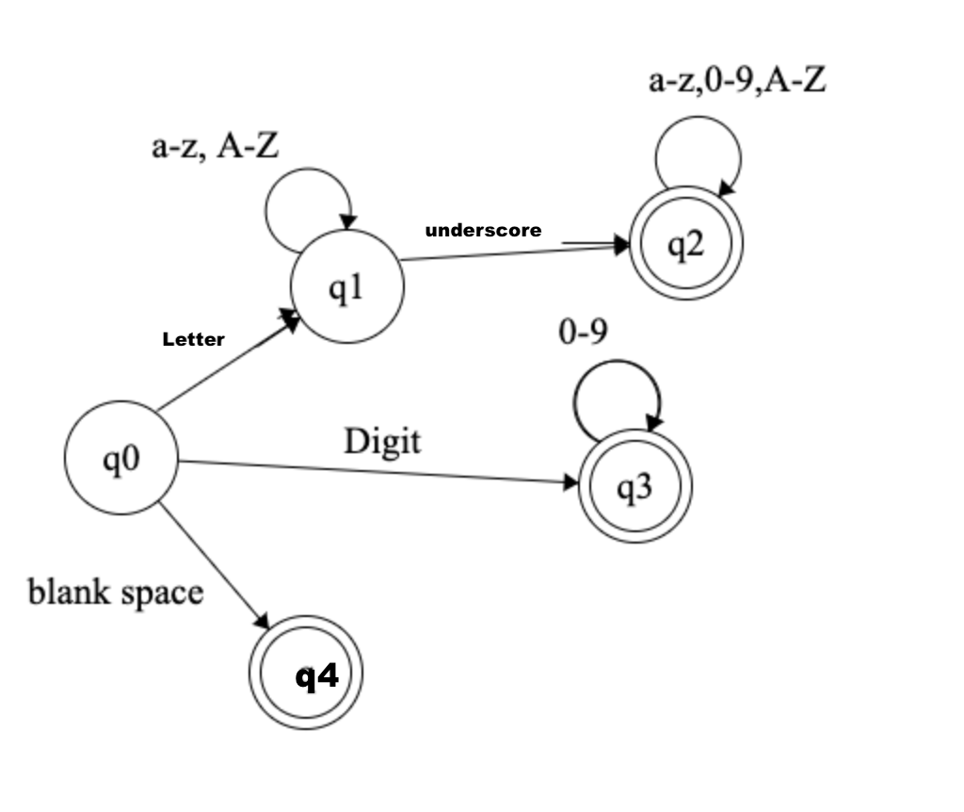

State Table

|  | Letter | Digit | Underscore |
| --- | --- | --- | --- |
| 0 | 0 | 0,1 | {} |
| 1 | 1 | 1 | 1 |
| 2 | {} | 2 | {} |

DFSM

