**CPSC 323-06 | PROJECT 1 | Programming Assignment 1 | 2 April 2023**

**Daniel Currey**

**Malka Lazerson**

**Regular Expressions**

<Keyword> ::= while | if | float | double | int | string

<Declaration> ::= <Keyword > <ID>

<ID> ::= <Identifier> | <Identifier>, <ID>

<Assign> ::= <Identifier> = <Expression> ;

<If> ::= if ( <Condition> ) <Statement>

| if ( <Condition> ) <Statement> else <Statement>

<While> ::= while ( <Condition> ) <Statement>

<Condition> ::= <Expression> <Operation> <Expression>

<Operation> ::= == | != | > | < | <= | => | =

<Real> ::= - <1-9> | <1-9> | 0

<Literal> ::= <a-z> | <A-Z>

<Separator> ::= [ | ] | ( | ) | ; | ,

**FSA for Identifiers and Integers**

Regular Expression: L(L|D|_)*

Expression must start with at least one L = letter and be followed by at least one D = digit or underscore. “File_2” is accepted while “6_var” is not accepted. “array4_” is accepted but “_var3” is not accepted.

NFSM

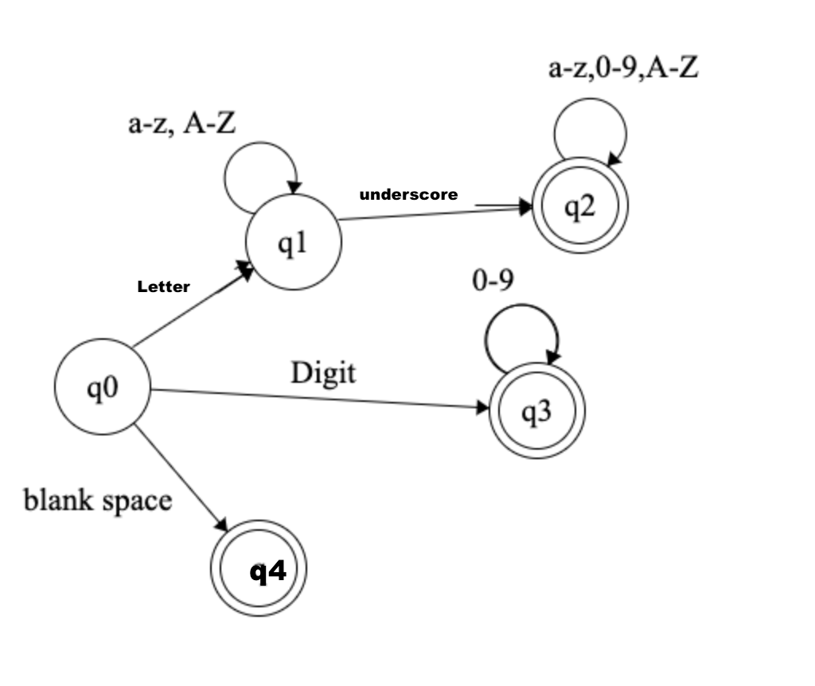

State Table

|  | Letter | Digit | Underscore |
| --- | --- | --- | --- |
| 0 | 0 | 0,1 | {} |
| 1 | 1 | 1 | 1 |
| 2 | {} | 2 | {} |

DFSM

