Southern New Hampshire University

CS 330 – Comp Graphic and Visualization

Module One Assignment – Final Project Review
Johnathan Smith

Vivan Lyon
9/11/2026

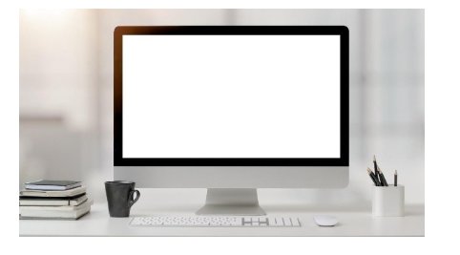
For this image, I decided to focus on 4 different objects in the picture. Even though it is not fully visible, I believe the desk itself could be created with a box that was scaled by stretching. You could even go further to be able to create legs utilizing the same approach. For the computer monitor, you could utilize a box for the screen, a tapered cylinder for the supporting base, and then a flattened-out sphere to create that rounded portion at the bottom of the supporting base. The keyboard could be designed as a single box or series of boxes to get indication to the keys coming off the keyboard. The last one I wanted to point out was the coffee mug which could be created as a cylinder for the body and then utilize a torus to make the handle.
When looking at this image, you must ask yourself what can be simplified and broken down into a single shape. For example, if the monitor was simply two boxes, it would look clunky and not realistic which takes away the point from putting it in there. Today, relatable and real objects are what pull customers’ appeal and make people want to utilize the program or application. The two objects that I believe must have additional shapes to create in this image on the computer monitor and the coffee mug. To create a realistic monitor based on this image, you will need a separate shape for the monitor and then a potential set of shapes to create the base. For the coffee mug, you will have a cylinder for the mug itself and then a torus to be used for the handle.
In order to simplify this image, I believe potentially tilting the keyboard up slightly in the image would allow you to utilize less boxes to design it as you wouldn’t be able to make out the individual keys. Potentially removing the pencils would be a plus to prevent from having to design each individual pencil. To provide simplification, I would also simplify the computers supporting base into a single tapered cylinder instead of adding a scaled sphere to help make the conversion easier. The final thing I would add is that for the stack of books, they could be converted to combined boxes instead of utilizing an individual box for each book.

