Southern New Hampshire University

CS 330 – Comp Graphic and Visualization

Module Two Assignment – Project Proposal
Johnathan Smith

Vivan Lyon
9/17/2026

For this project, I decided to go with a simple photograph of a kitchen countertop with several items displayed to reference my 3D scene. These items seemed approachable and realistic when thinking about how to utilize the basic shapes that I would have access to recreate this scene in 3D. The image contains a toaster oven, blender, paper towel holder, and a bread rack which will be the objects I utilize for recreation. Below is the scene that I chose.
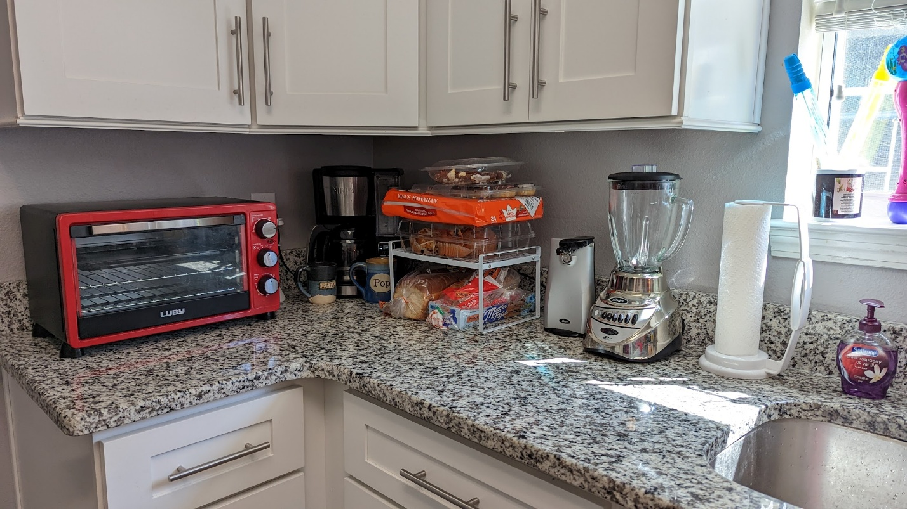

I will start off with the toaster oven which I believe to be a solid choice in recreation as the overall shape will be represented with a box, while its control knobs will be represented with cylinders. The blender will provide a bit of a challenge; however, I believe it can be done utilizing a box as a base, a tapered cylinder for the pitcher, and another combination of cylinders for the lid. The paper towels on the counter can be created with a simple cylinder. The last item would be the bread rack which can be created with a combination of scaled boxes to create the supports and rack. I found that each of these household items were visually distinct but provided enough information to be able to utilize simple geometrical shapes to provide a recreation.
The entire scene will be grounded using a plane, which will be represented as the countertop in the scene. This was one of the most logical choices for me because it creates common ground for all objects and allows the scene to feel connected. This means that in the scene, I will be using a plane, box, cylinder, and tapered cylinder. The toaster oven will primarily use boxes and cylinders, the blender will use a box, tapered cylinder, and cylinders, the paper towel holder will use cylinders, and the bread rack will use scaled boxes and cylinders. The toaster oven and blender will each be constructed from multiple basic shapes, satisfying the requirement to combine two or more 3D primitives into a single object. The biggest focus I will have while working on this project is to start with the big picture and focus on the larger objects, ensuring the scaling is where it needs to be. After this process is completed, I believe it will give me adequate time to properly fine-tune the details, such as the knobs on the toaster oven. I believe these objects will provide enough variety to make the scene interesting to explore while keeping the project achievable within the time and tools available to me.

Sources:
- The Martha Review. (n.d.). Rearranging the kitchen counter. http://themarthareview.com/rearranging-the-kitchen-counter/

