CS 305 Module Two Coding Assignment Template

Run Dependency Check

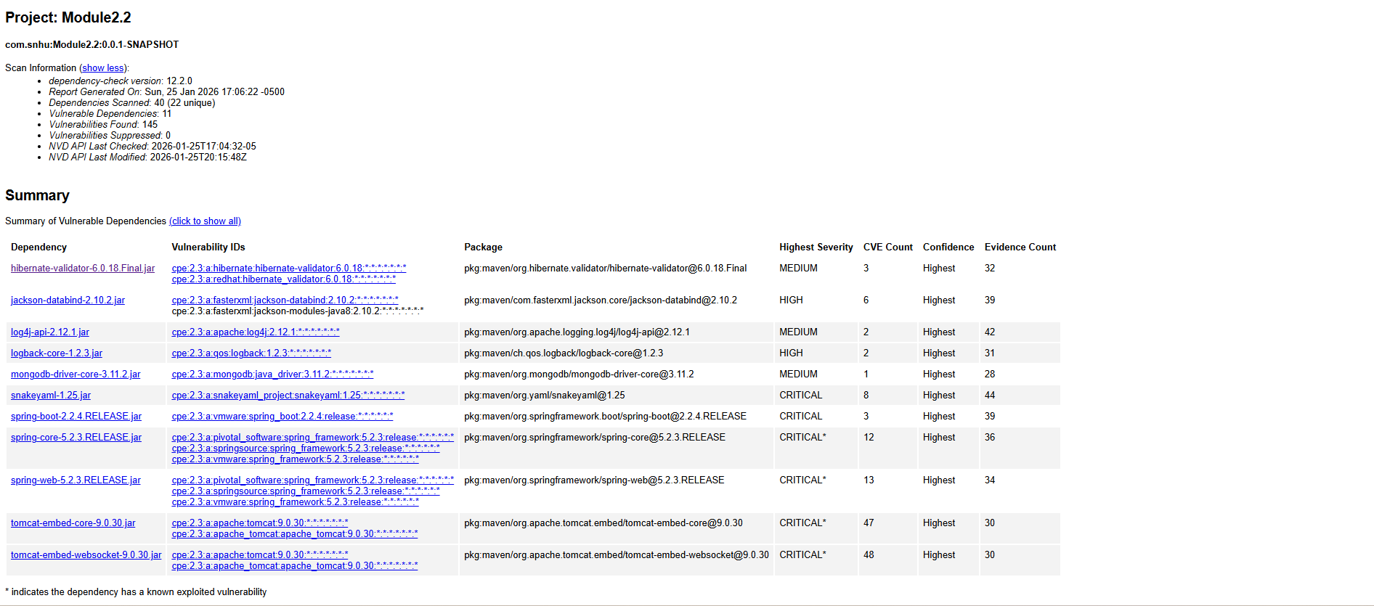

Document Results

Hibernate-validator-6.0.18.Final.jar | Hibernate Validator before 6.2.0 and 7.0.0, by default and depending how it is used, may interpolate user-supplied input in a constraint violation message with Expression Language. This could allow an attacker to access sensitive information or execute arbitrary Java code.
jackson-databind-2.10.2.jar | General data-binding functionality for Jackson: works on core streaming API
log4j-api-2.12.1.jar | The Apache Log4j API
logback-core-1.2.3.jar | logback-core module
mongodb-driver-core-3.11.2.jar | The Java operations layer for the MongoDB Java Driver.  Third parties can wrap this layer to provide custom higher-level APIs
snakeyaml-1.25.jar | YAML 1.1 parser and emitter for Java
spring-boot-2.2.4.RELEASE.jar | Spring Boot
spring-core-5.2.3.RELEASE.jar | Spring Core
spring-web-5.2.3.RELEASE.jar | Spring Web
tomcat-embed-core-9.0.30.jar | Core Tomcat implementation
tomcat-embed-websocket-9.0.30.jar | Core Tomcat implementation

Analyze Results

From the report, we can gain insight that Spring Framework had multiple critical vulnerabilities with CVE counts exceeding 10 which highlights excessive opportunities. From what I could gather, these related heavily to remote code execution, data exposure, and denial of service. Apache Tomcat also had 48 CVE’s marked as critical showing a huge vulnerable surface across this service being utilized. SnakeYAML was flagged critical inidication potential risk of remote code execution. Jackson Databind was identified as high severity and was stated as having known risks of deserialization vulnerabilities. The logging libraries were classified as medium, however this does not mean it wouldn’t be a concern as these would be part of the core infrastructure of a program where data is housed and if a vulnerability was taken down, it would lead to a potential program shut down.

From many of the found vulnerabilities, a recommendation would be to upgrade them to the most secure versions. Being knowledgeable on what verisions of these programs are applicable and secure is the key for a programs success. We have to stay on par with what is currently being utilized and what is working. This would be similar for the libraries as some of them were outdated or completely unsupported leading to a flagged vulnerability. An intense focus would need to be placed on the Spring Framework as well as TomCat due not only to the security risk posed, but the sheer number of CVE’s affected in the program.

False positives in our world is something that is naturally part of data as anything can create a positive based on it finding one or two key findings that cause it to flag without further analysis. We have to aware of what causes this and why as it would be futile to spend resources on something that is functioning in a way that doesn’t impede the applications execution. Being able to filter the false positives would improve accuracy and clarity and would reduce the already heavy workload it comes to managing security risks.

I would say that throughout all of this, a highlight would be the importance of managing versions as well as third-party libraries. This would also go to show that during the application building process, a dependency report would need to be created fairly consistently to ensure we are meeting standards and aren’t allowing any additional vulnerabilities into the program. It is a huge amount of knowing where the data is and ensuring we are protecting what the user is able to input such as the stackoverflow from the TomCat. These need to be understood and anything with excessive CVE vulnerabilities needs to be addressed no matter what the security risk may be as this creates a huge surface area of attack.

