Johnathan Smith
CS305
2/4/2026

When it comes to critical infrastructure of a program, it is essential to rely on trusted sources to ensure security, especially when accessing servers that you have not worked on before. Certificate Authorities (CAs), such as Symantec, VeriSign, and Comodo, provide this trust by verifying the identity of entities and signing cryptographic certificates for servers. When a client connects to a server, it receives the certificate and can verify that a trusted CA issued it, ensuring the server’s identity is legitimate. This process creates a heightened level of trust and secures the data transmitted between the client and server. CAs also play a key role in preventing impersonation and man-in-the-middle attacks, ensuring that communication occurs with the intended server. While self-signed certificates can be used during development for testing purposes, only certificates issued by a trusted CA are recognized by browsers and operating systems without warnings, making them essential for public-facing services. Using a CA provides advantages such as automated trust, identity verification, encryption assurance, and scalability for large organizations or applications.

~Questions Answered~
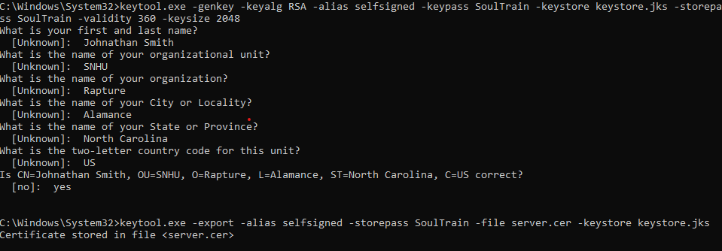

~Information Stored~
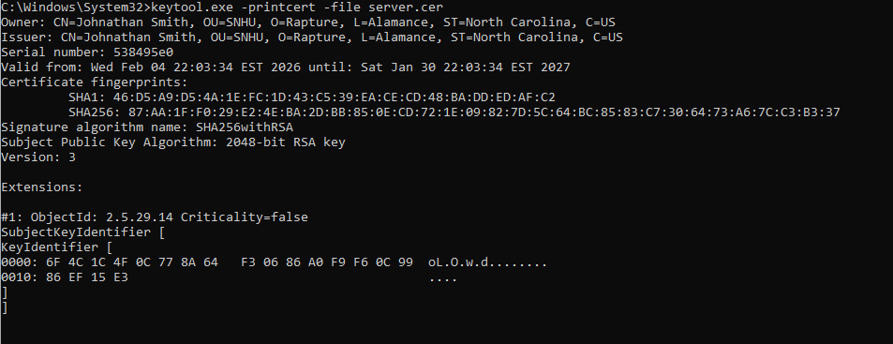
~Certificate Generated~

