Module 6 Coding Assignment
CS 305
Johnathan Smith
2/21/2026

Vulnerabilities found before suppression:
file:///C:/Users/smith/Downloads/CS%20305%20Module%20Six%20Code%20Base/Module6/target/dependency-check-report.html
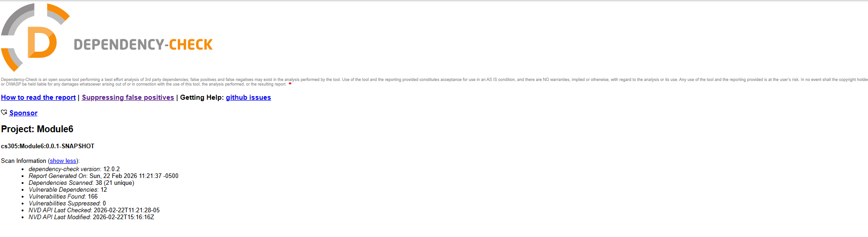

Vulnerabilities found after suppression:
file:///C:/Users/smith/Downloads/CS%20305%20Module%20Six%20Code%20Base/Module6/target/dependency-check-report.html#header-suppressed
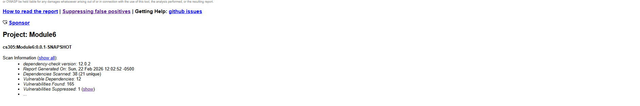

Pom file before:
<?xml version="1.0" encoding="UTF-8"?>
<project xmlns="http://maven.apache.org/POM/4.0.0"
xmlns:xsi="http://www.w3.org/2001/XMLSchema-instance"
xsi:schemaLocation="http://maven.apache.org/POM/4.0.0
http://maven.apache.org/xsd/maven-4.0.0.xsd">

<modelVersion>4.0.0</modelVersion>

<groupId>cs305</groupId>
<artifactId>Module6</artifactId>
<version>0.0.1-SNAPSHOT</version>
<packaging>jar</packaging>

<parent>
<groupId>org.springframework.boot</groupId>
<artifactId>spring-boot-starter-parent</artifactId>
<version>2.2.2.RELEASE</version>
</parent>

<properties>
<java.version>1.8</java.version>
<start-class>cs305.Module6.App</start-class>
</properties>

<dependencies>

<dependency>
<groupId>org.springframework.boot</groupId>
<artifactId>spring-boot-starter-web</artifactId>
</dependency>

<dependency>
<groupId>org.springframework</groupId>
<artifactId>spring-context-indexer</artifactId>
</dependency>

<dependency>
<groupId>org.springframework.boot</groupId>
<artifactId>spring-boot-starter-test</artifactId>
<scope>test</scope>
</dependency>

<dependency>
<groupId>org.springframework.boot</groupId>
<artifactId>spring-boot-starter-webflux</artifactId>
<scope>test</scope>
</dependency>

<dependency>
<groupId>io.projectreactor</groupId>
<artifactId>reactor-test</artifactId>
<scope>test</scope>
</dependency>

</dependencies>

<build>
<plugins>

<plugin>
<groupId>org.springframework.boot</groupId>
<artifactId>spring-boot-maven-plugin</artifactId>
</plugin>

<!-- OWASP Dependency Check BEFORE -->
<plugin>
<groupId>org.owasp</groupId>
<artifactId>dependency-check-maven</artifactId>
<version>12.0.2</version>

<configuration>
<format>HTML</format>
<nvdApiKey>de15e896-5947-4cf1-9f6d-215e167d93cd</nvdApiKey>
<nvdApiDelay>10000</nvdApiDelay>
<failOnError>false</failOnError>
</configuration>

<executions>
<execution>
<goals>
<goal>check</goal>
</goals>
</execution>
</executions>
</plugin>

</plugins>
</build>

</project>
Pom file after:
<?xml version="1.0" encoding="UTF-8"?>
<project xmlns="http://maven.apache.org/POM/4.0.0"
xmlns:xsi="http://www.w3.org/2001/XMLSchema-instance"
xsi:schemaLocation="http://maven.apache.org/POM/4.0.0
http://maven.apache.org/xsd/maven-4.0.0.xsd">

<modelVersion>4.0.0</modelVersion>

<groupId>cs305</groupId>
<artifactId>Module6</artifactId>
<version>0.0.1-SNAPSHOT</version>
<packaging>jar</packaging>

<parent>
<groupId>org.springframework.boot</groupId>
<artifactId>spring-boot-starter-parent</artifactId>
<version>2.2.2.RELEASE</version>
</parent>

<properties>
<java.version>1.8</java.version>
<start-class>cs305.Module6.App</start-class>
</properties>

<dependencies>

<dependency>
<groupId>org.springframework.boot</groupId>
<artifactId>spring-boot-starter-web</artifactId>
</dependency>

<dependency>
<groupId>org.springframework</groupId>
<artifactId>spring-context-indexer</artifactId>
</dependency>

<dependency>
<groupId>org.springframework.boot</groupId>
<artifactId>spring-boot-starter-test</artifactId>
<scope>test</scope>
</dependency>

<dependency>
<groupId>org.springframework.boot</groupId>
<artifactId>spring-boot-starter-webflux</artifactId>
<scope>test</scope>
</dependency>

<dependency>
<groupId>io.projectreactor</groupId>
<artifactId>reactor-test</artifactId>
<scope>test</scope>
</dependency>

</dependencies>

<build>
<plugins>

<plugin>
<groupId>org.springframework.boot</groupId>
<artifactId>spring-boot-maven-plugin</artifactId>
</plugin>

<!-- OWASP Dependency Check BEFORE -->
<plugin>
<groupId>org.owasp</groupId>
<artifactId>dependency-check-maven</artifactId>
<version>12.0.2</version>

<configuration>
<format>HTML</format>
<nvdApiKey>de15e896-5947-4cf1-9f6d-215e167d93cd</nvdApiKey>
<nvdApiDelay>10000</nvdApiDelay>
<suppressionFiles>
<suppressionFile>
${project.basedir}/src/main/resources/suppression.xml
</suppressionFile>
</suppressionFiles>
<failOnError>false</failOnError>
</configuration>

<executions>
<execution>
<goals>
<goal>check</goal>
</goals>
</execution>
</executions>
</plugin>

</plugins>
</build>

</project>
Suppression.xml file:
<?xml version="1.0" encoding="UTF-8"?>
<suppressions xmlns="https://jeremylong.github.io/DependencyCheck/dependency-suppression.1.3.xsd">

<suppress>
<notes>hibernate-validator false positive</notes>
<packageUrl regex="true">^pkg:maven/org\.hibernate\.validator/hibernate-validator@.*$</packageUrl>
<cve>CVE-2025-15104</cve>
</suppress>

</suppressions>

