

Practices for Secure Software Report

Table of Contents
Document Revision History 3
Client 3
Instructions 3
Developer 4
1. Algorithm Cipher 4
2. Certificate Generation 4
3. Deploy Cipher 4
4. Secure Communications 4
5. Secondary Testing 4
6. Functional Testing 4
7. Summary 4
8. Industry Standard Best Practices 4

Document Revision History

Version | Date | Author | Comments
1.0 | 2/19/2026 | Johnathan Smith

Client



Developer
Johnathan Smith

Algorithm Cipher

To address security vulnerabilities found in the Artemis Financials’ system, we need to ensure an appropriate encryption algorithm cipher is used to meet the industry’s standards and best practices. In this type of application, it will be susceptible to man-in-the-middle attacks, data interception, and unauthorized access. The key things to consider here would be that data needs to be secure in transit and when it comes to its destination, an inurement of secure key management, and upholding recognized and non-depreciated ciphers. While researching encryption algorithms, I found that the Advanced Encryption Standard (AES) would be the most ideal for this application. This was issued by the National Institute of Standards and Technology after approval by the Secretary of Commerce. This encryption standard is a FIPS-approved algorithm that can be used to protect electronic data. It is considered a symmetric block cipher. The symmetric piece simply means that a single key will be utilized for both the encryption and decryption of the data. The sender and the receiver will have to have access to the key to be able to participate in the data transfer unlike asymmetric which will utilize a public-private key. This will require less computational power overall making this ideal for large amounts of data encryption.
An important note when selecting the Advanced Encryption Standard is what one we would utilize. I would highly recommend the company go with AES-256, in which the number indicates the actual size of the key. A larger key is necessary for larger applications and programs. Also, AES utilizes a pseudo – random number generator which will in turn cause key scheduling and initialization become that more challenging to decrypt. If the numbers are unknown even by the client until they are made, an attacker will have a much tougher time trying to find that code. Something to keep in mind through all of this is why not just find the best and top-dog cipher out there? Just like any computer or gaming system, everything is designed with a balance point, and one must consider how much resources can be dedicated to preserving the intended target of the application. If we pour 90% of allocated resources into security, we’ll be left with 10% of an application that may not even meet its beginning criteria. A balance of security and performance must be maintained throughout the entirety of the development process.
In addition to using AES-256 for encrypting sensitive financial data, Artemis Financial should also implement a secure hash function such as SHA-256 to ensure data integrity during transmission. While AES-256 provides confidentiality through symmetric encryption using a shared key, SHA-256 generates a fixed 256-bit hash value that verifies whether transmitted data has been altered by an attacker. Secure communication protocols like HTTPS combine both symmetric and asymmetric encryption by using algorithms such as RSA to securely exchange keys, followed by AES-256 to efficiently encrypt large amounts of data during the session. AES-256 also relies on initialization vectors (IVs), generated through secure pseudo-random number processes, to prevent recognizable data patterns that could lead to interception. Older encryption methods such as DES and 3DES were phased out due to weaker key lengths, leading to AES becoming the modern NIST-approved standard that balances strong security with system performance.

Certificate Generation
Insert a screenshot below of the CER file.
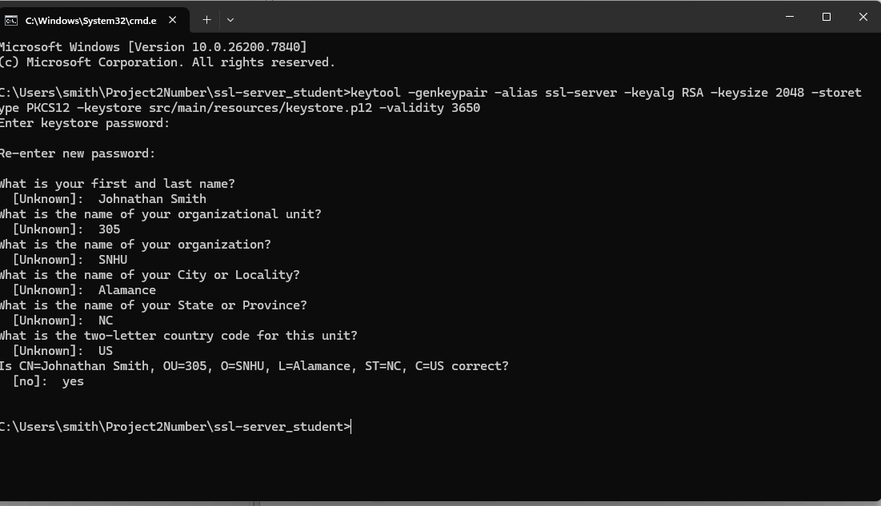
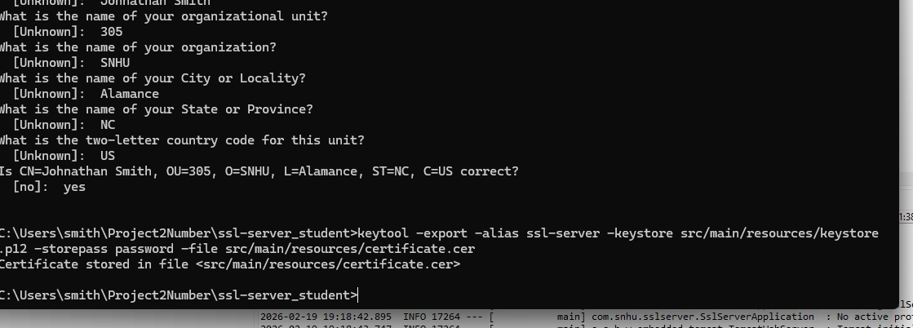

Deploy Cipher
Insert a screenshot below of the checksum verification.

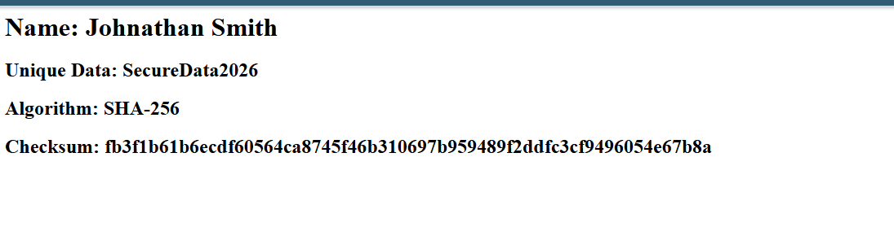

Secure Communications
Insert a screenshot below of the web browser that shows a secure webpage.
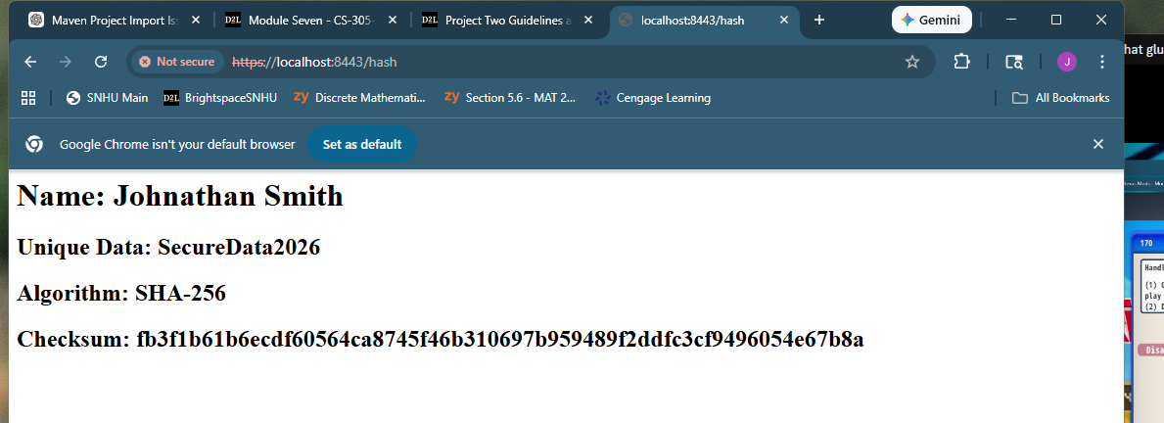
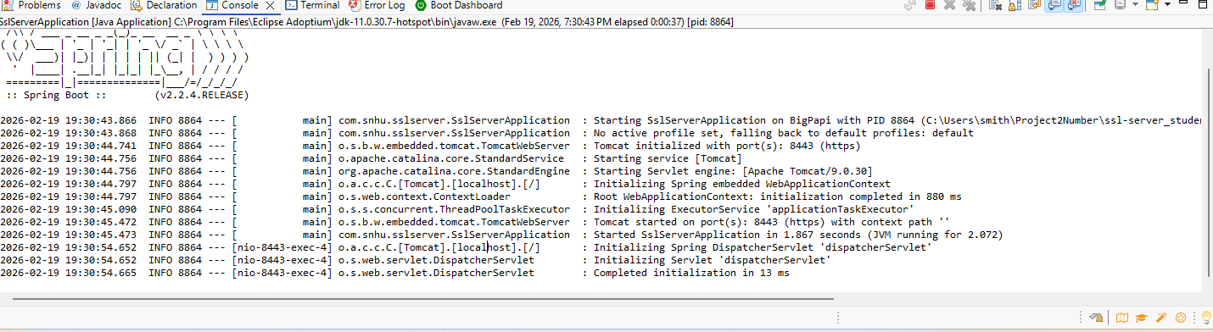

Secondary Testing
Insert screenshots below of the refactored code executed without errors and the dependency-check report.

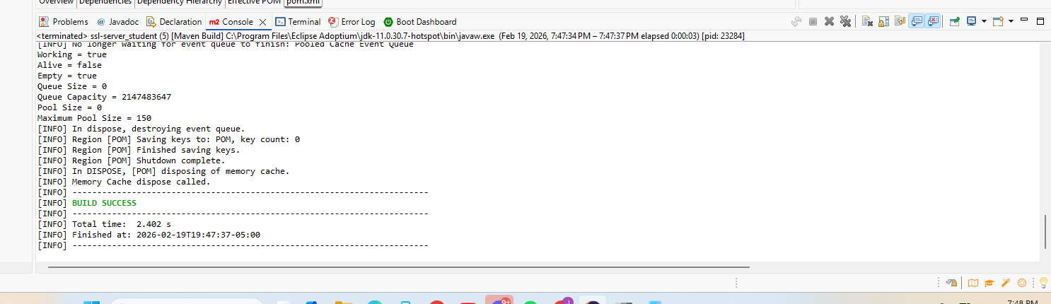
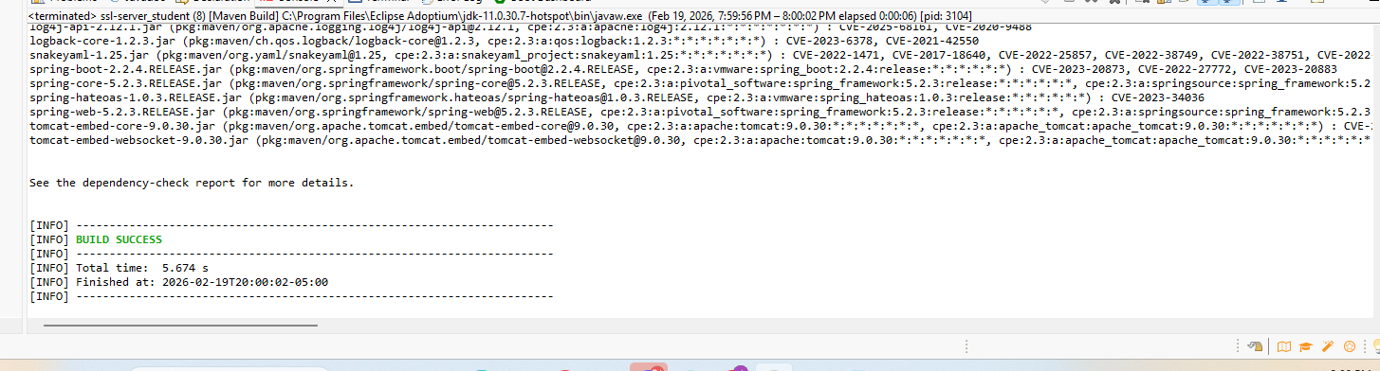
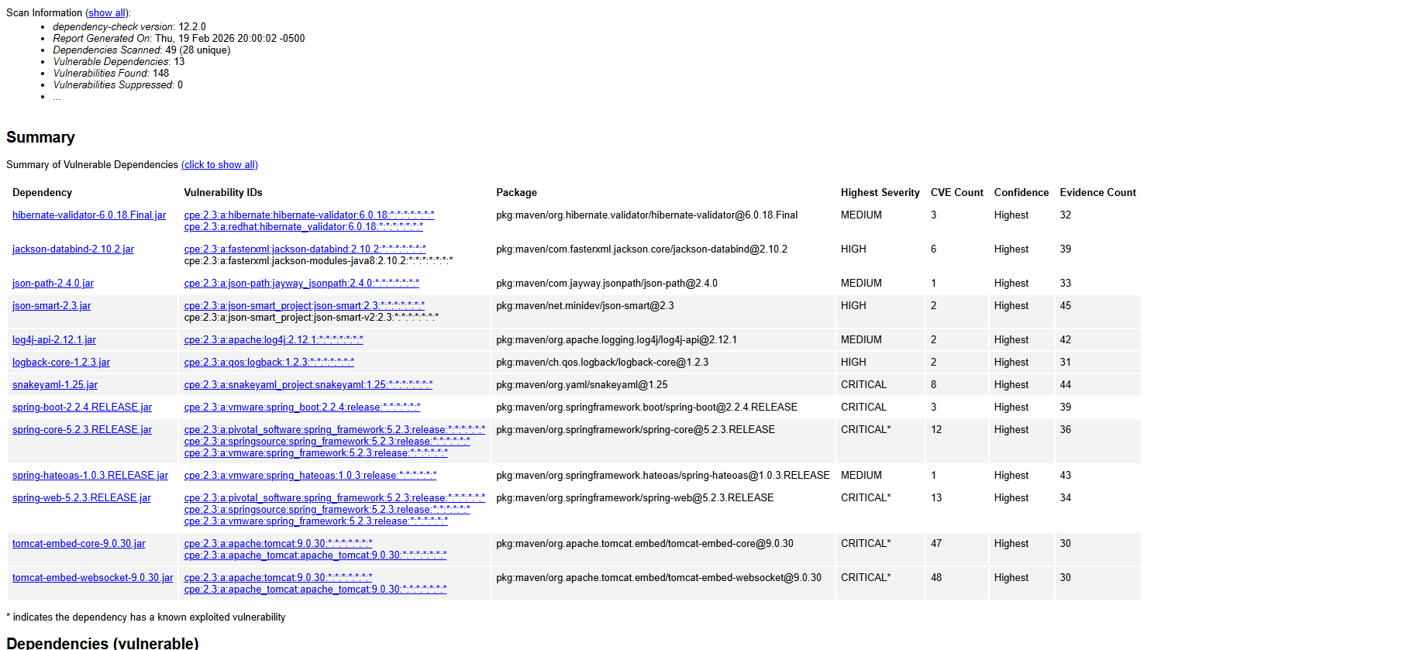

Functional Testing
Insert a screenshot below of the refactored code executed without errors.

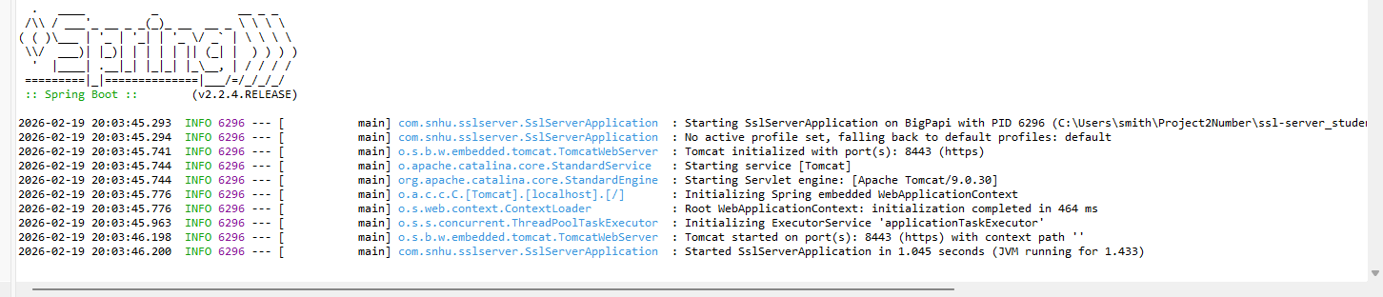
After manually reviewing the application code, several syntactical, logical, and security vulnerabilities were identified and corrected during refactoring. Syntactical issues such as missing or improper method implementations were resolved to ensure successful compilation and execution of the application without runtime errors, as demonstrated in the screenshot above. Logical vulnerabilities related to insecure data handling were corrected by implementing SHA-256 message digest hashing prior to transmission to ensure data integrity and prevent tampering. Additionally, a major security vulnerability was identified in the use of the HTTP protocol, which exposed the system to interception and man-in-the-middle attacks. This was mitigated by refactoring the application properties to utilize the HTTPS protocol along with a self-signed SSL certificate to encrypt data in transit. These improvements ensure that the application now meets secure communication standards and executes without syntactical or security-related errors.

Summary

The Artemis Financial application was refactored after completing a vulnerability assessment to identify areas where the system was at risk from potential security threats. Through this process, it was determined that one of the main concerns involved the use of the HTTP protocol, which allowed data to be transmitted without encryption and left sensitive financial information vulnerable to interception or man-in-the-middle attacks. Another concern was the lack of an ability to verify the integrity of the data being transmitted across the network. To address these issues, the code was updated to replace HTTP with HTTPS, allowing data to be encrypted while in transit. In addition, SHA-256 hashing was implemented to ensure that any data being transmitted could be verified and had not been altered during communication.
As part of the refactoring process, additional layers of security were added to strengthen the application overall. SSL encryption was configured with a self-signed certificate to support secure communication between systems. AES-256 encryption standards were also incorporated to protect sensitive financial data more effectively while maintaining system performance. Taking this layered approach to security helps reduce the likelihood of unauthorized access and protects the application against common network-based attacks. Overall, these updates allow the application to better align with secure software testing protocols and improve the protection of sensitive financial data without negatively impacting the functionality of the existing system.

Industry Standard Best Practices

Industry standard best practices for secure coding were applied throughout the refactoring process to improve the overall security of the Artemis Financial application while maintaining its original functionality. This included implementing NIST-approved encryption standards such as AES-256 and SHA-256 to protect sensitive financial data from unauthorized access or tampering. Secure communication protocols were also introduced through HTTPS to ensure that data transmitted between systems is encrypted and less susceptible to interception. By following these widely accepted security practices, the application is better equipped to prevent common vulnerabilities such as data exposure and man-in-the-middle attacks without disrupting existing system operations.
Applying these secure coding best practices provides long-term value to the organization by reducing the risk of data breaches and helping to protect sensitive client information. In everything that is accomplished as a software developer, these standards must be upheld and maintained throughout everyone who plays a part in the development life cycle. Rules and guidelines must have a standard throughout to maintain that integrity of security of our constantly evolving technological field. Strengthening the application’s security posture also supports customer trust and helps Artemis Financial maintain compliance with industry regulations and standards. Overall, incorporating industry standard security measures into the software development process contributes to the company’s operational stability and helps safeguard its financial and reputational well-being. As a company, we must strive to support security across the board to continue to keep reduced costs and safeguard our assets.

