citik_humains_analyse_moyenne_kh

khaldoune hilami

1/27/2021

# Comparaison des données Météo MF et DSK

## vérification des jeux de donnée

ls(dskdatavg)

## [1] "cloudcover" "date_releve" "dewpoint"   
## [4] "humidity" "id" "precipintensity"   
## [7] "precipintensitymax" "pressure" "temperature"   
## [10] "temperaturehigh" "temperaturehighoffset2" "temperaturelow"   
## [13] "temperaturelowoffset2" "temperatureoffset2" "uvindex"   
## [16] "visibility" "windgust" "windspeed"

ls(mfdatavg)

## [1] "date_iso" "humidite"   
## [3] "id" "nebulosite"   
## [5] "point_rose" "precip_01h"   
## [7] "precip_24h" "press_mer"   
## [9] "press_sta" "rafale_10min"   
## [11] "temperature" "temperature_diurne"   
## [13] "temperature_diurne_offset2" "temperature_nocturne"   
## [15] "temperature_nocturne_offset2" "temperatureoffset2"   
## [17] "visibilite" "vvent"

## sommaire de la donnée et analyse primaire

kable(summary(dskdatavg[c(17,3:10)]))

|  |  |  |  |  |  |  |  |  |  |
| --- | --- | --- | --- | --- | --- | --- | --- | --- | --- |
|  | temperature | humidity | dewpoint | pressure | windspeed | visibility | cloudcover | windgust | uvindex |
|  | Min. :-3.38 | Min. :48.00 | Min. :-11.770 | Min. : 985.4 | Min. :1.610 | Min. : 5.73 | Min. : 5.00 | Min. : 3.330 | Min. :0.550 |
|  | 1st Qu.: 8.33 | 1st Qu.:68.00 | 1st Qu.: 3.785 | 1st Qu.:1013.2 | 1st Qu.:2.925 | 1st Qu.: 9.62 | 1st Qu.:57.00 | 1st Qu.: 6.742 | 1st Qu.:1.430 |
|  | Median :12.31 | Median :75.00 | Median : 7.440 | Median :1017.8 | Median :3.540 | Median : 9.98 | Median :71.00 | Median : 8.395 | Median :3.190 |
|  | Mean :13.17 | Mean :73.57 | Mean : 7.730 | Mean :1017.4 | Mean :3.777 | Mean :10.61 | Mean :65.79 | Mean : 9.245 | Mean :3.389 |
|  | 3rd Qu.:18.39 | 3rd Qu.:80.00 | 3rd Qu.: 12.215 | 3rd Qu.:1022.2 | 3rd Qu.:4.380 | 3rd Qu.:12.14 | 3rd Qu.:79.50 | 3rd Qu.:11.260 | 3rd Qu.:5.000 |
|  | Max. :27.90 | Max. :89.00 | Max. : 18.140 | Max. :1039.9 | Max. :8.940 | Max. :13.59 | Max. :94.00 | Max. :23.520 | Max. :9.170 |
|  | NA | NA | NA | NA’s :109 | NA | NA | NA | NA’s :97 | NA |

kable(summary(mfdatavg[c(13,3:4,6:12)]))

|  |  |  |  |  |  |  |  |  |  |  |
| --- | --- | --- | --- | --- | --- | --- | --- | --- | --- | --- |
|  | temperature | humidite | point_rose | press_mer | vvent | visibilite | nebulosite | rafale_10min | precip_24h | precip_01h |
|  | Min. :-3.49 | Min. :47.98 | Min. :-11.860 | Min. : 985.6 | Min. :1.700 | Min. : 9.35 | Min. : 6.22 | Min. : 2.600 | Min. :-0.010 | Min. :-0.01000 |
|  | 1st Qu.: 7.93 | 1st Qu.:68.23 | 1st Qu.: 3.965 | 1st Qu.:1013.3 | 1st Qu.:2.905 | 1st Qu.:21.91 | 1st Qu.:73.42 | 1st Qu.: 4.595 | 1st Qu.: 0.230 | 1st Qu.: 0.00000 |
|  | Median :11.98 | Median :75.63 | Median : 7.470 | Median :1017.5 | Median :3.550 | Median :26.39 | Median :85.74 | Median : 5.580 | Median : 1.120 | Median : 0.03000 |
|  | Mean :12.75 | Mean :74.55 | Mean : 7.743 | Mean :1017.3 | Mean :3.742 | Mean :25.47 | Mean :79.74 | Mean : 5.894 | Mean : 1.974 | Mean : 0.07725 |
|  | 3rd Qu.:18.05 | 3rd Qu.:81.12 | 3rd Qu.: 12.135 | 3rd Qu.:1021.8 | 3rd Qu.:4.300 | 3rd Qu.:29.50 | 3rd Qu.:91.72 | 3rd Qu.: 6.745 | 3rd Qu.: 2.935 | 3rd Qu.: 0.12000 |
|  | Max. :28.11 | Max. :91.65 | Max. : 17.700 | Max. :1040.5 | Max. :8.790 | Max. :36.88 | Max. :98.91 | Max. :14.340 | Max. :15.100 | Max. : 0.61000 |

## [1] 10

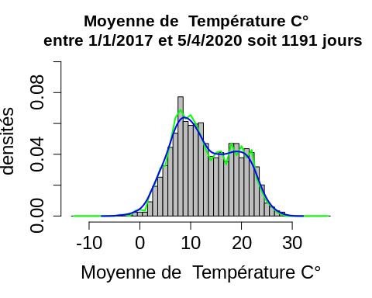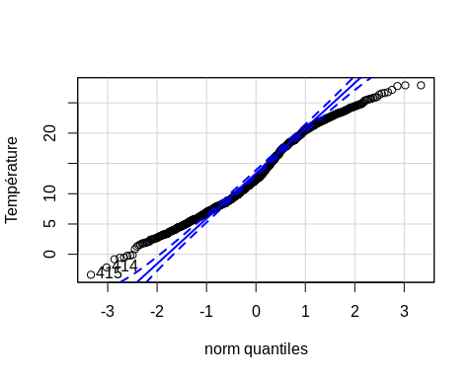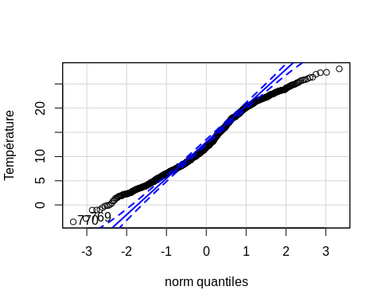

##   
## Shapiro-Wilk normality test  
##   
## data: paramDSK  
## W = 0.97673, p-value = 6.425e-13  
##   
##   
## Shapiro-Wilk normality test  
##   
## data: paramMF  
## W = 0.97696, p-value = 7.649e-13  
##   
##   
## Welch Two Sample t-test  
##   
## data: paramDSK and paramMF  
## t = 1.6379, df = 2379.9, p-value = 0.1016  
## alternative hypothesis: true difference in means is not equal to 0  
## 95 percent confidence interval:  
## -0.08148214 0.90757785  
## sample estimates:  
## mean of x mean of y   
## 13.16784 12.75479   
##   
## param type   
## Min. :-3.49 dsk:1191   
## 1st Qu.: 8.10 mf :1191   
## Median :12.14   
## Mean :12.96   
## 3rd Qu.:18.17   
## Max. :28.11   
##   
## Kruskal-Wallis rank sum test  
##   
## data: param by type  
## Kruskal-Wallis chi-squared = 2.5858, df = 1, p-value = 0.1078  
##   
##   
## Wilcoxon rank sum test with continuity correction  
##   
## data: param by type  
## W = 736229, p-value = 0.1078  
## alternative hypothesis: true location shift is not equal to 0

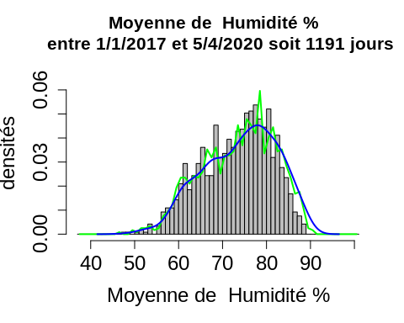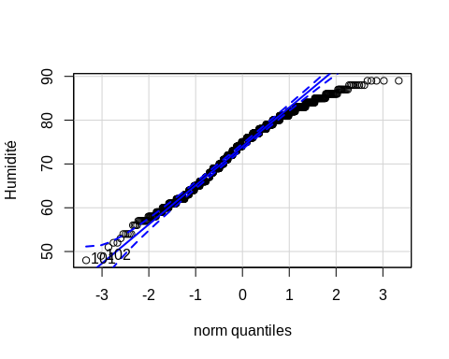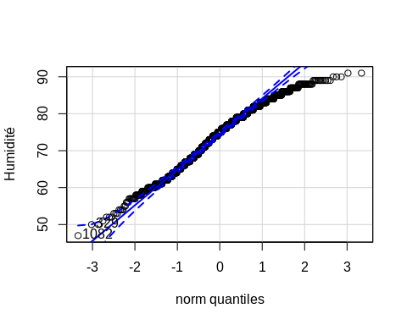

##   
## Shapiro-Wilk normality test  
##   
## data: paramDSK  
## W = 0.97679, p-value = 6.718e-13  
##   
##   
## Shapiro-Wilk normality test  
##   
## data: paramMF  
## W = 0.97849, p-value = 2.587e-12  
##   
##   
## Welch Two Sample t-test  
##   
## data: paramDSK and paramMF  
## t = -1.4824, df = 2369.8, p-value = 0.1384  
## alternative hypothesis: true difference in means is not equal to 0  
## 95 percent confidence interval:  
## -1.1467878 0.1593823  
## sample estimates:  
## mean of x mean of y   
## 73.56675 74.06045   
##   
## param type   
## Min. :47.00 dsk:1191   
## 1st Qu.:68.00 mf :1191   
## Median :75.00   
## Mean :73.81   
## 3rd Qu.:80.00   
## Max. :91.00   
##   
## Kruskal-Wallis rank sum test  
##   
## data: param by type  
## Kruskal-Wallis chi-squared = 2.5847, df = 1, p-value = 0.1079  
##   
##   
## Wilcoxon rank sum test with continuity correction  
##   
## data: param by type  
## W = 682276, p-value = 0.1079  
## alternative hypothesis: true location shift is not equal to 0

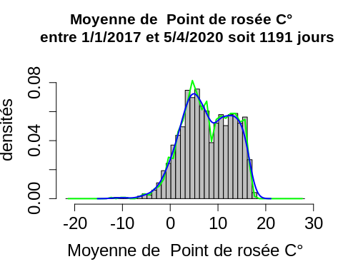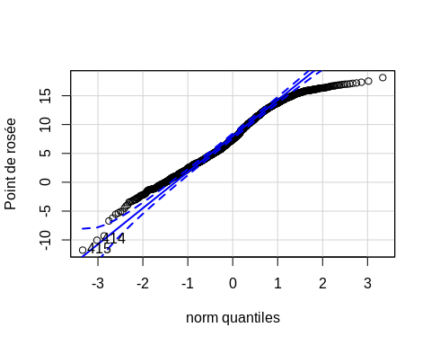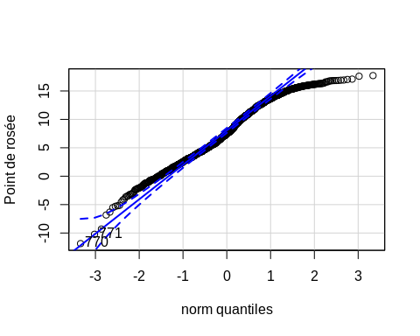

##   
## Shapiro-Wilk normality test  
##   
## data: paramDSK  
## W = 0.97812, p-value = 1.924e-12  
##   
##   
## Shapiro-Wilk normality test  
##   
## data: paramMF  
## W = 0.97813, p-value = 1.932e-12  
##   
##   
## Welch Two Sample t-test  
##   
## data: paramDSK and paramMF  
## t = -0.063932, df = 2378.9, p-value = 0.949  
## alternative hypothesis: true difference in means is not equal to 0  
## 95 percent confidence interval:  
## -0.4302785 0.4031081  
## sample estimates:  
## mean of x mean of y   
## 7.729824 7.743409   
##   
## param type   
## Min. :-11.860 dsk:1191   
## 1st Qu.: 3.870 mf :1191   
## Median : 7.460   
## Mean : 7.737   
## 3rd Qu.: 12.175   
## Max. : 18.140   
##   
## Kruskal-Wallis rank sum test  
##   
## data: param by type  
## Kruskal-Wallis chi-squared = 0.0024133, df = 1, p-value = 0.9608  
##   
##   
## Wilcoxon rank sum test with continuity correction  
##   
## data: param by type  
## W = 708416, p-value = 0.9608  
## alternative hypothesis: true location shift is not equal to 0

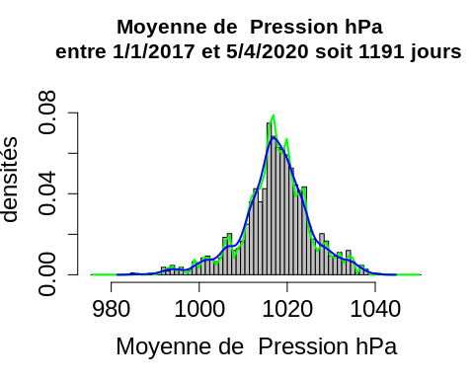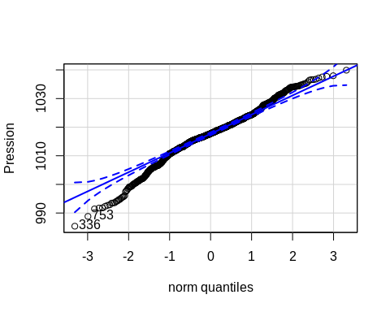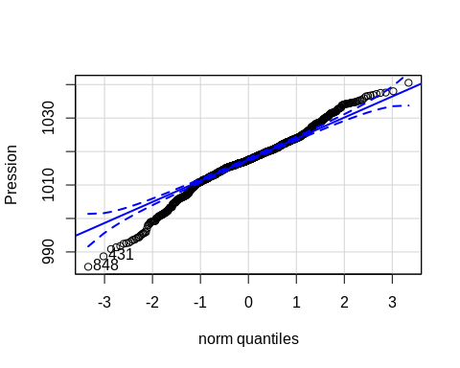

##   
## Shapiro-Wilk normality test  
##   
## data: paramDSK  
## W = 0.98046, p-value = 6.908e-11  
##   
##   
## Shapiro-Wilk normality test  
##   
## data: paramMF  
## W = 0.9784, p-value = 2.414e-12  
##   
##   
## Welch Two Sample t-test  
##   
## data: paramDSK and paramMF  
## t = 0.34466, df = 2233.7, p-value = 0.7304  
## alternative hypothesis: true difference in means is not equal to 0  
## 95 percent confidence interval:  
## -0.5406857 0.7712699  
## sample estimates:  
## mean of x mean of y   
## 1017.420 1017.305   
##   
## param type   
## Min. : 985.4 dsk:1191   
## 1st Qu.:1013.2 mf :1191   
## Median :1017.6   
## Mean :1017.4   
## 3rd Qu.:1022.0   
## Max. :1040.5   
## NA's :109   
##   
## Kruskal-Wallis rank sum test  
##   
## data: param by type  
## Kruskal-Wallis chi-squared = 0.43237, df = 1, p-value = 0.5108  
##   
##   
## Wilcoxon rank sum test with continuity correction  
##   
## data: param by type  
## W = 654606, p-value = 0.5108  
## alternative hypothesis: true location shift is not equal to 0

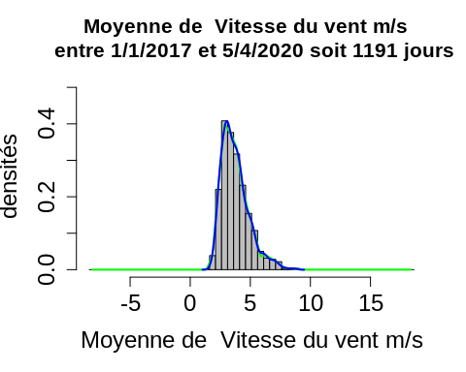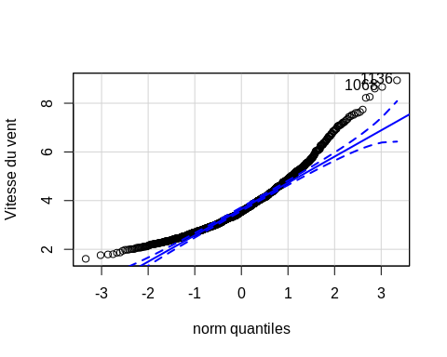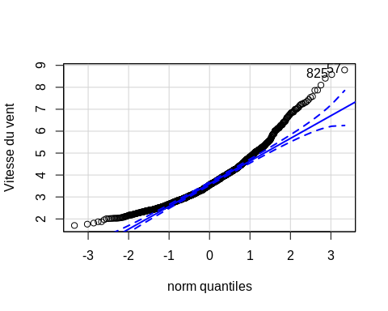

##   
## Shapiro-Wilk normality test  
##   
## data: paramDSK  
## W = 0.93208, p-value < 2.2e-16  
##   
##   
## Shapiro-Wilk normality test  
##   
## data: paramMF  
## W = 0.93244, p-value < 2.2e-16  
##   
##   
## Welch Two Sample t-test  
##   
## data: paramDSK and paramMF  
## t = 0.73363, df = 2378.3, p-value = 0.4632  
## alternative hypothesis: true difference in means is not equal to 0  
## 95 percent confidence interval:  
## -0.05811147 0.12758250  
## sample estimates:  
## mean of x mean of y   
## 3.777103 3.742368   
##   
## param type   
## Min. :1.61 dsk:1191   
## 1st Qu.:2.91 mf :1191   
## Median :3.55   
## Mean :3.76   
## 3rd Qu.:4.34   
## Max. :8.94   
##   
## Kruskal-Wallis rank sum test  
##   
## data: param by type  
## Kruskal-Wallis chi-squared = 0.36632, df = 1, p-value = 0.545  
##   
##   
## Wilcoxon rank sum test with continuity correction  
##   
## data: param by type  
## W = 719398, p-value = 0.545  
## alternative hypothesis: true location shift is not equal to 0

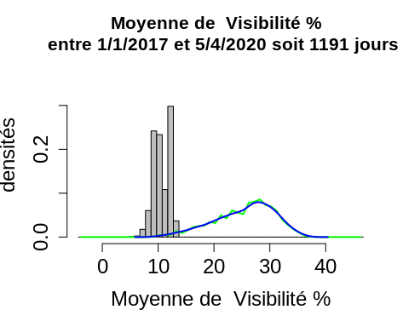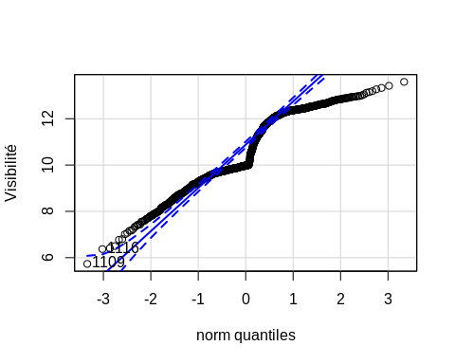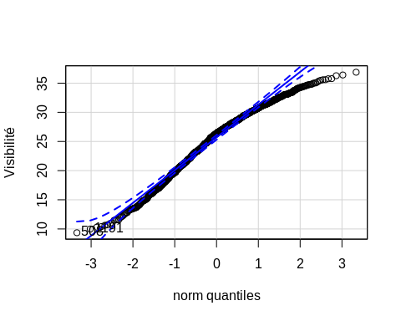

##   
## Shapiro-Wilk normality test  
##   
## data: paramDSK  
## W = 0.93231, p-value < 2.2e-16  
##   
##   
## Shapiro-Wilk normality test  
##   
## data: paramMF  
## W = 0.97402, p-value = 8.433e-14  
##   
##   
## Welch Two Sample t-test  
##   
## data: paramDSK and paramMF  
## t = -92.446, df = 1369.9, p-value < 2.2e-16  
## alternative hypothesis: true difference in means is not equal to 0  
## 95 percent confidence interval:  
## -15.17366 -14.54307  
## sample estimates:  
## mean of x mean of y   
## 10.60748 25.46584   
##   
## param type   
## Min. : 5.73 dsk:1191   
## 1st Qu.: 9.98 mf :1191   
## Median :12.89   
## Mean :18.04   
## 3rd Qu.:26.39   
## Max. :36.88   
##   
## Kruskal-Wallis rank sum test  
##   
## data: param by type  
## Kruskal-Wallis chi-squared = 1746.4, df = 1, p-value < 2.2e-16  
##   
##   
## Wilcoxon rank sum test with continuity correction  
##   
## data: param by type  
## W = 7853.5, p-value < 2.2e-16  
## alternative hypothesis: true location shift is not equal to 0

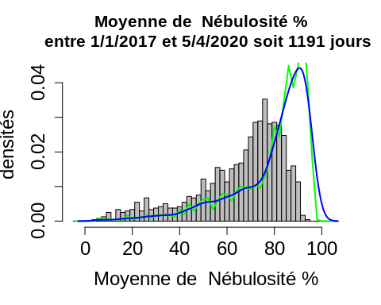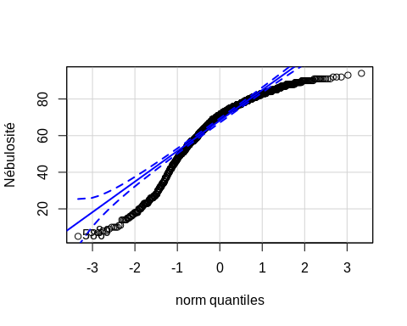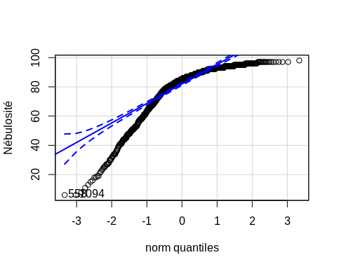

##   
## Shapiro-Wilk normality test  
##   
## data: paramDSK  
## W = 0.90472, p-value < 2.2e-16  
##   
##   
## Shapiro-Wilk normality test  
##   
## data: paramMF  
## W = 0.82496, p-value < 2.2e-16  
##   
##   
## Welch Two Sample t-test  
##   
## data: paramDSK and paramMF  
## t = -18.46, df = 2349.6, p-value < 2.2e-16  
## alternative hypothesis: true difference in means is not equal to 0  
## 95 percent confidence interval:  
## -14.88254 -12.02426  
## sample estimates:  
## mean of x mean of y   
## 65.78925 79.24265   
##   
## param type   
## Min. : 5.00 dsk:1191   
## 1st Qu.:63.00 mf :1191   
## Median :78.00   
## Mean :72.52   
## 3rd Qu.:87.00   
## Max. :98.00   
##   
## Kruskal-Wallis rank sum test  
##   
## data: param by type  
## Kruskal-Wallis chi-squared = 448.42, df = 1, p-value < 2.2e-16  
##   
##   
## Wilcoxon rank sum test with continuity correction  
##   
## data: param by type  
## W = 353918, p-value < 2.2e-16  
## alternative hypothesis: true location shift is not equal to 0

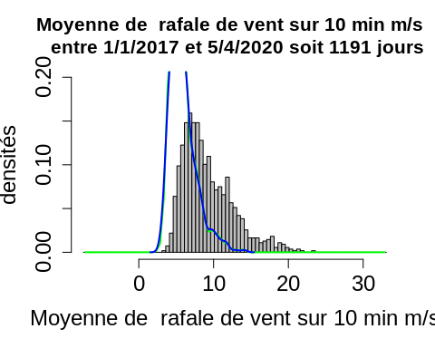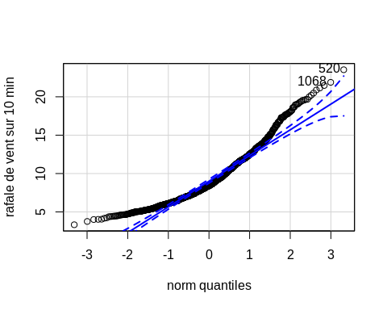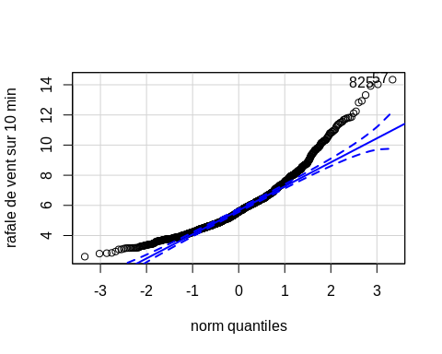

##   
## Shapiro-Wilk normality test  
##   
## data: paramDSK  
## W = 0.92466, p-value < 2.2e-16  
##   
##   
## Shapiro-Wilk normality test  
##   
## data: paramMF  
## W = 0.92202, p-value < 2.2e-16  
##   
##   
## Welch Two Sample t-test  
##   
## data: paramDSK and paramMF  
## t = 29.089, df = 1644.3, p-value < 2.2e-16  
## alternative hypothesis: true difference in means is not equal to 0  
## 95 percent confidence interval:  
## 3.124627 3.576463  
## sample estimates:  
## mean of x mean of y   
## 9.244735 5.894190   
##   
## param type   
## Min. : 2.600 dsk:1191   
## 1st Qu.: 5.210 mf :1191   
## Median : 6.680   
## Mean : 7.498   
## 3rd Qu.: 8.850   
## Max. :23.520   
## NA's :97   
##   
## Kruskal-Wallis rank sum test  
##   
## data: param by type  
## Kruskal-Wallis chi-squared = 742.22, df = 1, p-value < 2.2e-16  
##   
##   
## Wilcoxon rank sum test with continuity correction  
##   
## data: param by type  
## W = 1080694, p-value < 2.2e-16  
## alternative hypothesis: true location shift is not equal to 0

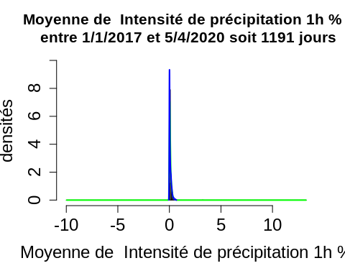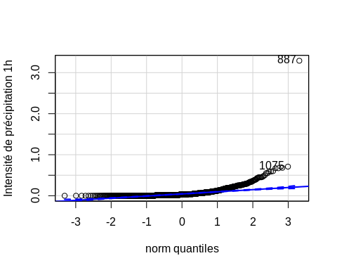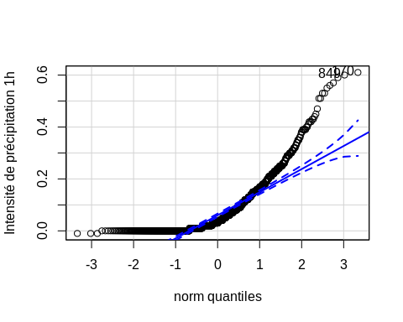

##   
## Shapiro-Wilk normality test  
##   
## data: paramDSK  
## W = 0.41001, p-value < 2.2e-16  
##   
##   
## Shapiro-Wilk normality test  
##   
## data: paramMF  
## W = 0.76234, p-value < 2.2e-16  
##   
##   
## Welch Two Sample t-test  
##   
## data: paramDSK and paramMF  
## t = -1.9816, df = 1967.3, p-value = 0.04766  
## alternative hypothesis: true difference in means is not equal to 0  
## 95 percent confidence interval:  
## -0.0201661012 -0.0001044878  
## sample estimates:  
## mean of x mean of y   
## 0.06711911 0.07725441   
##   
## param type   
## Min. :-0.01000 dsk:1191   
## 1st Qu.: 0.01000 mf :1191   
## Median : 0.03000   
## Mean : 0.07243   
## 3rd Qu.: 0.10000   
## Max. : 3.29000   
## NA's :108   
##   
## Kruskal-Wallis rank sum test  
##   
## data: param by type  
## Kruskal-Wallis chi-squared = 6.3012, df = 1, p-value = 0.01207  
##   
##   
## Wilcoxon rank sum test with continuity correction  
##   
## data: param by type  
## W = 606007, p-value = 0.01207  
## alternative hypothesis: true location shift is not equal to 0

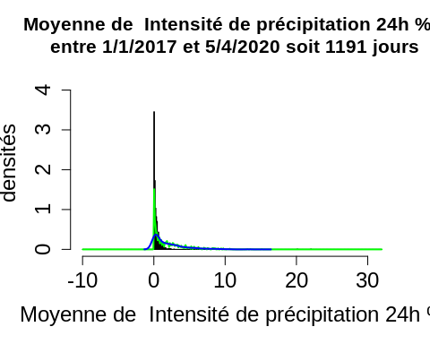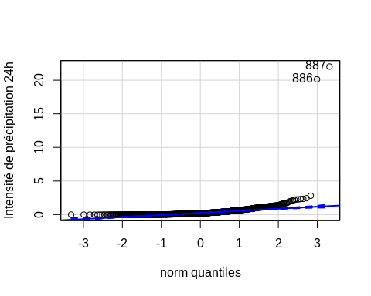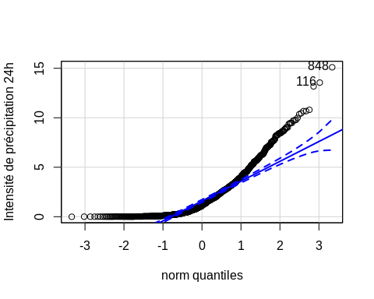

##   
## Shapiro-Wilk normality test  
##   
## data: paramDSK  
## W = 0.22586, p-value < 2.2e-16  
##   
##   
## Shapiro-Wilk normality test  
##   
## data: paramMF  
## W = 0.80774, p-value < 2.2e-16  
##   
##   
## Welch Two Sample t-test  
##   
## data: paramDSK and paramMF  
## t = -22.177, df = 1642.6, p-value < 2.2e-16  
## alternative hypothesis: true difference in means is not equal to 0  
## 95 percent confidence interval:  
## -1.750113 -1.465699  
## sample estimates:  
## mean of x mean of y   
## 0.3665189 1.9744249   
##   
## param type   
## Min. :-0.010 dsk:1191   
## 1st Qu.: 0.100 mf :1191   
## Median : 0.390   
## Mean : 1.209   
## 3rd Qu.: 1.400   
## Max. :22.030   
## NA's :108   
##   
## Kruskal-Wallis rank sum test  
##   
## data: param by type  
## Kruskal-Wallis chi-squared = 469.31, df = 1, p-value < 2.2e-16  
##   
##   
## Wilcoxon rank sum test with continuity correction  
##   
## data: param by type  
## W = 306207, p-value < 2.2e-16  
## alternative hypothesis: true location shift is not equal to 0