Image & Assets Documentation

Original Image | Source | Uses | After Editing
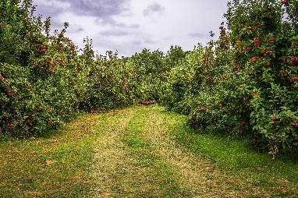 | https://www.pexels.com/photo/an-apple-orchard-with-a-dirt-path-leading-to-it-28387811/ | On produce.php as background image | 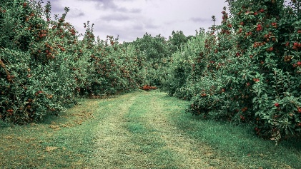
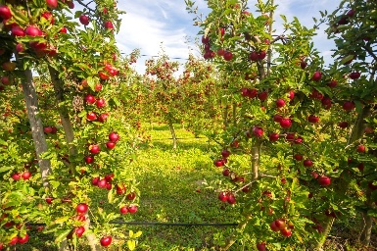 | canva – pro education license | On user-dashboard, producer-dashboard as background image | 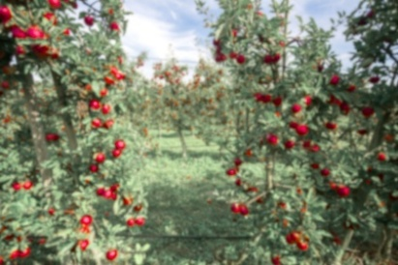
 | canva – designed by myself | LOGO – on header | none
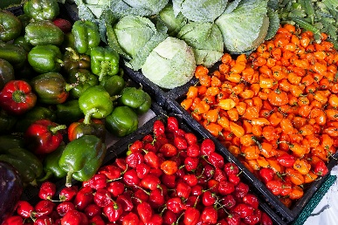 | Photo by Mark Stebnicki: https://www.pexels.com/photo/assorted-vegetable-store-displays-2252584/ | used on produce.php as featured products placeholder | none
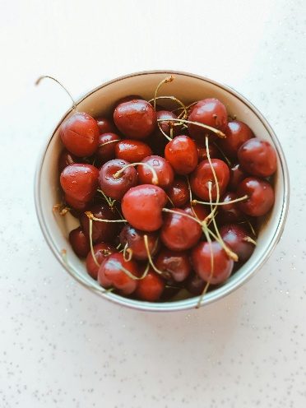 | Photo by Nur Tok: https://www.pexels.com/photo/fresh-red-cherries-in-a-bowl-on-white-table-30339231/ | used on products.php as product image placeholder | 