**Practical No: 1**

Aim: **Introduction to Excel**

**• Perform conditional formatting on a dataset using various criteria.**

**• Create a pivot table to analyze and summarize data.**

**• Use VLOOKUP function to retrieve information from a different worksheet or table.**

# • Perform what-if analysis using Goal Seek to determine input values for desired output.

**i) Introduction to Excel**

**A. Perform conditional formatting on a dataset using various criteria.**

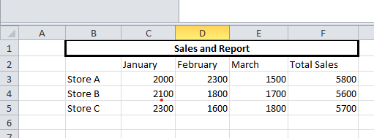

Steps Step 1: Go to conditional formatting > Greater Than

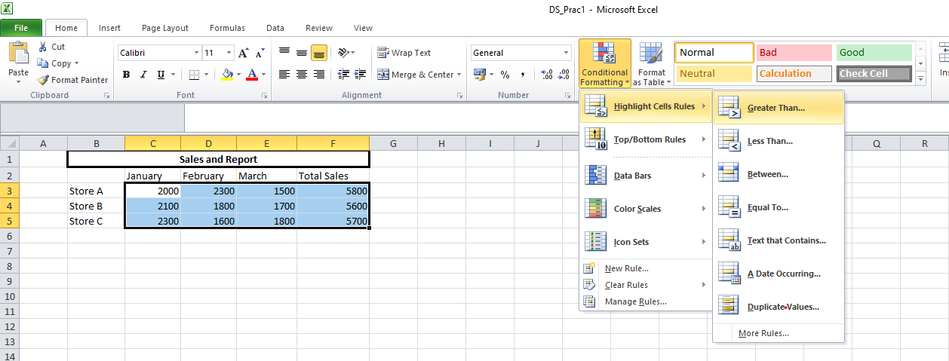

Step 2: Enter the greater than filter value for example 3650.  
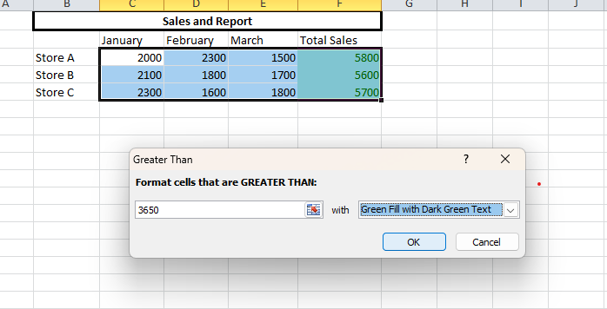

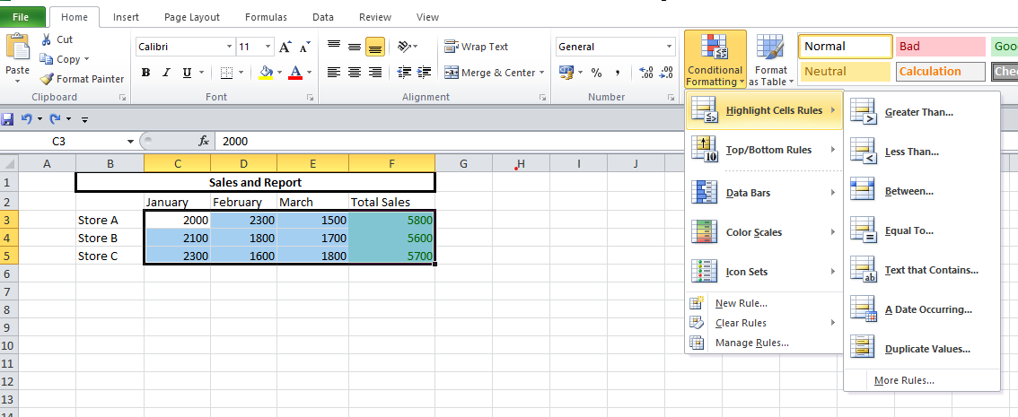

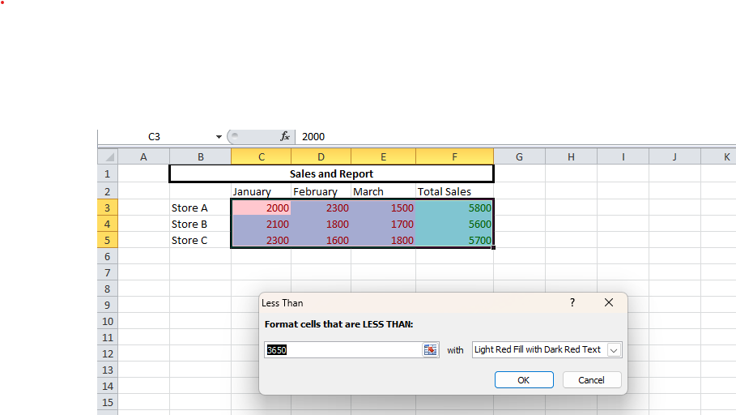

Step 3: Go to Data Bars > Solid Fill in conditional formatting.

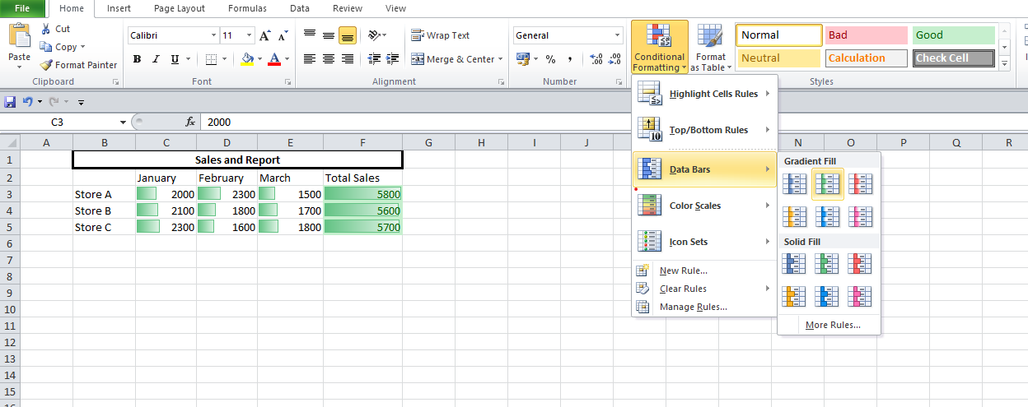

**B. Create a pivot table to analyse and summarize data.**

Step 1: select the entire table and go to Insert tab PivotChart > Pivotchart .

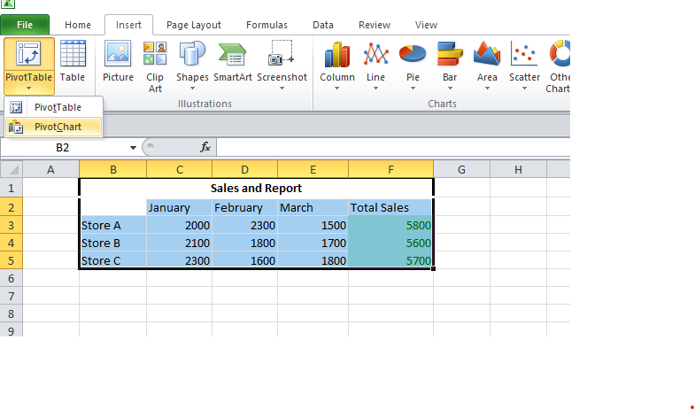

Step 2: Select “New worksheet” in the create pivot chart window.  
  
Step 3: Select and drag attributes in the below boxes.

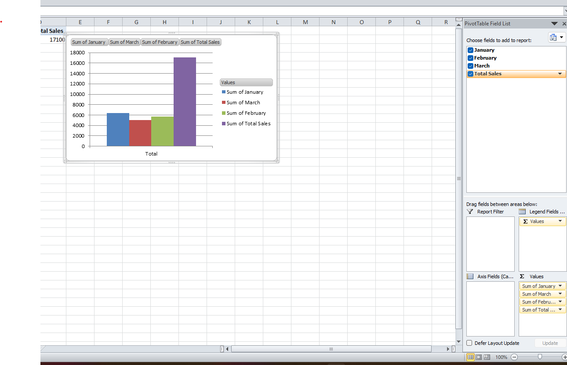

A. Use VLOOKUP function to retrieve information from a different worksheet or table. Steps: Step 1: click on an empty cell and type the following command. =VLOOKUP(B5, B2:F5,4, TRUE)

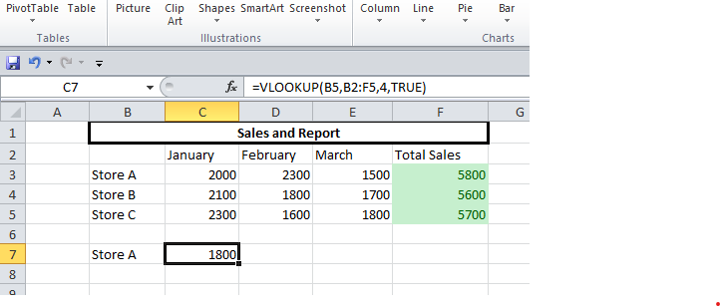

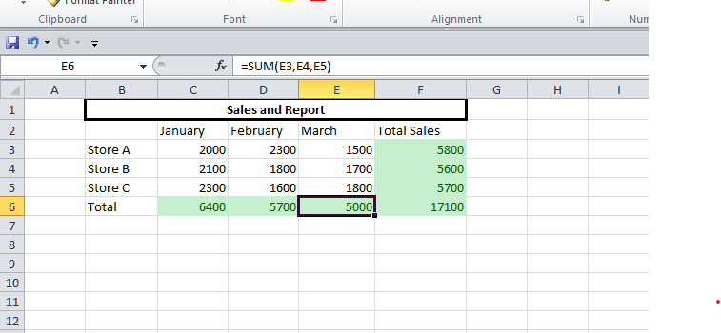

**B. Perform what-if analysis using Goal Seek to determine input values for desired output.**

Steps-

Step 1: In the Data tab go to the what if analysis>Goal seek.

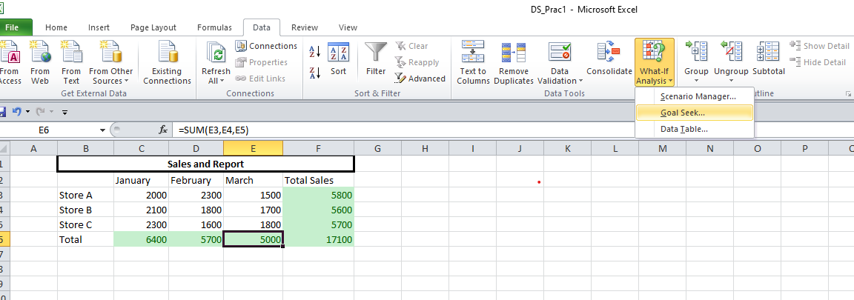

Step 2: Fill the information in the window accordingly and click ok.

