**Practical No: 2**

Aim: **Data Frames and Basic Data Pre-processing**

**• Read data from CSV and JSON files into a data frame.**

**• Perform basic data pre-processing tasks such as handling missing values and outliers.**

**• Manipulate and transform data using functions like filtering, sorting, and grouping.**

**Data Frames and Basic Data Pre-processing**

**A. Read data from CSV and JSON files into a data frame**

**1)**

import pandas as pd

dataframe = pd.read_csv("C:\\Users\COMPUTER LAB\Documents\Harshal_TYCS_Files\DS\DS_Prac_2.csv")

print("Our Dataframe : ",dataframe)

**Output:**

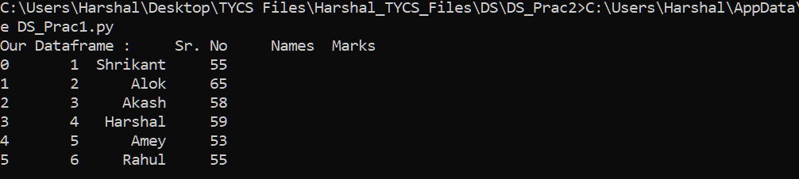

**2)**

import pandas as pd

import json

a = '[[["fruit","Apple"],["size","Large"],["Color","Red"]]]'

parsed_data=json.loads(a)

data_dict=dict(parsed_data[0])

data=pd.DataFrame([data_dict])

print(data)

**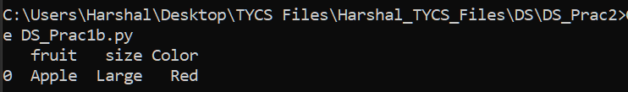  
  
B. Perform basic data pre-processing tasks such as handling missing values and outliers.**