

Deep Deterministic Policy Gradient for Regularity Rally in TORCS Simulator

Facoltà di Ingegneria dell’Informazione, Informatica e Statistica

Dipartimento di Ingegneria Informatica, Automatica e Gestionale
Corso di laurea in Ingegneria Informatica e Automatica

Alessio Ragno
Matricola 1759198

Thesis Advisor
Prof. Roberto Capobianco

Academic Year 2018-2019

Deep Deterministic Policy Gradient for Regularity Rally in TORCS Simulator
Bachelor thesis. Sapienza University of Rome

© 2019 Alessio Ragno. All rights reserved.

Version: TODO
Author’s email: spideralessio97@gmail.com

Dedicated to
BHO
Table of Contents
1. Introduction 5
2. TORCS 6
2.1. Simulated Car Racing Championship 6
3. Reinforcement Learning 7
3.1. Monte Carlo and Temporal Difference (TD) Learning 8
3.2. Three approaches to solve a RL problem. 8
3.3. Value based 8
3.4. Policy Based 9
3.5. Model Based 9
3.6. Actor Critic 9
4. Reinforcement Learning Algorithms Improvements 10
4.1. Deep Learning 10
4.1.1. Deep Q-Learning 10
4.2. Bellman equation and Target Function 10
4.3. Exploration-Exploitation trade off 11
4.4. Replay Buffer 11
5. Deep Deterministic Policy Gradient 12
6. Implementation 13
6.1. Environment 13
6.2. DDPG in Tensorflow 14
6.2.1. Critic Network 14
6.2.2. Actor Network 15
6.3. Ornstein–Uhlenbeck Noise 18
6.4. Reward Shaping 19
7. Training 20
8. Evaluation 21

Introduction
This thesis is a report for the Excellence Course Project developed during the degree’s last year.
The aim of the project is to study an application of Deep Reinforcement Learning by training a sensor-based autonomous car to drive in a Regularity Rally. Regularity Rally is a type of motor sport race with the object of driving in the minimum time at a specified average speed [1].
Deep Reinforcement Learning is a branch of Artificial Intelligence that studies algorithms to teach an agent how to act in an environment. Some applications of this subject are robotics, advertising, business and chemistry.
For this project the environment chose is TORCS, an open source car simulator that can be controlled by Python APIs.
In order to achieve the goal Deep Deterministic Policy Gradient algorithm has been applied.

TORCS
TORCS (The Open Racing Car Simulator) is an open-source 3D car racing simulator released for the first time in 1997 and developed by Bernhard Wymann (project leader), Christos Dimitrakakis (simulation, sound, AI) and Andrew Sumner (graphics, tracks). [2].

Simulated Car Racing Championship
Simulated Car Racing Championship is an international competition with the goal to design a pre-programmed driver that can compete on unknown tracks first alone and then against other autonomous drivers. The drivers perceive the environment through a number of sensors that describe relevant features of the car surroundings (e.g., the track limits, the position of near-by obstacles), of the car state (the fuel level, the engine RPMs, the current gear, etc.), and the current game state (lap time, number of lap, etc.).
The competition software extends the original TORCS architecture by adding a client-server module, real time events simulation and an abstraction layer between the driver code and the race server [3].
Table 1: Description of TORCS available sensors.

Table 2: Description of TORCS available effectors.

Reinforcement Learning
Machine Learning is an application of artificial intelligence that studies algorithms and methods that can automatically learn and improve from experience without being explicitly programmed.
Typically Machine Learning methods are divided in three main categories: supervised learning, unsupervised learning and reinforcement learning.
The former’s goal is to learn a mapping from inputs x to outputs y, given a labeled set of input-output pairs called training set; the second focuses on finding “interesting patterns” in data; [4] the latter, is the problem faced by an agent that must learn behavior through trial-and-error interactions with a dynamic environment.
In the standard Reinforcement-Learning (RL) model, also known as Markov Decision Process, an agent is connected to an environment with which it can interact. Every time an action is performed, the agent receives its current state in the environment with the gained reward, that can be positive or negative.
Formally, in Markov Decision Process a model is defined by:
- a set of environment states S
- a set of agent actions A
- a set of scalar rewards R
Reinforcement Learning focuses to learn a behavior that maximizes the expected cumulative reward [5].
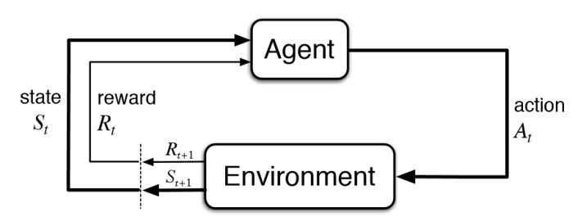
Figure 1: The agent-environment interaction in a Markov decision process.
The cumulative reward at each time step t can be written as:
(1)
The equation just defined is also called finite-horizon model, but it is not always appropriate: in many cases the precise length of the agent's life is not known in advance, so it is preferable to use the infinite-horizon discounted model, which can be defined in the following way:
where | (2)
The infinite-horizon discounted model takes the long-run reward of the agent into account, but rewards that are received in the future are geometrically discounted according to discount factor γ.

Monte Carlo and Temporal Difference (TD) Learning
A Reinforcement learning model could be learned in two ways:
- Monte Carlo: Rewards are given at the end of the game and the agent learns on the cumulative reward.
(3)
- TD Learning: Every step the agent gets the reward and model is updated.
(4)
With long episodes TD Learning is preferable because using only the cumulative reward could penalize good actions chosen in bad episodes and could reward bad actions taken in good episodes.

Three approaches to solve a RL problem.
There are three main approaches to solve a Reinforcement Learning problem: value based, policy based and model based.
From these three methods take place other ones, like actor critic, that are simply the mixture of the basic ones.

Value based
Value based class of algorithms aims to build a value function of states (or of state-action pairs) that estimate “how good” it is for the agent to be in a given state (or how good it is to perform a given action in a given state). The notion of “how good” here is defined in terms of future rewards that can be expected. One of the simplest and most popular value based algorithms is Q-learning (Watkins, 1989).
Basically Q-learning keeps a lookup table of values with one entry for every state-action pair that estimates the expected cumulative reward. The value function Q can be defined in the following way:
(5)
Once the value function is known (or estimated) it is possible to apply argmax to chose the action that would give the highest reward in a specific state.

Policy Based
In policy based Reinforcement Learning the goal is to optimize the policy function π without using a value function. The policy takes in input the state and returns the action the agent should take:
(6)
It is possible to define a deterministic policy, which returns the same action at a given state or a stochastic one that outputs a distribution probability over actions at a given state.

Model Based
Model based algorithms goal is to build a model of the environment in order to take the right action at a given state. This approach is less general than the other two, in facts, for every environment it is necessary to build a specific model.

Actor Critic
If the value function is learned in addition to the policy, we would get Actor-Critic algorithm:
- Critic: updates value function parameters w and depending on the algorithm it could be action-value Q(a|s;w) or state-value V(s;w).
- Actor: updates policy parameters θ, in the direction suggested by the critic, π(a|s;θ).
This class of algorithms is very powerful and it is the one we will focus on, since it is implemented in Deep Deterministic Policy Gradient.

Reinforcement Learning Algorithms Improvements
This Chapter focuses on some improvements that could be used in Reinforcement Learning to have better performance and to handle some problems that could be easily encountered.

Deep Learning
The adoption of Neural Networks (NN) in Reinforcement Learning gave birth to the so called Deep Reinforcement Learning. Using NNs to model policies and value functions is easier to handle continuous domain states and actions. An important example of this approach is Deep Q-Learning.

Deep Q-Learning
Deep Q-Learning is an improvement of Q-Learning that uses Neural Networks instead of tables to estimate the value function. Q-Learning is very powerful but it can only be used with discrete actions and states while the deep version allows also continuous inputs.

Bellman equation and Target Function
When using TD value based models, and in particular Deep Q-Learning, the value learned at time t strongly depends on the function learned at time t-1, this relation is described by the Bellman Equation:
(7)
What the Bellman Equation points out is that the new Q value for that state-action tuple is the current Q value plus the learning rate α times the reward for taking that action at that state added to the difference between the discounted maximum expected future reward given the next state-action tuple and the current Q value.
What value based models try to do is minimize the error between real value function and the estimated one. The error is calculated by taking the difference between predicted Q target (maximum possible value from the next state) and the current Q value. When using Neural Networks, weights could be updated by multiplying the error and gradient of the Q value:
(8)

Since the Q target is not known, it needs to be estimated together with the Q value, but using the same same weights for estimating both makes a big correlation between the target and the error that leads to slow learning. Instead of using the same weights, Google DeepMind introduced the notion of fixed Q-targets, which is, the use of a separate network with a fixed parameter for estimating the target that is updated every τ step by copying the same parameters of the Q Network.

Exploration-Exploitation trade off
Since RL tries to maximize the cumulative reward, it is frequent that the model reaches local maximum points, which is, in the most of the times, due to a weak knowledge of the environment. To avoid the model to exploit the “closest” source of rewards, in the training phase, it is necessary to add some noise to the actions in order to allow the agent to explore the entire environment and reach a better maximum point.

Replay Buffer
Replay Buffer or Experience Replay is a technique that consists in keeping buffer that stores the tuples (s, a, r, s’) of the various steps. At each step, the training routine picks a batch of examples from the buffer and uses them to update the model. This is quite useful because avoids forgetting previous experiences and reduces correlation between experiences.

Deep Deterministic Policy Gradient
In 2016 Google Deepmind Researches created an algorithm based on the actor critic approach to apply Reinforcement Learning in environments with continuous action domain and continuous action spaces: Deep Deterministic Policy Gradient (DDPG).
Described in the paper “Continuous control with Deep Reinforcement Learning”, DDPG is the mixture of Deep Q-Learning and Deterministic Policy Gradient. [6].
The DDPG algorithm is quite simple and its pseudo-code is the following:
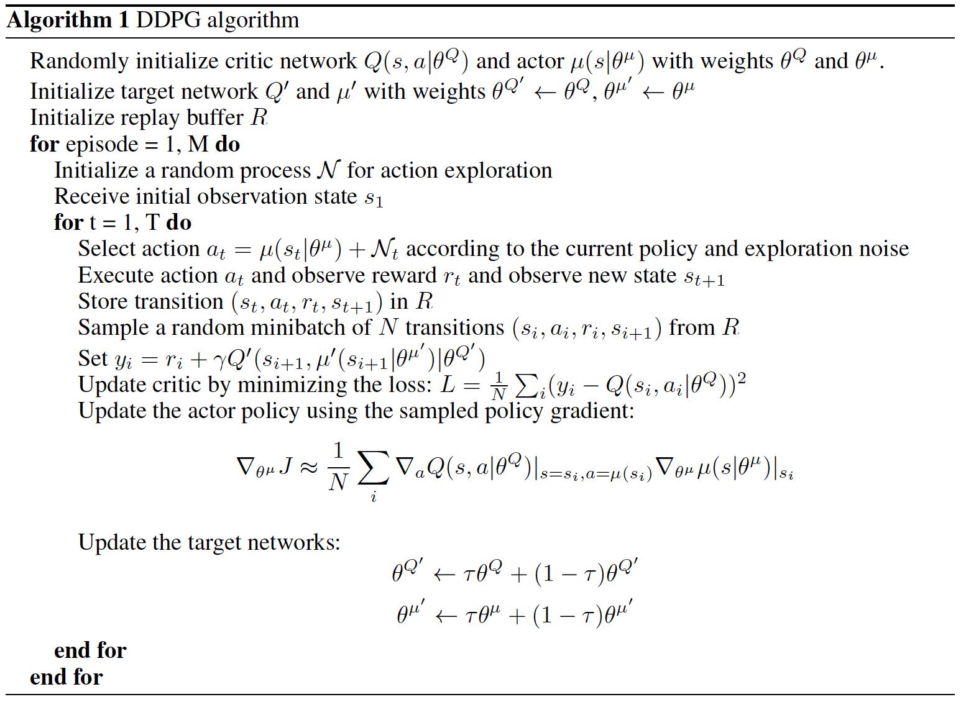

Implementation
What follows is an explanation of the Project Implementation with some pieces of code and instructions to allow the reader to replicate it.

Environment
As explained in Chapter 2.1, the environment is completely developed in the Simulated Car Racing Championship Software that is available at the following Git Hub repository with a readme file that explains how to compile and install it: https://github.com/fmirus/torcs-1.3.7.
To interact with the simulator the developer Naoto Yoshida created a Python API that allows programmers to communicate with the environment with OpenAI-like methods. A detailed readme of the API is available at the following link: https://github.com/ugo-nama-kun/gym_torcs.
Here is a small piece of code that shows how gym_torcs can be used to drive a TORCS car.
from gym_torcs import TorcsEnv

#### Generate a Torcs environment
# enable vision input, the action is steering only (1 dim continuous action)
env = TorcsEnv(vision=True, throttle=False)

# without vision input, the action is steering and throttle (2 dim continuous action)
# env = TorcsEnv(vision=False, throttle=True)

ob = env.reset(relaunch=True) # with torcs relaunch (avoid memory leak bug in torcs)
# ob = env.reset() # without torcs relaunch

# Generate an agent
from sample_agent import Agent
agent = Agent(1) # steering only
action = agent.act(ob, reward, done, vision=True)

# single step
ob, reward, done, _ = env.step(action)

# shut down torcs
env.end()

DDPG in Tensorflow
Deep Deterministic Policy Gradient implementation has been coded in Python Tensorflow using the Keras high-level API. The code has not been written from scratch, but starting from an old implementation based on the old version of Keras that is now deprecated. The original project owned by Ben Lau can be found at the following link: yanpanlau.github.io/2016/10/11/Torcs-Keras.html

Critic Network
The Critic Network consists in a class that contains four methods.
The constructor __init__ that initializes the parameters and instatiates the Critic Network and the Target Critic Network.
class CriticNetwork(object):
def __init__(self, sess, state_size, action_size, BATCH_SIZE, TAU, LEARNING_RATE):
self.sess = sess
self.BATCH_SIZE = BATCH_SIZE
self.TAU = TAU
self.LEARNING_RATE = LEARNING_RATE
self.action_size = action_size
K.set_session(sess)
self.model, self.action, self.state = self.create_critic_network(state_size, action_size)
self.target_model, self.target_action, self.target_state = self.create_critic_network(state_size, action_size)
self.action_grads = tf.gradients(self.model.output, self.action)
self.sess.run(tf.initialize_all_variables())
… continues
The gradients method evaluates estimated value gradient on actions to train the Actor Network.
…
def gradients(self, states, actions):
return self.sess.run(self.action_grads, feed_dict={
self.state: states,
self.action: actions
})[0]
… continues

target_train that updates target network as explained in Chapter 4.2
…
def target_train(self):
critic_weights = self.model.get_weights()
critic_target_weights = self.target_model.get_weights()
for i in range(len(critic_weights)):
critic_target_weights[i] = self.TAU * critic_weights[i] + (1 - self.TAU)* critic_target_weights[i]
self.target_model.set_weights(critic_target_weights)
… continues
create_critic_network method builds the Critic Neural Network by concatenating the input layers (state and action) with two hidden layers made respectively of 300 and 600 neurons.
…
def create_critic_network(self, state_size,action_dim):
print("Now we build the model")
S = Input(shape=[state_size])
A = Input(shape=[action_dim],name='action2')
w1 = Dense(HIDDEN1_UNITS, activation='relu')(S)
a1 = Dense(HIDDEN2_UNITS, activation='linear')(A)
h1 = Dense(HIDDEN2_UNITS, activation='linear')(w1)
h2 = add([h1,a1])
h3 = Dense(HIDDEN2_UNITS, activation='relu')(h2)
V = Dense(action_dim,activation='linear')(h3)
model = Model(inputs=[S,A],outputs=V)
adam = Adam(lr=self.LEARNING_RATE)
model.compile(loss='mse', optimizer=adam)
return model, A, S

Actor Network
Actor Network realization is quite similar except for training method and the neural network initialization routine. In facts, the neural network input is just the agent state and the output is composed of the three commands the agent every step controls. The full implementation is provided in the next piece of code.

class ActorNetwork(object):
def __init__(self, sess, state_size, action_size, BATCH_SIZE, TAU, LEARNING_RATE):
self.sess = sess
self.BATCH_SIZE = BATCH_SIZE
self.TAU = TAU
self.LEARNING_RATE = LEARNING_RATE
K.set_session(sess)
self.model , self.weights, self.state = self.create_actor_network(state_size, action_size)
self.target_model, self.target_weights, self.target_state = self.create_actor_network(state_size, action_size)
self.action_gradient = tf.placeholder(tf.float32,[None, action_size])
self.params_grad = tf.gradients(self.model.output, self.weights, -self.action_gradient)
grads = zip(self.params_grad, self.weights)
self.optimize = tf.train.AdamOptimizer(LEARNING_RATE).apply_gradients(grads)
self.sess.run(tf.initialize_all_variables())

def train(self, states, action_grads):
self.sess.run(self.optimize, feed_dict={
self.state: states,
self.action_gradient: action_grads
})

def target_train(self):
actor_weights = self.model.get_weights()
actor_target_weights = self.target_model.get_weights()
for i in range(len(actor_weights)):
actor_target_weights[i] = self.TAU * actor_weights[i] + (1 - self.TAU)* actor_target_weights[i]
self.target_model.set_weights(actor_target_weights)

def create_actor_network(self, state_size,action_dim):
print("Now we build the model")
S = Input(shape=[state_size])
h0 = Dense(HIDDEN1_UNITS, activation='relu')(S)
h1 = Dense(HIDDEN2_UNITS, activation='relu')(h0)
Steering = Dense(1,activation='tanh',kernel_initializer=variance_scaling(scale=1e-4, distribution='normal'), bias_initializer=variance_scaling(scale=1e-4, distribution='normal'))(h1)
Acceleration = Dense(1,activation='sigmoid', kernel_initializer=variance_scaling(scale=1e-4, distribution='normal'), bias_initializer=variance_scaling(scale=1e-4, distribution='normal'))(h1)
Brake = Dense(1,activation='sigmoid', kernel_initializer=variance_scaling(scale=1e-4, distribution='normal'), bias_initializer=variance_scaling(scale=1e-4, distribution='normal'))(h1)
V = concatenate([Steering,Acceleration,Brake])
model = Model(inputs=S, outputs=V)
return model, model.trainable_weights, S
Since acceleration and brake are values between 0 and 1 and steering value is between -1 and 1, in create_actor_network method,, the Critic Network output layer parameters are initialized with a normal distribution scaled of a 1e-4 factor.
The main work is done by the updated routine that is run right after an action is taken every step.
At first the environment is reset and the first state is stored observed.
ob = env.reset()
s_t = np.hstack((ob.angle, ob.track, ob.trackPos, ob.speedX, ob.speedY, ob.speedZ, ob.wheelSpinVel/100.0, ob.rpm))
After that, a loop over the max number of steps starts. The actor predicts an action, to which some noise is added and the agent interacts with the environment by sending the chosen action and a new observation is made.
for j in range(max_steps):
loss = 0
epsilon -= 1.0 / EXPLORE
a_t = np.zeros([1,action_dim])
noise_t = np.zeros([1,action_dim])
a_t_original = actor.model.predict(s_t.reshape(1, s_t.shape[0]))
noise_t[0][0] = train_indicator * max(epsilon, 0) * OU.function(a_t_original[0][0], 0.0 , 0.60, 0.10)
noise_t[0][1] = train_indicator * max(epsilon, 0) * OU.function(a_t_original[0][1], 0.6 , 1.00, 0.10)
noise_t[0][2] = train_indicator * max(epsilon, 0) * OU.function(a_t_original[0][2], -0.1 , 1.00, 0.05)
#The following code do the stochastic brake
if random.random() <= 0.1:
print("********Now we apply the brake***********")
noise_t[0][2] = train_indicator * max(epsilon, 0) * OU.function(a_t_original[0][2], 0.1 , 1.00, 0.10)
for x in range(action_dim):
a_t[0][x] = a_t_original[0][x] + noise_t[0][x]
ob, r_t, done, info = env.step(a_t[0])
s_t1 = np.hstack((ob.angle, ob.track, ob.trackPos, ob.speedX, ob.speedY, ob.speedZ, ob.wheelSpinVel/100.0, ob.rpm))
The tuple (state, action, reward, next_state) is then stored in the replay buffer. A batch of samples is picked from the replay buffer and for each sample the Target Q value is calculated, as well as the real value. Critic is trained by minimizing the mean squared error by the estimated Q value and the calculated Q value. Actor
update is more complex: for every sample, actor predicts the action for the state and the value gradient is calculated on it, after that actor is trained by maximizing the value function over the state-action tuple. Finally, Target networks are updated.
for j in range(max_steps):
...
buff.add(s_t, a_t[0], r_t, s_t1, done)
batch = buff.getBatch(BATCH_SIZE)
states = np.asarray([e[0] for e in batch])
actions = np.asarray([e[1] for e in batch])
rewards = np.asarray([e[2] for e in batch])
new_states = np.asarray([e[3] for e in batch])
dones = np.asarray([e[4] for e in batch])
y_t = np.asarray([e[1] for e in batch])
target_q_values = critic.target_model.predict([new_states, actor.target_model.predict(new_states)])
for k in range(len(batch)):
if dones[k]:
y_t[k] = rewards[k]
else:
y_t[k] = rewards[k] + GAMMA*target_q_values[k]
if (train_indicator):
loss += critic.model.train_on_batch([states,actions], y_t)
a_for_grad = actor.model.predict(states)
grads = critic.gradients(states, a_for_grad)
actor.train(states, grads)
actor.target_train()
critic.target_train()
total_reward += r_t
s_t = s_t1

Ornstein–Uhlenbeck Noise
To avoid the model to exploit and guarantee exploration OU Noise is used. The definition and its implementation are the following:
(9)

class OU(object):
def function(self, x, mu, theta, sigma):
return theta * (mu – x) * 0.002 + sigma * np.random.randn(1)
θ means how “fast “ the variable reverts towards the mean. μ represents the equilibrium or the mean value. σ is the degree of volatility of the noise. Since in
TORCS engine time discretization is set to 0.002s of simulated time, in our implementation the time delta is set to 0.002.
In the project the chosen parameters for steering, acceleration and brake are the following:
Action | θ | μ | σ
Steering | 0.60 | 0.00 | 0.30
Acceleration | 1.00 | 0.60 | 0.10
Brake | 1.00 | -0.10 | 0.05

Stochastic Brake
As suggested by Ben Lau in his implementation it has been added stochastic brake: during the exploration phase, 10% of the times brake is hit while 90% it isn’t. This leads to agent learning to brake before and during turns, otherwise agent would not understand the brake functionality and remain stuck at the same position for the whole race.
Stochastic Brake is applied by adding some OU Noise 10% of the times with the following parameters:
Action | θ | μ | σ
Brake | 1.00 | 0.10 | 0.10

Reward Shaping
Since the aim of this project is to teach the agent to drive and to maintain a specified speed, the reward should be maximum when the speed is exactly the selected one, the angle between car axis and track is close to zero and the car position is approximately at the center of the track.
The implemented reward function definition is the following:
(10)
Where θ is the angle between car axis and track, v is the car speed, v* is the specified speed and d is the normalized distance between the car and the track edge.

Training
Training phase has been run making ---- steps. Initially the car moved randomly, which often led it out of track. After about --- steps of training the reward started increasing since car learned how to stay in the middle of the track, but it still was not at the maximum. Reward kept increasing until the agent understood how to maintain a certain speed by pushing the throttle pedal and the brake one.

Evaluation

References
1: Wikipedia, Regularity Rally,
2: Wikipedia, TORCS,
3: Daniele Loiacono, Luigi Cardamone, Pier Luca Lanzi, Simulated Car Racing Championship Competition Software Manual, 2013
4: Kevin P. Murphy,, Machine Learning: A Probabilistic Perspective, 2012
5: Leslie Pack Kaelbling, Michael L. Littman, Andrew W. Moore, Reinforcement Learning: A Survey, 1996
6: imothy P. Lillicrap∗, Jonathan J. Hunt∗, Alexander Pritzel, Nicolas Heess, Tom Erez, Yuval Tassa, David Silver & Daan Wierstra, Continuous Control with Deep Reinforcement Learning, 2016

