**Tax Policy**

Economic growth can be defined as the annual rate increase in total production or income in the economy. Taxes are a proportion of income or consumption of a country’s population. This led to many studies aiming to determine whether there is a long run relationship between economic growth and taxation.

All developing countries face difficult problems in trying to marshal limited resources to promote economic growth. Few face a combination of problems as challenging as those confronting South Africa. Economic constraints are conjoined with the political legacy of apartheid. The democratically elected governments that took office in 1994 and 1999 have managed, with quite limited resources, to preserve a remarkable measure of political cohesion and to bring South Africa relatively unscathed through the Asian economic turmoil that threatened to spread to other developing nations. While it will take more than a little good luck to surmount the challenges South Africa faces, current auguries are hopeful.

Though the democratically elected government has modestly changed the tax laws, the current tax regime is not fundamentally different from the system inherited from the apartheid years

Because income inequality is extreme, all personal income tax and most revenue is collected from a small proportion of the population. The yield of the current system—more than one-fourth of GDP—means that tax policymakers must reform a vigorously functioning tax system and not design a new system, starting from a blank slate. As a result, they must take careful account of existing tax rules, contractual obligations, and transition problems.

The South African economy has experienced a significant transformation since the advent of democracy. South Africa has achieved an average rate of economic growth of 3.3% per year in real terms over the period 1994 to 2012, an exceptional improvement on the average annual growth of 1.4% during the period 1980 to 1993 (Industrial Development Corporation, 2013). However, the pace of growth fell somewhat short of the 3.6% average recorded by the world economy (Industrial Development Corporation, 2013). In the 2014 and 2015 fiscal year tax revenue that was collected amounted to R986.3 billion and grew by R86.3 billion (9.6%), this growth was supported by personal income tax and value added tax which grew by 13.9% and 9.9% respectively (South African Revenue Service, 2015). The gross domestic product of South Africa by 2012 was 77% larger in real terms relative to 1994. It is realized that since the advent of democracy in South Africa, tax revenue and economic growth have been experiencing an upward growth trajectory in absolute terms

Taxation may involve payments to a minimum of two different levels of government: central government through SARS or to local government..Prior to 2001 the South African tax system was "source-based", where income is taxed in the country where it originates. Since January 2001, the tax system was changed to "residence-based" wherein taxpayers residing in South Africa are taxed on their income irrespective of its source. Non residents are only subject to domestic taxes.

Revenues as a share of GDP for major tax types of central government, South Africa, 1993/84-2007/08 shown in Table :

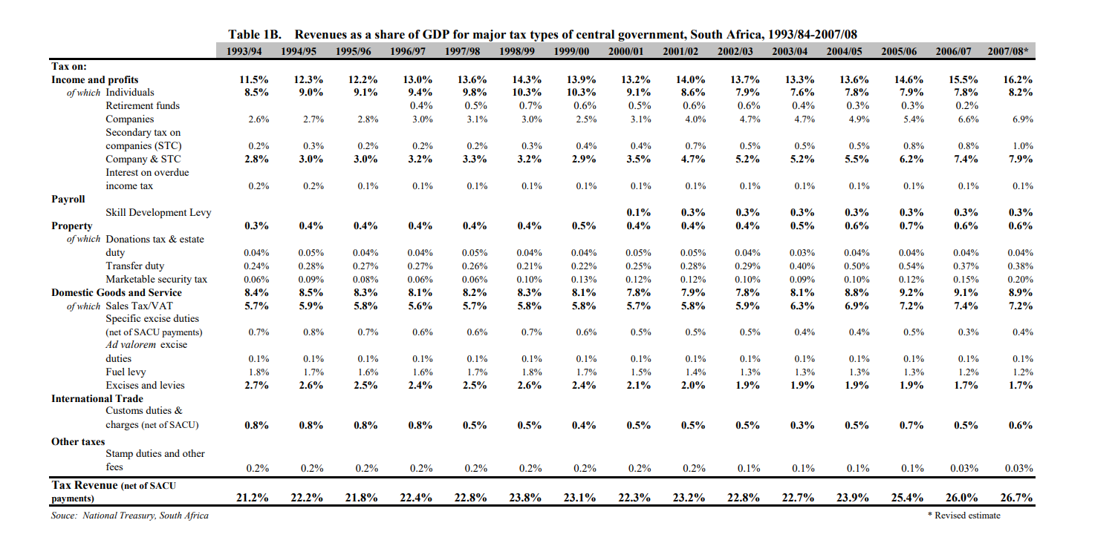

Central government revenues come primarily from income tax, value added tax (VAT) and corporation tax. Local government revenues come primarily from grants from central government funds and municipal taxes.

In 2018/19 financial year, South Africa had a tax-to-GDP ratio of 26.2% that was only slightly more than the 25.9% in 2017/18

South Africa uses its fiscal instruments to significantly reduce market income inequality and poverty through a progressive tax system and highly progressive social spending. The rich bear the brunt of taxes, and the government redirects these resources to the poorest in society to raise their incomes. Despite the large fiscal redistribution, however, South Africa remains one of the most unequal countries in the world.

The tax policy challenges facing South Africa are intellectually fascinating, but finding a way to meet them is much more than interesting: it is vital to the success of South Africa’s efforts to sustain a multiracial democracy. The black and colored majority’s forbearance from extracting vengeance for the feral oppression they endured at the hands of the white minority is impressive and humbling. But forbearance cannot endure if the lot of the once- disenfranchised population fails to improve. Given low average incomes, such improvement cannot come in a politically and economically sustainable way from redistribution, but must flow from sustained and broadly based economic growth