HTML CALCULATOR
Source Code and Output Screenshot
Project files: a1.html, style.css, and script.js. Keep all three files in the same folder and open a1.html in a web browser to run the calculator.

HTML Code
File: a1.html
<!DOCTYPE html>
<html>
<head>
<title>HTML Calculator</title>
<link rel="stylesheet" href="style.css">
</head>
<body>

<h1>HTML Calculator</h1>

<input type="text" id="display" aria-label="Calculator display" autocomplete="off">

<br><br>

<button type="button" onclick="clearDisplay()">C</button>
<button type="button" onclick="deleteNumber()">DEL</button>
<button type="button" onclick="addValue('*')">x</button>
<button type="button" onclick="addValue('/')">/</button>

<br><br>

<button type="button" onclick="addValue('1')">1</button>
<button type="button" onclick="addValue('2')">2</button>
<button type="button" onclick="addValue('3')">3</button>
<button type="button" onclick="addValue('+')">+</button>

<br><br>

<button type="button" onclick="addValue('4')">4</button>
<button type="button" onclick="addValue('5')">5</button>
<button type="button" onclick="addValue('6')">6</button>
<button type="button" onclick="addValue('-')">-</button>

<br><br>

<button type="button" onclick="addValue('7')">7</button>
<button type="button" onclick="addValue('8')">8</button>
<button type="button" onclick="addValue('9')">9</button>
<button type="button" onclick="addValue('(')">(</button>

<br><br>

<button type="button" onclick="addValue('0')">0</button>
<button type="button" onclick="addValue('.')">.</button>
<button type="button" onclick="calculate()">=</button>
<button type="button" onclick="addValue(')')">)</button>

<script src="script.js"></script>
</body>
</html>

CSS Code
File: style.css
body {
font-family: Arial, sans-serif;
margin: 3px;
width: 340px;
background: white;
}

h1 {
color: black;
background: green;
padding: 20px 0;
margin: 0;
font-size: 25px;
}

#display {
box-sizing: border-box;
width: 100%;
height: 48px;
margin-top: 4px;
padding: 6px;
font-size: 22px;
text-align: right;
}

button {
width: 76px;
height: 75px;
padding: 8px;
font-size: 20px;
background-color: #ddd;
border: 2px solid black;
cursor: pointer;
}

button:active {
background-color: #aaa;
}

JavaScript Code
File: script.js
function addValue(value) {
let display = document.getElementById("display");
display.value = display.value + value;
display.focus();
}

function clearDisplay() {
document.getElementById("display").value = "";
}

function deleteNumber() {
let display = document.getElementById("display");
display.value = display.value.slice(0, -1);
display.focus();
}

function calculate() {
let display = document.getElementById("display");
let expression = display.value.trim();

if (expression === "") {
return;
}

// Allow only numbers, arithmetic operators, decimal points and parentheses.
if (!/^[0-9+\-*/().\s]+$/.test(expression)) {
display.value = "Error";
return;
}

try {
let result = Function('"use strict"; return (' + expression + ')')();

if (typeof result !== "number" || !Number.isFinite(result)) {
display.value = "Error";
} else {
display.value = String(Number(result.toPrecision(12)));
}
} catch (error) {
display.value = "Error";
}
}

// Let Enter calculate and Escape clear the display when typing directly.
document.addEventListener("keydown", function(event) {
if (event.key === "Enter") {
calculate();
} else if (event.key === "Escape") {
clearDisplay();
}
});

Output Screenshot
The screenshot below shows the calculator running in the browser, with an example expression entered in the display.
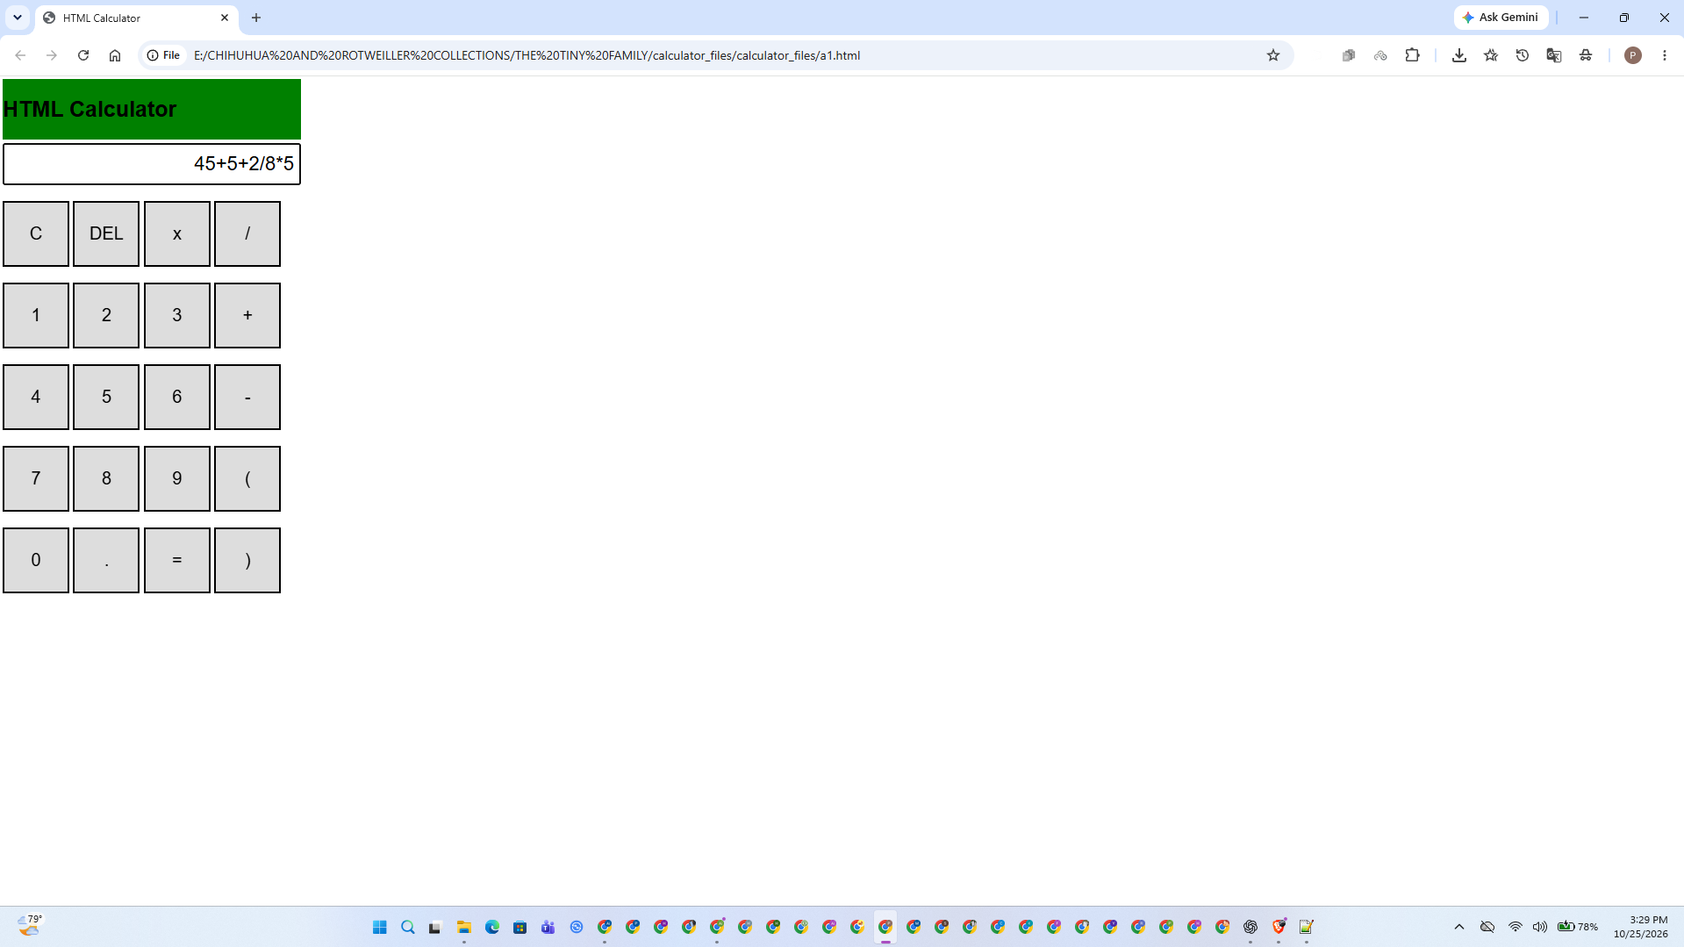
Figure 1. HTML Calculator output in Google Chrome.

