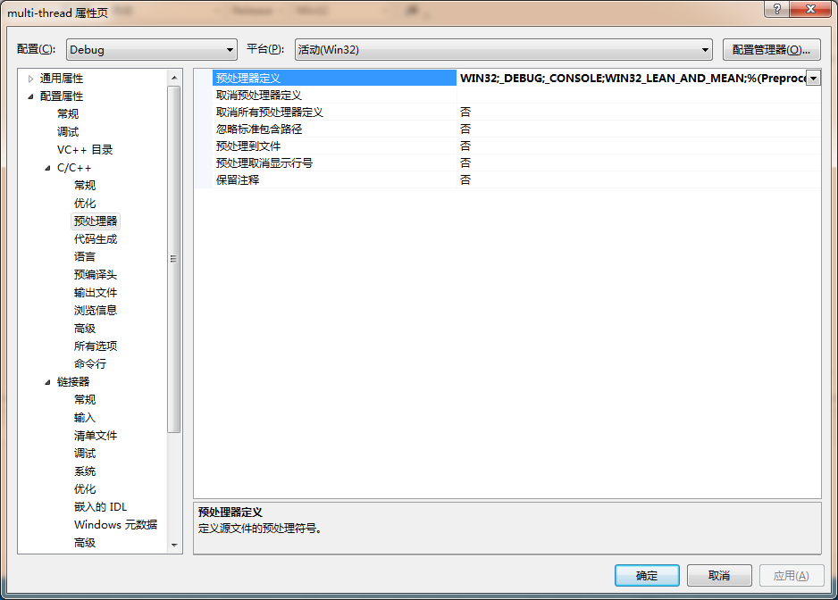

WIN32_LEAN_AND_MEAN;