**Exercise 1: Implementing the Singleton Pattern**

**Scenario:**

You need to ensure that a logging utility class in your application has only one instance throughout the application lifecycle to ensure consistent logging.

**Steps:**

1. **Create a New Java Project:**
   * Create a new Java project named **SingletonPatternExample**.
2. **Define a Singleton Class:**
   * Create a class named Logger that has a private static instance of itself.
   * Ensure the constructor of Logger is private.
   * Provide a public static method to get the instance of the Logger class.
3. **Implement the Singleton Pattern:**
   * Write code to ensure that the Logger class follows the Singleton design pattern.
4. **Test the Singleton Implementation:**
   * Create a test class to verify that only one instance of Logger is created and used across the application.

**FILE STRUCTURE**

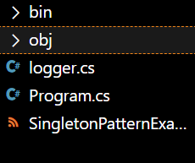

**CODE**

**Logger.cs**

**using System;**

**public class Logger**

**{**

**private static Logger instance;**

**private Logger()**

**{**

**Console.WriteLine("Logger instance created.");**

**}**

**public static Logger GetInstance()**

**{**

**if (instance == null)**

**{**

**instance = new Logger();**

**}**

**return instance;**

**}**

**public void Log(string message)**

**{**

**Console.WriteLine($"[LOG]: {message}");**

**}**

**}**

**Program.cs**

**using System;**

**class Program**

**{**

**static void Main(string[] args)**

**{**

**Logger logger1 = Logger.GetInstance();**

**logger1.Log("This is the first log message.");**

**Logger logger2 = Logger.GetInstance();**

**logger2.Log("This is the second log message.");**

**if (object.ReferenceEquals(logger1, logger2))**

**{**

**Console.WriteLine("Both logger instances are the same (Singleton verified).");**

**}**

**else**

**{**

**Console.WriteLine("Different logger instances exist (Singleton failed).");**

**}**

**}**

**}**

**Output**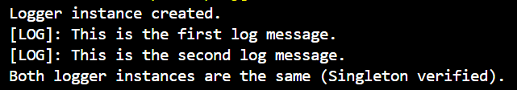

**Exercise 2: Implementing the Factory Method Pattern**

**Scenario:**

You are developing a document management system that needs to create different types of documents (e.g., Word, PDF, Excel). Use the Factory Method Pattern to achieve this.

**Steps:**

1. **Create a New Java Project:**
   * Create a new Java project named **FactoryMethodPatternExample**.
2. **Define Document Classes:**
   * Create interfaces or abstract classes for different document types such as **WordDocument**, **PdfDocument**, and **ExcelDocument**.
3. **Create Concrete Document Classes:**
   * Implement concrete classes for each document type that implements or extends the above interfaces or abstract classes.
4. **Implement the Factory Method:**
   * Create an abstract class **DocumentFactory** with a method **createDocument()**.
   * Create concrete factory classes for each document type that extends DocumentFactory and implements the **createDocument()** method.
5. **Test the Factory Method Implementation:**
   * Create a test class to demonstrate the creation of different document types using the factory method.

**File structure**

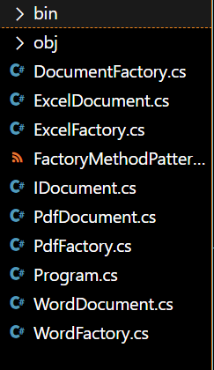

**Program.cs**

**using System;**

**class Program**

**{**

**static void Main(string[] args)**

**{**

**DocumentFactory wordFactory = new WordFactory();**

**IDocument wordDoc = wordFactory.CreateDocument();**

**wordDoc.Open();**

**DocumentFactory pdfFactory = new PdfFactory();**

**IDocument pdfDoc = pdfFactory.CreateDocument();**

**pdfDoc.Open();**

**DocumentFactory excelFactory = new ExcelFactory();**

**IDocument excelDoc = excelFactory.CreateDocument();**

**excelDoc.Open();**

**}**

**}**

**DocumentFactory.cs**

**public abstract class DocumentFactory**

**{**

**public abstract IDocument CreateDocument();**

**}**

**ExcelDocument.cs**

**using System;**

**public class ExcelDocument : IDocument**

**{**

**public void Open()**

**{**

**Console.WriteLine("Opening Excel document.");**

**}**

**}**

**ExcelFcatory.cs**

**public class ExcelFactory : DocumentFactory**

**{**

**public override IDocument CreateDocument()**

**{**

**return new ExcelDocument();**

**}**

**}**

**IDocument.cs**

**public interface IDocument**

**{**

**void Open();**

**}**

**PdffDocument.cs**

**using System;**

**public class PdfDocument : IDocument**

**{**

**public void Open()**

**{**

**Console.WriteLine("Opening PDF document.");**

**}**

**}**

**PdfFactory.cs**

**public class PdfFactory : DocumentFactory**

**{**

**public override IDocument CreateDocument()**

**{**

**return new PdfDocument();**

**}**

**}**

**WordDocument.cs**

**using System;**

**public class WordDocument : IDocument**

**{**

**public void Open()**

**{**

**Console.WriteLine("Opening Word document.");**

**}**

**}**

**WordFactory.cs**

**public class WordFactory : DocumentFactory**

**{**

**public override IDocument CreateDocument()**

**{**

**return new WordDocument();**

**}**

**}**

**OUTPUT**

