Guide to Reading the Metabolomics Longitudinal Heatmaps
Plasma metabolomics — Longitudinal differential analysis

1. What the Heatmap Shows
Each heatmap summarises how plasma metabolite levels change over time in a given group (e.g. Complication, HDP, or Control). Rather than plotting raw concentrations, it shows the direction and relative magnitude of change between adjacent timepoints, so patterns across the pregnancy timeline become immediately visible.

2. Axes

Columns — Timepoint Comparisons (x-axis)
Each column is a consecutive timepoint comparison:
- B−A — change from first to second blood draw
- C−B — change from second to third blood draw
- D−C — change from third to fourth blood draw
- E−D — change from fourth to fifth blood draw
Columns are fixed in chronological order and are not clustered.

Rows — Metabolites (y-axis)
Each row is one metabolite that reached statistical significance (FDR < 0.05) in at least one of the four comparisons within that group. Named metabolites (e.g. D-(+)-Maltose, Acetyl-L-carnitine) have been identified by spectral library matching. Unnamed peaks (e.g. p1339_POS, n1370_NEG) are detected features that could not be matched to a known compound; the prefix indicates the ionisation mode (POS = positive, NEG = negative).

3. Colour Scale
Cell colour encodes the row-wise z-scored fold change (i.e. the value in each cell is standardised across the four comparisons for that metabolite before colouring). This row-wise standardisation highlights the temporal pattern of each metabolite independently of its absolute magnitude.

Colour scale (z-scored fold change, clipped ±2.0)
Dark red  (+2) | Light red  (+1) | White  (0) | Light blue  (−1) | Dark blue  (−2)

- Red cells — the metabolite increased more (or decreased less) at this comparison relative to its own average across timepoints.
- Blue cells — the metabolite decreased more (or increased less) at this comparison relative to its own average across timepoints.
- White / pale cells — little change relative to the metabolite’s own average.

4. Significance Dot (•)
A small black dot (•) inside a cell indicates that the fold change for that metabolite at that specific timepoint comparison is statistically significant after multiple-testing correction (FDR < 0.05, Benjamini–Hochberg). Cells without a dot still appear coloured but represent non-significant trends.

5. Dendrogram (Left Side)
The tree on the left groups metabolites with similar temporal patterns together using hierarchical clustering (Ward linkage, Euclidean distance on z-scored fold changes). Metabolites on nearby branches behave similarly across the four comparisons. Distinct clusters may reflect shared biological processes or co-regulated pathways.

6. The Three Heatmaps

Complication Group (pooled FGR + HDP + sPTB) — 13 metabolites
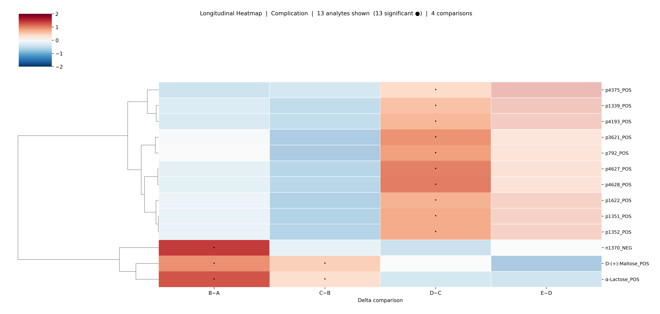
Figure 1. Longitudinal heatmap for the pooled Complication group (FGR, HDP, sPTB combined). 13 metabolites shown, all significant in ≥1 comparison.
The largest cluster (middle rows, unnamed peaks) shows a consistent rightward shift towards red at D−C, suggesting these features increase between the third and fourth timepoint specifically in complicated pregnancies. The bottom cluster (n1370, D-(+)-Maltose, α-Lactose) shows the opposite pattern: strongly elevated at B−A, then attenuating.

HDP Group (Hypertensive Disorders of Pregnancy) — 18 metabolites
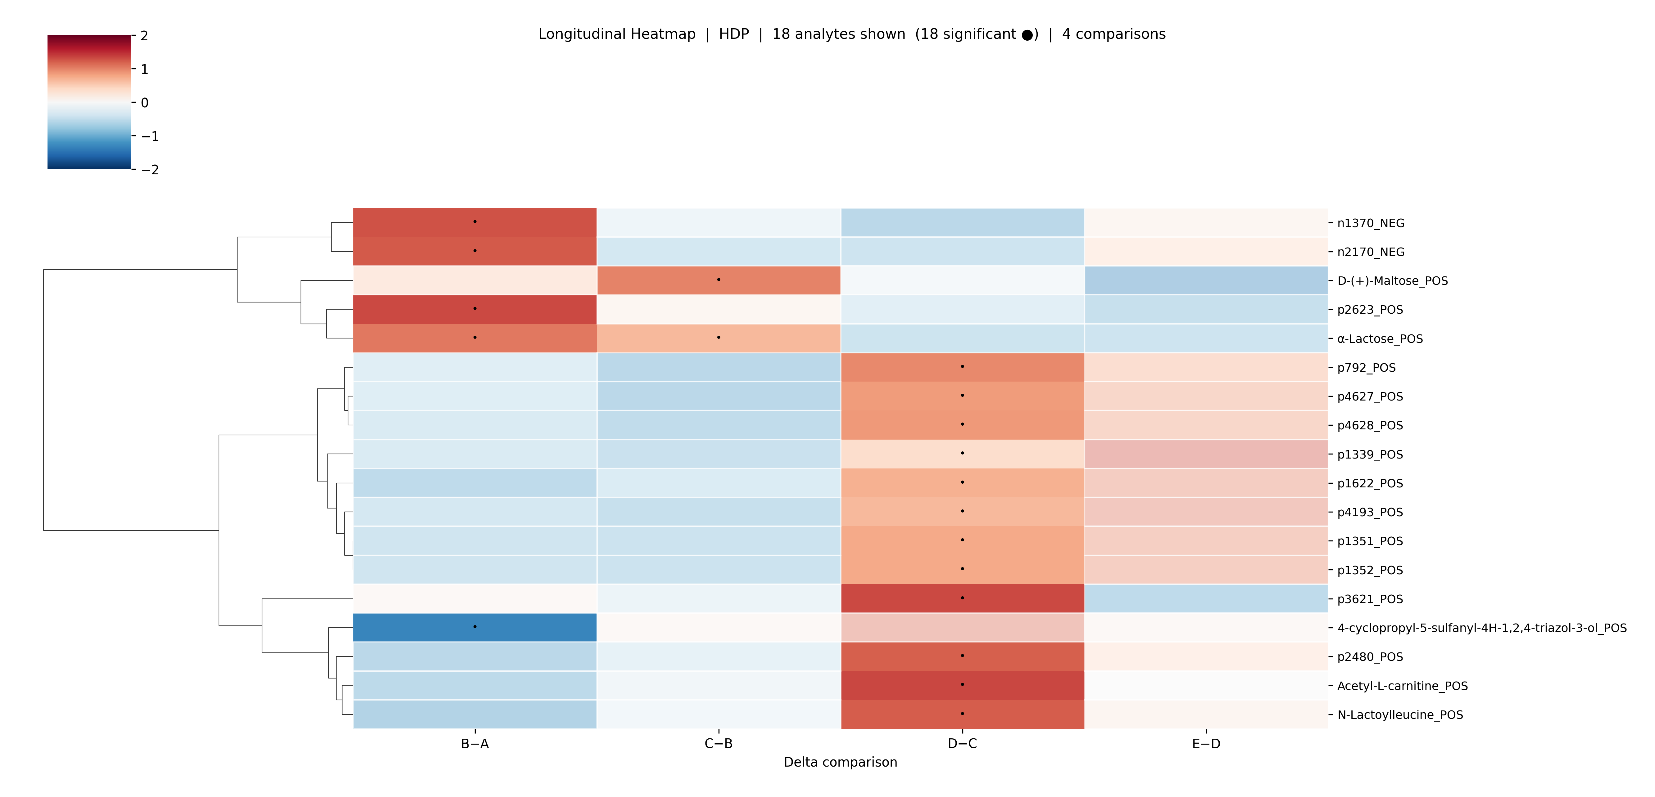
Figure 2. Longitudinal heatmap for the HDP group. 18 metabolites shown, all significant in ≥1 comparison.
HDP shows the richest signal. The top cluster (n1370, n2170, D-(+)-Maltose, α-Lactose, p2623) is strongly red at B−A, indicating early elevation followed by attenuation. A distinct bottom cluster (4-cyclopropyl-5-sulfanyl-4H-1,2,4-triazol-3-ol, p2480, Acetyl-L-carnitine, N-Lactoylleucine) shows peak signal at D−C, consistent with changes appearing later in the third trimester. Acetyl-L-carnitine and N-Lactoylleucine are named compounds with known metabolic roles (fatty acid transport and amino acid metabolism respectively).

Control Group — 8 metabolites
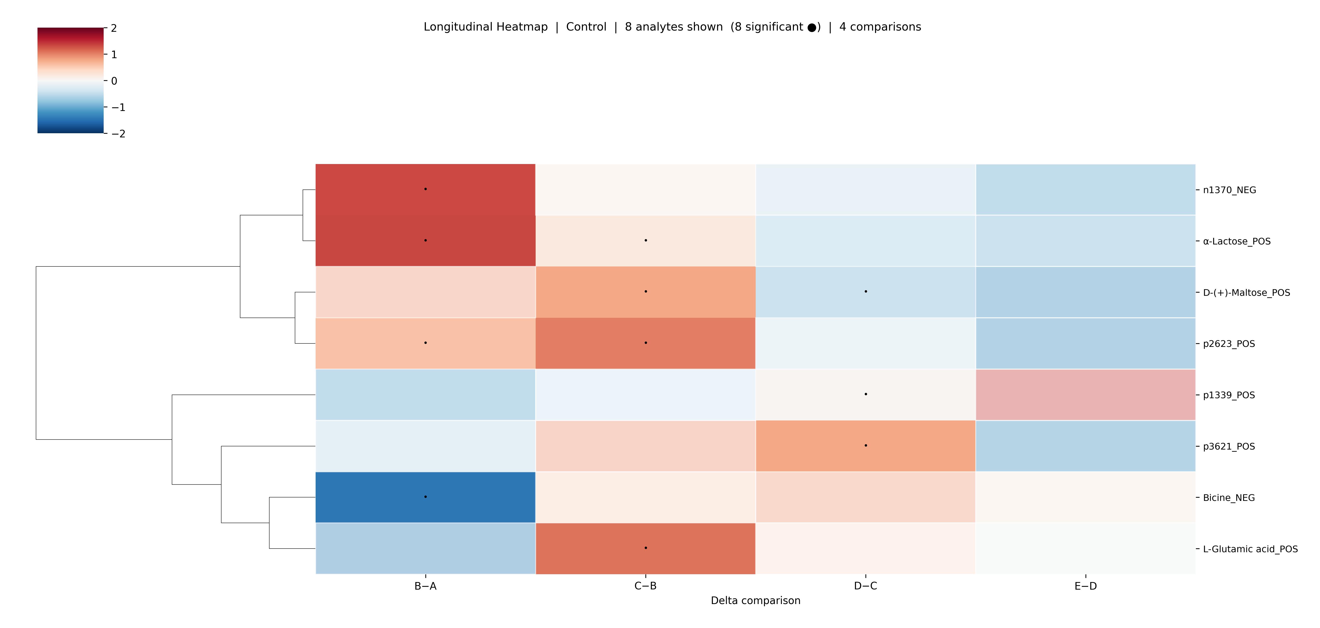
Figure 3. Longitudinal heatmap for the Control group. 8 metabolites shown, all significant in ≥1 comparison.
The Control group shows fewer significant metabolites. The main visible pattern is a late increase at D−C and E−D for the unnamed peak cluster, which may reflect normal gestational progression rather than a pathological process.

7. How to Read a Single Cell — Step-by-Step Example
Take the cell for D-(+)-Maltose at B−A in the HDP heatmap:
- The cell is dark red → z-score ≈ +2, meaning Maltose increased substantially between timepoints A and B in HDP patients relative to its own average change over all timepoints.
- There is a dot • → this change is statistically significant (FDR < 0.05).
- At C−B the cell is pale/white → the rate of change returned to near-average.
- Interpretation: Maltose levels surged early in HDP pregnancies (B−A) but the elevation was transient.

8. What the Heatmap Does Not Show
- Absolute concentrations — the colour reflects relative change, not whether the metabolite is high or low overall.
- Direction of raw fold change — z-scoring is row-wise, so red at one timepoint means higher than that metabolite’s own average, not necessarily an absolute increase vs. baseline.
- Cross-sectional group differences — a separate cross-sectional analysis (Control vs Complication at each timepoint) was performed but yielded no significant metabolites, so no cross-sectional heatmaps are shown.
- Unnamed peaks — p####_POS and n####_NEG features are real detected signals but cannot be annotated without the original mass spectrum and m/z library file from the instrument.

9. File Locations
All heatmap files are saved in:
04_results_and_figures/heatmaps/metabolomics/plasma/longitudinal/
Each heatmap is provided in both PNG (for presentations) and PDF (for print) format, along with a _data.csv file containing the underlying z-scored fold change values.

