*** VEGA ***
A strategy game for 2-6 players
(C) 1989-2026 Michael Schweitzer

VEGA ` ` ` ` ` ` ` ` ` `
` ` ` ` ` ` ` jj.wwg@#@4k.
` ` ` ` .,;!'` Qyxsj#@Qm
` ` ` ` ` .j!''`.` `..Q@$h$$@`
` ` ` ` ` ` ` ` `..!|:. jJ"^s, `..7@$$Qk
` .z|`.``..b.jaoud,..j.7Qk `
` ` ` ` ` ..T;::..``..pJ$Xoooa :!xgk `
` ` ` ` .jj, .jl:``````````3yqSooo3.vzwt
` ` ..g@@@@@ggl:''`'`''`'''`'.=&gwZvoa2`
` ` ` ` ` j2@@###$#$g@.:::'`'':'':'`:':::jxogP
` ` ` ` .@@@X$$$$@g8l:;''':''::''`'':::!uxq@l
` ` j2@@$$qg#@gMu:::'::':':!''`':`::jxqpl `
` ` ` .@@QgpP` .k||!:::::':':::`:.::jxq2n ` `
` ` ` .2@@@P` jCv|,,,!::::::```:.jxzwH` ` `
` ` ` .@@@l Jn||i!,,!!:`:`.::j|agZF
` .@R jox||i,,::;:::!j2@#@E `
` ` ` ` = ..jjjj, jpvxxx"xvvxxcsj@@$$pQI `
` ` `` j.qgpRsjuz|Yg.5paojaagpA^@@$XX#g@t `
` ` .q#Q8xzgpT 4.3PT=' .@$h#$@@t ` `
` ` .@@@@sJo2l .im .@$$#$@@P `
` ` .@$@gE.nuF ..5!jk .@###p@@l ` ` `
` ` .@@$qFjv2` ..Zn;:j@ ..@$pg@PT ` ` `
` .@$eKqk.iZ ..!n!|'ujQm .@@@pPT `
` ` .@@$Xgm.|;:!:|':jz@p@F .@MP` ` ` ` ` ` `
` .@@##Qm `:jjjwW$#pgpP ` `
` .@@kh###D#VyyppogpP` ` ` ` `
` .@$kh#opV#pppgpHT` ` ` ` ` `
.@$#k3f#gg#H=' ` ` ` ` ` `
@@$@8PT' ` ` ` ` (c) 1989-2026
` ` ` ` ` ` Michael Schweitzer

I offer VEGA under the GNU Affero General Public License. You can find the VEGA source code on GitHub. The wording of the license can be found in the source code file "APGL_License.txt". VEGA also uses:
- GSON, (c) Google: https://github.com/google/gson, see the "ApacheLicense-2.0.txt" file in the "src" Github directory.
- iText PDF, (c) ITEXT GROUP NV: http://www.gnu.org/licenses/agpl-3.0.de.html, see the "APGL_License.txt" file in the "src" Github directory.
- "JetBrains Mono" font, (c) JetBrains: https://www.jetbrains.com, see the "ApacheLicense-2.0.txt" file in the "src" Github directory.
- Default Icons: http://www.defaulticon.com, see the "DefaultIconLicense.txt" file in the "src" Github directory.
- FlatLaf, (c) FormDev Software GmbH: https://www.formdev.com/flatlaf/, see the "ApacheLicense-2.0.txt" file in the "src" Github directory.
- QR Code generator library (Java), (c) Project Nayuki: https://www.nayuki.io/page/qr-code-generator-library, MIT license: https://opensource.org/licenses/MIT
Table of contents
1 Overview 3
2 Game rules 4
2.1 Gameplay 4
2.2 Game board 4
2.3 Spaceships 4
2.4 Planets 6
2.5 Conquer and defend planets 8
2.6 Combat strength 8
2.7 Alliances 9
2.8 Visible and invisible information 9
2.9 Evaluation of the year 10
2.10 Scoring 10
3 Game modes 10
3.1 Hot Seat 10
3.2 E-mail game 10
3.3 Server game 11
4 Operation and settings 11
4.1 The VEGA screen 11
4.2 The menu list 12
4.3 Game parameters 13
4.4 Main menu 13
4.5 Entering moves 14
5 System requirements, installation and execution 15
6 The VEGA Web server 16
7 VEGA Display 16
8 VEGA Server 17
8.1 Functionality 17
8.2 Setting up a VEGA Server 17
8.3 Administrate a VEGA Server 17
8.4 Create users 18
8.5 Change users 18
8.6 Delete users 18
8.7 Hints for the server admin 18
8.8 Initiating and playing server-based games 19
9 VEGA history 19
10 Final words 20

Overview
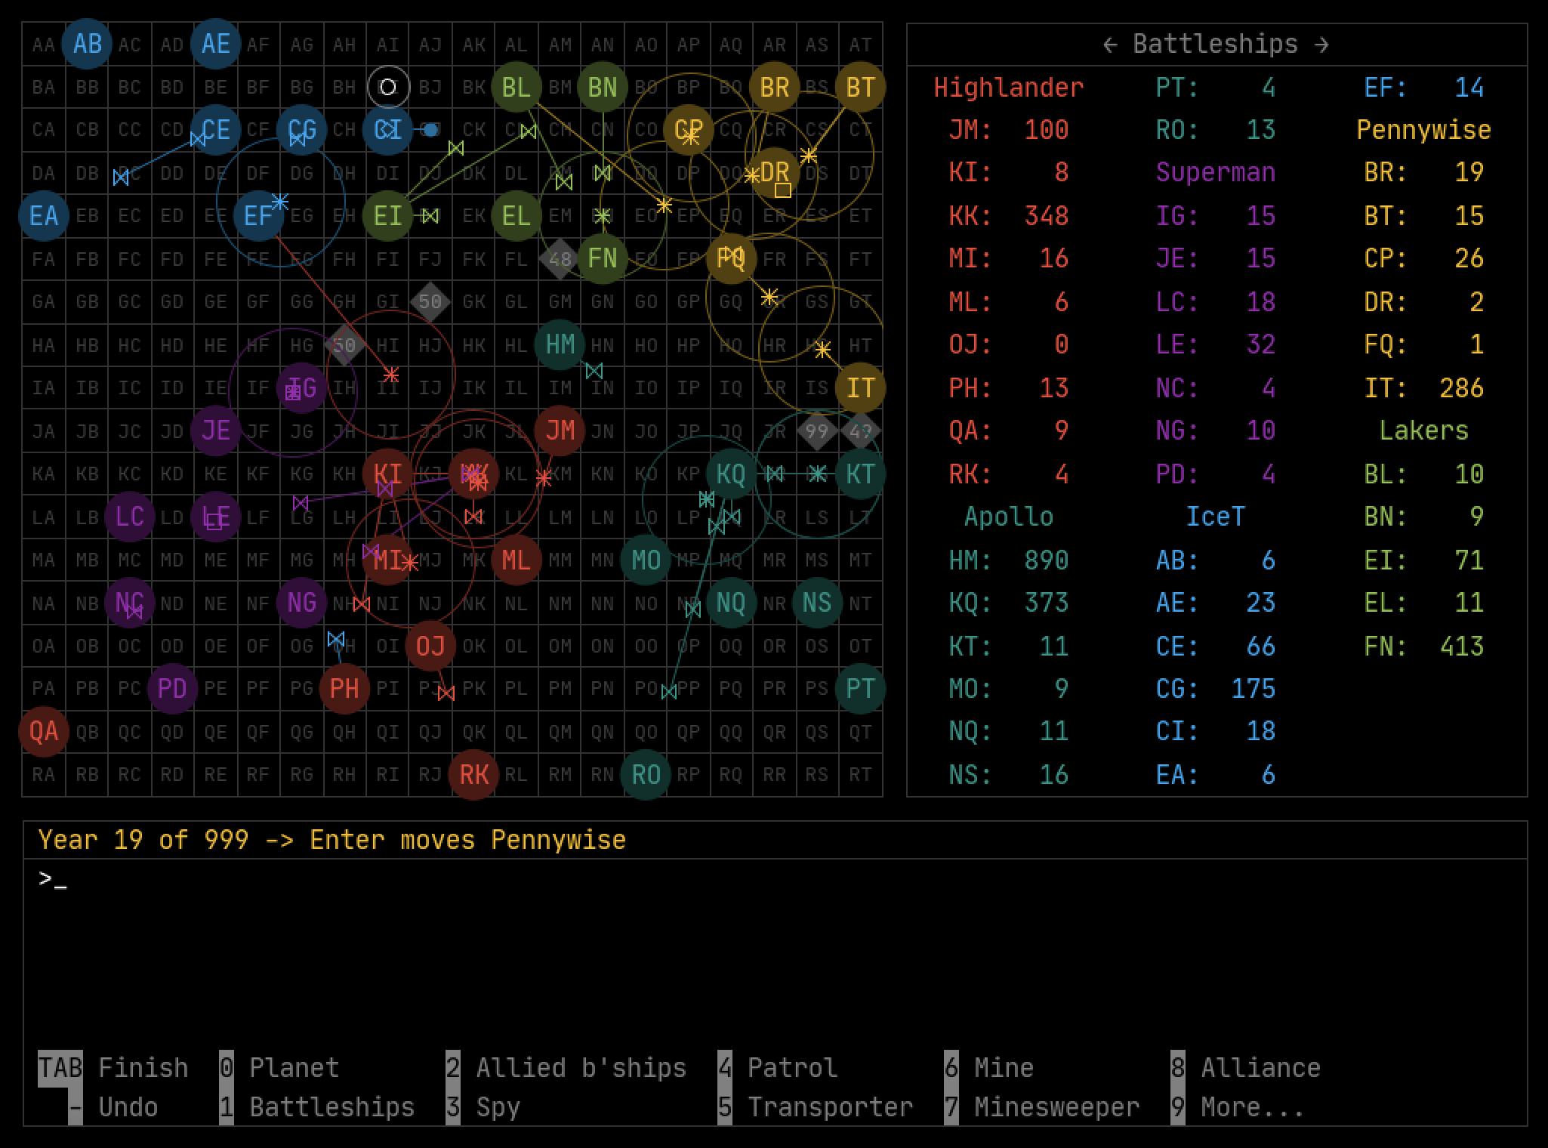
A VEGA game in full action
VEGA is a turn-based strategy game for 2 to 6 people in an 80s retro design. Whoever conquers the most planets with their spaceships wins the game. Play individually or in teams. Strategic thinking, diplomatic skills and a little luck are required. That's why VEGA is most fun in a friendly group of at least four players. There are no computer opponents, nor are there any graphic or sound effects.
There are various types of spaceships with special abilities at your disposal. You can expand your planets to increase production capacity and combat strength.
You can play VEGA in different ways:
- In the classic "Hot Seat" mode, players sit at a computer and enter their moves one by one. Take an afternoon and evening, sit on a big couch in front of a big screen or projector, line out chips and unhealthy drinks, turn off any gadgets that didn't exist in the '80s and have a good time together.
- As an e-mail game. The players enter their moves on their own computers and send them by e-mail to the game master, who in turn distributes the evaluation to the players by e-mail.
- As a server game: Set up your own VEGA server to host the games with little effort. The players enter their moves on their own computers and send them to the server, which carries out the evaluations. You can use it to host a social LAN party or allow players from all over the world to join a VEGA game.
VEGA offers you a tutorial for a quick introduction to the game.

Game rules

Gameplay
STAR is turn-based. A round is called a year. At the beginning of the year all players enter their moves, after that the spaceships are moved in 365 daily steps. The game begins in year 1 and ends after an agreed number of years or when only one player is left. During turn entry, players can buy, sell, and launch spaceships, change the battleship production, equip planets with defensive battleships and increase its combat strength, and form or break alliances with other players.

Game board
The game board is a grid of square sectors AA to RT. The distance between the centers of adjacent sectors is 1 light-year (Lj) horizontally and vertically. Some of the sectors have planets shown as circles, such as planets BB, BH, DB, and DF in the example below.
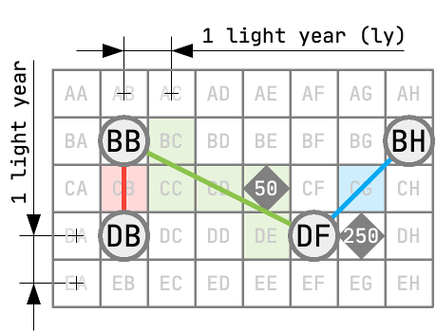
The game board

Spaceships
Send spaceships from planet to planet or sector to sector. They fly from the center of the start sector in a straight line to the center of the target sector. Overflown planets are not an obstacle for spaceships. If there are minefields (grey diamonds with numbers) on the playing field, you need to know which sectors are overflown. In the example above, battleships on their way from planet BB to planet DF enter sector CE with a minefield of magnitude 50. When sectors fly over sector nodes, such as on the way from DF to BH, the sectors to the left and right of it become so like sector DG, not affected.
Most types of spacecraft travel at twice the speed of light (2c). So they travel 2 light years per year. In the example above, battleships cover the distance from BB to DB in one year and reach their destination in the same year that they are launched. The distance from BB to DF is 4.472 light years, which is why battleships take three years.
In the VEGA universe there are the following types of spaceships with different abilities and speeds:
Type | Symbol | Speed | Price | Description
Battleships |  | 2c | $1 | Only battleships can conquer and defend planets. Launch battleships as fleets of one to infinite ships.  In the evaluation of year 10 and every five years thereafter, VEGA launches a neutral battleship fleet that flies from a random sector to a random planet. If the neutral fleet conquers a player planet, the planet becomes neutral. If the neutral fleet reaches a neutral planet, its ships are added to the neutral planet.
Spy |  | 2c  4c | $3-6 | Send a spy to a planet at four times the speed of light in "Mission" mode and you'll have full access to the planet's data until the end of the game. The spy's ship is lost in the process. In the inventory you can see which players have spies on which planets.  In "Transfer" mode, you can send a spy to another planet at twice the speed of light.
Transporter |  | 2c | $4-7 | Transporters can transport $0 to $30 from planet to planet. They can be used as often as you like.
Patrol |  | 1c  2c | $12-18 | Send a patrol to a planet or sector in "mission" mode. It moves at the speed of light and captures enemy spies, transporters, minelayers, minesweepers, transferred patrols, and battleship fleets with five ships or less within a radius of 1.5 light years. Captured ships do not move for the rest of the evaluation. You must choose a new target planet for the captured ships on the next turn input.  If two enemy patrols meet in mission, one patrol captures the other. The patrol that captures the other at a smaller angle wins. Imagine that the two patrols are traveling with their onboard cannons pointing forward. Suddenly they notice one other and have to point their onboard cannons at each other. Whoever has to turn their cannon at a smaller angle wins.  If the target of the patrol is a sector and not a planet, the patrol turns around and flies back to the starting planet. It also hijacks alien spaceships on the way back.  You can transfer a patrol to another planet at twice the speed of light. The patrol cannot hijack alien ships during the transfer.
Minelayers (type 50, 100, 250, 500) |  | 2c | $12-17  $20-25 $40-47 $60-70 | You can use mines to make sectors of the game board impassable for battleships. Send a mine from a planet to a sector. Once there, the minelayer turns into a live mine and destroys battleships as soon as they enter the sector. A 50 mine can destroy up to 50 combat ships before becoming ineffective. Similarly, a 100 mine can destroy 100 battleships, etc. If you place more mines in a mined sector, the strengths of the mines add up to a large mine.  You can transfer mines to other planets in order to use them from there.
Minesweepers |  | 1c  2c | $20-28 | Send a minesweeper to a sector to clear all mines there. It flies 1c on the outward journey and 2c on the return journey. In "Transfer" mode, you can send a minesweeper to another planet at twice the speed of light.
The Black Hole |  | 2c | - | In evaluation of year 8, the black hole appears for the first time in a random location. Every year it moves 2 light years further in a random direction. All spaceships that come within 0.5 light years of the center of the black hole are lost. If the center of the black hole enters a sector with mines, all mines there are cleared. After a random number of years, the black hole disappears and after some time reappears in a different location.

Planets
Planets are your economic base for the production of new spaceships. All planets produce between $1 and $15 annually. For every $ produced, a new battleship is created. You can reduce the annual battleship production on your planet and use the $ saved to buy other spaceship types over the next years and increase the planet's annual $ production.
The following items are available in the planet editor. You can buy most items there at a price that changes every year and sell them at 2/3 of the current purchase price.
Item | Purchase price | Selling price | Description
$ production/year | $60-90 | Not for sale | Increase the planet's annual $ production in $5 increments up to $100/year.
Production of battleships/year | Free | Free | Determine how many $ of the annual $ production should flow into the production of new battleships. A new battleship is created for every $ spent. The rest go into the planet's $ supply.
Defensive battleships | $60-90 | $40-60 | You can also secure the planet against attacks with defensive battleships. When defending the planet, the defensive battleships are added to the regular battleships. Losses are divided proportionally between defensive and regular battleships. Buy and sell defensive battleships in lots of 450 ships. On the planet you can have up to 900 defensive battleships. The defensive battleship are only visible to your fellow players if they have a spy on the planet or are an alliance member.
Combat strangth | $60-90 | Not for sale | The combat strength increases the defense power of the planet and the attack power of battleships launched from that planet. For more information, see chapter 2.6.
Spies | $3-6 | $2-4 | Spaceships of type "Spy".
Transporters | $4-7 | $3-5 | Spaceships of type "Transporter".
Patrols | $12-18 | $8-12 | Spaceships of type "Patrol".
Minesweepers | $20-28 | $13-19 | Spaceships of type "Minesweeper".
Mines (50)  Mines (100)  Mines (250)  Mines (500) | $12-17  $20-25  $40-47  $60-70 | $8-11  $13-17  $27-31  $40-47 | Spaceships of type "Minelayer" for mines of different strengths.

You cannot buy or sell regular battleships. The buying and selling prices are the same on all planets in the universe.
At the start of the game, each player owns one planet. All other planets are neutral. Neutral planets only produce new battleships. No attacks come from neutral planets.
The metrics of the planets at the start of the game are:
Key figure | Players' planets | Neutral planets
Battleships | 350 | 0-10
$ supply | $30 | $0-5
$ production/year  Production of battleships/year | $10/year  10/year | $1-15/year  1-15/year
Defensive battleships | 450 | 0
Combat strength | 100% | 100%
Spies, transporters, patrols, minesweepers, minelayers | 0 | 0

Conquer and defend planets
Send battleships to conquer a foreign planet. You fight against all battleships on the planet, including the defensive battleships. The outcome of the battle is very easy to calculate:
The defender loses the number of attacking battleships, the attacker loses the number of defending battleships. If there are any attacker ships left, the attacker takes over the planet.
Example:
Attacker before fight: 100 ships
Defender before fight: 75 ships
Attacker after fight: 100 - 75 = 25 ships
Defender after fight: 75 - 100 < 0 --> defender loses
In this example, the attacker takes over the planet with 25 ships.
If two or more of your battleship fleets reach the same planet on the same day, these fleets do not join forces, but attack one after the other.

Combat strength
You can increase the combat strength of a planet from 100% to 150% and 200%. When the planet is attacked, the strength of all battleships on the planet – including defensive battleships and battleships of allied partners – is multiplied by 1.5 and 2 respectively. 100 battleships therefore act like 150 or 200 battleships. When you launch an attack on another planet from one planet, the battleships take on the combat strength of the starting planet.
With a higher combat strength, you can inflict more damage on the opponent while reducing your own losses. If both parties have the same combat strength, the effect is canceled out.
During move input, you can use the fight simulation to familiarize yourself with the effect of different combat strengths.

Alliances
Players can declare individual planets to be alliance planets in order to defend them together with their battleships and launch joint attacks from there. Attack and defense losses are split proportionally.
Allies can only command the battleships on the planet, not the other types of spaceships. Allies have full visibility into the planet's production data and supplies, but cannot change them.
Allies can send their battleships to an alliance planet without counting as an attack. Any alliance partner that has at least one battleship on an alliance planet can launch an alliance fleet, becoming the leader of the alliance fleet. The leader gets the planet when captured by the alliance fleet. The alliance structure of the starting planet is transferred to the conquered planet.
All battleship fleets sent from an alliance planet receive its combat strength.
The principle "A player does not fight against his own battleships" applies. So if a player is a member of an alliance fleet and the target planet belongs to that player or is part of the alliance there, the battleships of the alliance fleet will merge with the battleships on the planet and the alliance will expand to include additional players if necessary.
Before you set up an alliance, you must coordinate with your alliance partners. They have to define the same alliance in the same year for it to actually take effect.
Any alliance partner can dissolve an alliance without the consent of the other partners. All foreign battleships must leave the planet in the following evaluation, wait there until the end of the evaluation and can no longer contribute to its defense. In the next turn input, the battleships must be sent to a new destination. The displaced battleships do not receive the planet's combat strength.
Alliance changes are processed first of all turns. When you cancel an alliance, you prevent other alliance partners from launching an alliance fleet. If you make multiple alliance changes for the same planet in the same year, only the last one will be implemented.
Sometimes, allies on the same alliance planet may have entered conflicting moves. Example: Two players want to access the same battleships, but there are not enough battleships to implement both turns. In such a case, chance decides the order in which the moves are booked.

Visible and invisible information
Spaceships, their destination, owner, strength, mode (mission/transfer), etc. are visible to all players as soon as they are on the move, but not the combat strength of battleships. In addition, all players can see where minefields and the black hole are located and how many battleships are present on which planets.
Only the owners of the planets can see their production data, the number of defensive battleships, the $ supply, the combat strength, the other types of spaceships and alliances there. Other players can see this information if they have a spy on the planet or are a member of an alliance.
You will receive a clear summary of all information when entering moves in the inventory (see chapter "Entering moves").

Evaluation of the year
After all players have entered their moves, the computer takes over and performs the annual evaluation. The evaluation runs in several steps:
Step 1: The players' moves are implemented, alliance changes are implemented, new spaceships are launched.
Step 2: The patrols observe the initial situation. After that, all spaceships and the Black Hole move in 365 daily steps until the end of the year. If several events take place on one day, chance decides the order of events.
Step 3: In the last step, the planets produce $ and new battleships.
After that, the new year begins with the players entering their moves.

Scoring
The player with the most planets wins the game. In order to make games with different numbers of players in the leaderboard comparable, a player's score is calculated as follows:
Points = 1000 x ([player planets]/42) x ([number of players]/6)
So you can get a maximum of 1000 points if you own 42 planets in a 6 player game.

Game modes

Hot Seat
In "Hot Seat" mode, players sit at a single computer and enter their moves one at a time. The game runs as a "local game" on this computer. In order to be able to enter the moves unobserved in Hot Seat mode, I recommend a second screen or a projector on which the additional output window can be displayed (in the menu list under "Open output window"). The output window shows the other players the game situation at the beginning of the year. The annual evaluation is shown both on the main screen and in the output window. With the app "VEGA Display" you can display up the output window on up to five other computers.
You can use the built-in VEGA web server to withdraw to an adjoining room for secret alliance negotiations or strategy meetings and still be able to keep an eye on the current game situation.

E-mail game
In an e-mail game, a game master e-mails the score to the other players. They import the score from the e-mail into their local VEGA app, enter their moves and e-mail them back to the game master.
Under "Game > Game parameters" you can switch a local game to e-mail game mode. Under 'E-mail Settings', highlight the e-mail players and enter the e-mail addresses of the players and the game master.
The game master sends the score and imports the moves in the main menu. A standard e-mail client must be installed on the computers of the game master and the other players, which opens when you click on a mailto link, such as spielwitz@icloud.com. The e-mails that VEGA generates contain precise instructions and should be sent unchanged.

Server game
A VEGA server manages games and carries out annual evaluations. Players can connect to the server with their VEGA app, select or restart a game, enter their moves and send them to the server. In this way it is possible for players to enter their moves at the same time on their own computers and take part in VEGA games from anywhere in the world.
You can find more about the configuration and operation of a VEGA server in the corresponding chapter.

Operation and settings

The VEGA screen
The VEGA screen
The VEGA screen is divided into three areas:
- Game board: Here you can see the positions of the planets, spaceships and mines. Planets are represented as circles with letters, spaceships as colored symbols that move during the evaluation. Minefields are marked with their strength as diamond symbols.
- With the help of the arrow keys ← and → you can display the following information in the list at the top right of the screen:
  - Ships on the planets.
  - All spaceships currently underway, sorted by arrival date.
  - Planet production dates and $ supplies.
  - Defensive battleships and combat strengths.
  - Alliances.
  - Active spies on the planets.
- Below the playing field and planet list is the input and output console. Here you operate VEGA solely via the keyboard.

The menu list
The menu list is hidden in the upper left corner, behind the "hamburger symbol". The menu items are in detail:
- About VEGA: Shows the build number and the link to the VEGA Web site.
- Manual: Opens this instruction manual in the PDF viewer associated with the *.pdf file extension by default on your computer.
- Tutorial and demo games: You can start the tutorial under this menu item. You will also find two demo games there that show what a well developed VEGA game can look like.
- New local game: Creates a new game that runs on your computer and is saved there.
- Load local game: Loads a local game from your computer.
- Save local game as: Saves a local game on your computer.
- Local leaderboard: You can only be added to the leaderboard by completing the final evaluation in the main menu of a local match.
- Recent local games: Quick access to your five recent local games.
- Import e-mail game from clipboard: If you are a player taking part in an e-mail game, you can load a game that you received from the game master via e-mail. You will find detailed instructions in the e-mail.
- Games on the VEGA server: Initiate, load and manage games on the VEGA server you are currently connected to.
- Leaderboard on the VEGA server: View the leaderboard on the VEGA server.
- Write e-mail: If you are playing an e-mail or server-based game, you can contact your fellow players and the game host or server administrator here.
- Game parameters: Shows the parameters of the current game. You can also change some parameters later.
- Open output window: Here you can open an additional output window and move it to the second screen. While a player enters his moves unobserved on the main screen, the other players only see the situation at the beginning of the year in the output window. The annual evaluation is displayed on all screens.
- Web server: Configure and activate the VEGA web server. You can find more about this in the corresponding chapter.
- Settings
  - Language/Sprache: VEGA is available in German and English.
  - VEGA server settings: Administrate the credentials for various VEGA servers, and administrate your VEGA servers.
  - VEGA Display server: Here you activate VEGA as VEGA Display server in order to be able to transfer your screen to VEGA Display computers.
- Quit VEGA: Terminates VEGA.

Game parameters
If you want to start a new game, choose the number of players and enter their names. Player names must be between three and ten characters and can only contain the characters a-z, A-Z and 0-9.
Example: "DarthVader" is a valid player name, but "Darth Vader", "DV" or "DarthVäder" is not.
You can change the colors of the players by clicking on the colored areas in front of the player names.
Other setting options are:
- Under "Years" you set the year in which the last evaluation takes place.
- "E-mail mode": Use this to switch a local game to e-mail mode.
- "Automatic save": Whenever players have finished entering their moves and after each annual evaluation, VEGA automatically saves the score.

Main menu
The main menu is only visible in the "Hot Seat" mode. Here, the players begin entering their moves. You can also access game information from here.
- Use the 1 to 6 keys to select the player who is to enter his moves next. If you press the tab key, VEGA will select a random player.
- Replay: The last annual evaluation is shown again.
- Statistics: You can see the development of points, fighters, planets and $ productions over the last few years in graphical form. Since $ productions in a running game represent sensitive information, you should only open the statistics with the consent of all players. In an e-mail or server-based game, you can only see the $ productions after the game has been completed.
- Game info: Shows the planets with defense fighters, the data of the planets including alliance structures and spies. This submenu should only be opened in a running game with the consent of all players and is only available in an e-mail or server-based game after the game has been completed.
- E-mail actions: If you are the game host of an e-mail game, you can send the game to the other players and later import their moves.
- Finalize: With this you finish the game before reaching the last evaluation year set in the game parameters.

Entering moves
At the beginning of a year, all players enter their moves. The move entry should be done as unobserved as possible. In Hot Seat mode, you should have the additional output window (see chapter "The Menu List") open on a second screen.
When it is your turn to enter moves, you can choose from the following options:
- Finish: This completes your move input. After that, there is no turning back, and the spaceships fly irrevocably towards their destination.
- Undo: You can undo all moves of a year step by step and, in the "Hot Seat" mode, get back to the main menu.
- Fighters / Allied Fighters / Spy / Patrol / Transport / Mine / Minesweeper: This launches spaceships of the selected type.
- Planet: Here you can see the data of a planet. You can change the $ production, increase the combat strength or buy and sell defense fighters, spies, transports, patrols, mines and minesweepers. Use the up and down arrow keys to move the cursor to a line and use the left and right arrow keys to increase or decrease a value. If you have a spy on an alien planet, you can view all the data on the alien planet.
- Alliance: This feature allows you to create, expand, or dissolve an alliance on a planet.
- More...: Some menu items have been moved to another menu for reasons of space:
  - Capitulate: If your current situation seems hopeless to you, you can use the "Capitulate" option to wave the white flag and drop out of the game. All of your planets become neutral, all of your flying spaceships disintegrate, and you are eliminated from all alliances. However, the defensive battleships, the combat strength, the $ supplies and spaceships that have not yet been launched remain on your former planets. The capitulate move is implemented at the beginning of the evaluation.
  - Replay: The last annual evaluation is shown again.
  - Statistics: Here, like in the main menu, you can see the development of points, fighters and planets over the last few years.
  - Hide/show spaceships: In order to reduce the density of the information displayed on the playing field, you can hide and show the spaceships of individual or all players during your move input.
  - Distance matrix: Outputs the playing field and a matrix with the distances between the planets in light years as a PDF document. To do this, you need a PDF viewer that is linked to files with the *.pdf extension. You can also call up the distance matrix via the VEGA web server.
  - Physical inventory: You receive a detailed list of your current possessions and alliances, as well as all flight movements. As with the distance matrix in the main menu, a PDF document opens on your computer. You can also call up the inventory via the VEGA web server. However, you only see the status at the beginning of the year, i.e. without your move entries.
  - Fight simulation: Here you can try out VEGA's fight algorithm.

System requirements, installation and execution
VEGA requires the Java 8 runtime environment (JRE). I tested under MacOS, Windows 10/11 and various Linux distributions (Ubuntu, Kubuntu, Raspberry Pi OS). If you're playing in the classic "Hot Seat" mode, I recommend a large TV or projector as a second screen so players on the first screen can input their moves unobserved.
VEGA outputs some content as a PDF document. In order to be able to display a PDF document, you need a display program on your computer that is linked to files with the *.pdf extension.
And for the e-mail-based features, you'll need a standard e-mail client on your machine, such as Microsoft Outlook, Apple Mail, Mozilla Thunderbird, etc., that opens when you click a "mailto:"- Click a link like this: spielwitz@icloud.com
You can get the latest VEGA build here. Unpack the contents of the ZIP file into a directory of your choice. If files with the jar extension are linked to the Java runtime environment on your computer by default, you can start the Vega.jar and VegaDisplay.jar apps with a double-click.
Otherwise, open a terminal window and launch the apps from there:
java -jar Vega.jar
java -jar VageDisplay.jar
You always have to start the VEGA Server from a terminal window:
java -jar VegaServer.jar
If you use a screen with a high resolution and a screen scaling other than 100% under Windows 10/11, dialog boxes may be distorted and not readable. If so, try the following steps:
- Open Windows Explorer and look for the "javaw.exe" file. You can find this in the "bin" subfolder in the installation directory of your Java JDK/JRE.
- Right-click on the "javaw.exe" file and select "Properties".
- In the "Compatibility" tab, change the settings for high DPI settings as follows:
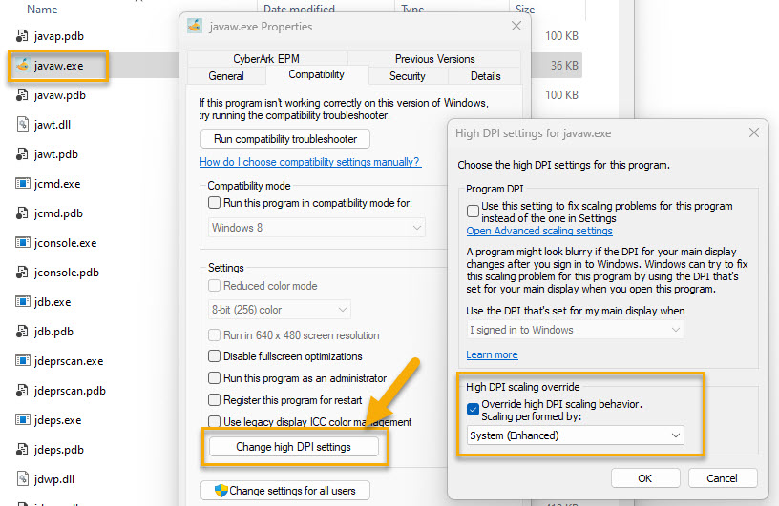

The VEGA Web server
When you're away from the computer in a Hot Seat game, you can use the built-in web server to view the playing field on another device on the same network, such as a smartphone or tablet computer. You can also call up the physical inventory with the status at the beginning of the year, i.e. before the move was entered.
Navigate to "Web server" in the menu bar. Enter the URL of the web server there. This is usually the IP address of the PC running the current local game. Also define a port.
As soon as you activate the web server, a URL and a QR code will appear. With a smartphone camera, you can capture this QR code and open the URL. You can choose whether you want to see the user manual, the board, the distance matrix or your inventory. Please select only your own inventory and not those of the other players.
At the beginning of each year, the web server creates new content that you can call up using the browser's "Reload page" button.
It should be noted that the VEGA web server only offers unprotected access, i.e. without authentication or encryption. You must skip any warnings from your browser. For the same reason, you should not make the web server accessible from outside your home network.

VEGA Display
With the "VEGA Display" app (VegaDisplay.jar) you can open an output window on another computer and enter your moves unobserved on the computer on which the local game is running.
To activate the VEGA Display Server, select the menu item "Settings > VEGA Display Server" in VEGA. Configure the port that the server computer opens for the VEGA Display clients. As soon as you activate the VEGA Display Server, a security code appears that the clients must enter to connect.
The number of connected clients is limited to 5.

VEGA Server

Functionality
A VEGA server hosts games and evaluates them. The players sit at their own computers and can start new games, take part in ongoing games and enter their moves at any time and without being observed.
Hardware requirements and set-up efforts for the VEGA Server are minimal. The idea is that a server is operated for a manageable group of users who know each other.
The VEGA server is purely passive. All actions emanate from the users. If there is a new evaluation, the server sends push notifications to the users. In addition, users can send direct messages to each other via the server.
There are two important roles in connection with the VEGA server: the server administrator and the game host. The server administrator, called admin for short, provides the server hardware, sets up the VEGA server and manages the users on the server. Any user with access to the server can initiate a game and invite other users to play. The initiator of a game is the game host of that game. He can start the year evaluation before all players have entered their moves, complete a game early or delete it from the server.

Setting up a VEGA Server
A VEGA server does not place high demands on the hardware. A mini computer of the type "Raspberry Pi 2 Model B" from 2012 is absolutely sufficient. Like Vega.jar and VegaDisplay.jar, the VEGA Server requires the Java Runtime Environment 8 (or newer). Start the server in a terminal window with the command
java -jar VegaServer.jar
When starting for the first time, you must specify the IP address or URL and the port - port 56084 is suggested - under which your server can be reached. Don't forget to open this port in your firewall(s) if you want users to connect from outside your local network. In this case, a fixed URL is recommended, for example via dynamic DNS. You also provide an e-mail address at which you can contact the user.

Administrate a VEGA Server
As an admin, you use the Vega.jar program for server administration. There, click on "Settings > VEGA server settings" in the menu. When you start it for the first time, you have to assign a password for credentials. First import the admin credentials under "Credentials > + > Active user from a file". These were written to the file "_ADMIN_[ServerUrl]_[ServerPort]" inside the "ServerData" directory when setting up the VEGA server.
In the "Server administration" tab you will find information about the server. There you can also create and delete users on the server.

Create users
As an admin of a VEGA server, you create new users. To do this, you agree on a user ID with the user candidate. The same rules apply to the user ID as to the player names in a local game, i.e. between three and ten characters long and only the characters a-z, A-Z and 0-9.
In addition, you agree on an activation password with the user.
As an admin, navigate to the menu list in the Vega.jar program to "Settings > VEGA server settings > Server administration". There you click the "Create new user" button and enter the new user's data. Then select "Submit changes to server". To activate his access, the new user needs the activation data, which you can send to him via email or text file. You can also copy the activation data to the clipboard and paste it there, for example into a messenger service. To decrypt the activation data, the user must enter the activation password.
The activation of a user is necessary because the mutual authentication of the VEGA server and players is carried out using certificates and the data exchange is encrypted. By activating a user, the server and user exchange their public certificate keys. It is therefore not possible for the admin to activate a user himself, as only the players have their private keys.

Change users
In the server administration dialog you can change the name and email of users, but not their user ID.
If a user his server credentials, select the "Renew credentials" checkbox. A new certificate key pair is then created for the user. The user must then be reactivated.

Delete users
A user you delete from the server will be removed from all games and replaced with a player named "_DELETED_". If the user is still participating in ongoing games, all of his moves will be deleted and replaced with a single "Capitulate" move.

Hints for the server admin
As a server admin, you only take care of the technical aspects of server operation. The users themselves are responsible for the games. Use the options of the server administration dialog to view the log from time to time, to check the status of the server and to manage users.
The VEGA Server stores its user and game data in subdirectories of the "data/ServerData" directory. Direct messages to users who are currently not connected are cached in a subdirectory called "Notifications". Under no circumstances may you manually create, change and delete files in these subdirectories while the server is running. Even if the server has been stopped, you must not delete individual users as this may cause inconsistencies with the games. On the other hand, in an emergency, and only if the server is not running, you can delete individual games from the "DataSets" subfolder, the entire "DataSets" subfolder, individual or all subdirectories and files from "Notifications" or, if you opt out of all users and games, delete the "Users", "DataSets" and "Notifications" subfolders together. If you delete the entire "ServerData" folder, all users, games, messages, logs, but also your admin credentials will be lost. The next time it is started, the VEGA Server sets up the missing subdirectories again, but of course without their previous contents.

Initiating and playing server-based games
As a user, you set up your access to the server in the menu list under "Settings > VEGA server settings". Please see the email you received from the server admin for specific instructions.
As soon as you have successfully connected to the server, you can initiate new games or take part in games to which you have been invited by other users under the menu item "Games on the VEGA Server".
The initiator of a game is the game host. He is always the first player in the player list. Only the game host can complete a game early or delete it from the server.
Always pay attention to the symbols in the status bar at the bottom left of the window. There you can see whether the connection to the VEGA server is established, whether other players are waiting for your moves or whether you have received a new message.
You can send messages to individual or multiple users. If a user is not currently connected to the server, the messages are stored on the server until the user connects again.

VEGA history
At the end of the 1980s, a classmate showed me a strategy game he had programmed on his PC, which he called "Stern". The game captivated me immediately. I immediately reprogrammed it on my Atari ST in GFA-Basic and later on Windows 3.1 under the name "Vega" and enriched it over time with additional elements such as spies, patrols, transporters, mines, defense shields, etc. During my studies, I played the game together with a tight-knit team.
It wasn't until 2016 that I found out that my classmate was obviously inspired by the game Galactic Conquest. On this website you can find an interesting history of this game:
http://www.galcon.com/classic/history.html
And this is what VEGA looked like in its childhood days:
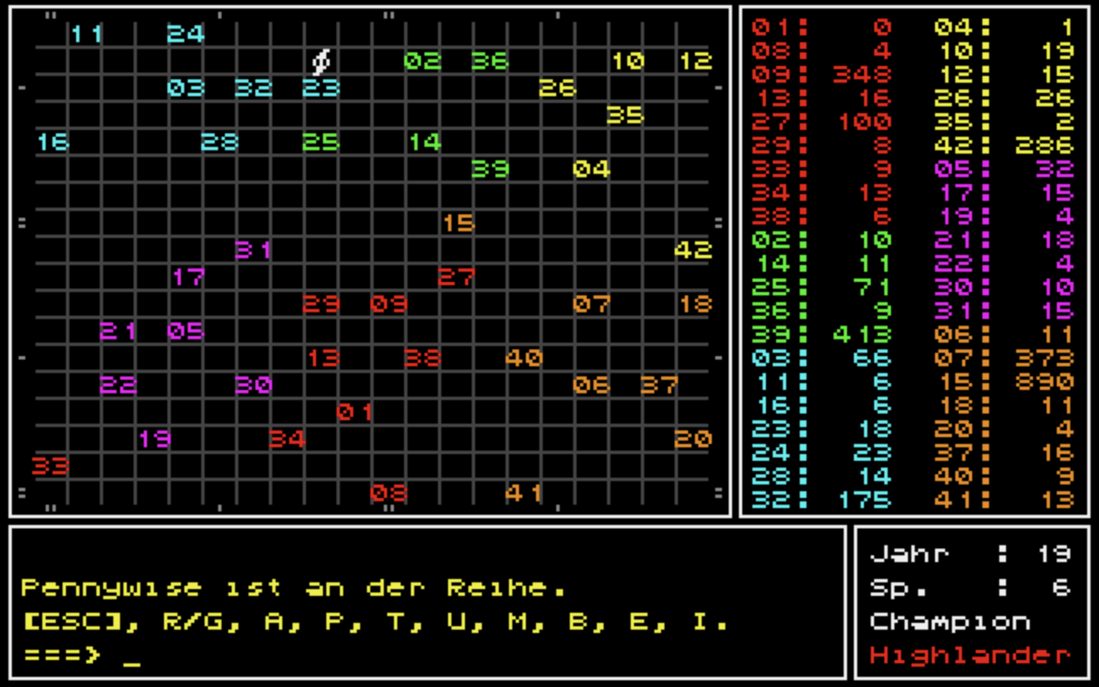
VEGA on an Atari ST, developed 1989 with GFA-BASIC. Did you notice that it's the same game as in the screenshots above? You can find it in today's VEGA as "Demo game 2"
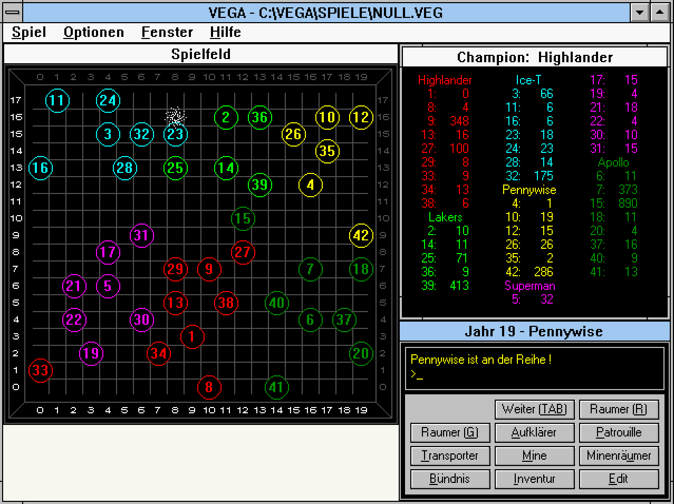
The same "Demo game 2" on VEGA under Windows 3.1 (1992), developed with GFA-BASIC for Windows.

Final words
VEGA is a hobby for me to try out programming techniques in my free time and to get a taste of software lifecycle management. I'm realistic enough not to believe in VEGA's rise to the top 10 of the major gaming rankings. For me, VEGA is a learning project that has been going on for more than 30 years. Perhaps there is some intelligent life form in the infinite vastness of the universe that shares the joy of VEGA with me. If so: please contact me under spielwitz@icloud.com!
Have fun playing!

