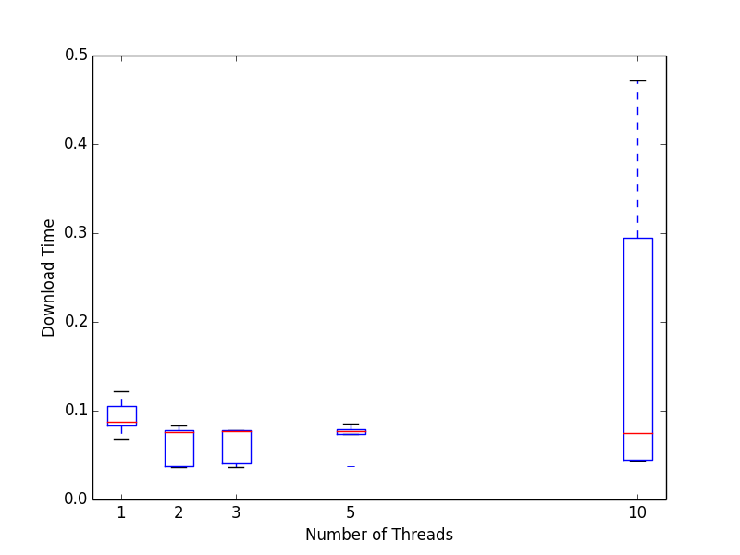
Fig. 1 Small size

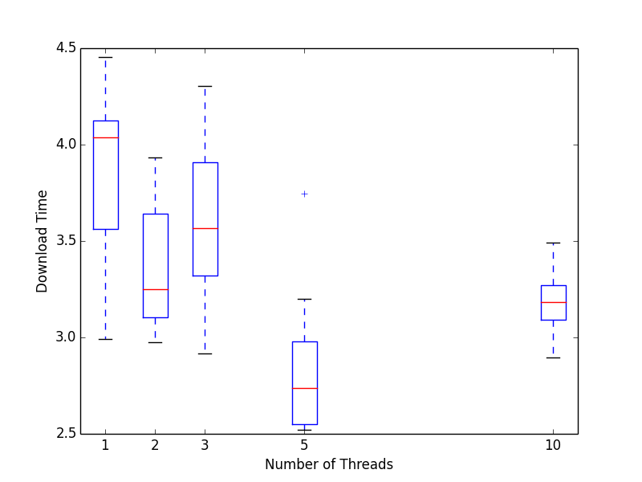
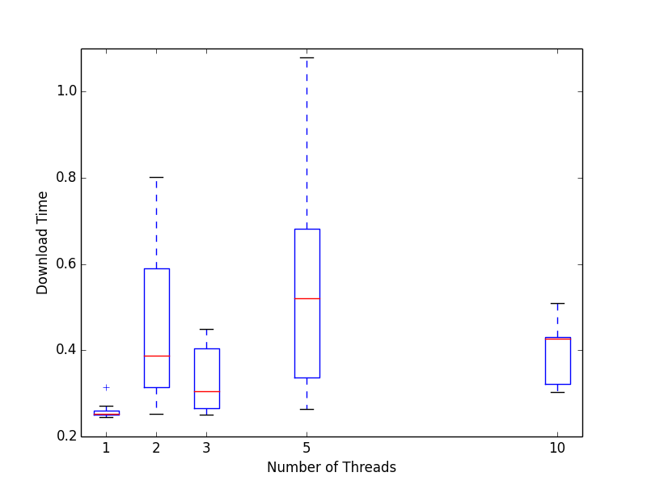
Fig. 2 Medium size

Fig. 3 Large size

At first when I was collecting my data. I has started my timer before all of my threads had been initialized. This caused my graphs to show that having more threads would result in a longer download time. Afterwards I changed my code to only start the timer after my threads were initialized but before I started running them. The resulting data had a few out-liars. Download times of 12 seconds or more. I took these out of the data set and graphed the data again resulting in the graphs above. The graphs show a general trend towards smaller download times with more threads. However the overhead required to initialize these threads often took longer than the time saved by having those threads. In figure 1 we can see that the time saved is almost negligible. The average download time with different numbers of threads barely changes at all. For files of medium size my data in Figure 2 showed that the average download time actually increased with more threads. Only with large files(Figure 3) was there a noticeable benefit in using more threads to download the files. Cutting the average download time by almost 1.5 seconds going from 1 thread to 5 threads. For large files, I believe that parallel downloading does have benefits. With large files, the benefit of having multiple threads downloading at once will outweigh the cost of creating those threads.

