Appendix A: Supplementary Figures
This appendix presents all supplementary figures from the research pipeline, grouped thematically. Figures 4.1–4.11 and 5.1a–5.1b (already embedded in the main chapters) are excluded. Section cross-references are provided in captions. All evaluation caveats in Section 4.1 — the upper-bound nature of expanding-window metrics and the single-episode character of Stage 2 — apply equally to all figures herein.

A.1 Dataset and Crisis Distribution
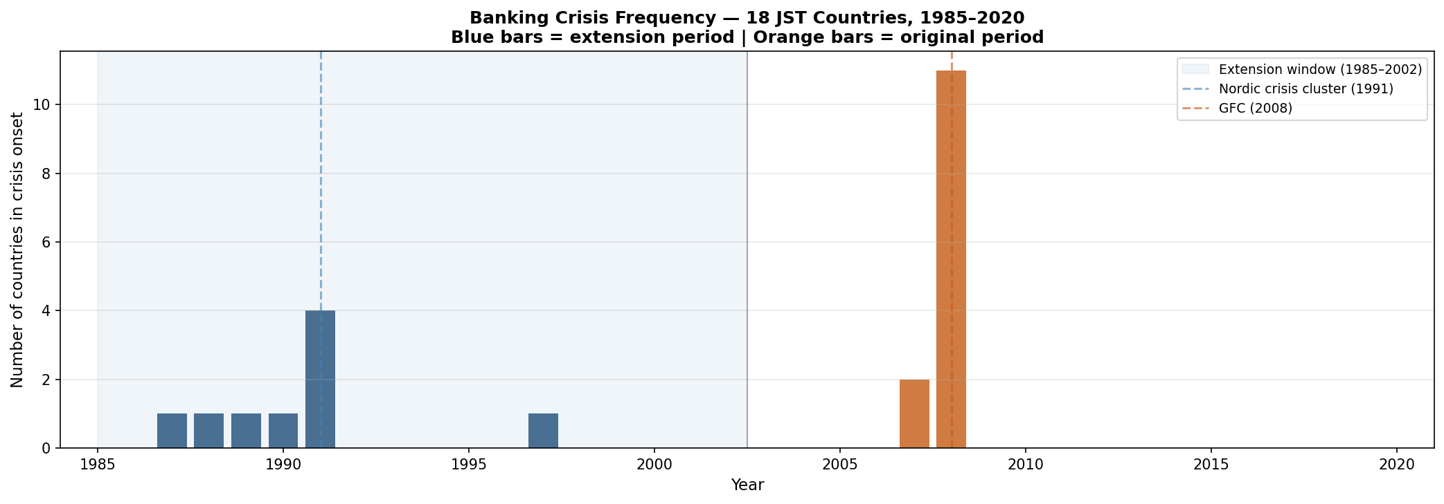
Figure A.1. Banking crisis frequency across 18 JST countries, 1985–2020. Blue bars = crisis onsets in the Stage 1 extension period (1985–2002); orange bars = onsets in the original evaluation window (2003–2020). The Nordic cluster peaks at four simultaneous onsets in 1991; the GFC produces 11 onsets in 2008, dominating the Stage 2 cross-sectional evaluation.

A.2 Early Prototype Analysis
Figures A.2–A.10 document the initial model development stage using unlagged or minimally-lagged features without the rolling-expanding demeaning applied in the main analysis. Read as a development reference, not primary evidence.
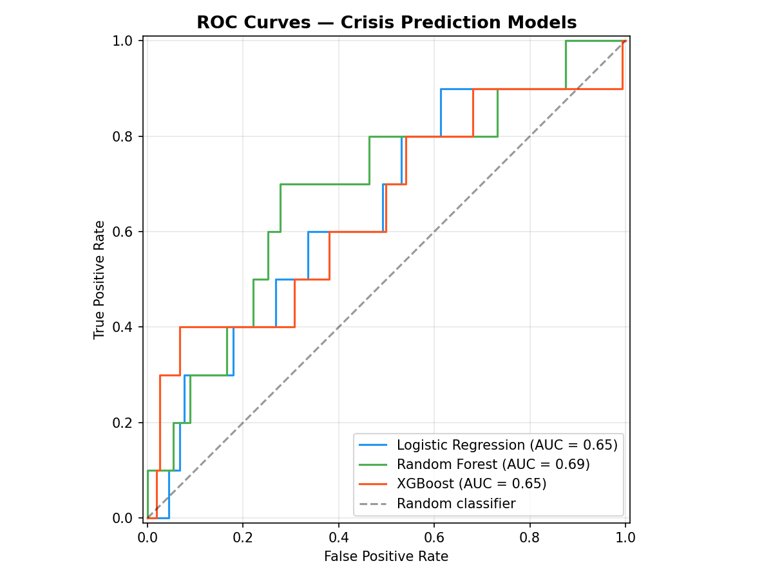
Figure A.2. ROC curves — early prototype. LR (AUC=0.65), RF (AUC=0.69), XGBoost (AUC=0.65). Evaluated on a hold-out test split with unlagged features. The gap versus Figure 4.1 reflects the addition of lag structure, expanding-window evaluation, and demeaned features.
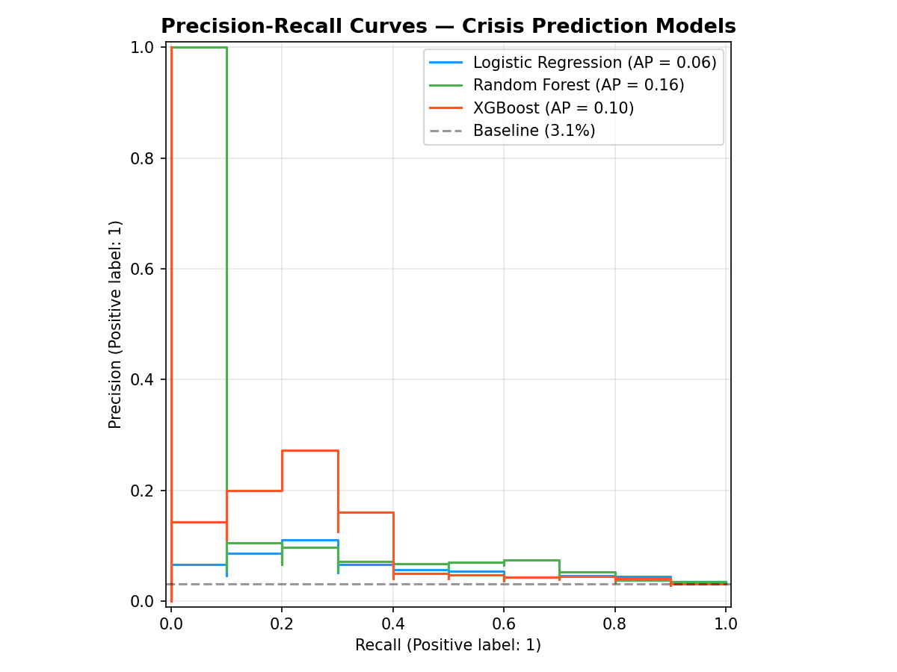
Figure A.3. Precision-Recall curves — early prototype. LR (AP=0.06), RF (AP=0.16), XGBoost (AP=0.10). Low AUPRC values reflect the absence of lagged features and the different evaluation methodology.
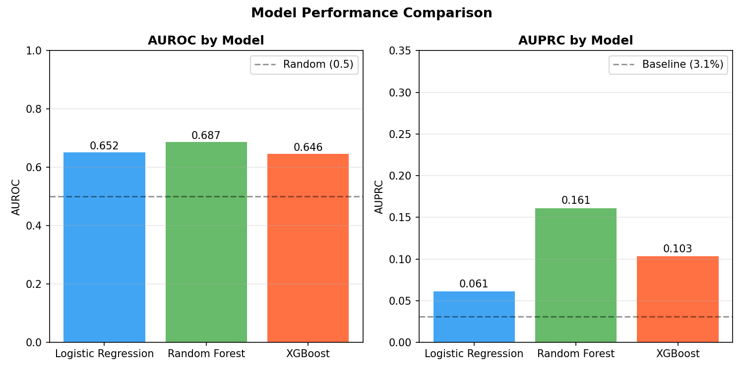
Figure A.4. Model performance comparison — early prototype. AUROC (left) and AUPRC (right) for LR, RF, and XGBoost. All exceed the random baseline but remain below the 0.75 literature AUROC benchmark.
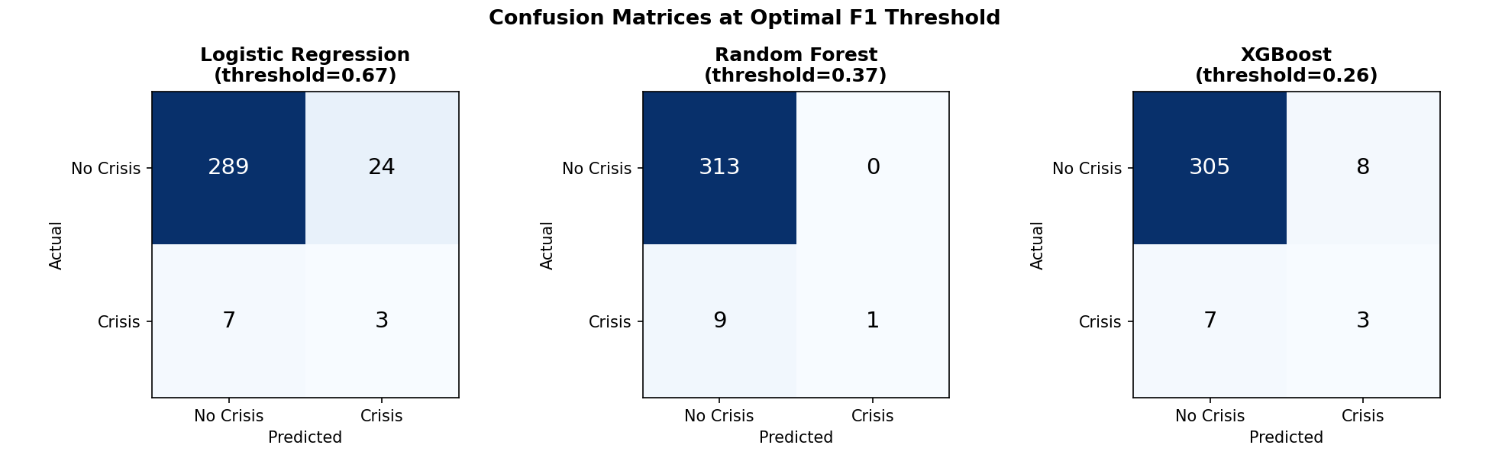
Figure A.5. Confusion matrices at optimal F1 threshold — LR (thr=0.67), RF (thr=0.37), XGBoost (thr=0.26). All models produce low true positive counts at the F1-optimising threshold, illustrating the class imbalance challenge.
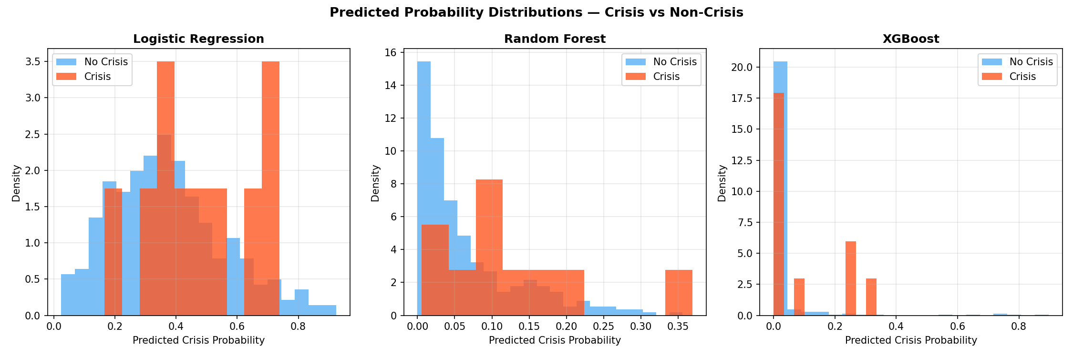
Figure A.6. Predicted probability distributions — crisis vs non-crisis, early prototype. LR (left) shows poor separation; RF (centre) assigns low probabilities to most observations; XGBoost (right) shows the tightest non-crisis spike near zero.
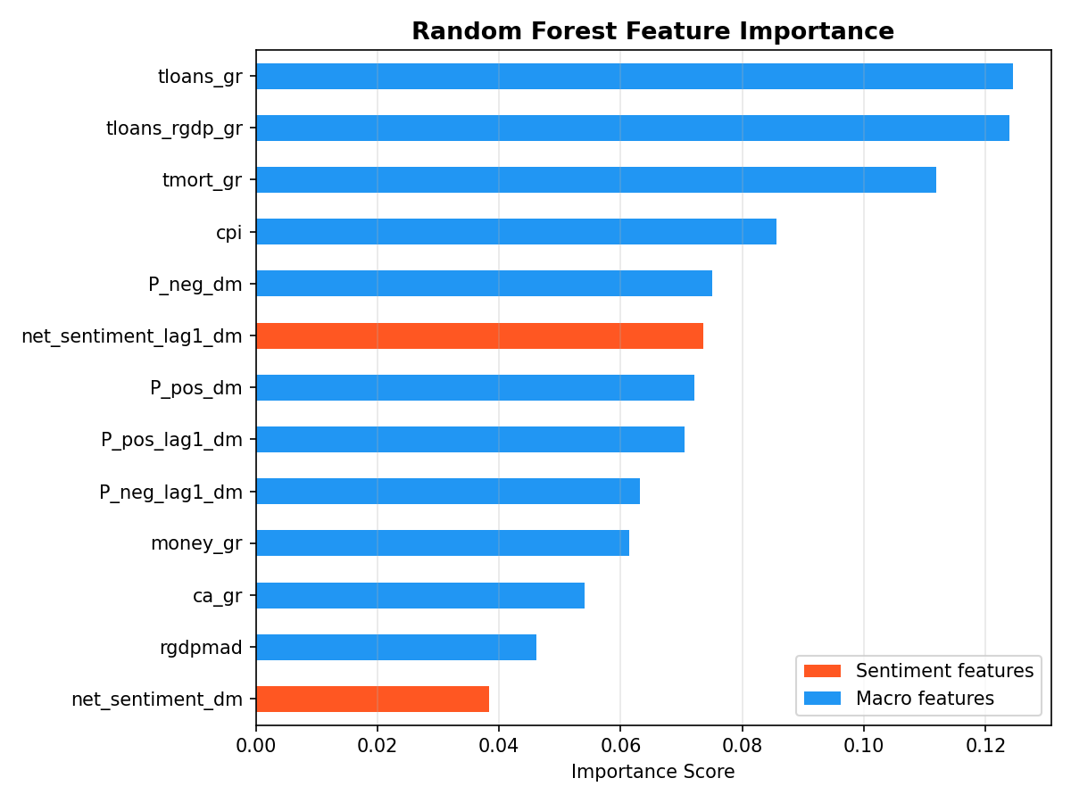
Figure A.7. Random Forest feature importance — early prototype (mean decrease in impurity). Credit growth features (tloans_gr, tloans_rgdp_gr) and mortgage growth (tmort_gr) dominate. Sentiment features appear in the top 13, at higher relative rank than in the demeaned augmented pipeline.
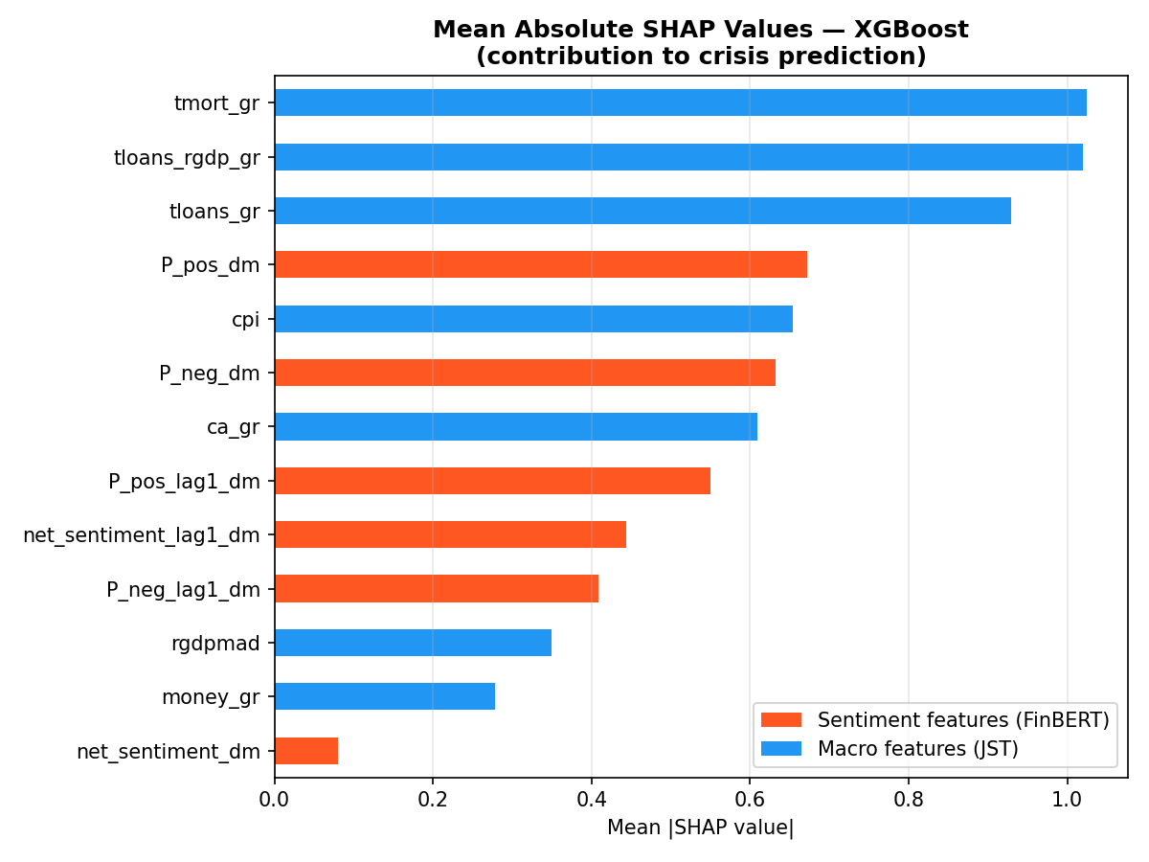
Figure A.8. SHAP mean absolute values — XGBoost early prototype. Mortgage growth, credit-to-GDP growth, and total loan growth are the top three contributors. Sentiment features rank 4th and 6th.
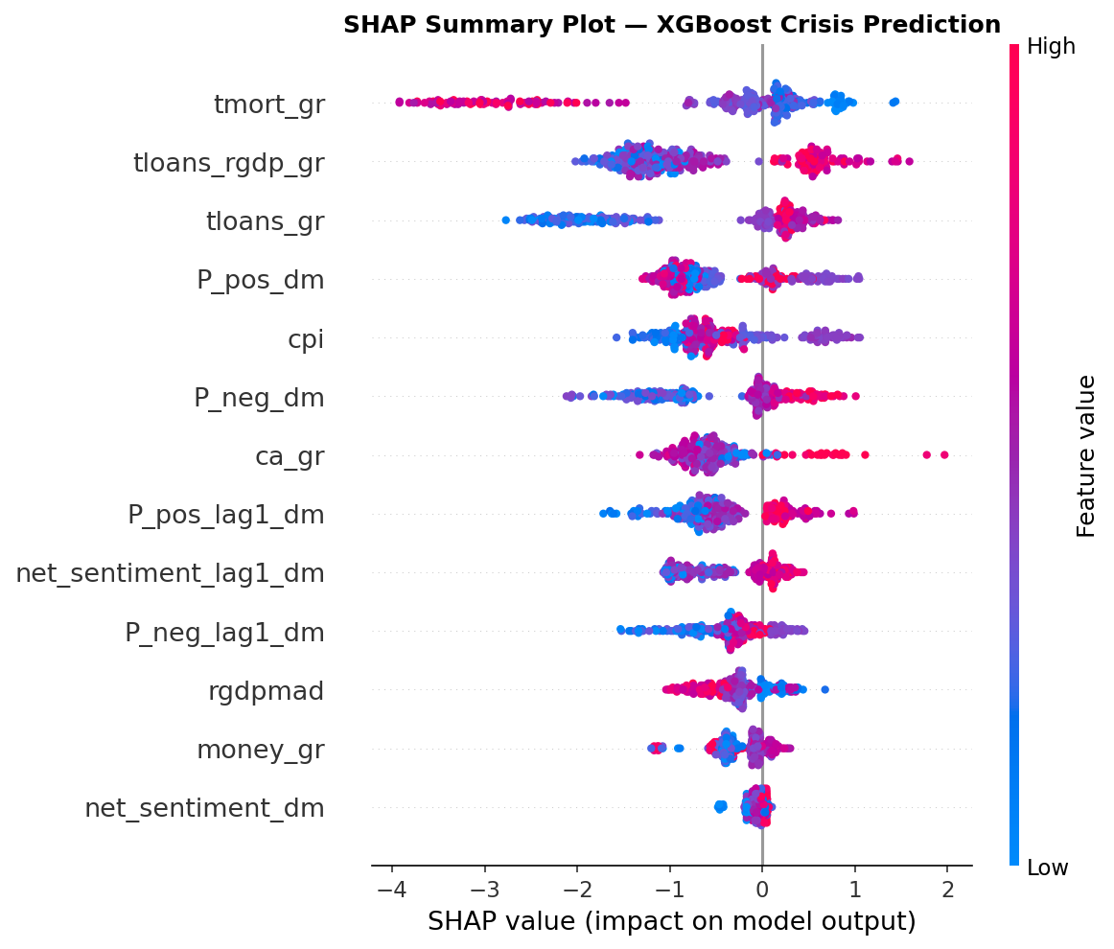
Figure A.9. SHAP beeswarm — XGBoost early prototype. High credit growth generates positive contributions; high P_pos (positive sentiment) generates negative contributions, suggesting excessive optimism in central bank communication precedes crises in this specification.
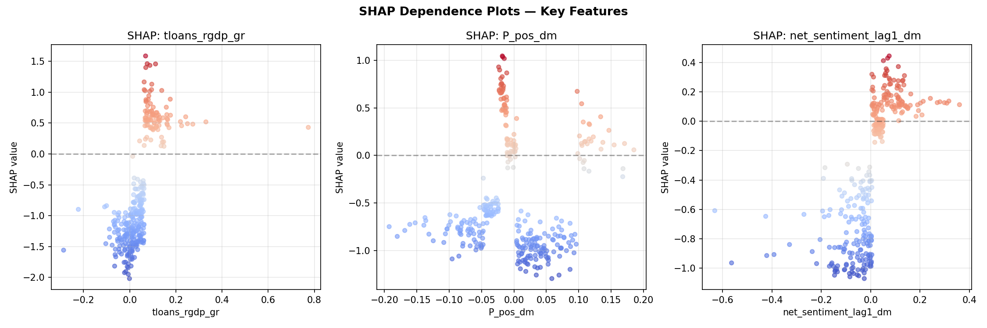
Figure A.10. SHAP dependence plots — three key features, early prototype. Left: credit-to-GDP growth (positive SHAP at high values). Centre: P_pos_dm (sentiment). Right: net_sentiment_lag1_dm (non-linear relationship with crisis risk).

A.3 Augmented Analysis — Pre-EBM Specification
Figures A.11–A.16 document the augmented analysis before EBM M2.5 was incorporated as the interpretable non-linear benchmark. All metrics are subject to the evaluation caveats of Section 4.1.
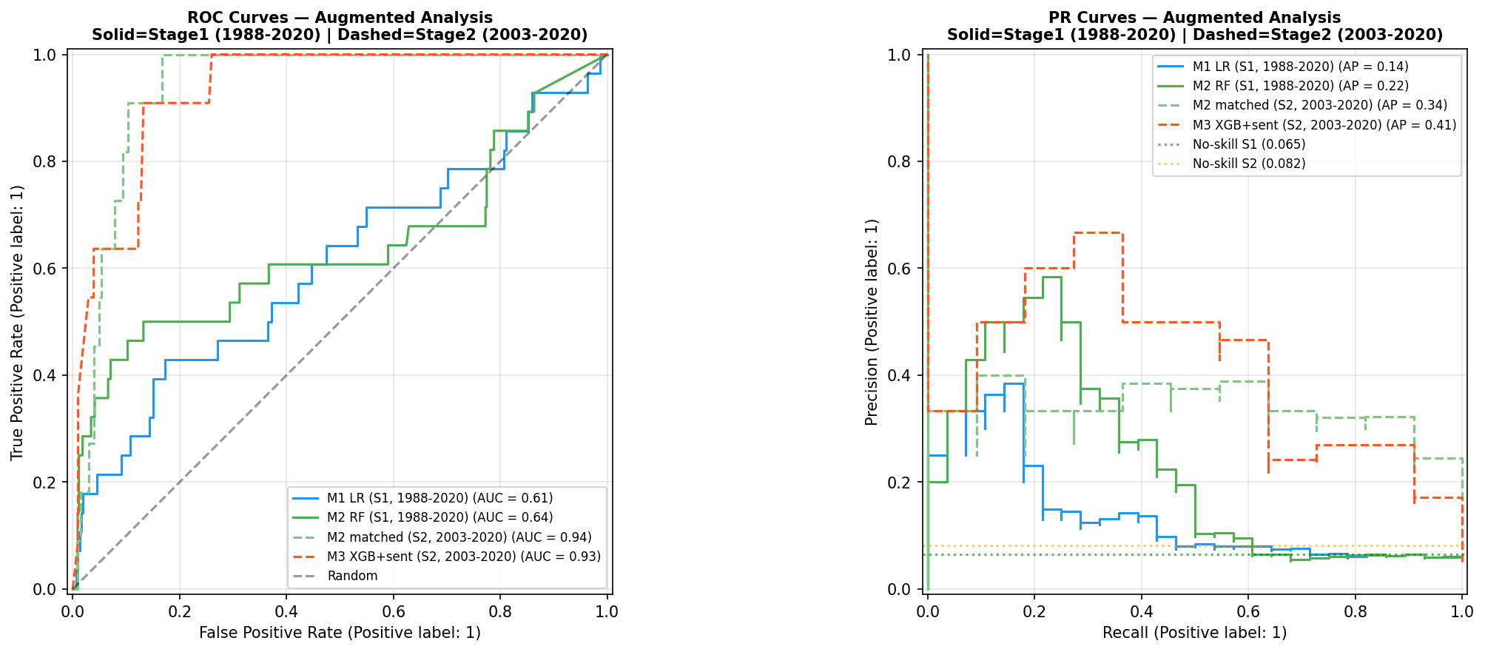
Figure A.11. ROC and PR curves — pre-EBM specification. Solid = Stage 1 (1988–2020), dashed = Stage 2 (2003–2020). M1 LR, M2 RF, M2-matched, M3 XGB+Sentiment. Figure 4.1 adds EBM M2.5 as the interpretable benchmark.
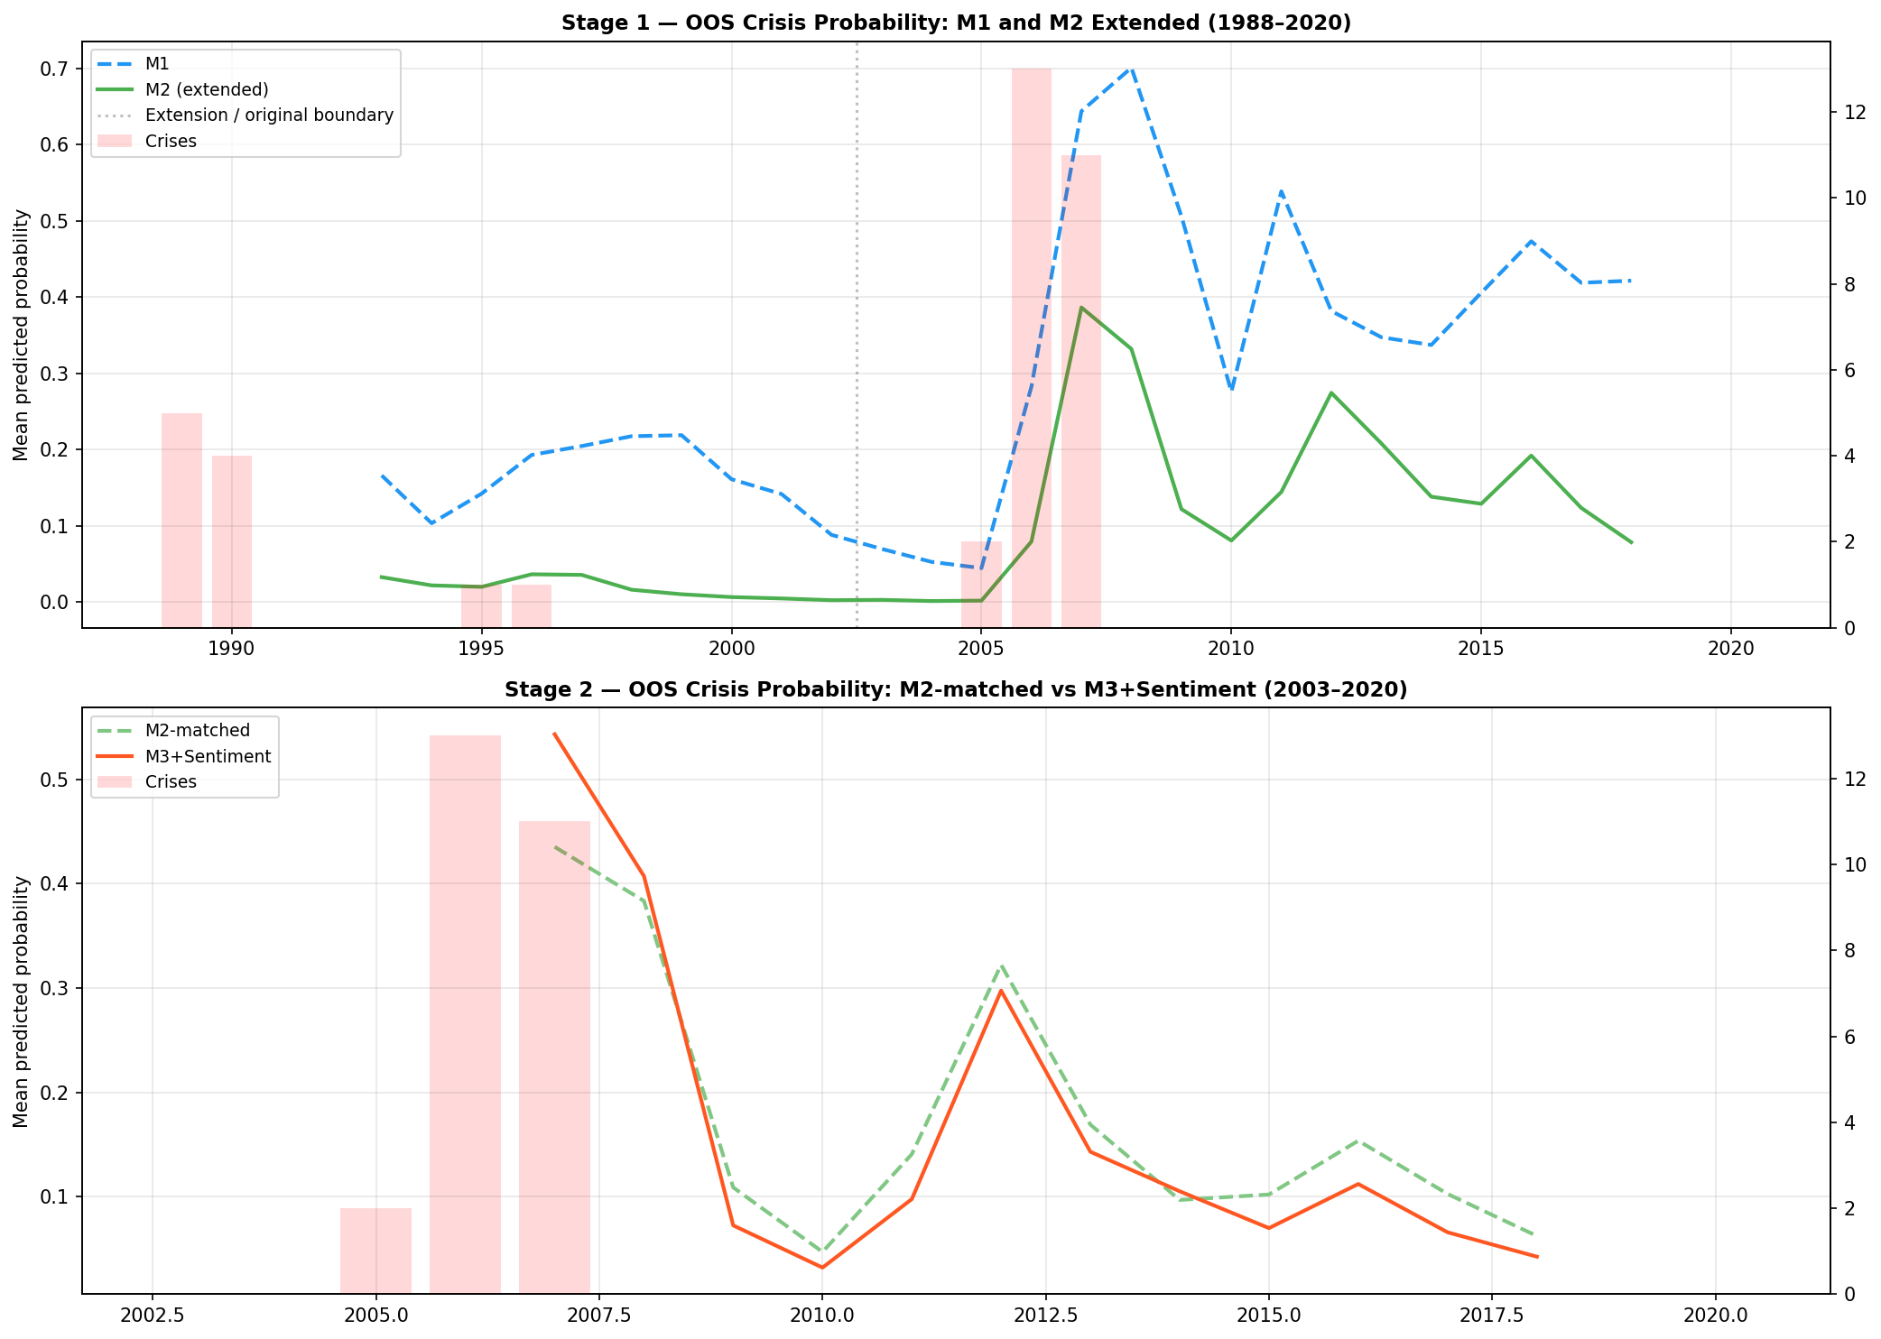
Figure A.12. Out-of-sample crisis probability — pre-EBM specification. Stage 1 (top): M1 LR and M2 RF extended 1988–2020. Stage 2 (bottom): M2-matched vs M3+Sentiment. Compare Figure 4.2, which adds EBM M2.5 trajectories.
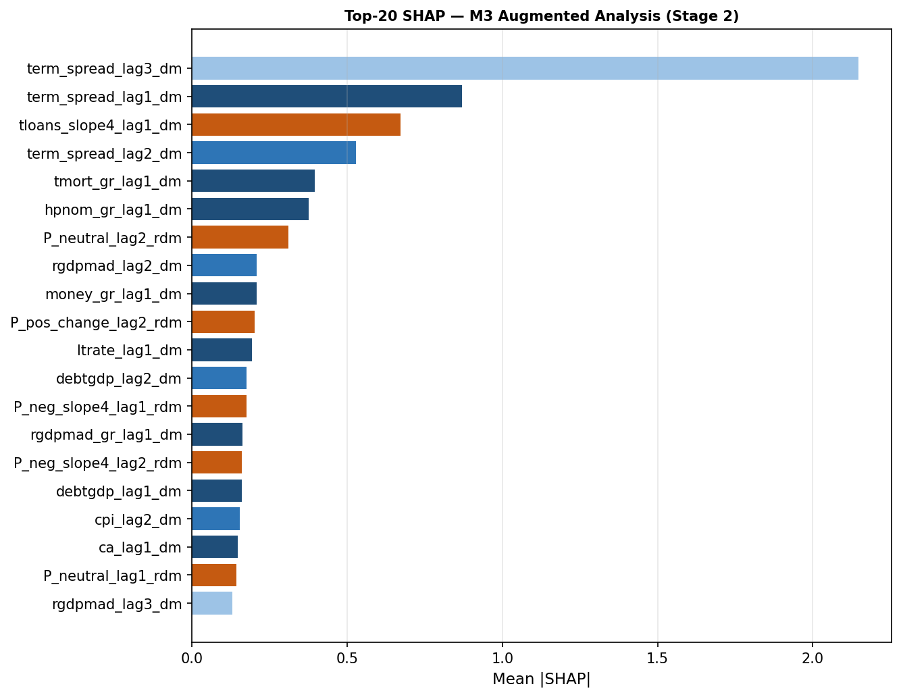
Figure A.13. Top-20 SHAP features — M3 augmented analysis (rolling-demeaned). Term spread lag 3 dominates (mean |SHAP|=2.17); sentiment features (P_neutral_lag2, P_pos_change_lag2) appear in the top 20 but at substantially lower importance. Compare Figure A.23.
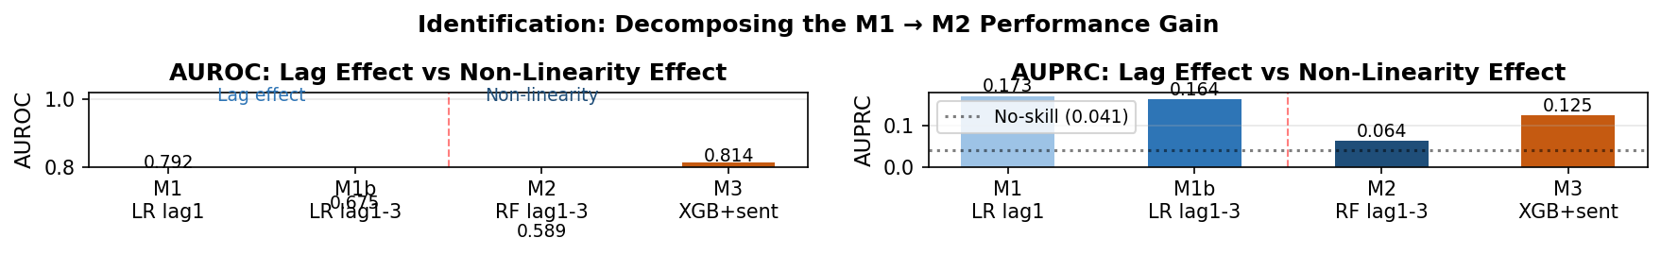
Figure A.14. Decomposing the M1→M2 performance gain: lag effect vs non-linearity. AUROC (left) and AUPRC (right). M1b (LR, lags 1–3) isolates the lag effect; M2 RF isolates non-linearity given the same three lags. AUPRC shows the lag effect is modest; M3 recovers performance via non-linear modelling.
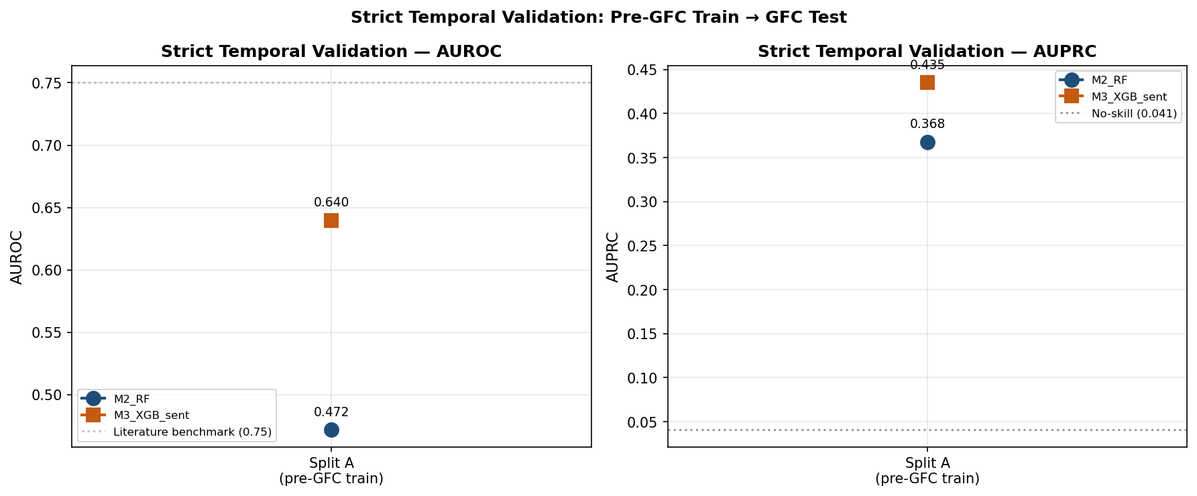
Figure A.15. Strict temporal validation: pre-GFC train (Split A) → GFC test. AUROC (left) and AUPRC (right) for M2 RF (blue, AUROC=0.472) and M3 XGB+Sentiment (orange, AUROC=0.640). Both fail the 0.75 benchmark. Consistent with the EBM Split B result (Section 4.5), models trained exclusively on pre-GFC data do not generalise prospectively to the GFC window.
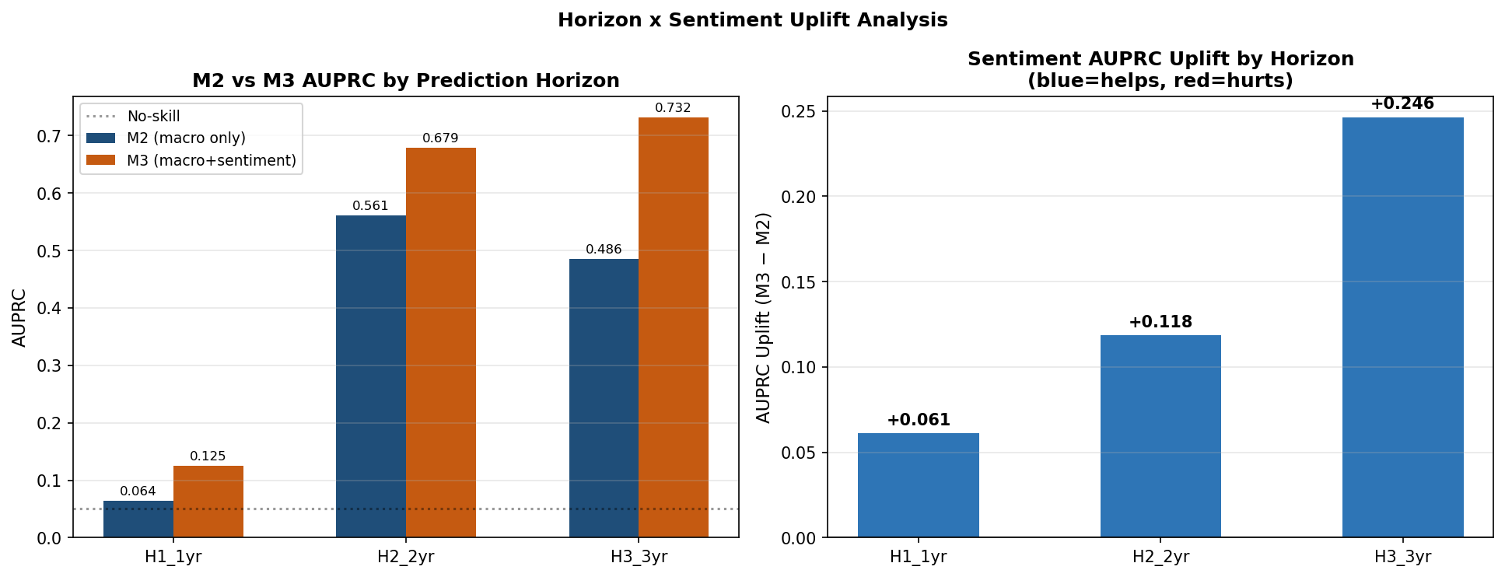
Figure A.16. Sentiment AUPRC uplift by prediction horizon. Left: M2 vs M3 AUPRC at H1 (1-year), H2 (2-year), H3 (3-year). Right: uplift M3−M2. Uplift grows from +0.061 (H1) to +0.246 (H3), suggesting a longer-horizon signal in central bank speech. Excluded from primary pipeline due to insufficient test events at H1/H3 (Section 4.8).

A.4 EBM Shape Function Analysis — Supplementary
Figure A.17 provides a simplified two-feature view of EBM shape function instability, complementing the six-panel display in Figure 4.7.
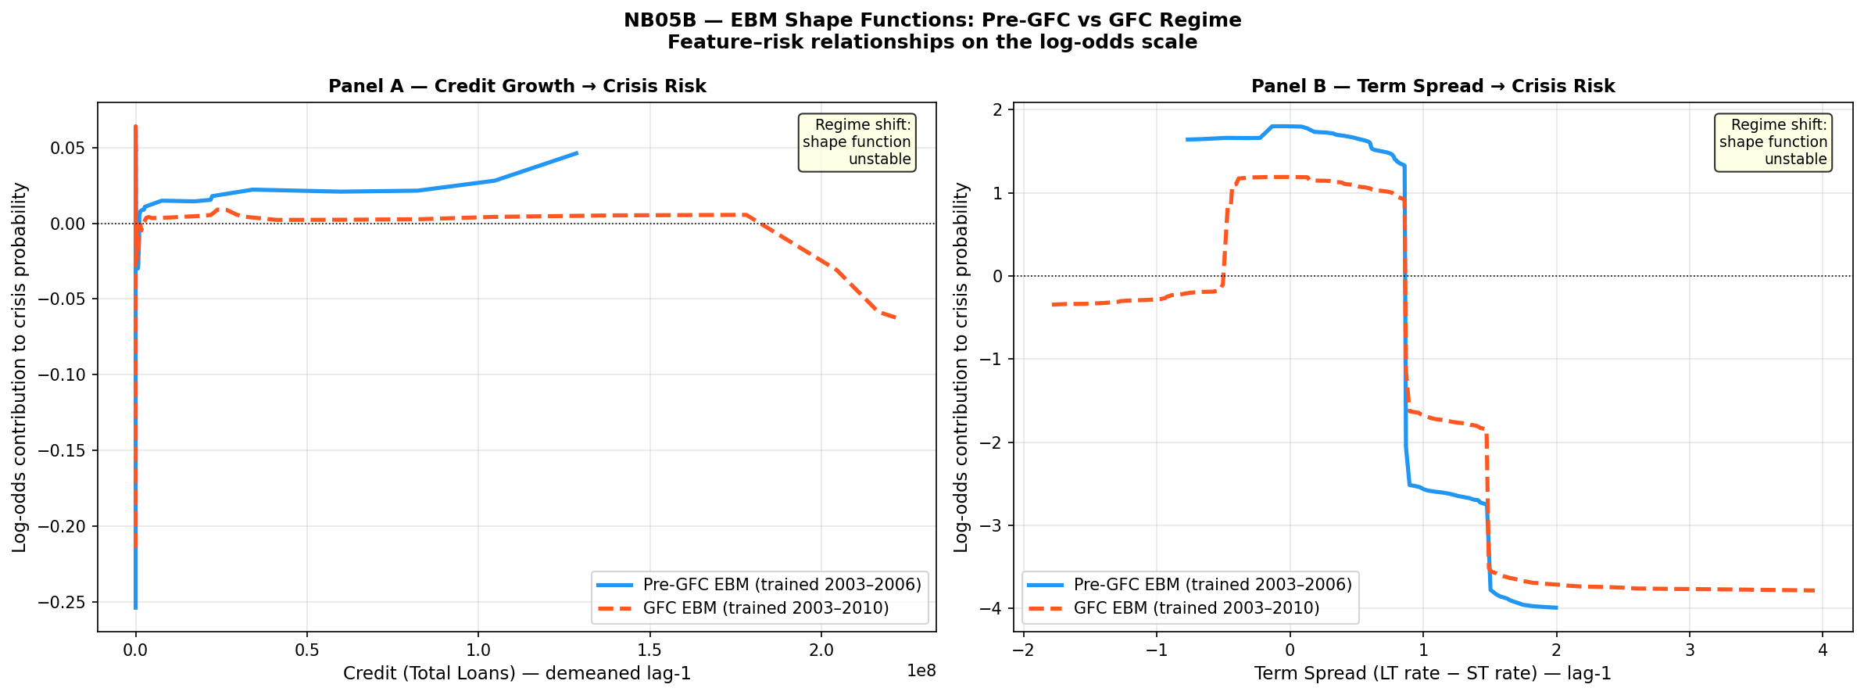
Figure A.17. EBM shape functions for credit growth (Panel A, lag 1) and term spread (Panel B, lag 1): Pre-GFC EBM (blue, 2003–2006) vs GFC-inclusive EBM (red dashed, 2003–2010). Both panels confirm regime instability: term spread contributions reverse sign at moderate positive values; credit growth shifts from near-zero to negative contributions at high values in the GFC window. Simplified two-feature view of Figure 4.7.

A.5 Sentiment Analysis — Additional Results
Figures A.18–A.25 present additional diagnostic output from the sentiment analysis pipeline, including Granger causality tests, SHAP attribution comparisons, and calibration diagnostics.
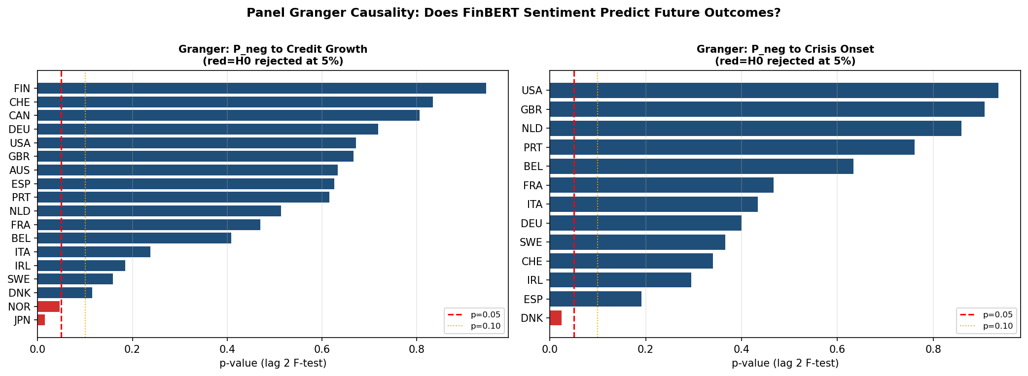
Figure A.18. Panel Granger causality: FinBERT P_neg → credit growth (left) and → crisis onset (right), lag-2 F-test p-values. Red line = p=0.05. Sentiment significantly Granger-causes credit growth in Japan and Norway only; no country reaches significance for the crisis onset target. Supports the conclusion that FinBERT sentiment does not carry a systematic predictive signal (Section 4.9).
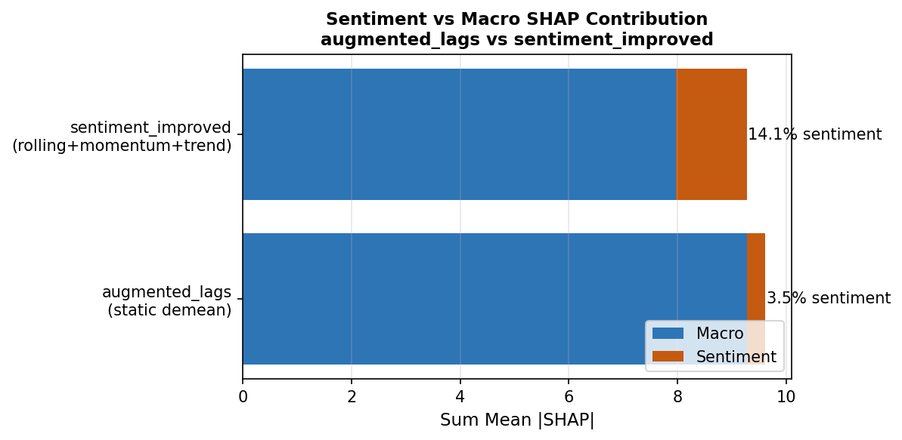
Figure A.19. Macro vs sentiment SHAP contribution: augmented_lags (static demeaning, 3.5% sentiment) vs sentiment_improved (rolling+momentum+trend, 14.1% sentiment). Improving sentiment feature engineering quadruples the sentiment SHAP share, though macro features remain dominant in both.
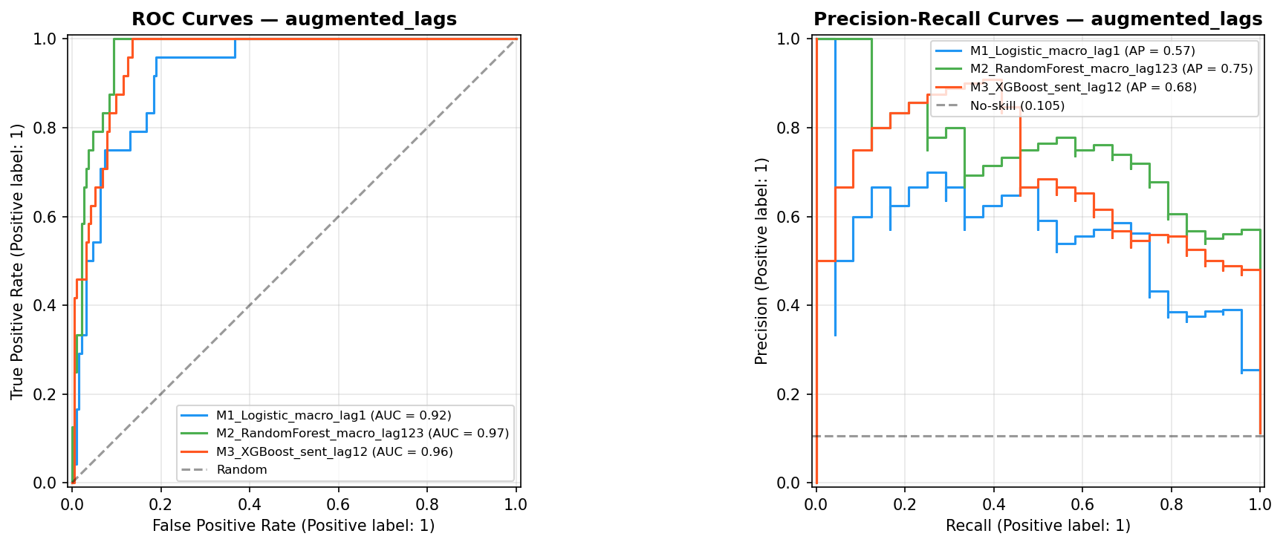
Figure A.20. ROC and PR curves — sentiment_improved specification. M1 Logistic (AUC=0.88), M2 RF (0.95), M3 XGBoost+Sentiment rolling (0.94). Stage 2 AUPRC for M3 improves to 0.63 vs 0.41 in the primary analysis, driven by improved rolling sentiment engineering. This specification is retained as exploratory: the AUPRC improvement occurs within the same single-episode Stage 2 structure and does not establish temporal generalisation. The improvement reflects sample-specific re-weighting under the rolling demeaning approach rather than a stable predictive channel (see Section 5.1 for discussion).
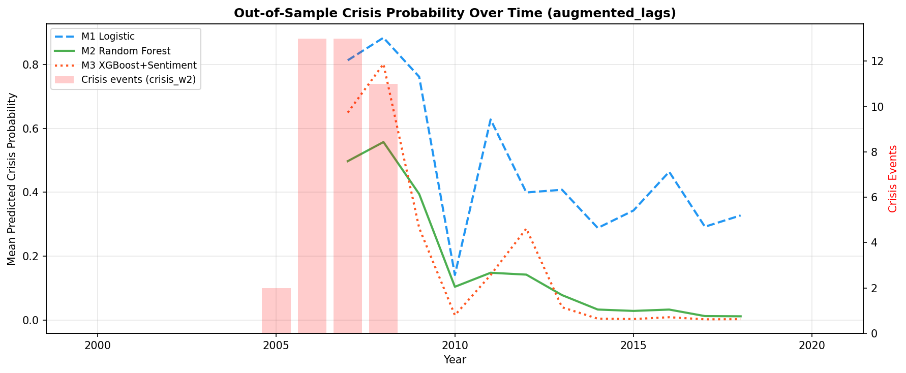
Figure A.21. Out-of-sample crisis probability — sentiment_improved. M1 (blue dashed), M2 (green), M3+Sentiment (red dotted). Sharper GFC peak (M3 reaching 0.62 in 2007–2008) vs primary analysis; post-crisis persistence and false positives in 2010–2015 remain.
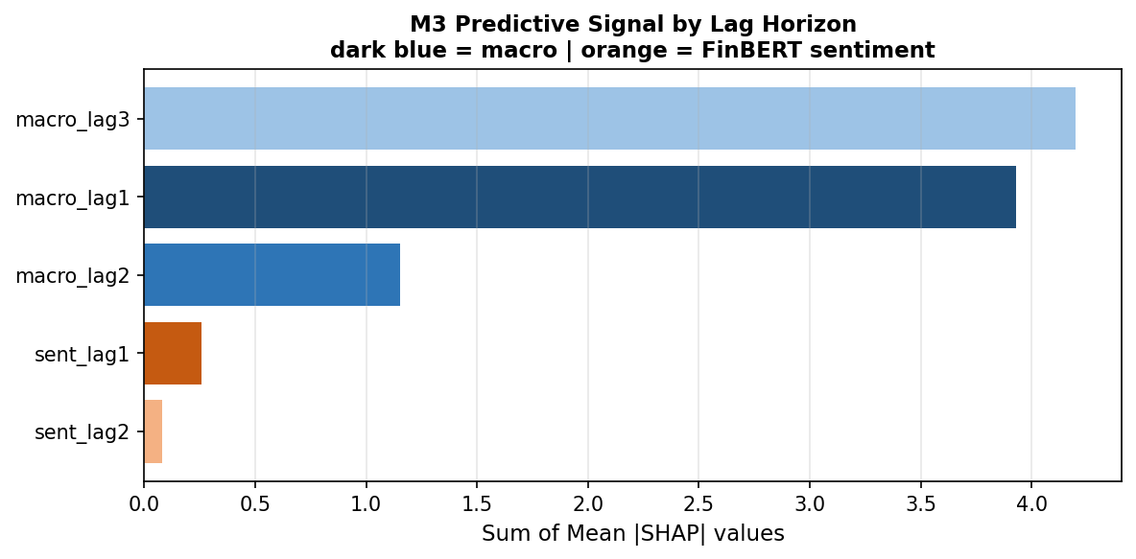
Figure A.22. M3 SHAP signal by lag horizon — sentiment_improved, rolling+momentum+trend. Macro lag 3 (4.2 units) and lag 1 (2.9 units) dominate; sentiment at lag 1 contributes ≈1.0 units (≈86% macro attribution). A rolling-demeaned variant (not shown) reduces the sentiment share to ≈3%, confirming sensitivity to the demeaning approach.
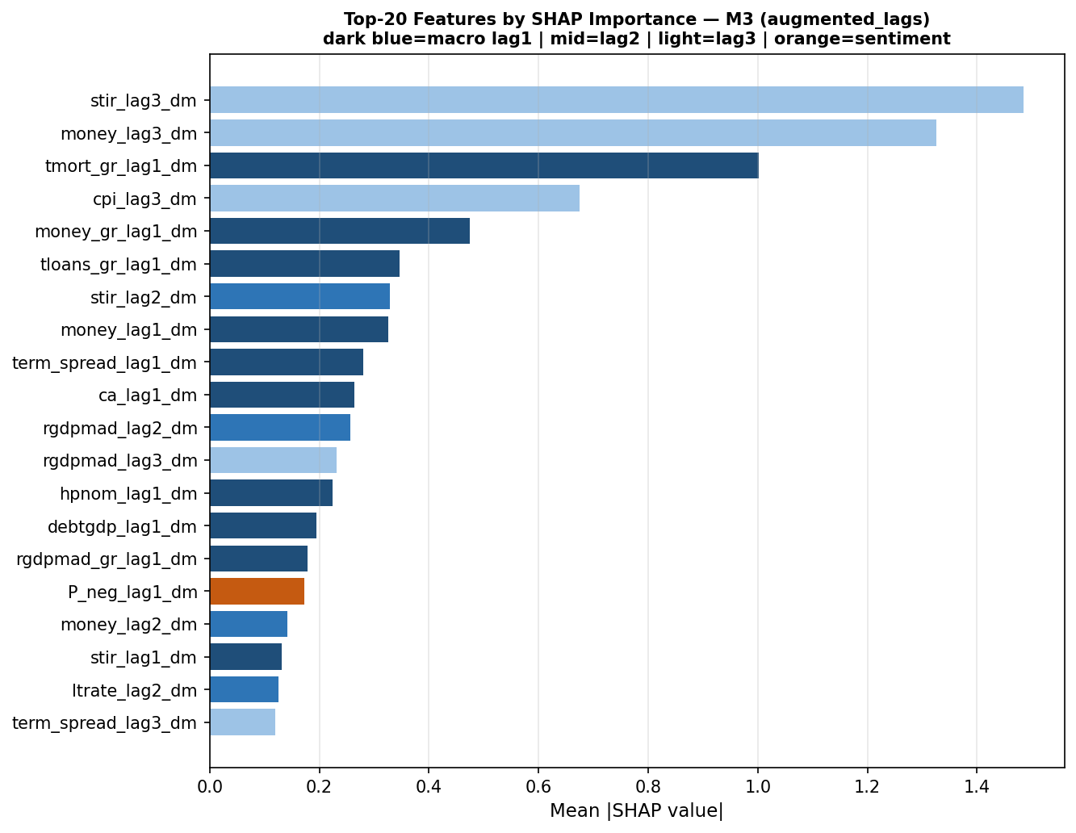
Figure A.23. Top-20 SHAP features — M3 sentiment_improved. Term spread lag 3 remains dominant (mean |SHAP|=1.87). Only one sentiment feature (P_neg_roll3_std_lag1) appears, at rank 20. Compare Figure A.13 (rolling-demeaned augmented analysis) where term spread also leads.
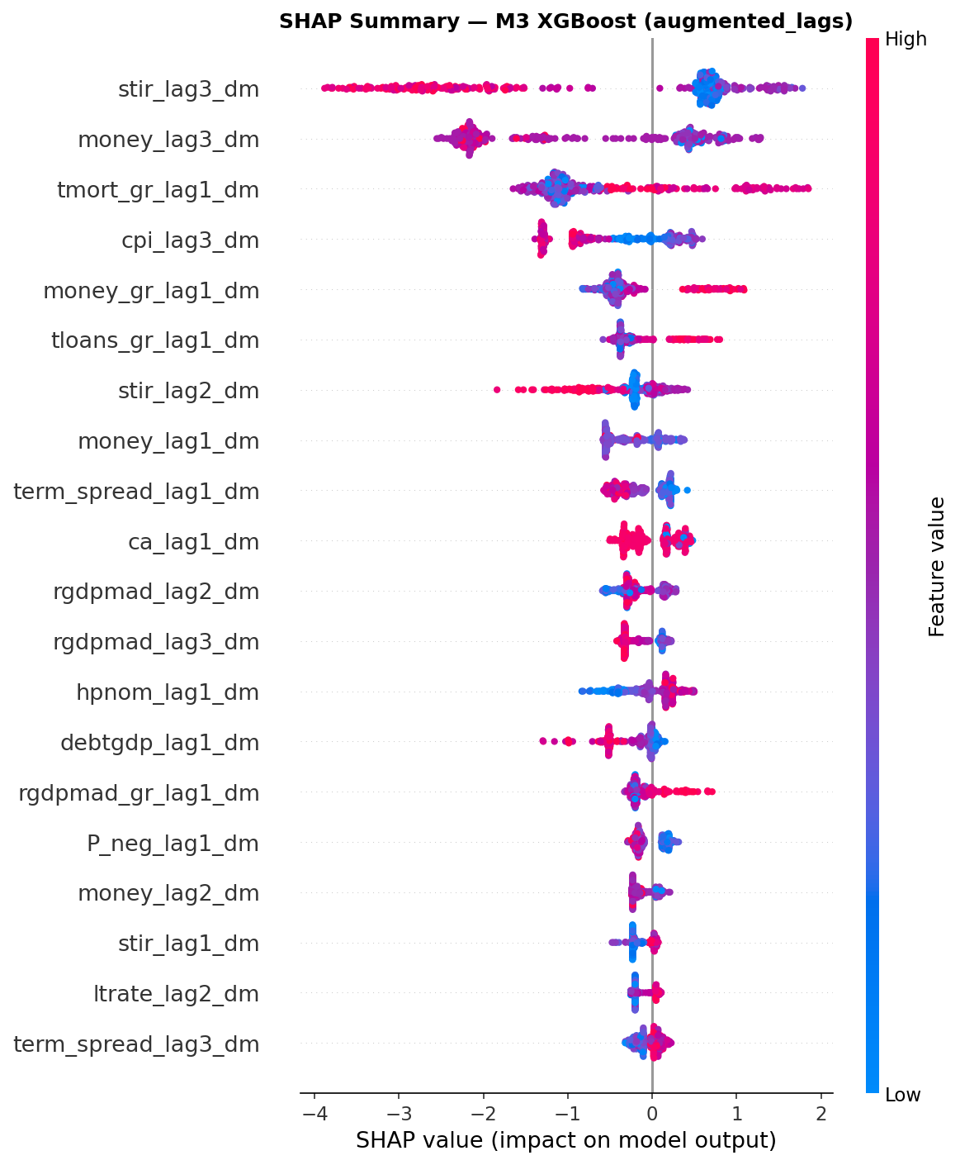
Figure A.24. SHAP beeswarm — M3 sentiment_improved. Each point = one observation; colour = feature value (red=high, blue=low). Term spread lag 3 shows the most complex distributional pattern, with both high and low values generating large negative contributions, consistent with the non-monotonic EBM shape functions in Figure 4.7.
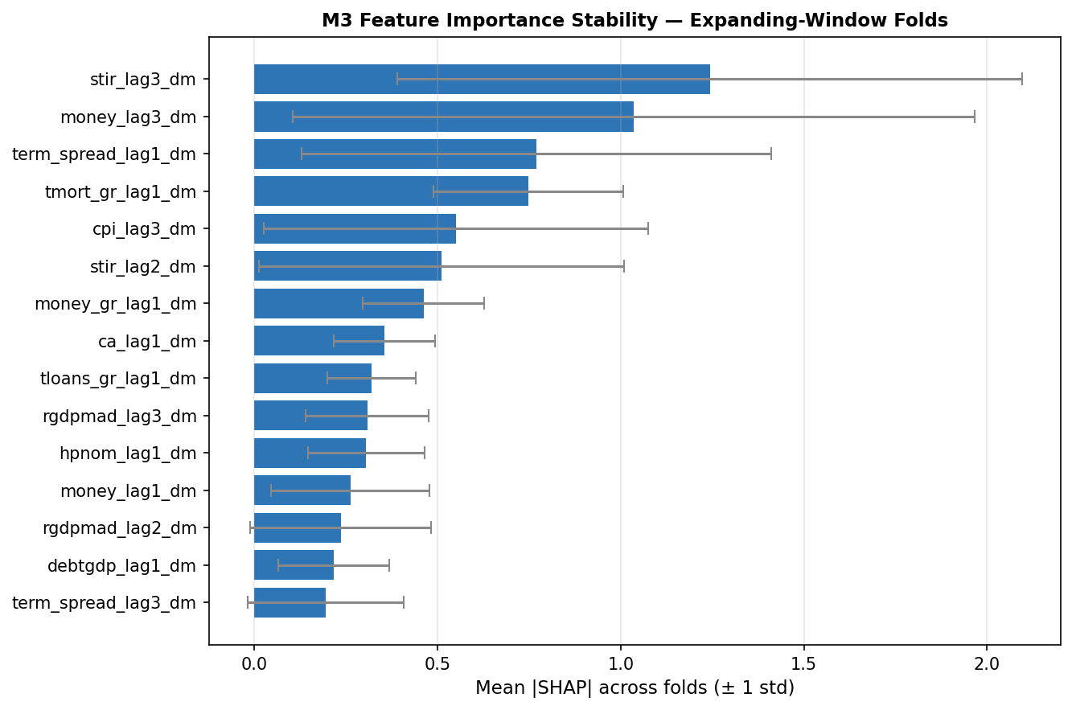
Figure A.25. M3 feature stability across expanding-window folds — sentiment_improved (mean ±1 std). Term spread lags 1 and 3 show highest mean importance but also widest confidence intervals, reflecting fold-to-fold variation consistent with structural non-stationarity (Section 4.5).

A.6 Calibration and Decision-Threshold Analysis
Figures A.26–A.29 provide additional calibration diagnostics and threshold sensitivity analysis to complement Figure 4.8.
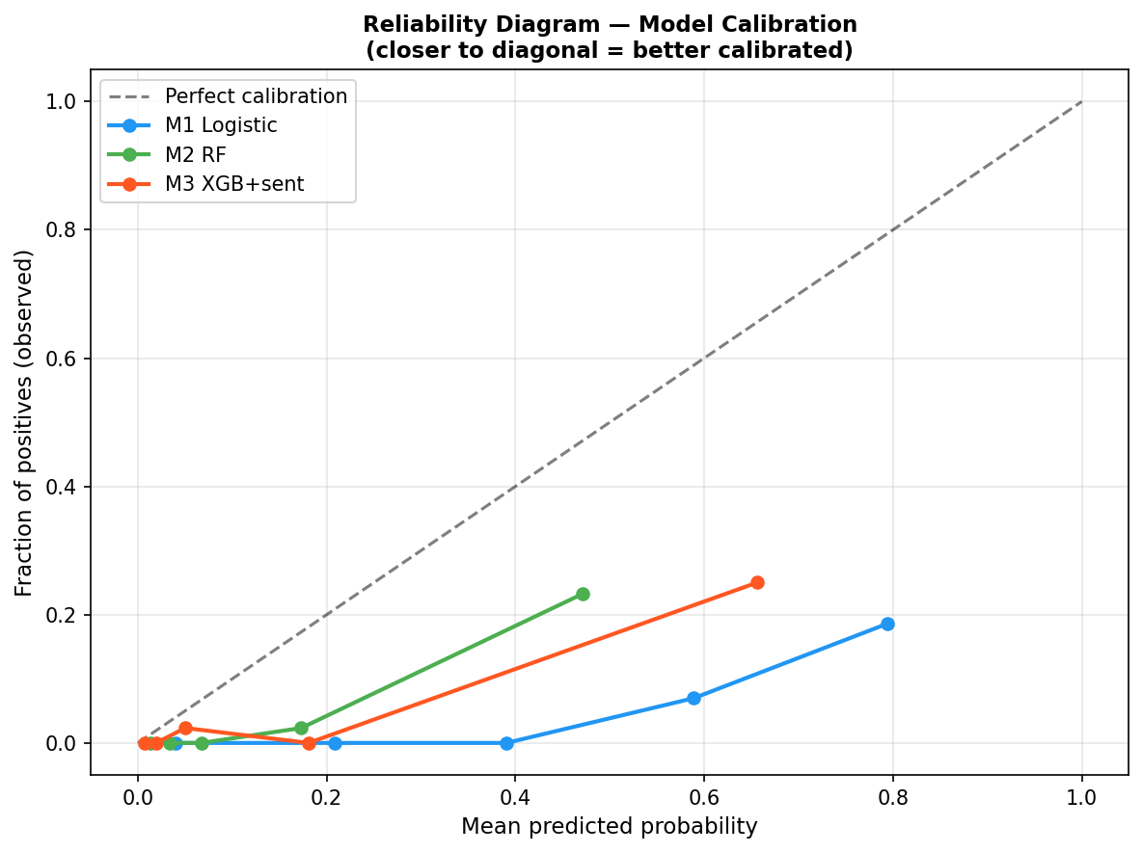
Figure A.26. Reliability diagram — M1 Logistic, M2 RF, M3 XGB+Sentiment, original specification. All three models exhibit systematic under-confidence. Compare Figure 4.8, where EBM M2.5 achieves ECE=0.084 without isotonic calibration.
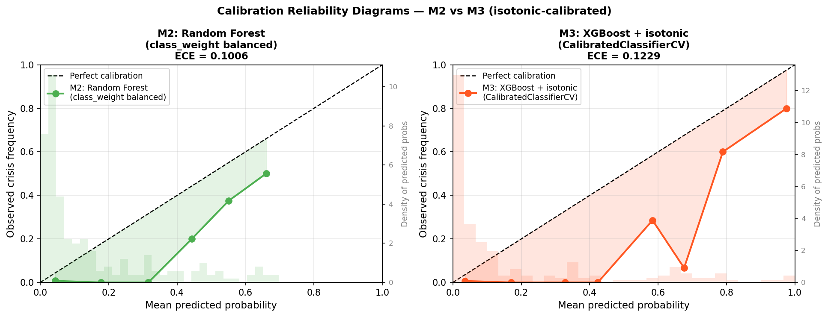
Figure A.27. Calibration reliability diagrams with isotonic correction — M2 RF (left, ECE=0.101) and M3 XGBoost+isotonic (right, ECE=0.123). M2 achieves better ECE under isotonic correction. EBM M2.5 in Figure 4.8 achieves ECE=0.084 without isotonic calibration.
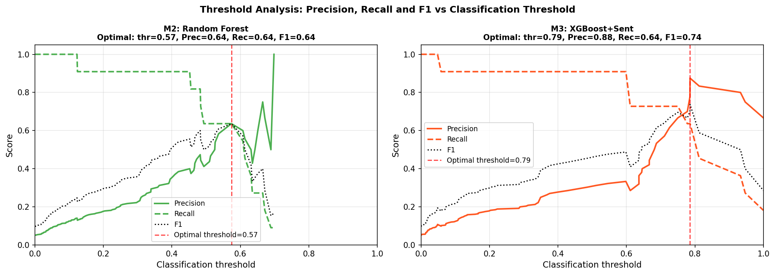
Figure A.28. Threshold analysis: Precision, Recall, and F1 vs classification threshold for M2 RF (left, optimal thr=0.57, F1=0.64) and M3 XGBoost+Sentiment (right, optimal thr=0.79, F1=0.74). M3 achieves higher optimal F1 at a substantially higher threshold.
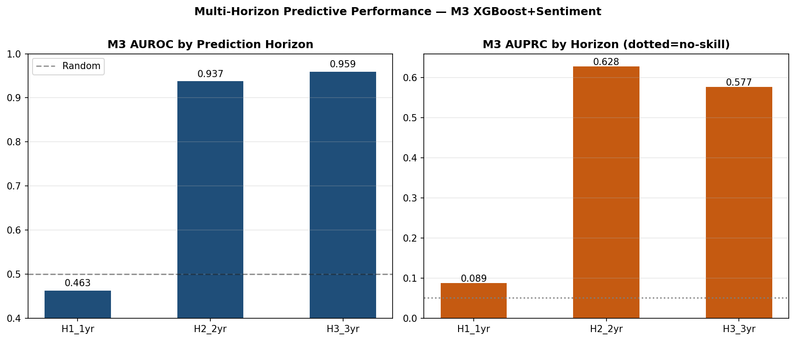
Figure A.29. M3 XGBoost+Sentiment performance by prediction horizon — sentiment_improved. AUROC (left) and AUPRC (right) at H1 (AUROC=0.463), H2 (0.937), H3 (0.959). H1 falls below random; H2/H3 are strong but inherit the cross-sectional concentration inflating Stage 2 metrics. Cross-reference Figure A.16 for the sentiment uplift pattern across horizons.

A.7 Original Ensemble Extension (NB09A)
Figures A.30–A.34 present the NB09A ensemble analysis (M4 = avg(M2-matched, M3)), preceding the EBM-based ensemble reported in Section 4.10. These results document the pre-EBM ensemble development trajectory.
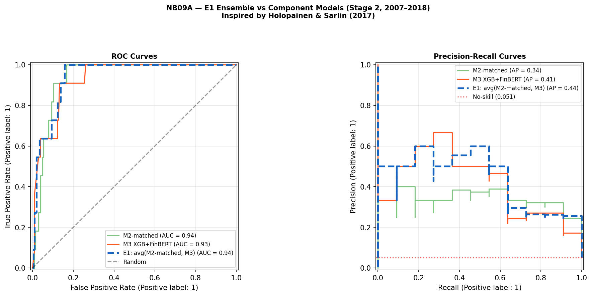
Figure A.30. NB09A E1 ensemble vs component models — Stage 2 ROC/PR (2007–2018). E1 = equal-weighted average of M2-matched and M3. E1 achieves AUPRC=0.44 vs M2-matched 0.34 and M3 0.41. Compare Figure 4.9 (EBM-based E1-EBM: AUPRC=0.43, AUROC=0.955).
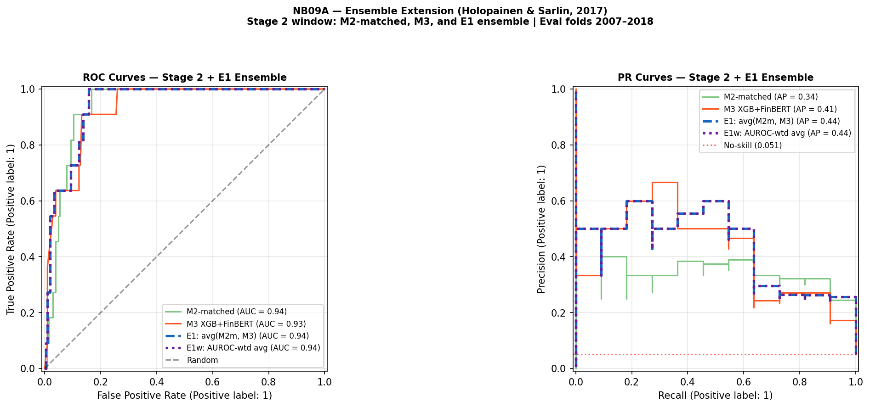
Figure A.31. NB09A ensemble variants including AUROC-weighted E1w — Stage 2. Both E1 and E1w achieve AUPRC=0.44 and AUROC=0.94, indicating AUROC-weighting provides no discrimination benefit over equal weighting.
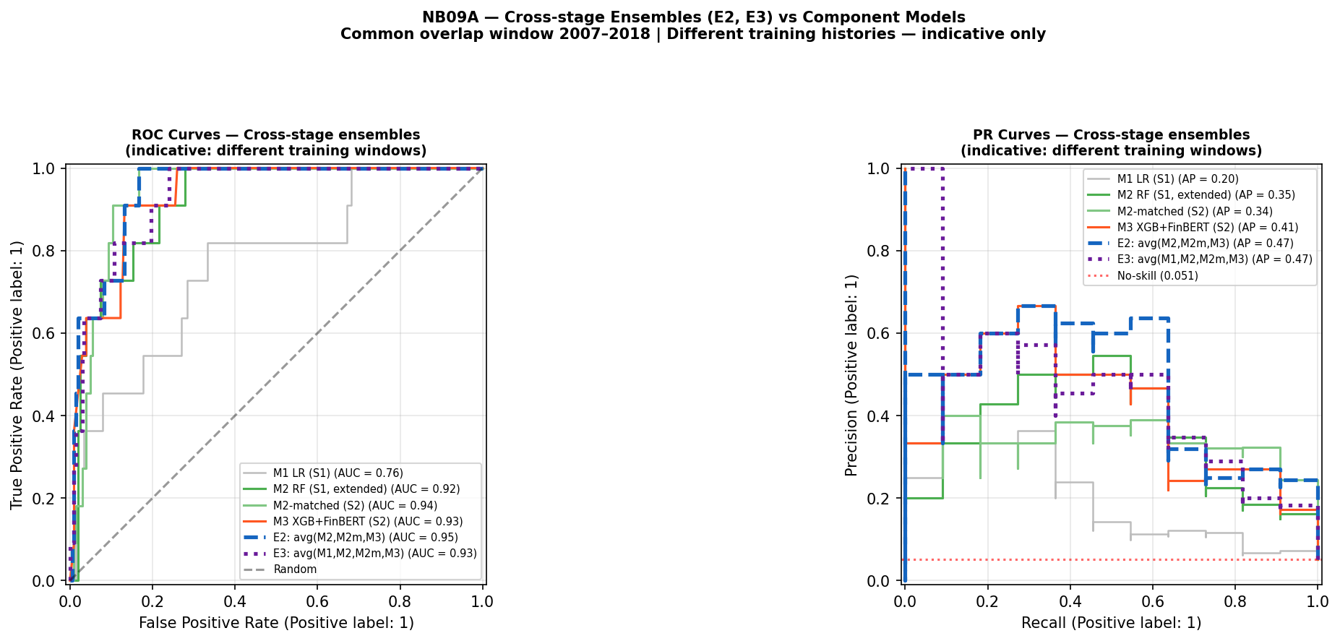
Figure A.32. NB09A cross-stage ensembles E2 (avg M2, M2m, M3) and E3 (avg M1, M2, M2m, M3) over 2007–2018. Both achieve AUPRC=0.47, marginally above E1 (0.44). Comparisons are indicative only due to different training histories.
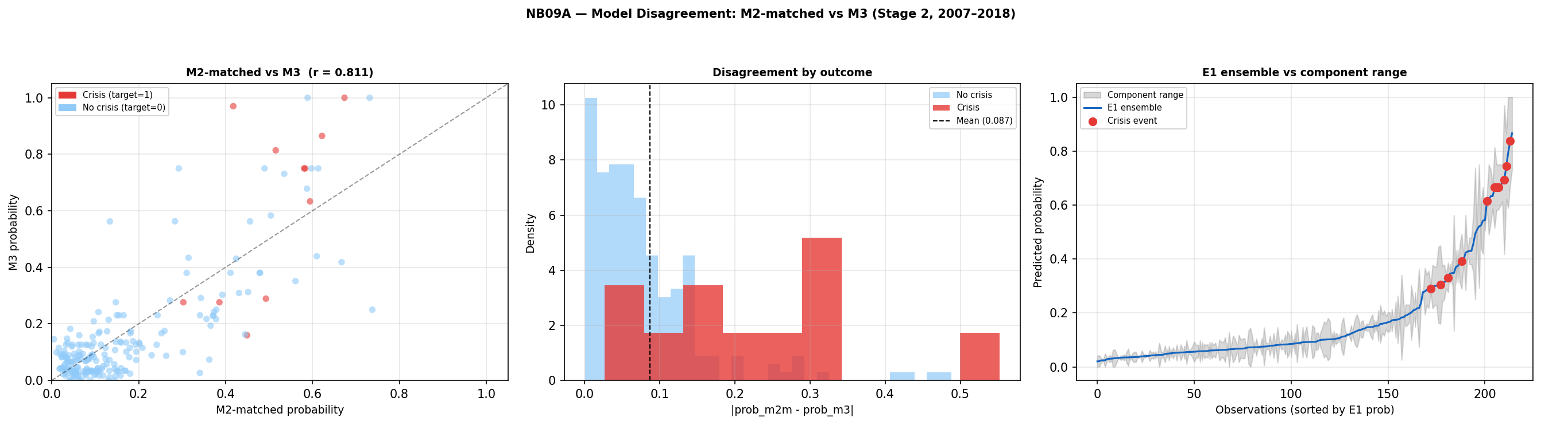
Figure A.33. NB09A model disagreement: M2-matched vs M3 (r=0.811). Left: probability scatter by crisis outcome. Centre: disagreement by outcome class — crisis observations show wider spread (mean=0.087). Right: E1 ensemble vs component range. Compare Figure 4.10, which extends analysis to include EBM M2.5.
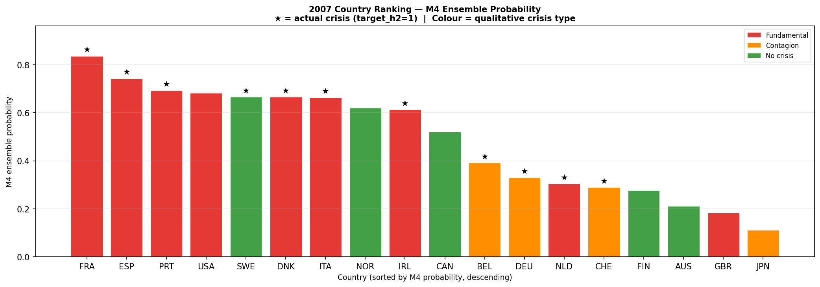
Figure A.34. 2007 country probability ranking — M4 original ensemble. France ranks first (0.84), Spain second (0.75); GBR 17th (0.18), JPN last (0.11). Compare Figure 4.11 (E1-EBM): IRL rises to rank 4 and the EBM component drives a markedly different ordering.

