Appendix B

Appendix B: Exploratory Regime-Conditional Prototype

B.1 Scope and Purpose
This appendix presents an exploratory proof-of-concept implementation of regime-conditional modelling, as proposed in Section 5.7 (Proposed Extension 1). It is included not to establish a superior forecasting model, but to demonstrate the methodological feasibility and limitations of operationalising regime-awareness within the existing EWS pipeline. Results should not be interpreted as confirmatory evidence of a validated predictive system.
The prototype uses two economic regimes defined manually using the same sub-period boundaries that motivate the shape function analysis in Section 4.7.3 — specifically, the pre-GFC period (1988–2002, covering the Nordic banking crisis cluster and the Japanese crisis of 1997) and the GFC-inclusive period (2003–2020). This manual definition avoids the additional model selection problem that a data-driven clustering approach would introduce (choice of algorithm, distance metric, and number of regimes), and connects the prototype directly to evidence already presented in the main dissertation. A separate EBM is trained on each regime using the same hyperparameter specification as the NB05B benchmark (Section 4.4), and results are compared against a pooled EBM trained on the full 1988–2020 panel.
The evaluation uses a held-out test set of 2006–2007, which captures the 24 target_h2 forward-looking crisis labels corresponding to the GFC onset. This window was identified empirically: the target_h2 construction (crisis in t+1 or t+2) means GFC crisis events (crisisjst = 1 in 2008) appear as positive labels in 2006–2007, with no further crisis positives in the panel after that point. The test set therefore represents the only feasible prospective evaluation window available in the current data.
Note: EBM-R2 (Regime 2 GFC-specific model) is trained on 2003–2005 and has only 2 crisis positives. Its metrics are reported for completeness but must be treated as statistically unreliable. All substantive interpretation focuses on EBM-Pooled vs EBM-R1.

B.2 Regime Sample Statistics
Table B.1 reports the sample composition of each regime and the test set. The key observation is the scarcity of crisis positives per regime — 11 for Regime 1 and 26 for Regime 2 — which is the binding statistical constraint identified in Section 5.7. This constraint prevents reliable shape function estimation in thin-sample conditions and is the primary reason a fully validated regime-conditional pipeline falls outside the scope of the present study. The test set base rate of 0.667 is unusually high, reflecting the temporal concentration of GFC forward labels in the 2006–2007 window; this elevated baseline must be borne in mind when interpreting AUPRC values in Section B.3.

Regime | Period | Rows | Crisis positives (target_h2) | Base rate | Crisis types
Regime 1 — Pre-GFC | 1988–2002 | 250 | 11 | 0.044 | Nordic cluster; Japan 1997
Regime 2 — GFC-inclusive | 2003–2020 | 269 | 26 | 0.097 | GFC 2008; post-GFC
Full panel (pooled baseline) | 1988–2020 | 569 | 37 | 0.065 | All crisis types
Test set (OOS evaluation) | 2006–2007 | 36 | 24 | 0.667 | GFC forward labels (target_h2)
Table B.1. Regime split statistics. Target variable: target_h2 (2-year forward crisis indicator). Crisis types are indicative based on JST chronology. Test set base rate of 0.667 (highlighted) reflects the concentration of GFC forward labels in 2006–2007; all AUPRC values reported in Table B.2 must be assessed against this no-skill precision-recall baseline.

B.3 Prospective Performance Comparison
Table B.2 reports AUROC, AUPRC, and Brier Score for each model evaluated on the 2006–2007 test set. All models are trained exclusively on data prior to the test window, preserving strict temporal separation. The 0.75 AUROC benchmark follows the practical-use threshold adopted throughout the main dissertation (Beutel, List and von Schweinitz, 2019). The no-skill baseline row shows the random AUROC (0.500) and the test-set positive prevalence (0.667), which is the no-skill precision-recall baseline for this evaluation; AUPRC values below 0.667 indicate performance below the no-skill precision-recall baseline implied by the test-set positive prevalence.

Model | Training period | Train+ | AUROC | AUPRC | Brier | Meets 0.75 benchmark?
EBM-Pooled | 1988–2005 | 13 | 0.410 | 0.636 | 0.606 | No
EBM-R1 (Pre-GFC regime) | 1988–2002 | 11 | 0.410 | 0.617 | 0.664 | No
EBM-R2 (GFC regime) † | 2003–2005 | 2 † | 0.392 | 0.644 | 0.296 | Unreliable †
No-skill baseline | — | — | 0.500 | 0.667 | — | —
Table B.2. Prototype OOS performance — test set 2006–2007 (36 rows, 24 positives, base rate 0.667). † EBM-R2 train positives on 2 crisis positives; results are statistically unreliable and excluded from interpretation. Red AUPRC values fall below the 0.667 no-skill precision-recall baseline. AUROC benchmark: 0.75 (Beutel, List and von Schweinitz, 2019).
B.3.1 Interpretation
Four observations follow from Table B.2. First, all models fail the 0.75 AUROC benchmark. This is consistent with the main dissertation finding that prospective performance collapses under strict temporal validation (Section 4.5, Split B: EBM AUROC = 0.333; RF AUROC = 0.481). The prototype does not resolve this failure.
Second, and more importantly, all three AUPRC values (0.636, 0.617, 0.644) fall below the no-skill precision-recall baseline of 0.667 implied by the test-set positive prevalence. This means that none of the three models exceeds the no-skill precision-recall baseline implied by the test-set prevalence. The elevated base rate of the 2006–2007 test window — a consequence of the temporal concentration of GFC forward labels — makes AUPRC a particularly stringent metric here; nonetheless, the result further confirms that prospective discrimination is not improved by regime-specific training under the current data constraints.
Third, EBM-Pooled and EBM-R1 produce identical AUROC (0.410). Training exclusively on pre-GFC crisis episodes provides no discrimination advantage over the pooled model when evaluated against the GFC test set. This supports the interpretation that the pre-GFC feature-risk mapping does not transfer well to the GFC regime — which is precisely the non-stationarity mechanism the dissertation identifies. The absence of improvement should not be read as a failure of the prototype design, but as evidence consistent with the core dissertation.
Fourth, EBM-R1 achieves a higher Brier Score than EBM-Pooled (0.664 vs 0.606), indicating worse probability calibration when restricted to pre-GFC training data. Recall that for Brier Score, lower is better. The pooled model benefits from the larger and more recent training sample even when that sample spans structurally distinct regimes, suggesting that in thin-data conditions the quantity of training positives partially compensates for the regime mismatch in terms of probability calibration, even where AUROC discrimination is unchanged.

B.4 Feature Importance Comparison
Important note on model scope: The feature-importance and shape-function comparisons in Sections B.4 and B.5 are explanatory diagnostics fitted on the full specified regime samples (EBM-Pooled on 1988–2020; EBM-R1 on 1988–2002; EBM-R2 on 2003–2020). These full-sample diagnostic fits are used here because they produce more stable importance estimates and shape functions than the restricted training windows used in the OOS evaluation. They are not used for any prospective performance claim. Prospective evaluation is reported exclusively in Table B.2, using models trained only on data prior to the 2006–2007 test window.
Table B.3 and Figure B.1 compare the top-10 main-effect features by mean absolute log-odds contribution for EBM-Pooled and EBM-R1. EBM-R2 is shown in Figure B.1 for visual reference but excluded from Table B.3.

Rank | EBM-Pooled — diagnostic (1988–2020) | Importance | EBM-R1 Pre-GFC — diagnostic (1988–2002) | Importance
1 | term_spread_lag3_dm | 0.791 | cpi_lag2_dm | 0.352
2 | term_spread_lag2_dm | 0.432 | cpi_lag1_dm | 0.324
3 | term_spread_lag1_dm | 0.384 | debtgdp_lag3_dm | 0.310
4 | debtgdp_lag3_dm | 0.272 | cpi_lag3_dm | 0.213
5 | tloans_gr_roll3_std_lag1_dm | 0.218 | tloans_gr_roll3_std_lag1_dm | 0.203
6 | hpnom_gr_lag1_dm | 0.174 | stir_lag3_dm | 0.160
7 | cpi_lag1_dm | 0.145 | term_spread_lag3_dm | 0.147
8 | money_gr_lag1_dm | 0.131 | tloans_gr_roll3_mean_lag1_dm | 0.130
9 | tloans_gr_lag1_dm | 0.118 | hpnom_lag3_dm | 0.127
10 | tmort_gr_lag1_dm | 0.109 | term_spread_lag2_dm | 0.112
Table B.3. Top-10 EBM main-effect features by mean absolute log-odds contribution — full-sample diagnostic fits. Feature suffix _dm denotes expanding-window demeaned. Importance scores are not directly comparable across models trained on different samples; the directional difference in feature rankings is the relevant quantity.
B.4.1 Interpretation
The feature hierarchy shift between EBM-Pooled and EBM-R1 is the most substantively important finding of the prototype. In the pooled diagnostic model, all three lags of term spread dominate the importance ranking (lag3: 0.791, lag2: 0.432, lag1: 0.384), consistent with the NB05B results reported in Section 4.6. In EBM-R1, trained exclusively on pre-GFC observations, term spread is largely absent from the top features: it appears only at rank 7 (lag3: 0.147) and rank 10 (lag2: 0.112). Instead, the top three features are CPI lags (lag2: 0.352, lag1: 0.324) and government debt-to-GDP at lag 3 (0.310).
This divergence is economically interpretable. The Nordic banking crises of the early 1990s and the Japanese crisis of 1997 were preceded by episodes of high inflation, rapid credit expansion, and fiscal deterioration — a macro-financial profile in which CPI and debt dynamics carry genuine predictive signal. The GFC, by contrast, was preceded by term spread compression in an environment of low inflation, making term spread the dominant pre-crisis indicator for that regime. In the full-sample pooled diagnostic model, the GFC crisis observations account for the majority of positive cases and therefore dominate the learned feature ranking. The prototype suggests that this dominance is not merely an artefact of model specification but a structural property of the pooled training distribution: when trained exclusively on pre-GFC data, the EBM recovers a fundamentally different feature hierarchy.
Figure B.1 (feature importance bar chart) illustrates this divergence visually. Readers should note that importance magnitudes are not directly comparable across models trained on different sample sizes; the directional difference in feature rankings is the relevant quantity.
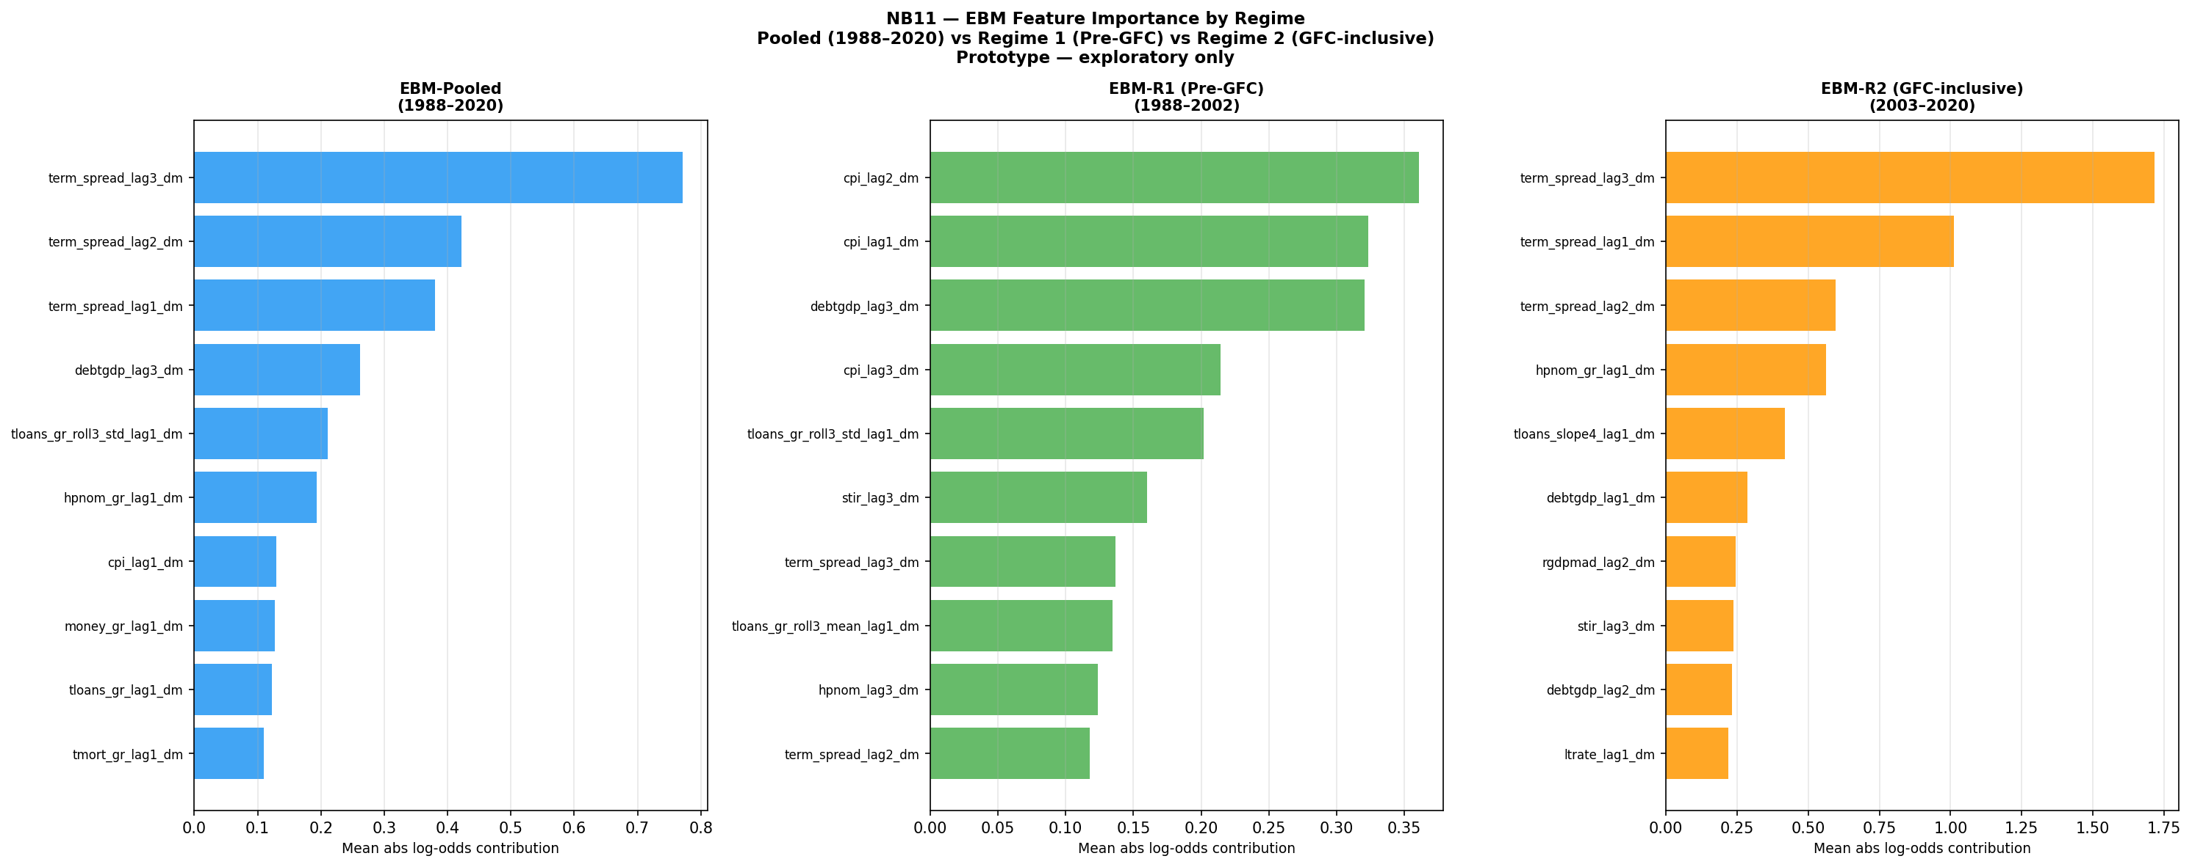
Figure B.1. EBM feature importance by regime — full-sample diagnostic fits. Left: EBM-Pooled (1988–2020), term spread dominates at all lags. Centre: EBM-R1 Pre-GFC (1988–2002), CPI and debt-to-GDP displace term spread as leading features. Right: EBM-R2 GFC-inclusive (2003–2020), term spread dominates consistent with GFC dynamics. The feature hierarchy shift between Pooled and R1 is the primary empirical finding of the prototype. Prototype — exploratory only.

B.5 Shape Function Analysis
Figure B.2 extends the shape function comparison of Figure 4.7 to three model configurations: EBM-Pooled, EBM-R1 (Pre-GFC), and EBM-R2 (GFC-inclusive). All three are full-sample diagnostic fits as defined in Section B.4. The three panels show the learned log-odds contribution of term_spread_lag3_dm, term_spread_lag2_dm, and term_spread_lag1_dm across the demeaned feature value range.
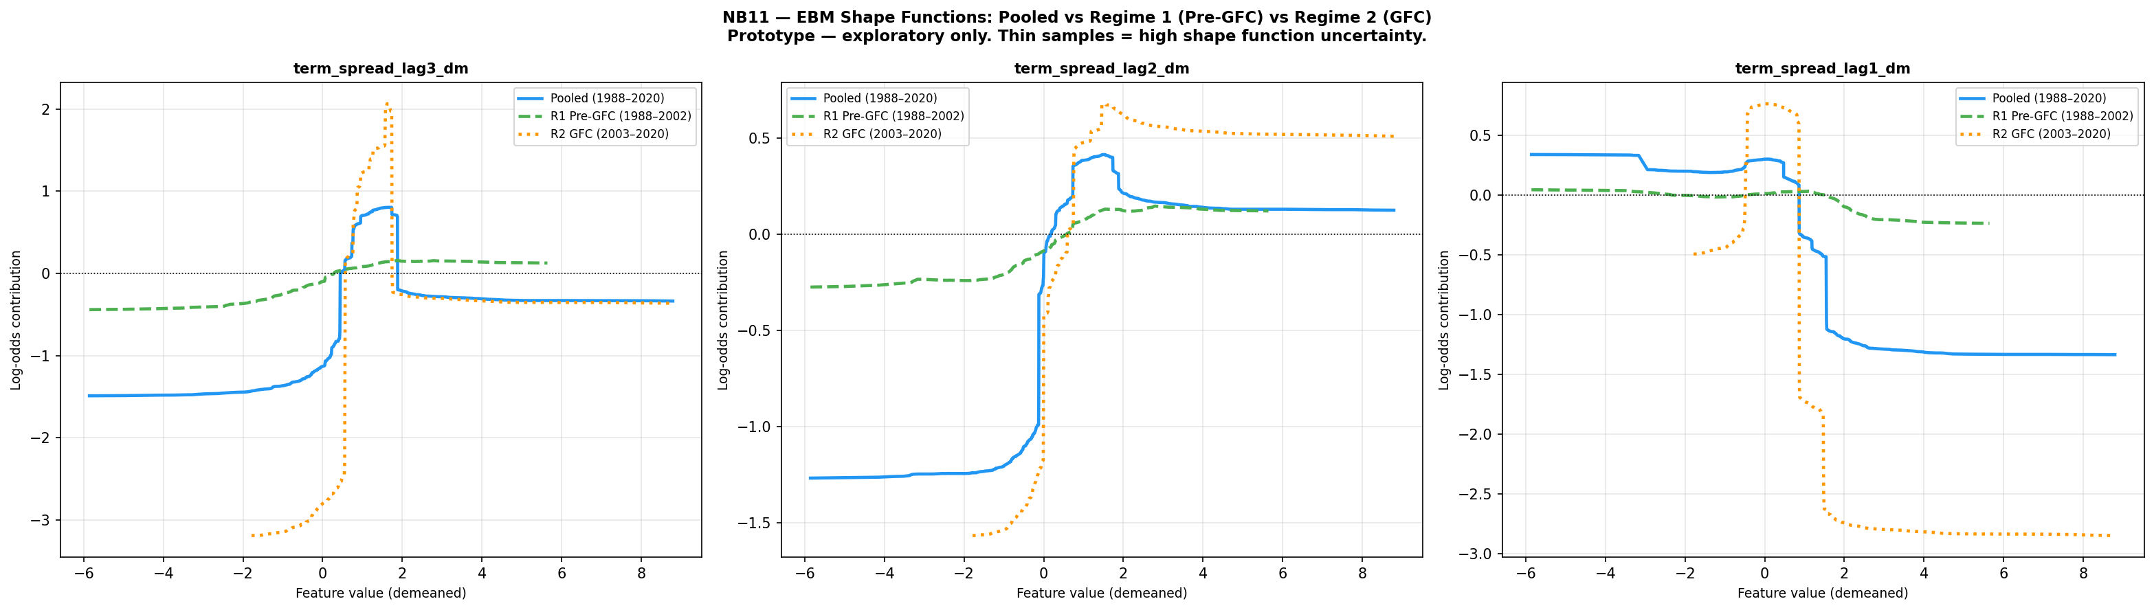
Figure B.2. EBM shape functions for term spread (lags 1–3): Pooled (blue solid), R1 Pre-GFC (green dashed), R2 GFC-inclusive (orange dotted). All three lags show near-zero R1 curves and high-amplitude R2 curves, consistent with term spread carrying no crisis signal in the pre-GFC regime and extreme non-linear signal in the GFC regime. Full-sample diagnostic fits — see Section B.4 note on model scope. Prototype — exploratory only; thin regime samples imply high shape function uncertainty.
B.5.1 Interpretation
The shape function divergence across the three configurations is the strongest visual evidence produced by the prototype. For all three lags of term spread, the EBM-R1 curve (green dashed) is near-flat across the full feature value range, with log-odds contributions close to zero. Term spread carries effectively no crisis-predictive signal in the pre-GFC regime. The EBM-R2 curve (orange dotted) shows extreme amplitude: for term_spread_lag1_dm, the contribution swings from approximately +0.5 to −3.0 log-odds, a 3.5-unit amplitude. The pooled model (blue solid) inherits a shape intermediate between these two extremes, dominated by the GFC signal because that regime contributes the majority of positive cases in the full-sample pooled fit.
This pattern directly extends the finding of Figure 4.7, where the pre-GFC and GFC-inclusive EBM curves diverge for term spread. The prototype adds a third configuration and confirms that the near-zero pre-GFC sensitivity is not an artefact of comparing two overlapping training windows: it is also observed in the EBM trained exclusively on pre-GFC data. The shape function instability is not symmetric — the pre-GFC regime is insensitive to term spread, while the GFC regime is extremely sensitive to it in a highly non-linear, threshold-driven manner. A pooled model cannot represent both structures simultaneously without misspecifying one or both.

B.6 Conclusion
The prototype produces three findings, each consistent with and supportive of the dissertation’s core argument. First, all regime-specific models fail the 0.75 AUROC benchmark and all AUPRC values fall below the 0.667 no-skill precision-recall baseline on the 2006–2007 GFC test set; EBM-R1 achieves identical AUROC to EBM-Pooled (0.410), supporting the interpretation that pre-GFC training data does not provide a transferable crisis-prediction signal for the GFC regime.
Regime-conditional training does not resolve the prospective failure whe the available crisis positives per regime are insufficient to reliably estimate the feature-risk mapping. Second, the feature hierarchy shift between EBM-Pooled and EBM-R1 — from term spread dominance to CPI and debt dominance — provides suggestive empirical evidence that the crisis-generating mechanism differs structurally across regimes. The pooled model learns a distribution dominated by GFC-era observations that is likely to misrepresent the pre-GFC crisis signature. Third, the shape function comparison shows that term spread carries near-zero predictive signal in the pre-GFC regime and extreme non-linear signal in the GFC regime; a pooled model cannot represent both structures simultaneously without misspecifying one or both. Together, these findings support the conclusion stated in Section 5.7: regime-conditional modelling is conceptually well motivated and empirically supported as a future research direction, but its implementation is constrained by the scarcity of crisis episodes per regime in the current panel. Resolving this constraint — through a longer historical panel or an alternative multi-country crisis database — remains the most impactful direction for future research.

References
Beutel, J., List, S. and von Schweinitz, G. (2019) ‘Does machine learning help us predict banking crises?’, Journal of Financial Stability, 45, pp. 1–16.
Note: All other references cited in Appendix B appear in the main dissertation reference list. Holopainen and Sarlin (2017) is cited in the main text for ensemble methodology; the 0.75 AUROC benchmark in this appendix follows Beutel, List and von Schweinitz (2019) consistently with Chapter 4 (Table 4.4 caption).

