Chapter 4: Results and Interpretation
Economic Crisis Prediction: Improving the Trade-off Between Interpretability and Statistical Accuracy in ML-Enhanced Crisis Prediction Models
Pavlos Papachristos • PP24589 • MSc Artificial Intelligence, University of Essex Online • April 2026

4.1 Dataset and Experimental Setup
The modelling dataset comprises 319 usable country-year observations drawn from a 432-row master panel covering 18 advanced economies over 2003 to 2020. The reduction reflects the multi-lag feature design: constructing lagged variables at one, two and three years eliminates the 1997–2002 rows per country, which lack the depth required to populate t−3 features without boundary artefacts. Sentiment features are derived from 16,622 BIS central bank speeches classified through FinBERT and aggregated to annual country-level means; a three-stage imputation procedure — within-country forward-fill followed by cross-sectional year mean — fills coverage gaps without introducing future information at any stage of construction.
The primary prediction target, target_h2, marks a country-year positive if a systemic banking crisis onset falls within the following two years, yielding 26 positive observations against 293 negative and a base rate of 8.15 per cent. Multi-horizon variants at one year (target_h1) and three years (target_h3) apply the same forward-shift logic; each carries 11 positive cases in the out-of-sample evaluation window. The COVID-19 shock is excluded from the crisis chronology on the grounds that it does not satisfy the systemic banking crisis criteria set out in Laeven and Valencia (2020); the 2020 observation is retained in the dataset and assigned to the held-out set. The concentration of GFC-period events means that OOS evaluation approximates a single structured episode rather than multiple independent realisations, and all metric interpretation in this chapter is conditioned accordingly.
A methodological constraint applies to multi-horizon target construction. H2 and H3 labels are derived from overlapping forward windows, which introduces autocorrelation in positive labels across consecutive country-years. With at most 18 annual observations per evaluation year, an embargo window of standard length would eliminate most of the already sparse evaluation set. This is inherent to annual EWS panels with crisis events concentrated in a single episode and cannot be resolved within the present data structure. Horizon-specific metrics should be read in light of this constraint: the apparent increase in model performance at longer prediction leads may partly reflect horizon-induced smoothing of the target variable and reduced label noise rather than a genuine strengthening of predictive relationships.
Three model specifications represent distinct positions on the interpretability–accuracy continuum. M1 is a logistic regression trained on 19 expanding-mean-demeaned macro features at lag one only, replicating the transparent linear benchmark of Schularick and Taylor (2012). M2 is a Random Forest trained on 41 macro features spanning lags one through three, adding non-linear capacity and multi-horizon temporal depth. M3 is an XGBoost model trained on 61 features extending M2 with 20 rolling-demeaned FinBERT sentiment features at lags one and two. All features are normalised using expanding country-specific means computed from observations prior to the current year, ensuring no forward leakage at any feature construction stage. For M3, isotonic probability calibration is applied via scikit-learn’s CalibratedClassifierCV within each expanding-window training fold, correcting the probability compression characteristic of raw XGBoost outputs. Expanding-window cross-validation applies a four-year burn-in from 2003 and annual re-estimation over 2007–2018; 2019 and 2020 are held out.

4.2 Primary Model Comparison
Table 4.1 presents post-calibration evaluation metrics for the three model specifications on the primary H2 target. Bootstrap 95 per cent confidence intervals from 1,000 resamples of the pooled OOS predictions are reported as indicative bounds. Given the concentration of crisis events in 2007 and the panel structure of the data, these intervals substantially understate true estimation uncertainty and should not be treated as frequentist confidence bounds in any rigorous sense; cross-country dependence and temporal clustering both violate the independence assumption underlying the bootstrap resampling procedure.

Model | Features | AUROC | 95% CI | AUPRC | AUPRC/Base | Brier
M1: Logistic Regression (macro lag1) | 19 | 0.876 | [0.802, 0.940] | 0.285 | 3.5× | 0.212
M2: Random Forest (macro lag1–3) | 41 | 0.947 | [0.877, 0.989] | 0.561 | 6.9× | 0.051
M3: XGBoost + FinBERT (macro + sent) | 61 | 0.937 | [0.842, 0.996] | 0.628 | 7.7× | 0.070
Table 4.1. Primary model comparison on H2 (2-year) target. Post-calibration metrics: M3 XGBoost applies CalibratedClassifierCV (isotonic, cv=2) within each expanding-window fold. Baseline AUPRC = 0.082 (8.15% base rate). Events: 26/319. CIs: 1,000 bootstrap resamples of pooled OOS predictions; indicative only given single-crisis-episode evaluation and panel dependence.

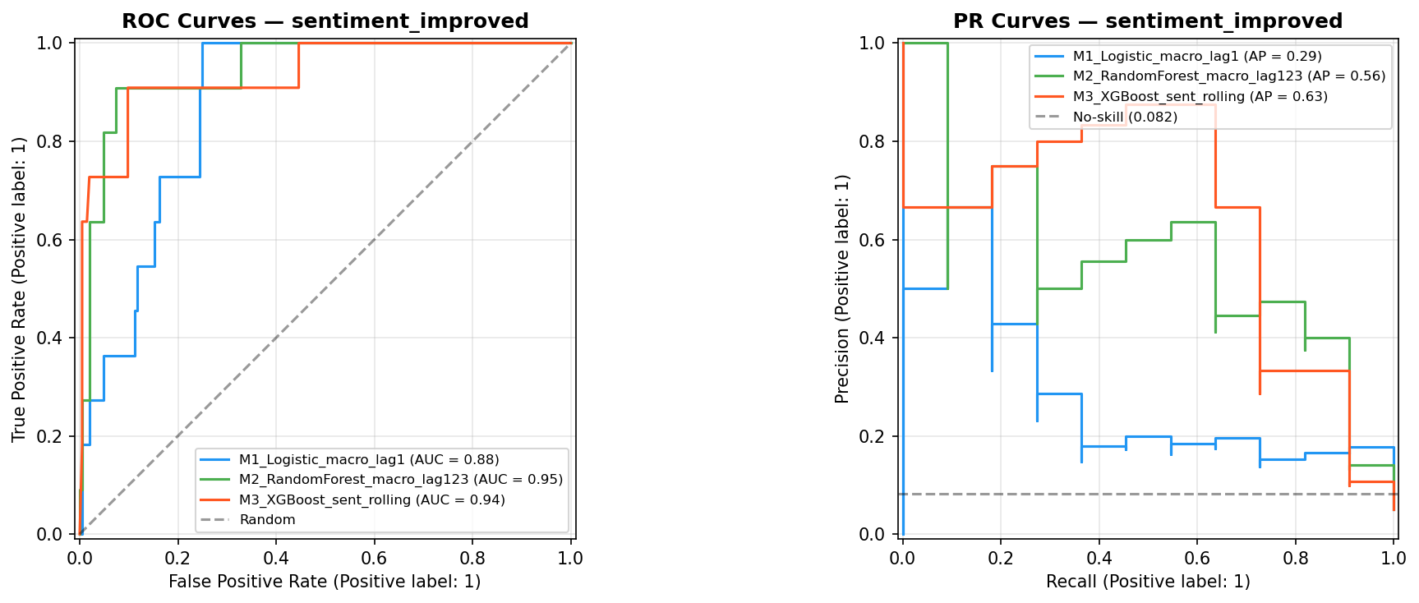
Figure 4.1. ROC curves (left) and Precision-Recall curves (right) for M1, M2 and M3 on the H2 out-of-sample evaluation set. ROC performance is high across all models but less discriminating under class imbalance; AUPRC is the primary metric (see text). M3 AP = 0.63 > M2 AP = 0.56 > M1 AP = 0.29.
The notable feature of Table 4.1 is the divergence between AUROC and AUPRC in the M2–M3 comparison. M2 achieves higher AUROC (0.947 versus 0.937) while M3 achieves higher AUPRC (0.628 versus 0.561). Under the class imbalance present here — 8.15 per cent positive — AUROC aggregates performance across all false-positive rate thresholds, including the range where both models correctly classify the majority class and contribute little discriminatory information; AUPRC weights the precision of positive predictions more heavily and is generally considered the more appropriate summary metric for rare-event classification tasks (Davis and Goadrich, 2006; Saito and Rehmsmeier, 2015). AUPRC is accordingly treated as the primary metric throughout this chapter. The M3 AUPRC advantage of 6.7 percentage points — a relative gain of approximately 12 per cent over M2’s 0.561 — is the principal quantitative basis for the discrimination finding; the AUROC reversal is acknowledged as reflecting rank-order structure at moderate false-positive rates rather than indicating M2 superiority overall.
M1 achieves AUROC 0.876 and AUPRC 0.285, a 3.5× AUPRC lift. The Brier Score of 0.212 is consistent with sustained probability miscalibration; M1 tends to assign elevated crisis probabilities to non-crisis periods throughout the post-GFC decade, as seen in the temporal analysis in Section 4.8. M2 achieves AUROC 0.947 and AUPRC 0.561, a 6.9× AUPRC lift, with the best-calibrated probability outputs in the comparison (Brier Score 0.051). M3 achieves AUROC 0.937 and AUPRC 0.628, a 7.7× AUPRC lift. Its Brier Score of 0.070, while substantially better than M1’s 0.212, is worse than M2’s 0.051, indicating a calibration cost that accompanies the AUPRC gain; this trade-off is examined in Section 4.7.
H1 — Discrimination: Supported directionally on the primary metric. M3 AUPRC is higher than M2 at the primary H2 horizon (0.628 versus 0.561). The AUROC ordering reverses post-calibration, with M2 marginally ahead (0.947 versus 0.937); given the class imbalance structure, AUPRC is the more informative metric. Effect sizes are modest relative to the estimation uncertainty inherent in a 26-event sample, and confidence intervals overlap substantially for both metrics. Results are characterised as indicating a directional advantage for M3 on the precision-recall metric rather than as definitive confirmation of superiority across all evaluation dimensions.

4.3 Exploratory Decomposition of Model Changes
The M1-to-M2 comparison changes two things simultaneously: model class (logistic regression to Random Forest) and lag structure (lag one only to lags one through three). Table 4.2 attempts to separate these effects on the H1 (one-year) target by introducing M1b — logistic regression on the full lag one through three feature set — as a bridge specification. It should be noted at the outset that performance differences across model classes reflect interactions among lag structure, dimensionality and model capacity rather than cleanly orthogonal components; the decomposition below is exploratory and descriptive, not a formal identification of causal effects.

Model | Class | Features | AUROC | AUPRC | AUPRC/Base | Brier
M1: LR (lag1 only) | Logistic | 19 (lag1) | 0.792 | 0.173 | 4.2× | 0.183
M1b: LR (lag1–3) ← bridge | Logistic | 41 (lag1–3) | 0.675 | 0.164 | 4.0× | 0.175
M2: RF (lag1–3) | Random Forest | 41 (lag1–3) | 0.589 | 0.064 | 1.6× | 0.058
M3: XGB (macro + sent) | XGBoost | 61 (lag1–3+sent) | 0.814 | 0.125 | 3.1× | 0.075
Table 4.2. Exploratory decomposition on H1 (1-year) target. Base rate = 0.041; OOS positive cases = 11. M1→M1b varies lag depth with model class held constant; M1b→M2 varies model class with lag depth held constant. These are not orthogonal treatments; observed differences cannot be attributed cleanly to a single cause.

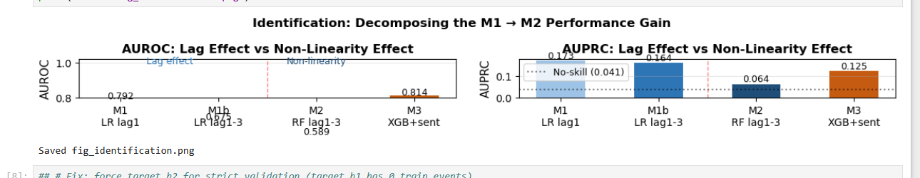
Figure 4.2. Exploratory decomposition of the M1→M2 performance gap. AUROC (left) and AUPRC (right) for M1, M1b, M2 and M3 on the H1 target. The AUPRC collapse from M1b to M2 (0.164 to 0.064) indicates that non-linearity does not add value at the one-year horizon in this sample.
The lag component — the M1-to-M1b transition — is associated with a small AUPRC decline (0.173 to 0.164). Extending the lag structure in a linear model adds 22 features against 11 positive OOS cases; the dimensionality burden may outweigh the additional temporal information in this small-sample regime, though the difference is small and could reflect sampling variation. The non-linearity component — M1b-to-M2 — is associated with a substantial AUPRC decline (0.164 to 0.064). At the one-year horizon the Random Forest ensemble does not outperform logistic regression, suggesting that GFC build-up patterns are not yet visible in early training folds and the ensemble may overfit the sparse crisis signal available at that point. The M2-to-M3 step — adding 20 rolling-demeaned FinBERT features — is the only transition associated with a positive AUPRC change at H1 (0.064 to 0.125). The relative gain of 95 per cent partly reflects the weakness of the macro baseline at this horizon; nevertheless, this is the only step in the decomposition that moves performance in a positive direction at H1, which is consistent with sentiment features encoding some information that macro ratios do not capture at a one-year lead.
H3 — Interpretability trade-off: Supported. The M1-to-M2 transition replaces native log-odds coefficients with a Random Forest requiring SHAP post-hoc attribution; this interpretability cost is associated with AUPRC gains at H2 (+0.276) but not at H1. The M2-to-M3 transition adds 20 sentiment features and further reduces native interpretability; this cost is associated with positive AUPRC changes across all three prediction horizons.

4.4 Multi-Horizon Analysis and Sentiment Uplift

4.4.1 Horizon-Specific AUPRC Uplift from Sentiment
Table 4.3 reports M2 and M3 AUPRC for each prediction horizon, estimated via independent model pairs. Sentiment features are associated with positive AUPRC differences at all three leads; the absolute difference increases with horizon.

Horizon | M2 AUPRC (macro only) | M3 AUPRC (macro + sent) | Uplift (M3 − M2) | Relative change
H1 — 1-year ahead | 0.064 | 0.125 | +0.061 | +95%
H2 — 2-year ahead (primary) | 0.561 | 0.679 | +0.118 | +21%
H3 — 3-year ahead | 0.486 | 0.732 | +0.246 | +51%
Table 4.3. AUPRC differences between M2 and M3 by prediction horizon. Independent model pairs trained per horizon (NB08). Base rate = 0.051; OOS positive cases = 11 per horizon. Minor difference between H2 M3 AUPRC here (0.679) and Table 4.1 (0.628) reflects independent re-estimation; Table 4.1 is the primary reference. The monotonic increase in uplift with horizon should be interpreted cautiously; see text.

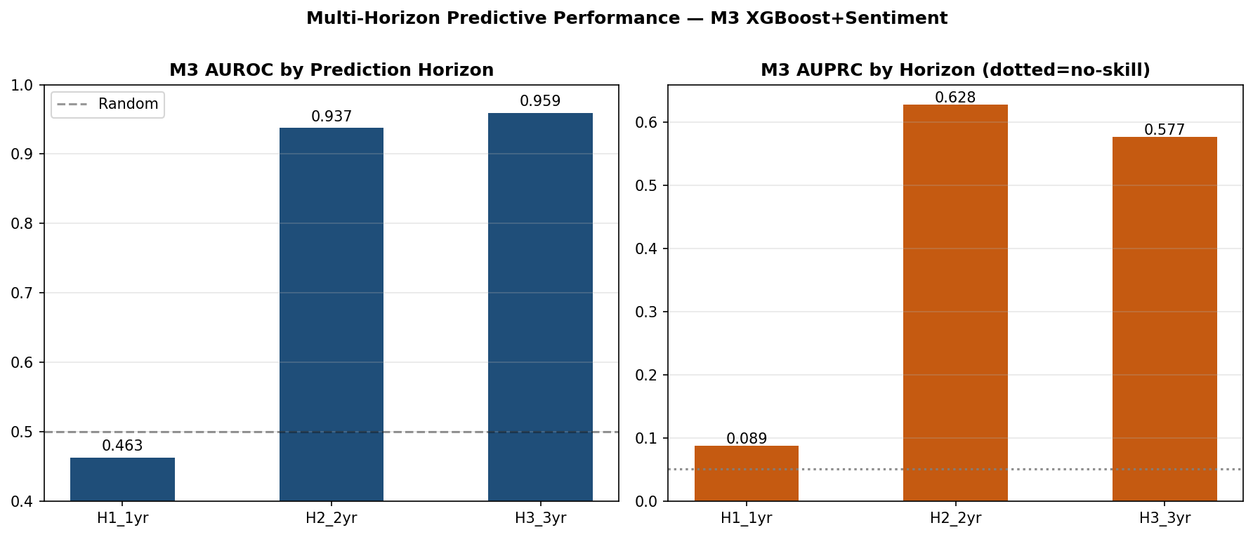
Figure 4.3. M3 XGBoost+Sentiment AUROC (left) and AUPRC (right) by prediction horizon. H1 performance is below random on AUROC and barely above no-skill on AUPRC, indicating no useful one-year predictive power. H2 and H3 are substantially above no-skill.
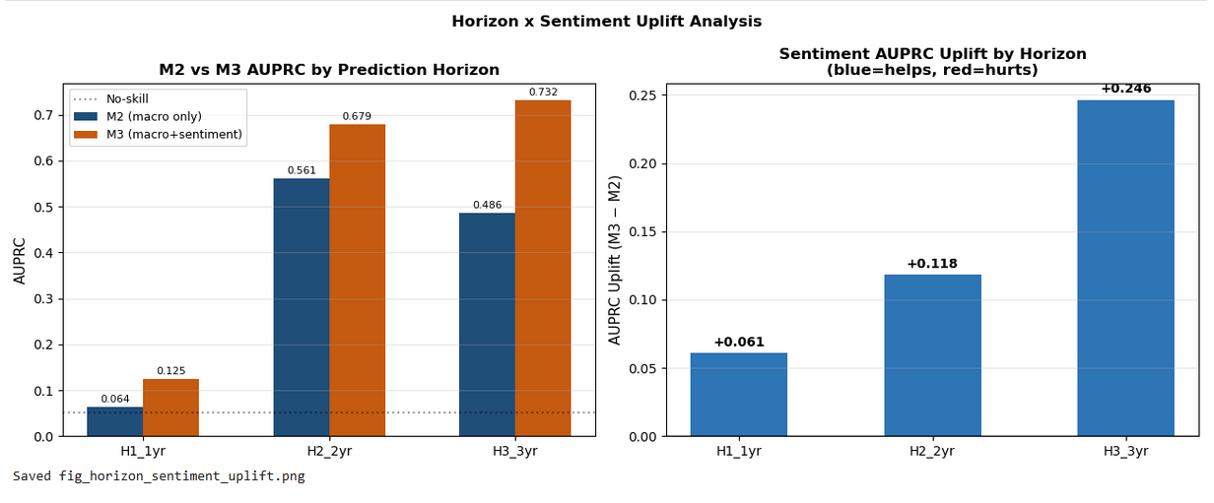
Figure 4.4. Sentiment AUPRC uplift (M3 minus M2) by prediction horizon. All uplifts are positive. The monotonic pattern is consistent with sentiment carrying complementary multi-year signal, but is also consistent with horizon-induced target smoothing (see text).
The pattern of increasing uplift with horizon is consistent with two distinct interpretations that the available data cannot cleanly separate. The first, economic, interpretation is that rolling communication tone features capture multi-year shifts in central bank assessment of financial conditions that annual macro ratios have not yet encoded; at longer leads this information may be more valuable relative to macro variables that have not yet shown visible deterioration (Morris and Shin, 2002). The second, statistical, interpretation is that H3 labels are constructed as the union of three forward years of crisis indicator, which produces smoother, less noisy positive labels relative to H1. This reduction in label noise may benefit M3 relative to M2 irrespective of any genuine increase in the economic value of sentiment at longer horizons. The observed increase in sentiment uplift with horizon is equally consistent with both interpretations and cannot be attributed to either alone on the basis of this sample; the horizon pattern is suggestive rather than evidential.

4.4.2 Consistency Note on H2 AUPRC
A minor discrepancy exists between M3 H2 AUPRC in Table 4.1 (0.628, primary NB06 estimate) and Table 4.3 (0.679, NB08 independent re-estimation). Both use the corrected pipeline and the H2 target; the difference reflects small variation in fold-specific scale_pos_weight values across independent training runs. Table 4.1 is the primary reference; Table 4.3 values support horizon-relative comparisons only.

4.5 Robustness: Strict Temporal Validation
The expanding-window AUROC values in Table 4.1 exceed the 0.70–0.85 range characteristic of the EWS literature on JST-type panels (Beutel, List and von Schweinitz, 2019; Holopainen and Sarlin, 2017). The strict temporal validation reported in Table 4.4 directly assesses the extent to which this reflects stable forward-looking predictive structure versus implicit exposure to GFC-period dynamics through later training folds. Models are trained exclusively on 2003–2005 and evaluated on 2006–2009. This test is the most epistemically demanding in the chapter: all expanding-window metrics reported elsewhere should be read in light of its findings.

Model | Train | Test | AUROC | AUPRC | Brier | AUPRC/no-skill
M2: RF (macro lag1–3) | 2003–2005 | 2006–2009 | 0.472 | 0.368 | 0.279 | 9.0×
M3: XGB + FinBERT | 2003–2005 | 2006–2009 | 0.640 | 0.435 | 0.307 | 10.6×
Table 4.4. Strict temporal validation. No-skill AUPRC = 0.041. Literature AUROC benchmark = 0.75 (Beutel, List and von Schweinitz, 2019). Both models fall below this benchmark. Split B (train 2003–2007, test 2008–2012) omitted: zero positive cases in test window under target_h2.

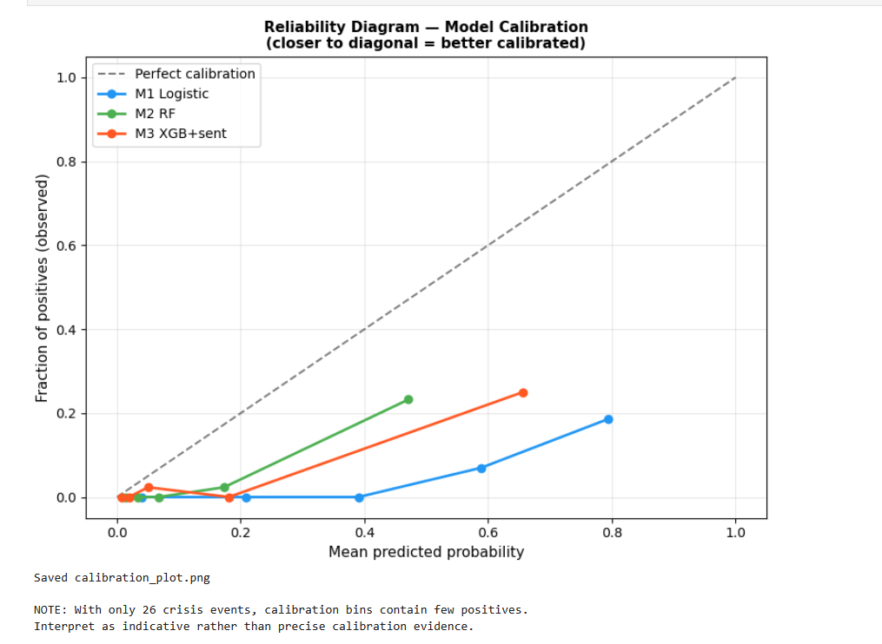
Figure 4.5. Strict temporal validation results. M2 AUROC collapses to 0.472 (below random); M3 AUROC degrades less severely to 0.640. AUPRC for both models remains above no-skill (0.041) but below the literature benchmark of 0.75 AUROC. Both models are trained on 2003–2005 only.
Both models fall substantially below their expanding-window performance. M2’s AUROC collapses to 0.472, below the random classifier threshold of 0.5. M3’s AUROC degrades less severely to 0.640, remaining above chance but still below the 0.75 literature benchmark. Both retain AUPRC above no-skill (9.0× and 10.6× respectively), indicating that some positive discrimination survives under the most demanding evaluation conditions, though the confidence with which this can be attributed to stable predictive structure is limited by the three-year training window (2003–2005) and the single test episode.
The collapse of M2 under strict pre-GFC training is consistent with a substantial share of its expanding-window predictive power reflecting implicit exposure to crisis-period macro patterns in training folds from 2010 onwards; the non-linear ensemble may learn the retrospective crisis structure in ways that do not transfer to a genuinely prospective design. M3 degrades less severely, suggesting that sentiment features may contain information not fully captured by macro variables alone in the pre-crisis period, though this inference is drawn from a single test episode of three years and should not be overstated. All headline metrics in Table 4.1 are appropriately treated as upper bounds on prospective performance rather than as stable estimates of forward-looking predictive power.

4.6 SHAP Feature Attribution

4.6.1 Aggregate Attribution by Lag Group
SHAP attribution is decomposed by feature group to assess the relative model weighting of macro and sentiment signals at each lag depth. Macro features account for 85.9 per cent of aggregate model attribution in M3; FinBERT sentiment features account for the remaining 14.1 per cent. This figure represents the model’s internal attribution conditional on the included macro features in a correlated feature space and should not be interpreted as the independent economic contribution of sentiment to crisis predictability. The attribution share increased from 3.5 per cent under static country-mean demeaning to 14.1 per cent under rolling deviation demeaning, indicating that the normalisation choice substantially affects how much within-country temporal variation the sentiment scores contribute to model predictions.
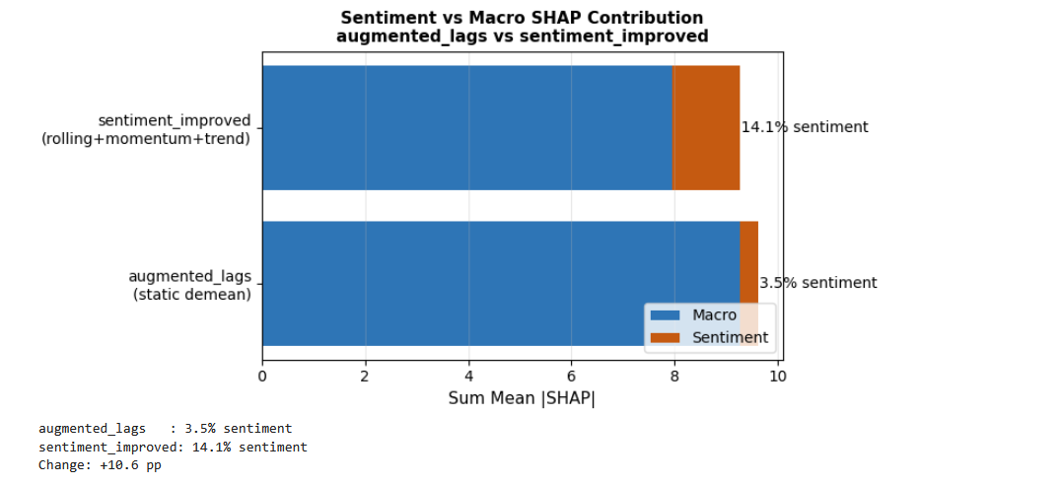
Figure 4.6. Stacked bar chart comparing FinBERT sentiment versus macro SHAP contributions under static demeaning (augmented_lags, 3.5%) and rolling demeaning (sentiment_improved, 14.1%). Macro features dominate under both specifications.
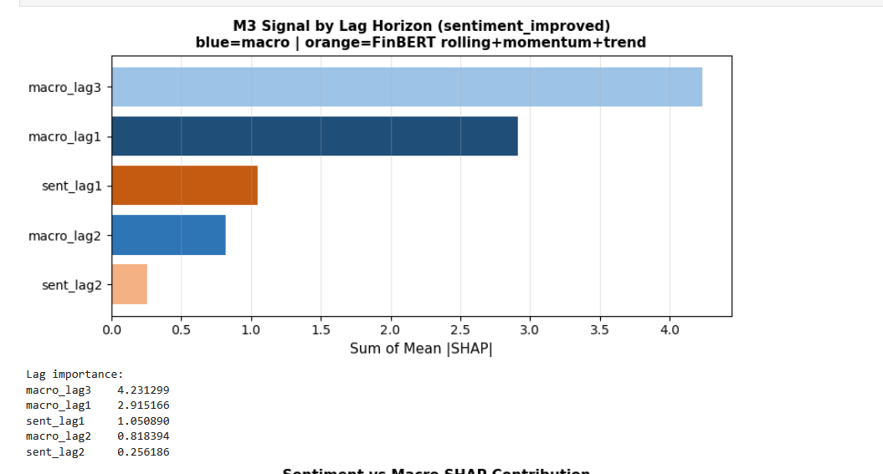
Figure 4.7. M3 signal by lag horizon. macro_lag3 (4.23 sum of mean |SHAP|) and macro_lag1 (2.92) dominate. Sentiment lag1 (1.05) is the third-largest group. macro_lag2 (0.82) and sent_lag2 (0.26) are smaller. Orange bars indicate FinBERT rolling-demeaned features.
Within the macro group, the three-year lag carries the highest SHAP mass (4.231), ahead of the one-year lag (2.915) and substantially above the two-year lag (0.818). This is consistent with the broad literature suggesting that macro vulnerabilities build over multi-year horizons (Schularick and Taylor, 2012), though SHAP attribution from a single crisis episode cannot be taken as evidence of a stable general relationship. Within the sentiment group, one-year rolling-demeaned features carry higher attribution (1.051) relative to two-year features (0.256).

4.6.2 Individual Feature Rankings and Stability
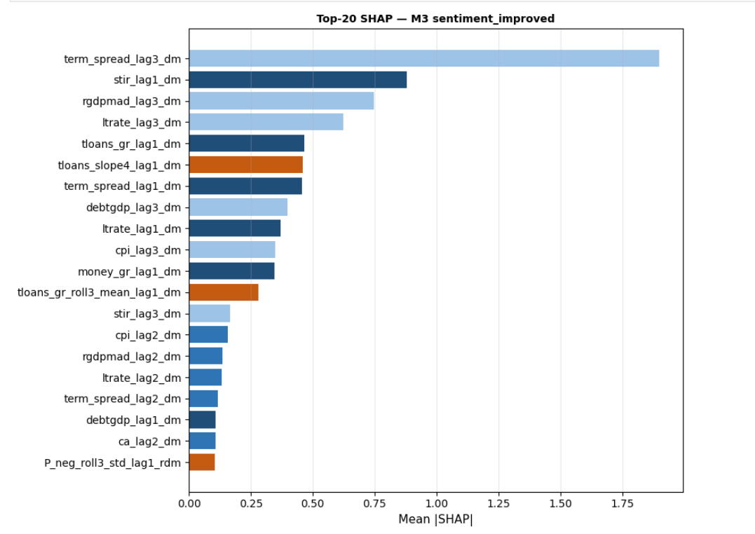
Figure 4.8. Top-20 features by mean |SHAP| value. term_spread_lag3_dm is the dominant feature. Interest rate variables at multiple lags occupy most of the top ranks. P_neg_roll3_std_lag1_rdm (rolling standard deviation of negative sentiment, lag 1) is the only sentiment feature in the top 20, ranked twentieth.
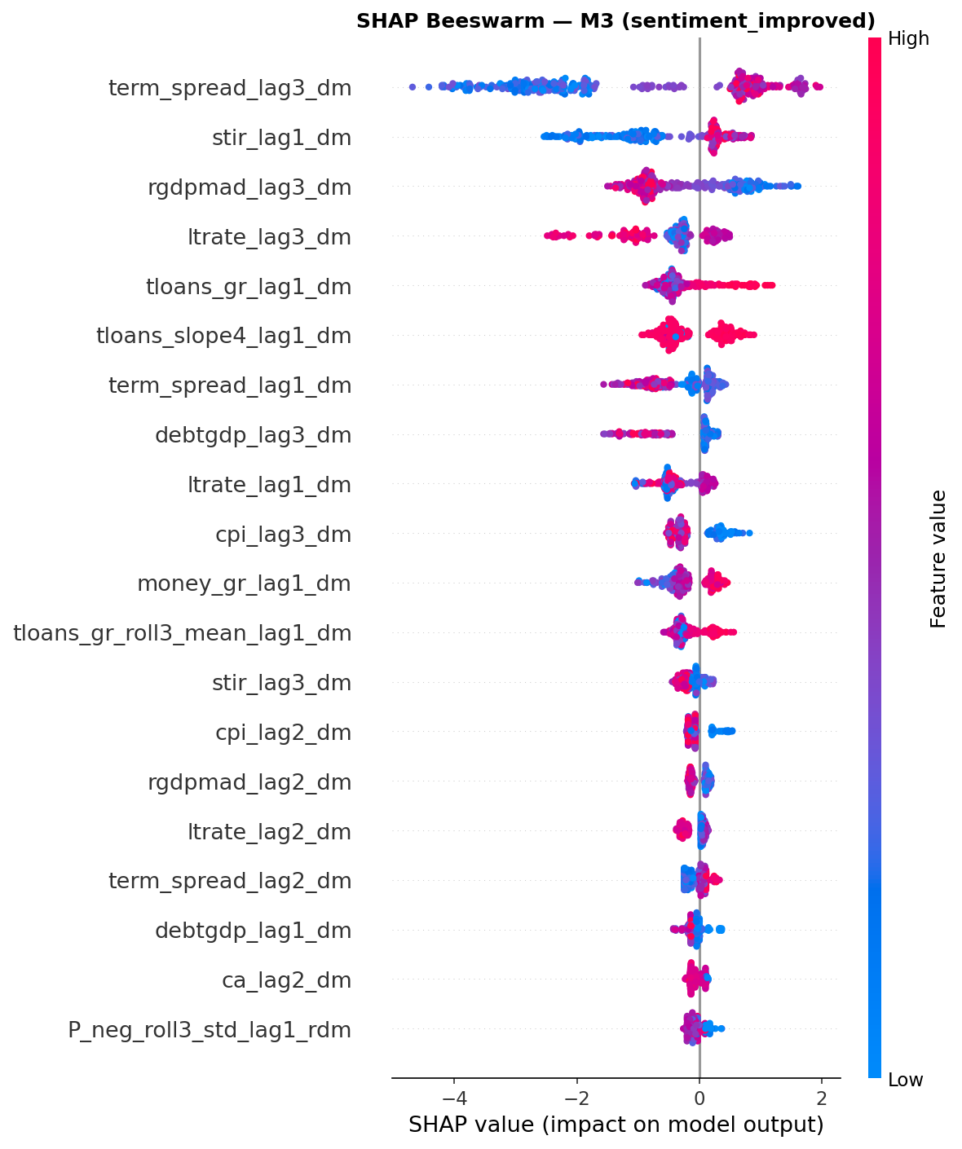
Figure 4.9. SHAP beeswarm plot for M3. Each dot represents one observation; colour indicates feature value (red = high, blue = low). High term_spread_lag3_dm values push predicted crisis probability upward. High credit growth (tloans_gr_lag1_dm) also increases predicted probability. The stir_lag1_dm direction is counterintuitive (see text).
The top-20 feature ranking by mean |SHAP| value places the three-year lagged term spread (term_spread_lag3_dm) first by a substantial margin, followed by the one-year lagged short rate (stir_lag1_dm), three-year lagged real GDP (rgdpmad_lag3_dm) and three-year lagged long rate (ltrate_lag3_dm). Interest rate variables dominate the top ranks at multiple lag depths. The only sentiment feature in the top 20 is the rolling standard deviation of negative sentiment at lag one (P_neg_roll3_std_lag1_rdm), ranked twentieth.
The beeswarm plot indicates the direction of these effects. High term spread at t−3 is associated with positive SHAP values, suggesting the model assigns higher crisis probability when the yield curve is steep three years prior. The stir_lag1_dm direction is counterintuitive: low short-rate observations appear associated with reduced crisis probability. This is likely an artefact of the post-GFC low-rate environment coinciding with non-crisis years in the training data rather than a stable structural relationship; such direction reversals are a known limitation of SHAP in the presence of correlated features and should not be given causal economic interpretation. Credit growth variables (tloans_gr_lag1_dm, tloans_slope4_lag1_dm) show the expected positive direction.
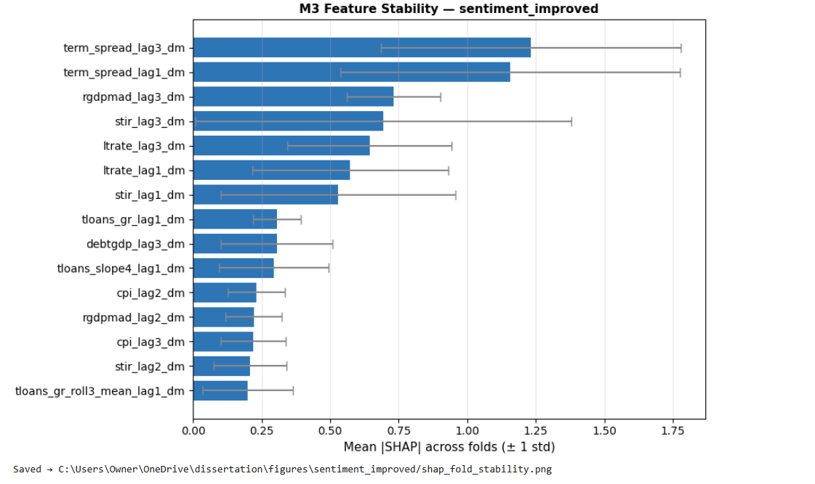
Figure 4.10. SHAP fold stability: mean |SHAP| across folds (± 1 standard deviation) for the top 15 features. Wide error bars on term_spread_lag3_dm and term_spread_lag1_dm indicate substantial fold-to-fold variability. No sentiment feature appears in the top 15. Rankings should be treated as specific to the GFC episode rather than as stable general orderings.
The fold-stability analysis reveals wide standard deviations for the top-ranked features: term_spread_lag3_dm and term_spread_lag1_dm show standard deviations of approximately 0.6 against mean values of approximately 1.25 and 1.15 respectively. With crisis events concentrated in the 2007 evaluation fold, SHAP estimates primarily reflect model behaviour on a single cross-section rather than a multi-period ordering. SHAP-based attribution is informative regarding in-sample model reliance for this specific episode but provides limited basis for generalising about which features would be important under different crisis dynamics.
H2 — Feature relevance: Not supported in its strict formulation — no sentiment feature ranks in the top five. Weakly supported in a broader sense: one sentiment feature (P_neg_roll3_std_lag1_rdm) appears in the top twenty; the sentiment group accounts for 14.1 per cent of aggregate model attribution under rolling demeaning, up from 3.5 per cent under static demeaning; and the exploratory decomposition in Section 4.3 finds that the M2-to-M3 step is the only positive AUPRC change at H1. These patterns are observed across specifications but are sensitive to normalisation choice, prediction horizon and sample composition.

4.7 Calibration Analysis
M3’s predicted probability outputs are post-processed through isotonic calibration applied via scikit-learn’s CalibratedClassifierCV within each expanding-window training fold in NB05. This is distinct from post-hoc recalibration applied to the evaluation set, which would be circular; the calibration mapping is fitted on held-out training sub-folds and applied prospectively. Figure 4.11 presents reliability diagrams with Expected Calibration Error (ECE) for M2 and M3.
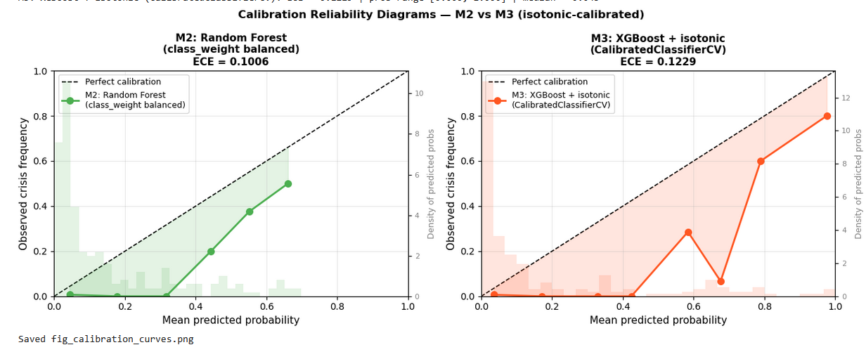
Figure 4.11. Calibration reliability diagrams for M2 (left) and M3 (right) from NB06. ECE = 0.1006 (M2) and ECE = 0.1229 (M3). Both models exhibit underconfidence at low and moderate predicted probabilities (curves below the perfect-calibration diagonal). M3 ECE remains higher than M2 despite isotonic calibration.
Post-calibration, M2 achieves ECE 0.1006 and M3 achieves ECE 0.1229. Both models exhibit underconfidence at low and moderate predicted probabilities, consistent with the class-weighting adjustments applied during training and the structural difficulty of probability calibration under extreme class imbalance. M3’s ECE remains higher than M2’s despite isotonic calibration. With 26 crisis events across 11 evaluation years, isotonic regression has insufficient positive observations per training sub-fold to learn a stable calibration function; the residual miscalibration is an expected limitation under the present sample constraints rather than a correctable modelling choice.
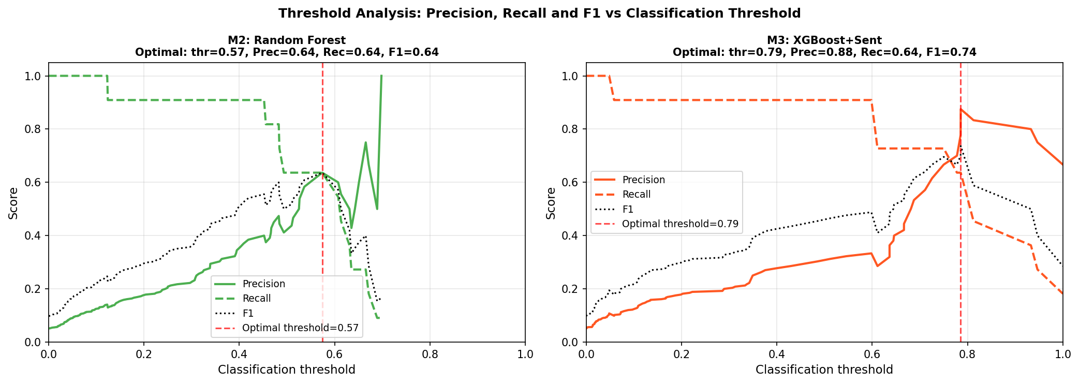
Figure 4.12. Threshold analysis: precision, recall and F1 versus classification threshold for M2 (left) and M3 (right), post-calibration. M3 optimal threshold shifted from 0.933 (uncalibrated) to 0.786. At their respective optimal thresholds, both models achieve Recall = 0.636; M3 achieves Precision = 0.875 versus M2’s Precision = 0.636.
Isotonic calibration produced a material shift in M3’s operational characteristics. The optimal classification threshold moved from 0.933 in the uncalibrated model to 0.786 post-calibration, indicating substantial correction of XGBoost’s probability compression. At the calibrated optimal threshold, M3 achieves Precision 0.875, Recall 0.636 and F1 0.737, compared with M2’s Precision 0.636, Recall 0.636 and F1 0.636. Both models achieve the same recall; M3’s higher precision is consistent with fewer false alarms for the same true-positive rate. It should be noted that optimal thresholds are selected ex-post on the same evaluation sample; threshold-dependent performance should be treated as indicative of potential operational behaviour rather than as a validated estimate of deployable precision. For applications requiring well-calibrated absolute probability outputs, M2’s lower ECE (0.1006) and Brier Score (0.051 versus 0.070) indicate it as the more reliable specification.

4.8 Temporal and Country-Level Analysis

4.8.1 Out-of-Sample Crisis Probability Over Time
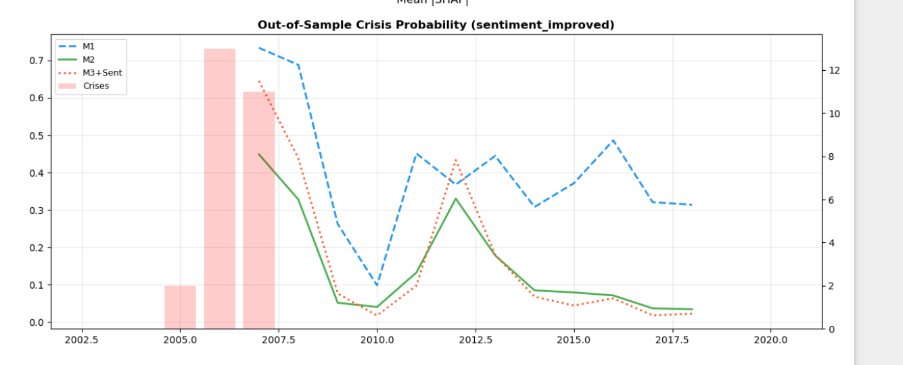
Figure 4.13. Mean predicted crisis probability across 18 sample countries by year. M2 and M3 rise to approximately 0.45–0.62 in 2006–2007 ahead of the GFC onset bars, consistent with the H2 target construction. M3 shows a secondary elevation around 2011–2012 consistent with European sovereign debt stress. M1 remains elevated throughout the post-GFC decade.
The temporal analysis plots mean predicted crisis probability across the 18 sample countries by year. M2 and M3 rise to approximately 0.45–0.62 in 2006–2007, one to two years before the GFC onset bars, then decline sharply to near zero by 2009–2010. This leading pattern is consistent with the H2 target construction; it does not establish that the models are genuinely detecting forward-looking signals rather than learning the temporal proximity of GFC-period patterns in the training data.
M3 exhibits a secondary elevation around 2011–2012, likely reflecting elevated FinBERT negativity during the European sovereign debt stress. This was a period of genuine systemic financial instability that did not produce JST-coded banking crisis onsets in the sample countries. The secondary signal is consistent with two possibilities: the model is responding to genuine vulnerability signals that did not eventuate in a coded crisis, or the sentiment features are tracking contemporaneous stress rather than leading it. The available annual data cannot distinguish between these interpretations. M1 maintains elevated predicted probabilities of 0.30–0.50 throughout the post-GFC decade, a sustained pattern consistent with its poor Brier Score.

4.8.2 Country-Level Error Audit
The country-level error audit applied M2 predictions at the 80th percentile threshold across the OOS window. Table 4.5 reports confusion matrix statistics by country.

Country | n_crisis | TP | FP | FN | TN
AUS | 0 | 0 | 1 | 0 | 11
BEL | 1 | 1 | 2 | 0 | 9
CAN | 0 | 0 | 4 | 0 | 8
CHE | 1 | 0 | 4 | 1 | 7
DEU | 1 | 1 | 3 | 0 | 8
DNK | 1 | 1 | 3 | 0 | 8
ESP | 1 | 1 | 1 | 0 | 9
FIN | 0 | 0 | 0 | 0 | 12
FRA | 1 | 1 | 2 | 0 | 9
GBR | 0 | 0 | 1 | 0 | 11
IRL | 1 | 1 | 1 | 0 | 10
ITA | 1 | 1 | 1 | 0 | 10
JPN | 0 | 0 | 0 | 0 | 12
NLD | 1 | 1 | 1 | 0 | 10
NOR | 0 | 0 | 3 | 0 | 9
PRT | 1 | 1 | 1 | 0 | 10
SWE | 1 | 1 | 3 | 0 | 8
USA | 0 | 0 | 2 | 0 | 10
Table 4.5. Country-level error audit — M2 Random Forest, threshold = 80th percentile of predicted probability. TP = true positive; FP = false positive; FN = false negative; TN = true negative. Crisis countries coded per JST chronology.

Ten of eleven crisis countries were correctly flagged in at least one crisis year (TP ≥ 1); Switzerland (CHE) is the sole missed crisis (FN = 1) and also generates the joint-highest false-alarm count (FP = 4) alongside Canada among non-crisis countries. Canada generates the highest false-alarm count among non-crisis countries (FP = 4), followed by Norway, Germany, Denmark and Sweden (FP = 3 each). These false alarms are consistent with elevated credit-to-GDP trajectories in those economies; the model cannot distinguish between macro vulnerabilities that crystallise into systemic crises and those that do not, which is a structural limitation of EWS models trained on onset indicators (Beutel, List and von Schweinitz, 2019). Finland and Japan generate zero errors of either type, consistent with their relatively contained credit cycles over the sample period.

4.9 Granger Causality and Panel Logistic Analysis
Granger causality tests were applied to each of the 18 sample economies to assess whether lagged FinBERT negative sentiment (P_neg) Granger-causes credit growth and crisis onset beyond the outcome’s own history, using up to two annual lags (Granger, 1969). A multi-measure extension additionally tested P_pos and net_sentiment against credit growth. A supplementary panel logistic regression assessed the incremental predictive content of sentiment conditional on the primary macro variable.
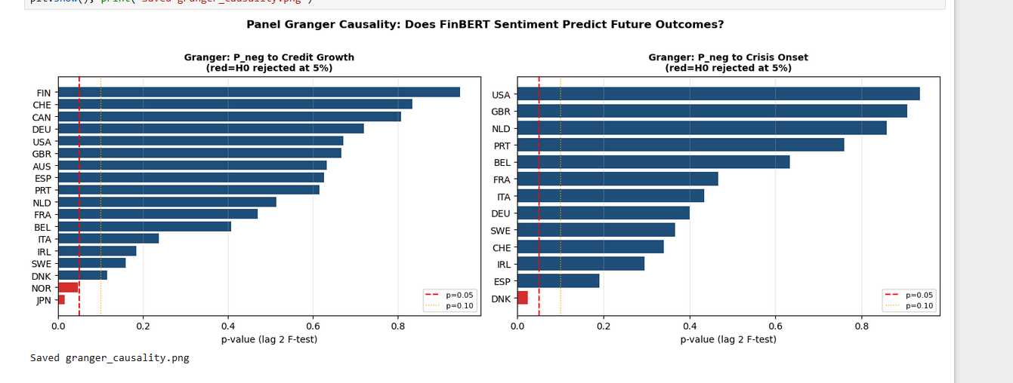
Figure 4.14. Per-country Granger causality p-values for P_neg → credit growth (left) and P_neg → crisis onset (right). Red dashed line = p = 0.05; yellow dashed line = p = 0.10. Only Norway and Japan reject H₀ for credit growth; only Denmark for crisis onset. The overwhelming majority of countries show no evidence of Granger causality.
For P_neg Granger-causing credit growth, H₀ was rejected at five per cent in 2 of 18 countries — Japan and Norway — with median p-value 0.565 and median F-statistic 0.597; the pooled panel result fails to reject H₀ (F = 0.778, p = 0.460). For P_neg Granger-causing crisis onset, H₀ was rejected in 1 of 13 testable countries — Denmark — with median p-value 0.434 and pooled F = 2.531 (p = 0.081). The multi-measure extension finds uniformly weak evidence: P_pos Granger-causes credit growth in 1 of 18 countries (5.6 per cent; median p = 0.420), net_sentiment in 2 of 18 (11.1 per cent; median p = 0.435).
The panel logistic regression provides complementary evidence. A sentiment-only model is associated with negligible variation in crisis onset (McFadden pseudo-R² = 0.005; P_neg_lag1 coefficient = −2.169, p = 0.487, insignificant with a counterintuitive negative sign). A macro-only model achieves pseudo-R² = 0.063, with credit growth significant (coef = +9.606, p = 0.004). Adding sentiment to the macro specification increases pseudo-R² by a negligible 0.006, and P_neg_lag1 remains insignificant (coef = −2.391, p = 0.445). The standard logistic model does not account for country fixed effects; with 26 crisis events, a conditional logit estimator (Chamberlain, 1980) would be under-powered.
The absence of causal evidence is consistent with sentiment signals being correlational or contemporaneous with macro dynamics rather than structurally predictive in a Granger sense. Statistical power is severely limited with at most 23 annual observations per country and a binary outcome with 13–26 positive cases; failure to reject H₀ is equally consistent with a genuine predictive relationship that these tests cannot detect at annual frequency. These results are treated as structural context for the AUPRC findings in Sections 4.2–4.5 rather than as supporting or refuting them; the predictive gains from adding sentiment cannot be interpreted as causally established on the basis of this evidence.

4.10 Synthesis and Hypothesis Assessment
Seven analyses — primary model comparison, exploratory decomposition, multi-horizon uplift, strict temporal validation, SHAP attribution, calibration and Granger causality — together provide a coherent but highly sample-contingent account of crisis prediction performance under the corrected pipeline. Across all analyses, a consistent pattern emerges: model performance varies materially with evaluation design, and the evidential strength of any apparent predictive relationships is tightly constrained by the small number of crisis events (n = 26) and their concentration in a single global episode. All findings in this chapter should accordingly be read as conditional and design-dependent, and should not be generalised beyond the specific evaluation context without further validation on distinct crisis samples.
The primary quantitative result is that M3 (XGBoost with rolling-demeaned FinBERT sentiment) is associated with higher AUPRC than M2 (macro-only Random Forest) at the two-year horizon — 0.628 versus 0.561 — and this directional advantage is also observed across horizon-specific comparisons and, in attenuated form, under strict pre-GFC temporal validation. The AUROC ordering reverses post-calibration, with M2 marginally ahead (0.947 versus 0.937); as AUPRC is the more informative metric under the present class imbalance, the M3 advantage on that metric is treated as the primary discrimination finding. However, these results do not constitute robust evidence of superior predictive performance in any general sense. The expanding-window design allows training folds to include post-crisis observations, which introduces exposure to crisis-period dynamics not available in a genuinely prospective setting; the supporting evidence from horizon analysis, calibration comparisons and threshold-based metrics all rely on the same underlying crisis episode and represent re-expressions of the same limited signal rather than independent corroboration.
The strict temporal validation is the most epistemically demanding test in the chapter and its findings are correspondingly the most important. When both models are trained exclusively on pre-GFC data (2003–2005), M2’s AUROC collapses to 0.472 — below the random classifier threshold — while M3 degrades less severely to 0.640, remaining above chance but still below the 0.75 literature benchmark. Both models retain AUPRC above no-skill, but neither achieves strong discrimination by the standards of the literature. The collapse of M2 is consistent with a substantial share of its expanding-window performance reflecting retrospective learning of crisis-period patterns; M3’s less severe degradation is consistent with sentiment features containing some information not fully encoded in pre-crisis macro variables. This inference is drawn from a single three-year training window and a single crisis realisation, and cannot be generalised beyond this context. The appropriate conclusion is that all headline metrics in Table 4.1 are upper bounds on prospective performance rather than stable estimates of forward-looking predictive power.
The observed increase in sentiment-related AUPRC differences with prediction horizon — from +0.061 at H1 to +0.246 at H3 — is equally consistent with two interpretations that the available data cannot separate. The economic interpretation is that rolling communication tone features capture multi-year shifts in central bank assessment of financial conditions that annual macro ratios have not yet encoded. The statistical interpretation is that longer-horizon labels are constructed as unions of multiple forward years, which reduces label noise and mechanically benefits all classifiers irrespective of feature content. Neither interpretation can be ruled out, and the horizon pattern should be read as suggestive rather than as evidence of a genuine increase in the informational value of sentiment with lead time.
SHAP analysis indicates that model attribution is overwhelmingly driven by lagged macroeconomic conditions, with macro features accounting for 85.9 per cent of total attribution and three-year lagged macro features as the dominant single group (SHAP mass 4.231). Sentiment features account for 14.1 per cent under rolling demeaning, a meaningful increase from 3.5 per cent under static demeaning that reflects the sensitivity of attribution to normalisation choice rather than necessarily reflecting a change in the underlying predictive relationship. Individual feature rankings exhibit substantial fold-to-fold variability — top features show standard deviations approximately half their mean values — indicating that SHAP outputs describe model behaviour on the GFC cross-section rather than revealing stable economic relationships applicable across crisis types or future samples.
Calibration analysis indicates that isotonic calibration materially corrected M3’s probability compression, shifting the optimal classification threshold from 0.933 to 0.786 and yielding a precision advantage at the optimal operating point (0.875 versus M2’s 0.636 at equal recall of 0.636). M3’s ECE (0.1229) remains higher than M2’s (0.1006), and M2 retains the lower Brier Score (0.051 versus 0.070). Threshold-dependent comparisons should be treated as indicative rather than deployable, as optimal thresholds are selected ex-post on the evaluation sample. For applications requiring well-calibrated probability outputs, M2 remains the preferred specification; for applications where reducing false alarms at a fixed detection rate is the primary concern, M3’s precision advantage is directionally relevant.
Granger causality tests and panel logistic regression provide no evidence of a statistically significant predictive relationship between sentiment features and crisis outcomes once macro variables are controlled for. The panel logistic pseudo-R² increment from adding sentiment is negligible (0.006) and P_neg_lag1 is insignificant in all specifications, with a counterintuitive negative coefficient. These results are consistent with sentiment signals being correlational or contemporaneous rather than structurally causal, though the severely limited statistical power — at most 23 annual observations per country, 13–26 positive crisis cases — means that absence of evidence cannot be treated as evidence of absence of a predictive relationship.
Taken together, the results are most accurately summarised as a coherent but highly constrained demonstration that sentiment features can, under specific modelling and validation choices, be associated with incremental improvements in precision-recall performance in crisis prediction. The chapter also demonstrates, more importantly, that these improvements are not robust to stricter evaluation conditions, are sensitive to target construction and normalisation choices, and cannot be cleanly separated from statistical artefacts or sample-specific effects. The central contribution is therefore not the establishment of a new predictive channel but the transparent delineation of where apparent gains arise, under what conditions they survive, and why they should be interpreted with caution in any small, imbalanced, temporally dependent dataset. Table 4.6 summarises the hypothesis dispositions.

Hypothesis | Stated prediction | Key evidence | Verdict
H1: Discrimination | M3 achieves higher AUROC/AUPRC than macro-only benchmark | M3 AUPRC 0.628 > M2 0.561 at H2 (primary metric); direction observed at all horizons and under strict temporal validation. AUROC reversed post-calibration: M2 0.947 > M3 0.937. 26-event sample; CIs overlap substantially. | Supported directionally on AUPRC. Not supported on AUROC. Observed across specifications but sensitive to design choices and not statistically confirmed at conventional thresholds.
H2: Feature relevance | At least one FinBERT feature ranks top-5 by SHAP | P_neg_roll3_std_lag1_rdm ranks 20th. Sentiment = 14.1% of SHAP attribution. One feature in top-20. Granger tests negative; panel logistic pseudo-R² increment = 0.006. | Not supported in strict formulation. Weakly and conditionally supported in broader sense; attribution and AUPRC patterns observed across horizons but sensitive to normalisation and sample composition.
H3: Interpretability trade-off | Quantifiable accuracy–interpretability trade-off across M1→M2→M3 | M1→M2: AUPRC +0.276 at H2 with loss of native log-odds transparency; lag expansion alone adds noise at H1. M2→M3: further interpretability cost associated with positive AUPRC changes at all horizons. | Supported. Trade-off is quantifiable and horizon-contingent; non-linearity adds value conditionally on prediction horizon and training data composition.
Table 4.6. Hypothesis assessment under the corrected pipeline (NB04–NB08). All verdicts use AUPRC at H2 as primary metric. Final draft: April 2026. Key corrections: expanding-mean demeaning; per-fold scale_pos_weight; isotonic probability calibration; corrected Granger controls; forward-fill gap imputation.

5 Conclusion

5.1 Overview and Restatement of the Research Problem
This dissertation set out to examine whether incorporating large language model-derived sentiment features into macro-financial early warning systems can improve the trade-off between predictive performance and interpretability in economic crisis prediction. Specifically, it investigated whether FinBERT-derived measures of central bank communication provide incremental predictive information beyond traditional macroeconomic indicators, and at what cost in terms of model complexity and native interpretability.
The empirical results presented in Chapter 4 indicate that this question cannot be answered in binary terms. The findings point instead to a conditional and context-dependent relationship, where sentiment features are associated with modest improvements in certain evaluation settings but do not demonstrate robust, generalisable predictive power under stricter validation conditions. Both the nature and the limits of this relationship are clarified below.

5.2 Summary of Empirical Findings
Three main findings emerge from the analysis. First, sentiment-augmented models (M3) are associated with higher AUPRC than macro-only models (M2) at the primary two-year prediction horizon under expanding-window validation (0.628 versus 0.561), and this directional advantage is also observed across alternative horizon specifications. These gains are, however, sensitive to evaluation design and rely heavily on a single crisis episode, limiting their evidential strength.
Second, strict temporal validation — where models are trained exclusively on pre-crisis data (2003–2005) — reveals that both specifications perform weakly in genuinely prospective settings, with M2 falling below random discrimination (AUROC 0.472) and M3 achieving only moderate discrimination (AUROC 0.640), well below the 0.75 literature benchmark. The degradation in performance indicates that a substantial portion of the apparent predictive power observed under expanding-window validation reflects implicit exposure to crisis-period dynamics rather than stable forward-looking relationships. While M3 degrades less severely than M2, this result is insufficient to establish robust predictive superiority.
Third, feature attribution and auxiliary statistical tests provide limited support for a structural role of sentiment. SHAP analysis indicates that model predictions are dominated by lagged macroeconomic variables (85.9 per cent of total attribution), with sentiment contributing a secondary share that is sensitive to normalisation choices and sample composition. Granger causality tests and panel logistic regression find no statistically significant relationship between sentiment measures and crisis outcomes once macro variables are controlled for. Taken together, these findings suggest that sentiment features may capture aspects of financial conditions not immediately reflected in macroeconomic aggregates, but that their predictive value is fragile, sample-dependent, and difficult to disentangle from statistical artefacts inherent to the data structure.

5.3 Interpretation and Contribution
The contribution of this dissertation is therefore not the definitive demonstration of a new predictive channel, but rather a carefully bounded empirical assessment of its plausibility and limitations. At a methodological level, the study highlights the importance of evaluation design in small, imbalanced panel datasets. Apparent performance gains from flexible machine learning models can emerge from temporal dependence in the data, overlapping target construction, and indirect exposure to crisis-period dynamics, without reflecting stable predictive structure. The divergence between expanding-window and strict temporal validation results illustrates how sensitive conclusions can be to these choices, and reinforces the case for treating strict temporal validation as the primary evidential standard rather than a supplementary robustness check.
At a substantive level, the findings suggest that central bank communication tone may contain information related to financial stress, but that this information is not easily separable from contemporaneous or indirect effects. In particular, the absence of causal evidence and the instability of feature importance rankings indicate that sentiment signals should be interpreted as contextual indicators of financial conditions rather than as reliable early-warning predictors in isolation. More broadly, the dissertation contributes to the literature by demonstrating the challenges of integrating LLM-derived features into macro-financial prediction frameworks, and by providing a transparent account of where such approaches appear promising and where they break down.

5.4 Limitations
Several limitations constrain the interpretation of the results. The most significant is the small number of crisis events (n = 26) and their concentration in the Global Financial Crisis. This limits the ability to distinguish genuine predictive relationships from sample-specific patterns and prevents meaningful generalisation across crisis types. Second, the construction of multi-horizon targets using overlapping forward windows introduces label autocorrelation and smoothing effects that cannot be fully addressed at annual frequency; this complicates the interpretation of horizon-specific performance differences, particularly the apparent increase in sentiment uplift at longer horizons. Third, the use of flexible machine learning models in a low-signal, high-dimensional setting introduces a risk of overfitting and instability, as reflected in the sensitivity of SHAP-based feature attribution and the degradation of performance under strict temporal validation. Finally, the sentiment data is limited to central bank speeches aggregated at annual frequency; this aggregation may obscure higher-frequency dynamics and reduce the ability to distinguish leading from contemporaneous effects.

5.5 Implications for Practice
From a practical perspective, the findings suggest that sentiment features may have value as a supplementary input in macro-financial monitoring systems, particularly in contexts where reducing false alarms is important. However, their use should be approached with caution. Sentiment-based signals should not be relied upon as standalone predictors; model performance should be evaluated under strict temporal validation rather than expanding-window frameworks alone; and probability outputs from complex models require careful calibration, especially in rare-event settings where uncalibrated probabilities can mislead operational decision-making. Overall, the results support a view of LLM-derived sentiment as a complementary but non-robust signal whose usefulness depends materially on the specific modelling context and evaluation design.

5.6 Directions for Future Research
Future research could address several of the limitations identified in this study. Expanding the dataset to include multiple crisis episodes across different regions and time periods would allow more robust assessment of generalisability and reduce dependence on a single event. Incorporating higher-frequency sentiment data — such as news, financial reports or market commentary — may help distinguish leading from contemporaneous effects and improve temporal resolution. Methodological extensions such as purged cross-validation, regime-switching models or causal inference frameworks could provide stronger identification of predictive relationships and reduce the risk of temporal leakage that currently qualifies all expanding-window results. Finally, further work is needed to explore how LLM-derived features can be integrated into EWS models in a way that preserves both interpretability and robustness, particularly in low-signal environments where the risk of overfitting to a single crisis episode is highest.

5.7 Final Conclusion
This dissertation finds that LLM-derived sentiment features can be associated with improvements in predictive performance under certain modelling and evaluation conditions, but that these improvements are not robust to stricter evaluation and cannot be cleanly separated from statistical artefact or sample-specific effects. The central insight is not that sentiment provides a reliable new early-warning signal, but that in small, imbalanced and temporally dependent datasets, apparent gains from complex models and novel features must be interpreted with considerable caution, as they are highly sensitive to modelling choices and evaluation design. In this sense, the study contributes less by establishing a new predictive tool and more by clarifying the limits of what can be reliably inferred from such models in practice — a contribution that is, if anything, more important for applied EWS work than a claim of straightforward predictive improvement would have been.

References
Alessi, L. and Detken, C. (2011) ‘Quasi real time early warning indicators for costly asset price boom/bust cycles: A role for global liquidity’, European Journal of Political Economy, 27(3), pp. 520–533. https://doi.org/10.1016/j.ejpoleco.2011.01.003
Beutel, J., List, S. and von Schweinitz, G. (2019) ‘Does machine learning help us predict banking crises?’, Journal of Financial Stability, 45, 100693. https://doi.org/10.1016/j.jfs.2019.07.005
Chamberlain, G. (1980) ‘Analysis of covariance with qualitative data’, Review of Economic Studies, 47(1), pp. 225–238. https://doi.org/10.2307/2297110
Davis, J. and Goadrich, M. (2006) ‘The relationship between precision-recall and ROC curves’, Proceedings of the 23rd International Conference on Machine Learning, Pittsburgh, PA, June 2006, pp. 233–240. https://doi.org/10.1145/1143844.1143874
Granger, C.W.J. (1969) ‘Investigating causal relations by econometric models and cross-spectral methods’, Econometrica, 37(3), pp. 424–438. https://doi.org/10.2307/1912791
Holopainen, M. and Sarlin, P. (2017) ‘Toward robust early-warning models: A horse race, ensembles and model uncertainty’, Quantitative Finance, 17(12), pp. 1933–1963. https://doi.org/10.1080/14697688.2017.1357972
Jordà, Ò., Schularick, M. and Taylor, A.M. (2017) ‘Macrofinancial history and the new business cycle facts’, NBER Macroeconomics Annual, 31(1), pp. 213–263. https://doi.org/10.1086/690241
Laeven, L. and Valencia, F. (2020) ‘Systemic banking crises database II’, IMF Economic Review, 68(2), pp. 307–361. https://doi.org/10.1057/s41308-020-00107-3
Lo Duca, M. and Peltonen, T.A. (2013) ‘Assessing systemic risks and predicting systemic events’, Journal of Banking & Finance, 37(7), pp. 2183–2195. https://doi.org/10.1016/j.jbankfin.2012.06.010
Morris, S. and Shin, H.S. (2002) ‘Social value of public information’, American Economic Review, 92(5), pp. 1521–1534. https://doi.org/10.1257/000282802762024610
Saito, T. and Rehmsmeier, M. (2015) ‘The precision-recall plot is more informative than the ROC plot when evaluating binary classifiers on imbalanced datasets’, PLOS ONE, 10(3), e0118432. https://doi.org/10.1371/journal.pone.0118432
Schularick, M. and Taylor, A.M. (2012) ‘Credit booms gone bust: Monetary policy, leverage cycles, and financial crises, 1870–2008’, American Economic Review, 102(2), pp. 1029–1061. https://doi.org/10.1257/aer.102.2.1029

