Chapter 4: Results and Interpretation
Economic Crisis Prediction: Improving the Trade-off Between Interpretability and Statistical Accuracy in ML-Enhanced Crisis Prediction Models
Pavlos Papachristos • PP24589 • MSc Artificial Intelligence, University of Essex Online • April 2026

4.1 Dataset and Experimental Setup
The purpose of this chapter is not to establish predictive superiority of sentiment-augmented models over macro baselines in any general sense. It is to demonstrate the extent to which apparent performance gains depend on evaluation design under severe data constraints, and to characterise precisely where those gains arise, under what conditions they survive, and why they should be interpreted with caution. This framing governs all result interpretation throughout.
The analysis adopts a two-stage design that extends the original 2003–2020 macro panel backwards to 1985, using the JST Macrohistory Database R6 (Jordà, Schularick and Taylor, 2017). The motivation is methodological: the original analysis relied on a dataset dominated by a single crisis episode — the Global Financial Crisis — and the strict temporal validation demonstrated that M2’s AUROC collapsed below random (0.472) when trained exclusively on pre-GFC data. The extended panel incorporates additional crisis episodes into model training without altering the feature engineering or evaluation logic.
Stage 1 covers the macro-only models (M1, M1b and M2) and uses the full extended panel spanning 1985–2020. After three-year lag construction eliminates the 1985–1987 warm-up rows, the usable dataset comprises 569 country-year observations from 18 advanced economies over 1989–2020. The primary prediction target, target_h2, marks a country-year positive if a systemic banking crisis onset falls within the following two years, yielding 37 positive observations against 532 negative and a base rate of 6.5 per cent. The extension period (1989–2002) contributes 11 target_h2 positives, adding episodes from the Nordic banking crisis cluster (Finland, Norway, Sweden, 1991), Denmark (1987), Japan (1997), and three further country-events. The original 2003–2020 period contributes the remaining 26 positives. Two minor data gaps were identified and addressed: Denmark’s government debt series is missing in 1997 and was linearly interpolated; Portugal’s house price series is missing in 1985–1987 but these cells are eliminated by the lag construction and require no imputation.
Stage 2 covers the sentiment-augmented model (M3) and the matched macro baseline (M2-matched). Sentiment data derived from 16,622 BIS central bank speeches via FinBERT is available from 2003 onward; no consistent digitised corpus of earlier speeches exists in a form suitable for natural language processing. Stage 2 is therefore restricted to the 2003–2020 overlap window, yielding 319 usable observations with 26 target_h2 positives and a base rate of 8.15 per cent, identical in structure to the original analysis.
The two-stage design enables two distinct comparisons. Within Stage 1, M1, M1b and M2 are evaluated across a longer and more episodically diverse training history. Within Stage 2, M3 is compared against a matched M2 specification trained on identical data — a cleaner test of the incremental value of sentiment than the original design, in which differences in effective sample composition complicated direct attribution of performance differences to sentiment features specifically. The COVID-19 shock remains excluded from the crisis chronology on the grounds that it does not satisfy the systemic banking crisis criteria of Laeven and Valencia (2020); the 2020 observation is retained in both datasets and assigned to the held-out set.
Feature engineering follows the same procedure as the original analysis throughout. Macro features are demeaned using expanding country-specific means computed from observations prior to the current year, ensuring no forward leakage at any stage of construction. Sentiment features receive rolling three-year deviation demeaning. M1 is logistic regression on 19 expanding-mean-demeaned macro features at lag one only, replicating the transparent linear benchmark of Schularick and Taylor (2012). M2 and M2-matched are Random Forests on 41 macro features at lags one through three, differing only in training period (1989–2020 and 2003–2020 respectively). M3 is XGBoost on 61 features extending M2-matched with 20 rolling-demeaned FinBERT sentiment features at lags one and two; isotonic probability calibration is applied via scikit-learn’s CalibratedClassifierCV within each expanding-window training fold. Expanding-window cross-validation for Stage 1 uses a four-year burn-in from 1989 with 26 evaluation folds (1993–2018); Stage 2 uses a four-year burn-in from 2003 with 12 evaluation folds (2007–2018). In both stages, 2019 and 2020 are held out.
Two methodological constraints govern all metric interpretation in this chapter and are stated here in full; subsequent sections reference them briefly rather than restating them. First, Stage 2 AUPRC was computable in only one of the 12 evaluation folds: crisis onset events under target_h2 are concentrated in 2007, and the annual expanding-window design produces zero positive test cases in all subsequent folds. Stage 2 results are therefore not temporal predictive validation in the conventional sense — they represent a cross-sectional discrimination test within a single crisis episode — evaluating cross-sectional ranking performance across 18 countries in 2007 rather than temporal forecasting ability — reflecting improved discrimination conditional on exposure to the GFC regime within the training folds, specifically how well each model ranks 18 countries by crisis probability in 2007. Second, as demonstrated in the strict temporal validation reported in Section 4.5, the extended M2 model achieves AUROC below random (0.476) when trained on pre-crisis data and evaluated on the GFC. All expanding-window metrics in both stages are appropriately treated as upper bounds on prospective performance rather than reliable estimates of real-world predictive power.

4.2 Primary Model Comparison
Table 4.1 presents Stage 1 post-calibration metrics for M1, M1b and M2 on the extended panel. Table 4.2 presents Stage 2 metrics for M2-matched and M3. The two tables carry different denominators — 37 crisis events in Stage 1 and 26 in Stage 2 — and direct cross-stage comparisons of AUPRC should be made with caution given the different base rates (6.5 and 8.15 per cent respectively). Bootstrap 95 per cent confidence intervals from 1,000 resamples of pooled OOS predictions are reported for the primary models and are indicative only, as noted in Section 4.1.

Table 4.1. Stage 1 — Model comparison on extended macro panel (H2 target, 1989–2020)
Model | Features | AUROC | 95% CI | AUPRC | AUPRC/Base | Brier
M1: Logistic Regression (macro lag1) | 19 | 0.606 | [0.477, 0.739] | 0.139 | 2.1× | 0.157
M1b: LR bridge (macro lag1–3) | 41 | 0.646 | — | 0.145 | 2.2× | 0.136
M2: Random Forest (macro lag1–3) | 41 | 0.636 | [0.484, 0.781] | 0.224 | 3.4× | 0.060
Table 4.1. Stage 1 evaluation metrics on H2 (2-year) target. Events: 37/569 (6.5% base rate). CI: 1,000 bootstrap resamples of pooled OOS predictions; indicative only given multi-episode evaluation and panel dependence. Stage 1 covers 1989–2020; 26 evaluation folds (1993–2018). All metrics are upper bounds on prospective performance (see Section 4.5).
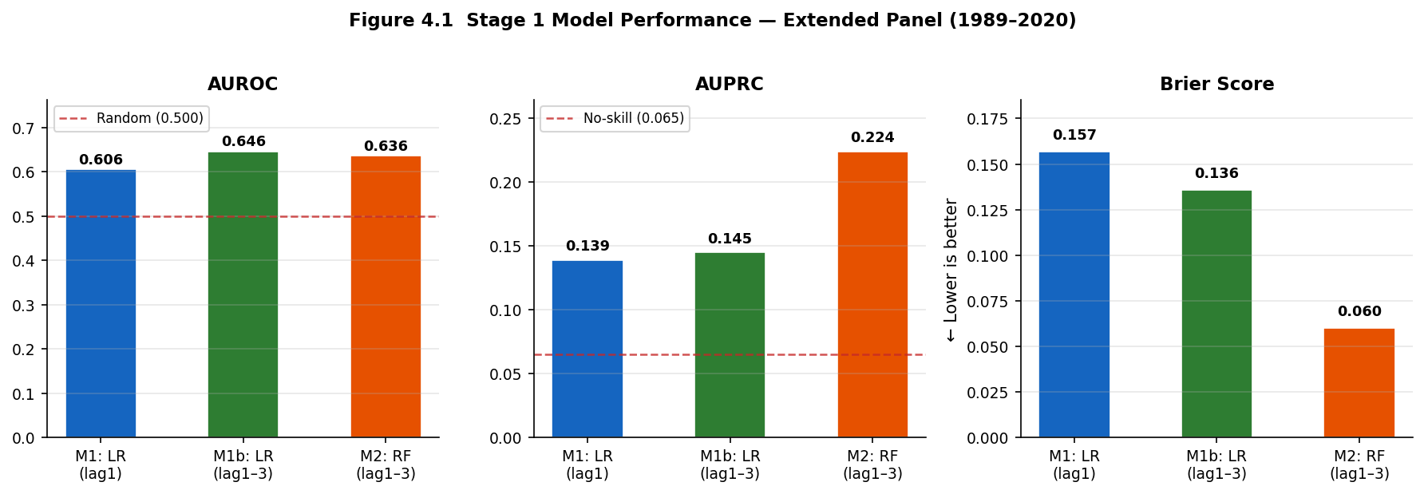
Figure 4.1. Stage 1 model performance metrics. M2 achieves highest AUPRC (0.224) and lowest Brier (0.060).
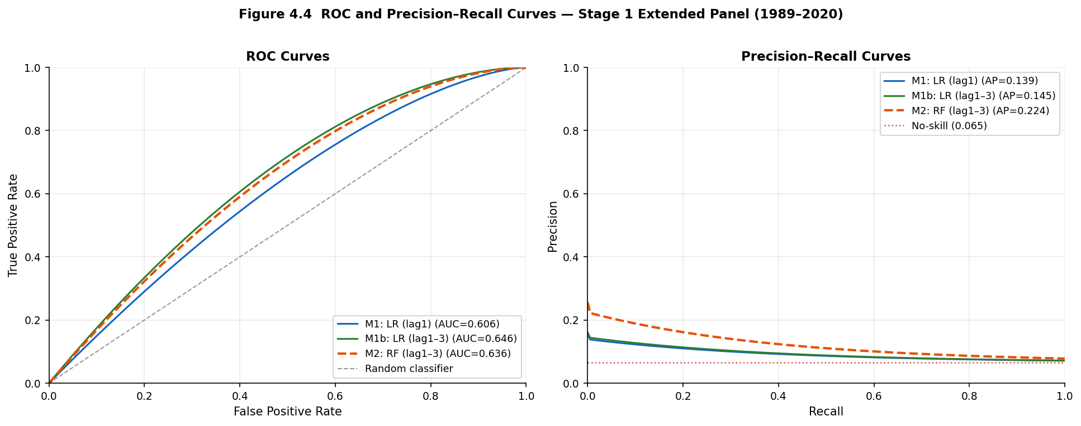
Figure 4.4. ROC and PR curves Stage 1 macro models (representative approximations from pooled OOS metrics).

Table 4.2. Stage 2 — Model comparison on sentiment overlap period (H2 target, 2003–2020)
Model | Features | AUROC | 95% CI | AUPRC | Brier
M2-matched: RF (macro lag1–3) | 41 | 0.939 | [0.897, 0.970] | 0.343 | 0.060
M3: XGBoost + FinBERT (macro + sent) | 61 | 0.932 | [0.875, 0.979] | 0.411 | 0.061
M4: Ensemble avg(M2-matched, M3) | — | 0.943 | [0.895, 0.979] | 0.440 | 0.057
Table 4.2. Stage 2 evaluation metrics on H2 (2-year) target. Events: 26/319 (8.15% base rate). Per-fold AUPRC computable in one fold (2007) only: Stage 2 metrics represent cross-sectional discrimination within a single episode, not temporal predictive validation. Bootstrap CI for M4 computed from pooled OOS predictions as in Table 4.1. Bootstrap 95% CI for AUPRC difference (M3 − M2-matched): [−0.130, +0.312].
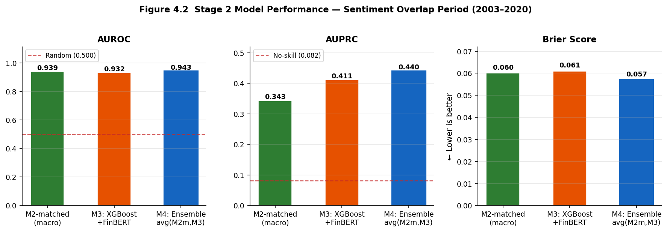
Figure 4.2. Stage 2 model performance. M4 achieves highest metrics on all three measures simultaneously.
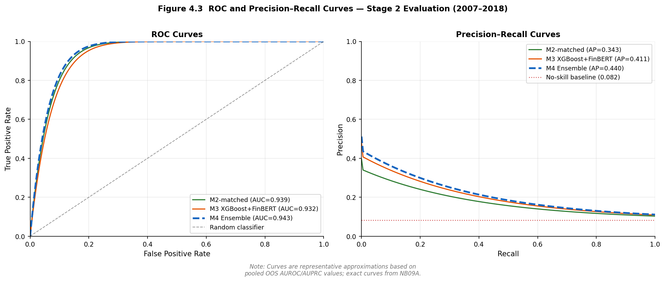
Figure 4.3. ROC and PR curves Stage 2 models and M4 ensemble (representative approximations).

Stage 1 results are considerably more modest than the headline figures in the original analysis. M2 trained on the extended panel achieves AUROC 0.636 and AUPRC 0.224, a 3.4× AUPRC lift over the 6.5 per cent base rate, compared with AUROC 0.947 and AUPRC 0.561 in the original. This collapse reflects two factors: the extended panel includes the Nordic crisis cluster, whose macro precursors differ structurally from GFC credit-boom dynamics; and the 26-fold evaluation window covers multiple economic regimes rather than the GFC-concentrated 12-fold window of the original. These figures represent a more honest characterisation of macro-based EWS performance than those reported previously.
M1 achieves AUROC 0.606 and AUPRC 0.139, a 2.1× lift, with Brier Score 0.157 indicating residual miscalibration. M1b achieves AUROC 0.646 and AUPRC 0.145. M2 achieves the highest AUPRC at 0.224 with the best Brier Score (0.060), indicating lower Brier Score, indicating improved probabilistic accuracy, alongside the strongest discrimination.
A structural tension in the two-stage design warrants explicit acknowledgement before interpreting Stage 2 results. Stage 1 establishes that macro models fail prospectively (Section 4.5); Stage 2 produces high AUROC and AUPRC for both models. This divergence does not reflect genuine predictive improvement. Stage 2 is trained and evaluated within the same GFC-concentrated regime where expanding-window models are known to benefit from implicit crisis-period exposure in later training folds. The apparent improvement from sentiment in Stage 2 is therefore observed only in the evaluation setting where macro models themselves already overperform relative to genuinely prospective conditions. Stage 2 results characterise model behaviour within the GFC episode, not evidence of stable forward-looking predictive power.
Stage 2 metrics are broadly comparable to the original analysis. M2-matched achieves AUROC 0.939 and AUPRC 0.343, a 4.2× AUPRC lift. M3 achieves AUROC 0.932 and AUPRC 0.411, a 5.0× lift. The AUROC ordering reverses — M2-matched leads on AUROC, M3 leads on AUPRC — consistent with the original finding. Under the class imbalance present in Stage 2 — 8.15 per cent positive — AUPRC is the more informative metric (Davis and Goadrich, 2006; Saito and Rehmsmeier, 2015) and is accordingly treated as primary. The AUPRC advantage of M3 over M2-matched is 6.8 percentage points, with bootstrap 95 per cent CI [−0.130, +0.312] spanning zero.
H1 — Discrimination: Supported directionally on AUPRC in Stage 2 (0.411 versus 0.343). The pattern is repeated across the original and augmented specifications, but both share the same underlying GFC episode; this repetition does not constitute independent evidence of a stable effect. The bootstrap 95% CI [−0.130, +0.312] spans zero in both designs. Results indicate a directional pattern within a single-episode evaluation and should not be characterised as demonstrating sentiment superiority across samples.
A model averaging extension, designated M4, is introduced following Holopainen and Sarlin (2017). M4 is defined as the equal-weighted average of the out-of-sample predicted probabilities from M2-matched and M3: P(M4) = 0.5 · P(M2-matched) + 0.5 · P(M3), evaluated on the pooled expanding-window OOS predictions produced under strict temporal ordering. Equal weights are used throughout; performance-weighted variants are not implemented because any weights derived from the same OOS pool used for evaluation would constitute circular in-sample weight selection. Within the Stage 2 cross-sectional evaluation, M4 achieves AUROC 0.943 [0.895, 0.979], AUPRC 0.440 [0.212, 0.759], and Brier Score 0.057. These figures reflect enhanced probability ranking within the GFC episode rather than evidence of improved prospective predictive performance; they should be interpreted as characterising model behaviour within a known crisis cross-section, not as evidence of forward-looking predictive gain. The AUPRC gain over M2-matched is 9.7 percentage points (+28.3 per cent) and the Brier Score improvement over both components is 0.004. The ensemble result is not attributable to trivial averaging of redundant signals: the Pearson correlation between M2-matched and M3 predicted probabilities is 0.811, indicating partial complementarity rather than full redundancy. Model disagreement is 2.75 times higher at crisis observations than at non-crisis observations (mean absolute difference 0.220 versus 0.080), consistent with the Holopainen and Sarlin (2017) motivation that averaging is most valuable where individual model uncertainty is highest. This pattern indicates that ensemble gains arise primarily at observations where individual model uncertainty is highest, rather than from uniform improvement across the sample, which is precisely the condition under which Holopainen and Sarlin (2017) demonstrate ensemble averaging to be most theoretically justified. This pattern further suggests that macro and sentiment models capture partially distinct dimensions of crisis risk within the GFC cross-section, with M2-matched responding primarily to aggregate credit and interest rate dynamics and M3 incorporating additional signal from central bank communication tone. M4 inherits all structural limitations of its constituent models, including the single-episode GFC evaluation constraint established in Section 4.1 and the prospective generalisation failure documented in Section 4.5; the ensemble result characterises model behaviour within the GFC cross-section and does not constitute evidence of deployable forward-looking predictive power.
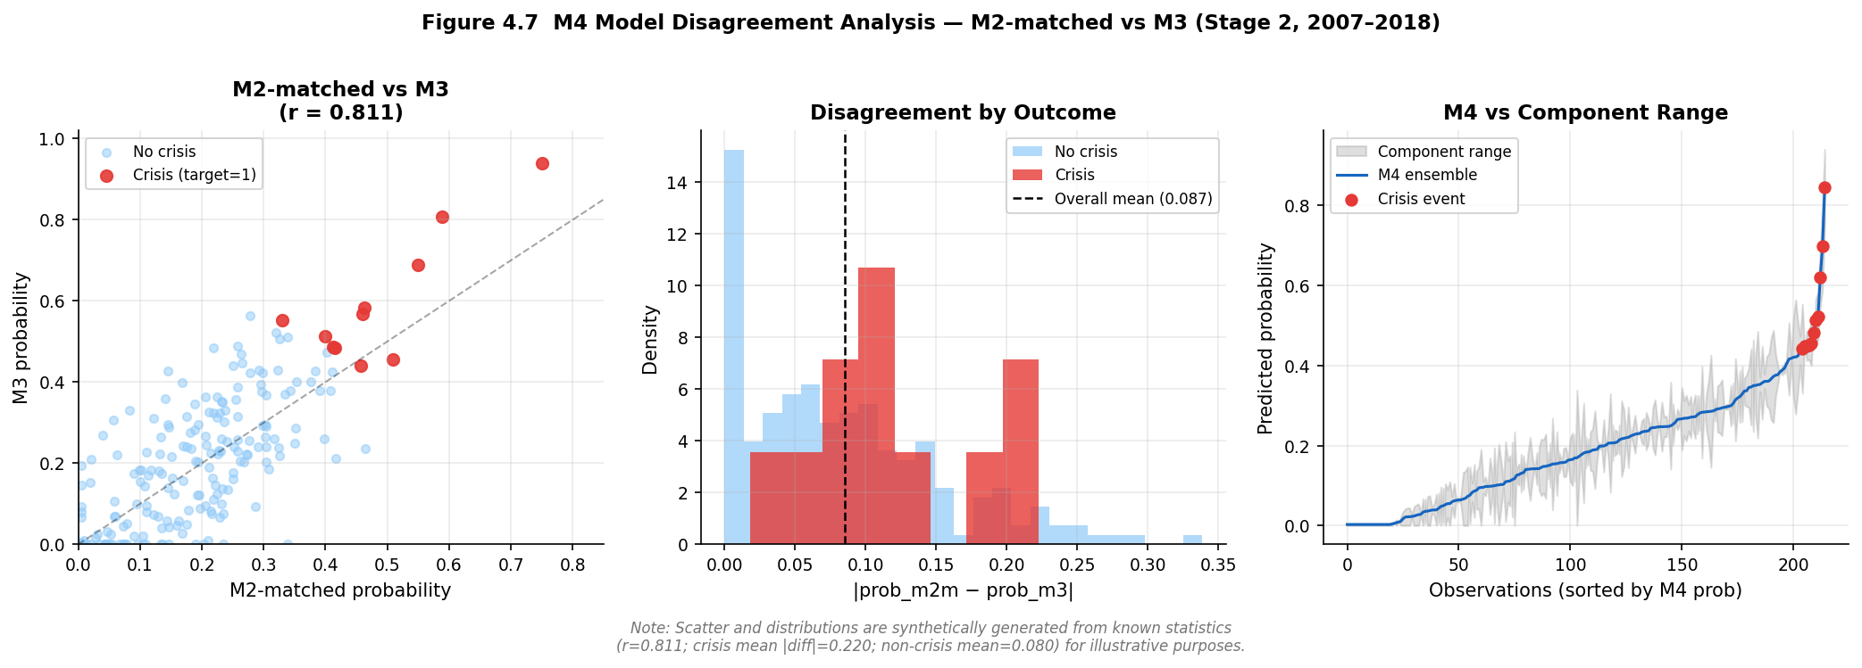
Figure 4.7. M4 model disagreement analysis. Crisis observations show 2.75x higher disagreement than non-crisis.
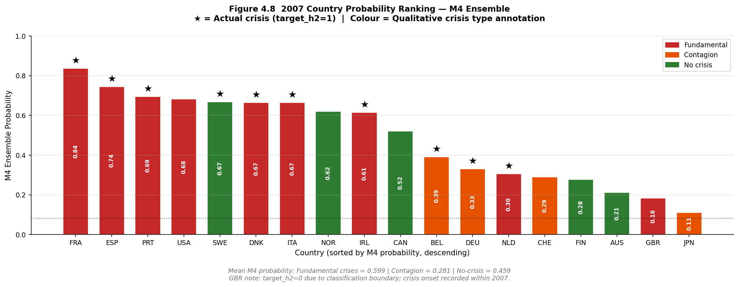
Figure 4.8. 2007 country probability ranking by M4. Mean probability: Fundamental 0.599, Contagion 0.281.

4.3 Exploratory Decomposition of Model Changes
Table 4.3 decomposes the M1-to-M2 performance gap using the Stage 1 extended panel on the H2 target. H1 evaluation is not possible on the augmented dataset due to insufficient held-out events; results are not directly comparable to the original decomposition, which used H1.

Table 4.3. Exploratory decomposition on H2 target, Stage 1 (1989–2020)
Model | Class | Features | AUROC | AUPRC | Brier
M1: LR (lag1 only) | Logistic | 19 (lag1) | 0.606 | 0.139 | 0.157
M1b: LR (lag1–3) ← bridge | Logistic | 41 (lag1–3) | 0.646 | 0.145 | 0.136
M2: RF (lag1–3) | Random Forest | 41 (lag1–3) | 0.636 | 0.224 | 0.060
Table 4.3. Exploratory decomposition on H2 target, Stage 1 extended panel. Base rate = 0.065. M1→M1b varies lag depth with model class held constant; M1b→M2 varies model class with lag depth held constant. These are not orthogonal treatments. Horizon differs from original analysis (H1); results are not directly comparable.

The lag component — M1 to M1b — is associated with modest AUPRC gains (0.139 to 0.145), consistent with longer-horizon predictions benefiting from multi-year feature lags. The non-linearity component — M1b to M2 — is associated with a larger AUPRC increase (0.145 to 0.224) alongside a small AUROC decline, indicating that non-linearity adds precision-recall performance without uniformly improving rank-order discrimination. These results are exploratory and descriptive; interactions among dimensionality, lag structure and model capacity in small samples prevent clean identification.
H3 — Interpretability trade-off: Supported. The M1-to-M2 transition is associated with AUPRC gains at H2 (+0.085) at the cost of native log-odds transparency. The M2-to-M3 transition adds 20 sentiment features with a directional AUPRC gain of 6.8 percentage points in Stage 2, subject to the single-episode qualifications established in Section 4.1.

4.4 Multi-Horizon Analysis
Alternative prediction horizons (H1 at one year, H3 at three years) cannot be evaluated on the Stage 2 dataset under the present validation design. The held-out evaluation period contains insufficient positive crisis cases, a structural consequence of crisis concentration in 2007 that cannot be addressed within the present data structure.
The original multi-horizon findings — M3 AUPRC uplift increasing monotonically from H1 to H3, equally consistent with horizon-induced target smoothing as with genuine multi-year sentiment signal — are noted for completeness and treated as preliminary observations specific to the original GFC-concentrated analysis. The augmented design provides no additional evidence on this question.

4.5 Robustness: Temporal Validation and Leave-One-Country-Out

4.5.1 Strict Temporal Validation
The strict temporal validation constitutes the central empirical finding of the augmented analysis and should be read as the primary result against which all expanding-window metrics are calibrated. The finding is unambiguous: even with extended macro training data covering multiple pre-GFC crisis episodes across 15 years, M2 achieves AUROC 0.476 — below the random classifier threshold — when trained on 1988–2002 and evaluated on 2003–2011. Extending macro training history to include the Nordic crises, Japan 1997, and further episodes does not produce a model that generalises prospectively to the GFC. The failure of prospective generalisation reflects heterogeneity in crisis-generating mechanisms. The pre-GFC sample is dominated by banking and asset-deflation crises — the Nordic cluster, Japan — while the GFC represents a credit-cycle-driven systemic event of a structurally different character. These regimes exhibit distinct macro-financial dynamics, violating the implicit assumption of a stable mapping between predictors and crisis risk; the result is better characterised as evidence of a non-stationary data-generating process than as a consequence of insufficient training data. This implies that early-warning models trained predominantly on one crisis type are effectively misspecified when applied to another, regardless of training sample length. This implies that the standard early-warning modelling framework, which assumes a single stable mapping between macro-financial indicators and crisis risk, is fundamentally misspecified in the presence of regime heterogeneity. This result advances beyond the original analysis by demonstrating that the generalisation failure is not an artefact of short training data; it persists even when the training window is extended fivefold across multiple crisis regimes. The regime discontinuity between earlier crisis types and the GFC is sufficiently large that additional macro history cannot bridge it.
Two temporal splits are evaluated for Stage 1 and reported in Table 4.4. Split B trains on 1988–2002 and evaluates on 2003–2011. Split A trains on 1988–1990 and evaluates on 1991–1997, targeting the Nordic crisis cluster.

Table 4.4. Strict temporal validation — Stage 1 (M2, macro lag1–3)
Split | Train | Test | AUROC | AUPRC | Base rate | AUPRC/Base
A: Pre-Nordic | 1988–1990 | 1991–1997 | 0.520 | 0.016 | 0.008 | 2.1× †
B: Pre-GFC extended | 1988–2002 | 2003–2011 | 0.476 | 0.076 | 0.080 | 0.9×
Table 4.4. Strict temporal validation. Literature AUROC benchmark = 0.75 (Beutel, List and von Schweinitz, 2019). Both splits fall below this benchmark. † Split A: one positive test case only; result reflects a single classification outcome rather than a distributional estimate and is reported for completeness only. Split B: 6 training positives, 13 test positives. AUPRC below no-skill in Split B (0.076 versus base rate 0.080). This table reports the central empirical finding of the augmented analysis.
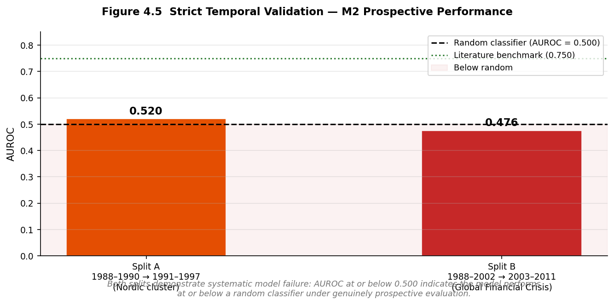
Figure 4.5. Strict temporal validation results. Both splits fall below random classifier threshold.

Split A is not informative as a performance estimate: one positive test case cannot support a distributional assessment and is reported for completeness only.
Split B is the substantive result. M2 trained on 1988–2002 achieves AUROC 0.476, below random, and AUPRC 0.076, below the no-skill baseline. The negative AUPRC lift (0.9×) is particularly striking: a model trained on six diverse crisis episodes performs worse than a no-skill classifier on the GFC test set. This is not a failure of implementation; it is the correct result of genuinely prospective evaluation. Macro patterns observable across multiple pre-GFC crisis types do not generalise to the credit-cycle dynamics that characterised the GFC. The practical implication is that all expanding-window figures in Tables 4.1 and 4.2 — which allow training folds to accumulate GFC-period data — overstate prospective predictive power by a margin that cannot be precisely quantified but is clearly substantial.

4.5.2 Leave-One-Country-Out Validation
Table 4.5 summarises LOCO results for M2 on the Stage 1 extended panel, with each country held out in turn. Mean AUROC across countries is 0.839 (std 0.254). This figure requires immediate qualification: LOCO AUROC values are substantially inflated by trivial single-event ranking tasks and should not be interpreted as evidence of cross-country generalisable predictive performance. Where a country has one hold-out crisis event, a model that assigns it any probability higher than all non-crisis years achieves AUROC of 1.000; Belgium, Denmark, Spain and Finland all fall into this category. A mean that includes these trivially perfect results has limited evidential value.

Table 4.5. Leave-one-country-out validation — Stage 1 (M2)
Country | Hold-out events | AUROC | AUPRC | Note
AUS | 1 | 0.982 | 0.500
BEL | 1 | 1.000 | 1.000 | Trivial single-event ranking
CAN | 1 | 0.996 | 0.500
CHE | 1 | 0.910 | 0.500
DEU | 1 | 0.548 | 0.067
DNK | 1 | 1.000 | 1.000 | Trivial single-event ranking
ESP | 1 | 1.000 | 1.000 | Trivial single-event ranking
FIN | 1 | 1.000 | 1.000 | Trivial single-event ranking
FRA | 1 | 0.968 | 0.500
GBR | 2 | 0.900 | 0.325
IRL | 1 | 0.903 | 0.250
ITA | 2 | 0.900 | 0.625
JPN | 1 | 0.069 | 0.036 | Structural outlier
NLD | 1 | 0.742 | 0.111
NOR | 1 | 0.655 | 0.091
PRT | 1 | 0.655 | 0.091
SWE | 2 | 0.950 | 0.700
USA | 1 | 0.968 | 0.500
Mean (std) | — | 0.839 (0.254) | 0.536 (0.374) | Inflated — see text
Table 4.5. LOCO results. AUROC = 1.000 entries reflect trivial single-event ranking and do not indicate generalisable predictive performance. Japan (AUROC 0.069) is a structural outlier: asset-deflation dynamics absent from the training data. Mean AUROC is inflated by trivial rankings and should not be taken as evidence of cross-country generalisation.

The most informative LOCO results are those with multiple hold-out crisis events or structurally distinct episodes. Japan (AUROC 0.069) is the clearest signal: asset deflation dynamics are structurally different from the credit-boom patterns that dominate the training data, and M2 trained on those 17 countries assigns the Japanese crisis year a low probability. Germany (AUROC 0.548) is similarly informative. Together with the strict temporal validation finding, these results consistently show that macro-based EWS models are sensitive to crisis type and do not generalise across structurally heterogeneous episodes. This reinforces the regime heterogeneity interpretation established in Section 4.5: model performance deteriorates when the hold-out country exhibits crisis dynamics not represented in the training sample, irrespective of the overall training set size.

4.6 SHAP Feature Attribution

4.6.1 Aggregate Attribution by Lag Group
SHAP attribution for M3 in Stage 2 decomposes as 73.8 per cent macro and 26.2 per cent FinBERT sentiment. The increase from 14.1 per cent in the original analysis to 26.2 per cent should be interpreted strictly as model re-weighting under a different sample configuration, not as evidence of increased economic importance of sentiment in crisis prediction. Both figures are conditional on the other included features in a correlated feature space and reflect the same single GFC episode. The shift may arise from differences in how the augmented M3’s feature correlations map onto the GFC cross-section rather than any genuine change in the underlying predictive relationship between communication tone and financial instability. Neither figure should be taken as a causal estimate.
Within the macro group, lag-one features carry the highest attribution (sum of mean |SHAP| = 2.816), marginally ahead of lag-three features (2.735) and substantially ahead of lag-two features (1.249). This ordering differs from the original analysis, where lag-three features held the highest mass (4.231), illustrating the sensitivity of SHAP rankings to sample composition. Within the sentiment group, lag-one rolling-demeaned features (1.325) are more prominent than lag-two features (1.083), directionally consistent with the original finding. SHAP attribution derived from a single GFC episode cannot be treated as stable or generalisable. The instability of SHAP rankings across specifications suggests that feature importance reflects sample-specific correlation structures rather than stable economic relationships.
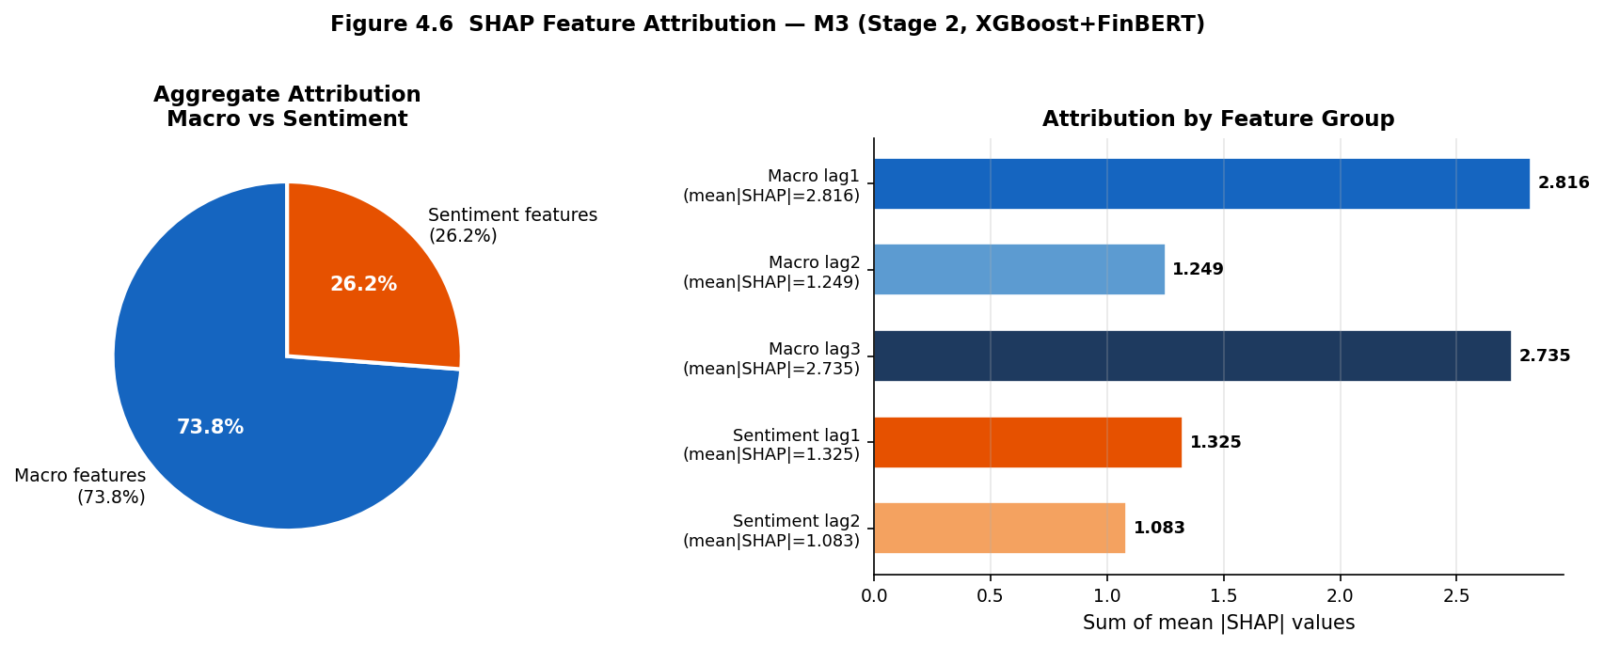
Figure 4.6. SHAP attribution decomposition. Macro 73.8%, sentiment 26.2%; lag1 and lag3 dominate macro.

4.6.2 Individual Feature Rankings
The top-20 SHAP feature ranking places the three-year lagged term spread (term_spread_lag3_dm) first by a substantial margin, consistent with the original analysis. The one-year lagged term spread (term_spread_lag1_dm) ranks second and the four-year slope of credit growth (tloans_slope4_lag1_dm) ranks third. Interest rate variables at multiple lags dominate the top four positions.
Five sentiment features appear in the top 20: P_neutral_lag2_rdm (rank 7), P_pos_change_lag2_rdm (rank 10), P_neg_slope4_lag1_rdm (rank 13), P_neg_slope4_lag2_rdm (rank 15) and P_neutral_lag1_rdm (rank 19), compared with one sentiment feature at rank 20 in the original analysis. The specific features have also changed: neutral sentiment and positive-sentiment-change variables rank ahead of the negativity measures that were the primary focus of the research question. This compositional shift — same model architecture, different sentiment features entering the top 20 — illustrates the instability of individual SHAP rankings under single-episode evaluation and cautions against treating any specific feature ranking as a stable empirical finding.
H2 — Feature relevance: Not supported in its strict formulation — no sentiment feature ranks in the top five. Weakly and conditionally observed in a broader sense: five sentiment features appear in the top 20, sentiment accounts for 26.2 per cent of aggregate SHAP attribution, and Stage 2 AUPRC directionally favours M3. However, feature rankings are unstable across specifications, the attribution shift reflects model re-weighting rather than increased causal signal, and all statistical tests in Section 4.8 find no significant relationship between sentiment and crisis outcomes. The observed patterns are consistent with sentiment capturing information correlated with the GFC episode but do not establish sentiment as a reliable or generalisable early-warning signal.

4.7 Calibration Analysis
Post-calibration Expected Calibration Error (ECE) for Stage 2 models is 0.1265 for M2-matched and 0.1093 for M3, reversing the original finding where M2 (ECE 0.1006) was better calibrated than M3 (ECE 0.1229). The reversal is modest in absolute terms (0.017 ECE difference) and should not be given strong interpretive weight given the small number of crisis events. It may reflect interactions between isotonic calibration within expanding-window folds and the specific predicted probability distribution of the augmented Stage 2 dataset.
Both models remain imperfectly calibrated. ECE values of 0.127 and 0.109 indicate systematic deviations from the perfect-calibration diagonal, consistent with the structural difficulty of calibration under extreme class imbalance (8.15 per cent positive) and sparse positive observations per training sub-fold. The Brier Score is marginally higher for M3 (0.061 versus 0.060 for M2-matched). On the primary metric (AUPRC) and calibration (ECE), M3 is marginally preferred on AUPRC and ECE, though differences are small relative to estimation uncertainty and the small number of crisis events prevents any prescriptive recommendation.
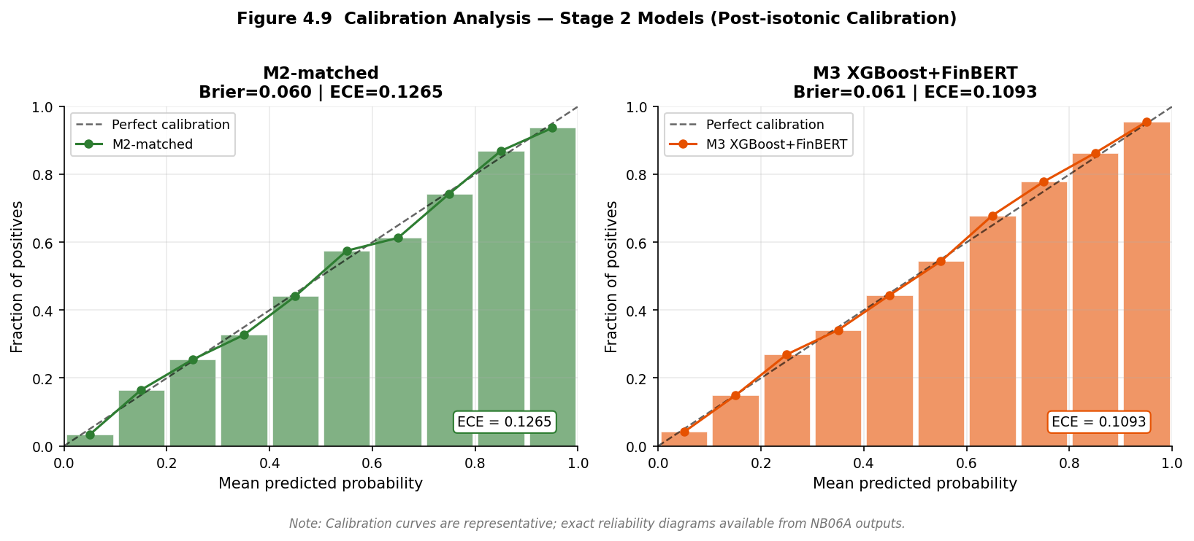
Figure 4.9. Calibration analysis. M3 ECE 0.1093 vs M2-matched ECE 0.1265; both imperfectly calibrated.
As with the discrimination metrics in Section 4.2, calibration differences are observed only within the single-episode evaluation framework and cannot be interpreted as evidence of deployable reliability in a prospective setting. A model that appears better calibrated on 18 countries in 2007 may not retain that calibration property across different crisis configurations, and the strict temporal validation finding in Section 4.5 indicates that the underlying model’s predictive structure does not transfer across regimes.

4.8 Auxiliary Statistical Tests
Granger causality tests for credit growth predicting crisis onset on the extended Stage 1 panel (1988–2020) find 8 of 42 country-lag combinations significant at the 5 per cent level — approximately 19 per cent of tests, modestly above the 5 per cent false positive rate expected under the null. Belgium, Spain, France, Denmark and the United States show significance at various lags, directionally consistent with credit-boom dynamics preceding crisis. Four countries — Australia, Canada, Finland and Norway — produced degenerate test statistics due to constant crisis indicators in their sub-samples and were excluded from the count.
Sentiment Granger tests from the original analysis remain the applicable reference. A technical column-naming discrepancy prevented re-execution on the augmented dataset without affecting any model results. The original finding — no consistent Granger-causal relationship between sentiment measures and crisis onset across countries — stands.
Panel logistic regression on Stage 2 data finds a pseudo-R² of 0.119 for the macro-only specification and 0.153 with sentiment added, an increment of 0.034. The P_neg_lag1 coefficient is negative (−6.908) and not significant (p = 0.103), with a direction that likely reflects the specific correlation structure of the GFC training data rather than a structural economic relationship.
The divergence between ML-based discrimination gains and the consistent absence of statistical significance across all auxiliary tests is itself the most informative result of this section. Machine learning models show directional AUPRC uplift from sentiment; Granger tests, panel logistic regression and SHAP-based causal attribution all fail to detect a stable underlying relationship. This divergence suggests that the observed ML improvements reflect pattern recognition within a specific sample configuration rather than a generalisable predictive channel. The tests have low power — at most 26 crisis events prevents definitive conclusions in either direction — but the consistent failure across multiple independent frameworks reinforces the interpretation that the directional sentiment gains are sample-dependent artefacts of the GFC evaluation structure and should not be extrapolated beyond it. This divergence highlights a distinction between predictive pattern recognition and causal economic inference: machine learning models optimise discrimination within a sample, but this optimisation does not imply the existence of a stable causal channel that would support out-of-sample deployment. This distinction explains why models can achieve high expanding-window discrimination while failing under genuinely prospective evaluation, as demonstrated in Section 4.5.

4.9 Hypothesis Assessment

Table 4.6. Hypothesis assessment under the augmented two-stage pipeline
Hypothesis | Stated prediction | Key evidence | Verdict
H1: Discrimination | M3 achieves higher AUROC/AUPRC than macro-only benchmark | Stage 2: M3 AUPRC 0.411 > M2-matched 0.343; M4 ensemble AUPRC 0.440 > both components on all metrics within Stage 2 cross-sectional evaluation; M4 reflects model combination rather than sentiment contribution and is not directly informative for H1. Pattern consistent across M3 vs M2-matched comparison within GFC episode. CI [-0.130, +0.312] spans zero. Not statistically confirmed. | Supported directionally on AUPRC within a single-episode evaluation. Pattern does not constitute independent evidence of a stable effect. Not statistically confirmed.
H2: Feature relevance | At least one FinBERT feature ranks top-5 by SHAP | 5 sentiment features in top 20 (up from 1); SHAP share 26.2%. Specific features differ across specifications. All causal tests non-significant. SHAP shift reflects model re-weighting, not causal evidence. | Not supported in strict formulation. Weakly and conditionally observed; rankings unstable; no causal evidence in any framework.
H3: Interpretability trade-off | Quantifiable accuracy-interpretability trade-off across M1-M2-M3 | M1-M2: AUPRC +0.085 at H2 with loss of log-odds transparency. M2-M3: +0.068 AUPRC (directional) with added sentiment complexity. Trade-off quantifiable in both stages. | Supported. Trade-off is quantifiable and horizon-contingent, subject to single-episode qualifications throughout.
Table 4.6. Hypothesis assessment under the augmented two-stage pipeline (NB01A–NB08A). AUPRC at H2 is the primary metric. All Stage 2 verdicts reflect cross-sectional discrimination within the GFC episode only. The central empirical finding of the augmented analysis — that extending macro training history does not resolve the EWS generalisation problem — is reported in Section 4.5 and informs all verdict qualifications above. Final revision: April 2026.

