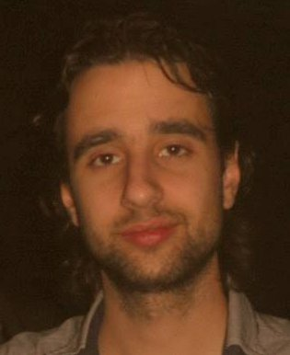
García Scardilli,

Andrés Sebastián
Ventura Bosch 6414, City of Buenos Aires, Argentina | 08/10/1986 | 15-3085-2898 | spike886@gmail.com
Objetives
Develop myself professionally while continue learning to become a better software engineer and provide my knowledge to help the software community

Education
2000-2005 | Electronic technician  Institute San José (A-355)
2006-Actualidad | Advanced student of Computer Engineering  University of Buenos Aires  Studying the last year

Work experience
2010 - 2013 | StartmeApps  Full Stack Developer for startups  Web app's development using Ruby on Rails, MySQL, Javascript, Linux y Amazon Web Services  Reference: emiliano.ritiro@startmeapps.com (Emiliano Ritiro)
2013 - 2015 | Inaka  Full Stack Developer of web server for apps  Server's development, for mobile apps, using Ruby, Rails and Grape. Frontend app's development using Javascript, AngularJS and React.
2015 - 2016 | Wedid.it  Remote Full stack developer for US located company.  Working on Rails server and moving frontend from jquery to react, using BDD methodologies

Idioms
Spanish | Native language
English | Excellent written level, good oral level

Technologies
C++ | Advanced knowledge
Java | Intermediate knowledge
OpenGL | Intermediate knowledge
SQL | Advanced knowledge
php | Intermediate knowledge
Linux | Advanced knowledge
Android | Basic knowledge
Ruby | Expert knowledge
Rails | Expert knowledge
Javascript | Advanced knowledge
AngularJS | Advanced knowledge
React | Advanced knowledge
Html5 / Css 3 | Advanced knowledge
Bootstrap 3 | Advanced knowledge

Academic projects
Programming algorithms I | Sudoku solver  Developed on Pascal
Programming algorithms II | Simulator of ants's behavior  Developed on C++
Programming algorithms III | Chopped racing type game with car tuning  Developed on Java
Data Organization | PPMC compressor  Developed on C++
Programming workshop I | System for design and simulation of electronic circuits with distributed design support  Developed on C++
Operating Systems | Payment management system  Developed on shell script
Design techniques | System for design and simulation of electronic circuits  Developed on Java
Data bases | Db for hospital system  Developed en SQL
Concurrent programming I | Concurrent chat  Developed on C++
Graphic systems | Seabed  Developed on C++ with OpenGL  http://youtu.be/-eASClqUO4I
Simulation | Simulation of customer care in shopping center  Developed on GPSS
Programming workshop II | Educational social network for the university  Developed on php
Project workshop I | Comprehensive system of risk management for systems development  Developed on Java
computer organization | Sort by mergesort algorithm  Developed on assembly for MIPS architecture
Automatic fault detection systems I | Inference engine  Developed on Java
Management and control of IT projects | Project to implement subways in the city of Cordoba  Design, management and control of subway construction project in the city of Cordoba
Automatic fault detection systems II | AI for bots development contest  Developed on Ruby
Project workshop II | Web server for rental and sale of properties  Developed on RoR and Grape

Personal projects
Framework 3D | Framework 3D  Developed on C++ with OpenGL
Mobile app | College organizer for FIUBA  Developed on Java from Android
Webmaster | Managing and maintaining websites
Home automation mobile app | Home automation system for spa equipment  Developed with AngularJS, Ionic on Cordova for Android and IOS
Home automation server | Server for synchronization and configuration of mobile application  Developed on RoR 4.1

Interests
Mensa Argentina | Member since 2013  Member N° 515

