Assignment 3: Understanding Algorithm Efficiency and Scalability
Algorithms and Data Structures

Sai Sravani Pillarisetty

Instructor: Michael Solomon
University of the Cumberlands

Date: 03/22/2026

Introduction
This project focuses on using both theoretical analysis and empirical evaluation to comprehend algorithm scalability and efficiency. Analyzing how algorithms react under various input situations is crucial because efficient algorithms are necessary for managing huge datasets and guaranteeing optimal system performance.
Two basic ideas are examined in this assignment: Hashing with Chaining and Randomized Quicksort. In order to lessen the possibility of worst-case behavior, the pivot in Randomized Quicksort is chosen uniformly at random, which is an improvement over the standard Quicksort method. A popular method for effective data storage and retrieval is hashing with chaining, which uses linked structures to handle collisions.
Implementing these algorithms, analyzing their theoretical performance, and assessing their behavior through empirical trials are the goals of this assignment. This assignment illustrates how algorithm design decisions impact efficiency and scalability in practical situations by contrasting Randomized Quicksort with Deterministic Quicksort and analyzing the effect of load factor on hash tables.
Implementation
A pivot element was chosen evenly at random from the input array in order to perform Randomized Quicksort. This strategy enhances average-case performance and helps prevent persistently bad pivot decisions.
In contrast, the first element was used as the pivot in the implementation of Deterministic Quicksort, which may result in worst-case behavior for specific inputs.
Edge cases like empty arrays, arrays with repeated elements, arrays that have already been sorted, and arrays that have been reverse-sorted are handled by both implementations.
Experiment Setup
Datasets comprising random arrays, sorted arrays, reverse-sorted arrays, and arrays containing repeating elements were created in order to assess performance.
To guarantee accuracy and minimize variability, each experiment was conducted several times, and the average runtime was noted.
Theoretical Analysis
The aforementioned recurrence relation can be used to characterize Randomized Quicksort's predicted execution time.
Each division is equally likely because the pivot is selected uniformly at random. Because each level completes O(n) work with an expected recursion depth of O(log n), solving this recurrence results in an expected time complexity of O(n log n).
Indicator random variables can be used for a more thorough investigation. Pivot selection determines the probability of comparison, and each pair of items is compared no more than once.
The predicted time complexity is O(n log n) since the expected number of comparisons is proportional to n log n by adding up all element pairs.
Results
Table 1: Runtime comparison of Deterministic and Randomized Quicksort across different input types and sizes.
Algorithm | Input Type | Size | Time (seconds)
Deterministic | Random | 100 | 0.0001124
Randomized | Random | 100 | 0.0001648
Deterministic | Sorted | 100 | 0.000463267
Randomized | Sorted | 100 | 0.000144867
Deterministic | Reverse | 100 | 0.000424933
Randomized | Reverse | 100 | 0.000151533
Deterministic | Repeated | 100 | 0.0001575
Randomized | Repeated | 100 | 4.81E-05
Deterministic | Random | 300 | 0.000413033
Randomized | Random | 300 | 0.000569933
Deterministic | Sorted | 300 | 0.0039346
Randomized | Sorted | 300 | 0.000546967
Deterministic | Reverse | 300 | 0.003514267
Randomized | Reverse | 300 | 0.000457733
Deterministic | Repeated | 300 | 0.000604967
Randomized | Repeated | 300 | 0.000137133
Deterministic | Random | 500 | 0.000642967
Randomized | Random | 500 | 0.0009063
Deterministic | Sorted | 500 | 0.009292367
Randomized | Sorted | 500 | 0.001213667
Deterministic | Reverse | 500 | 0.016097333
Randomized | Reverse | 500 | 0.0019462
Deterministic | Repeated | 500 | 0.005001933
Randomized | Repeated | 500 | 0.000917933
Deterministic | Random | 1000 | 0.004673633
Randomized | Random | 1000 | 0.0045002
Deterministic | Sorted | 1000 | 0.0568223
Randomized | Sorted | 1000 | 0.002113733
Deterministic | Reverse | 1000 | 0.048290467
Randomized | Reverse | 1000 | 0.0019857
Deterministic | Repeated | 1000 | 0.006126567
Randomized | Repeated | 1000 | 0.000358667

Graph
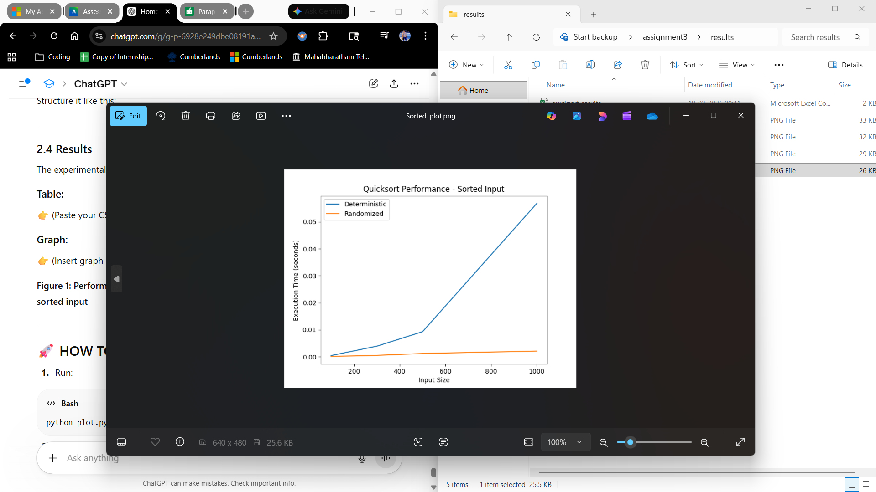
Figure 1: Performance comparison of Deterministic and Randomized Quicksort on sorted input.
The outcomes demonstrate Randomized Quicksort's constant performance for all input kinds. Unbalanced partitions cause Deterministic Quicksort to perform badly on sorted and reverse-sorted arrays.
As a result, the recursion depth is O(n), while the time complexity is O(n²). Randomized Quicksort, on the other hand, achieves O(log n) recursion depth while maintaining balanced partitions on average.
Theoretical and real findings differ because of randomization, system performance, and recursion overhead.
Hash Implementation
The hash table was implemented using chaining for collision resolution. Each bucket stores a list of key-value pairs.
A hash function based on Python’s built-in hash() combined with modulo operation was used. While not a formal universal hash function, it provides a reasonably uniform distribution in practice.
Dynamic resizing ensures the load factor remains low, improving efficiency.
Hash Analysis
The load factor α represents the ratio of elements to table size.
Under simple uniform hashing, each element is equally likely to be placed in any bucket. Therefore, the expected chain length is α.
Expected time complexities:
Insert: O(1)
Search: O(1 + α)
Delete: O(1 + α)
When α is small, operations run in constant time.
As the load factor increases, collisions increase and chains become longer.
Dynamic resizing ensures that α remains small, maintaining efficiency.
Maintaining a low load factor through dynamic resizing is essential to minimize collisions and ensure consistent performance.
Conclusion
This assignment used both theoretical and empirical study to highlight the significance of algorithm efficiency and scalability.
While Deterministic Quicksort deteriorated in adverse circumstances, Randomized Quicksort offered steady performance.
When the load factor was managed, hashing with chaining produced effective performance.

