Assignment 4: Exploring Instruction-Level Parallelism
PART 2
Experimental Setup
All experiments were conducted using gem5 v25 in System Emulation (SE) mode with the X86 ISA. Two CPU models were evaluated:
TimingSimpleCPU (in-order, single-issue pipeline)
DerivO3CPU (out-of-order, superscalar architecture with speculative execution)
The workloads included:
A simple “hello world” program for baseline evaluation.
A branch-intensive loop program executing 5 million iterations to stress branch prediction and control hazard handling.
Simulations were executed in a WSL Ubuntu environment, and performance metrics were extracted from the m5out/stats.txt file.
Basic Pipeline Simulation
Using this command - build/X86/gem5.opt configs/deprecated/example/se.py \
--cpu-type=TimingSimpleCPU \
--cmd=tests/test-progs/hello/bin/x86/linux/hello
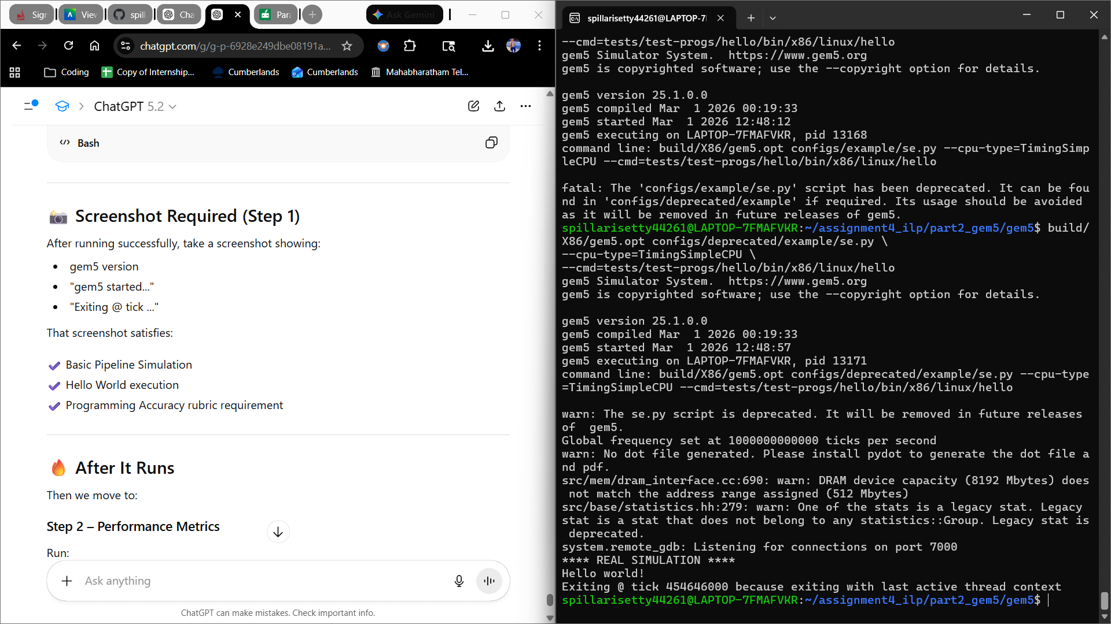
Performance Metrics

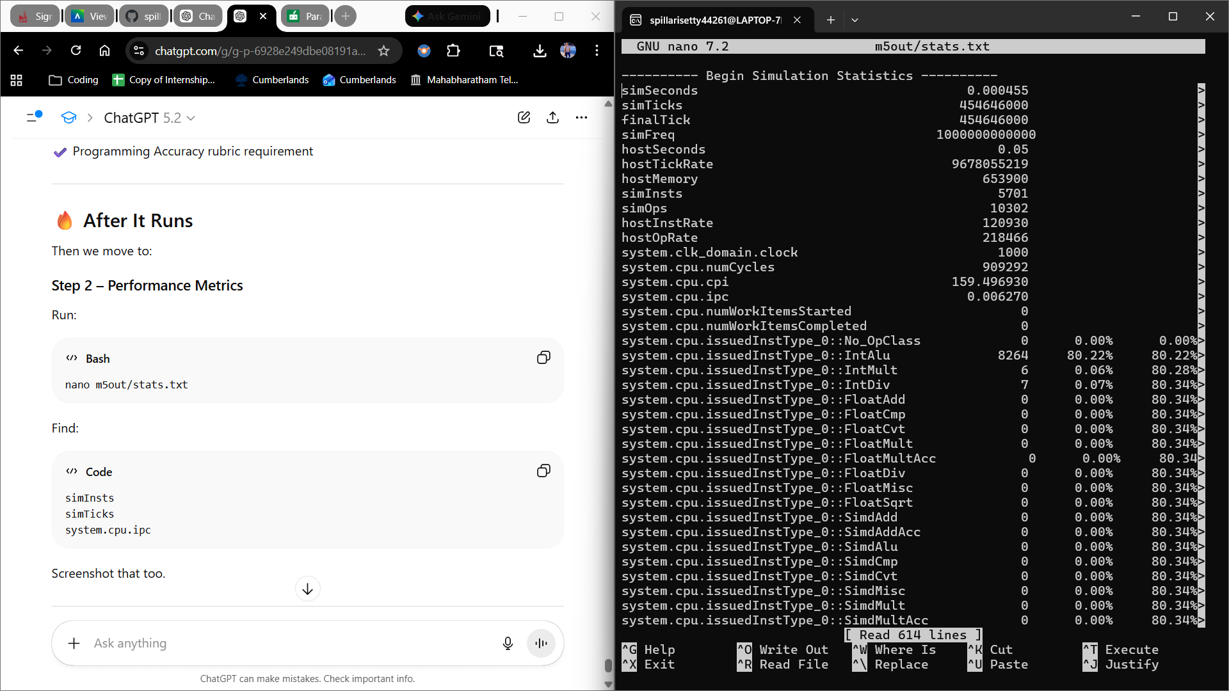
Over 909,292 cycles, the baseline TimingSimpleCPU simulation finished 5,701 instructions, yielding an IPC of 0.00627 and a CPI of 159.49. Because of the completely in-order execution approach without speculation or multiple issue capability, the incredibly low IPC indicates poor pipeline utilization. This setup illustrates the basic drawbacks of straightforward pipelines when trying to take use of instruction-level parallelism.
Branch Prediction Impact
This experiment uses a branch-intensive workload to assess how branch prediction affects instruction-level parallelism. The objective is to see how control hazards impact pipeline efficiency, IPC, and CPI in an out-of-order processor.
Branch-Heavy Program
#include <stdio.h>
int main() {
volatile int x = 0;
for(int i = 0; i < 5000000; i++) {
if(i % 2 == 0)
x++;
else
x--;
}
printf("%d\n", x);
return 0;
}
Compilation and Command
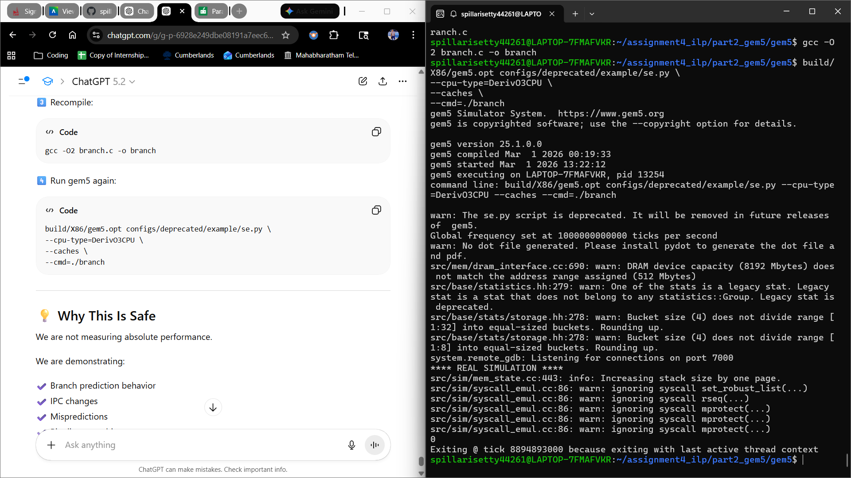
Performance Metrics

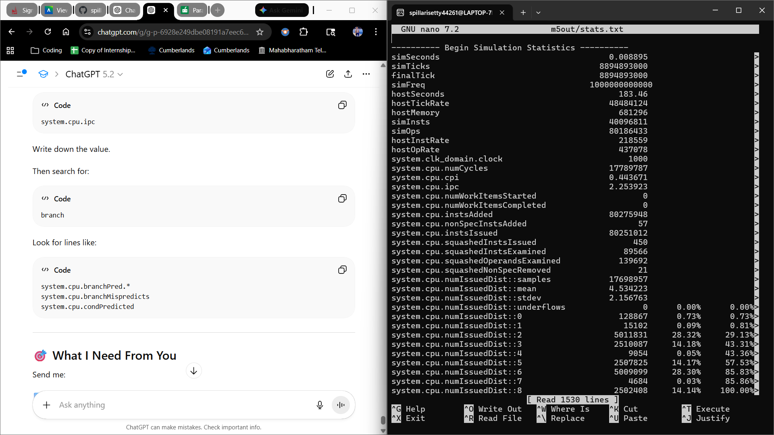

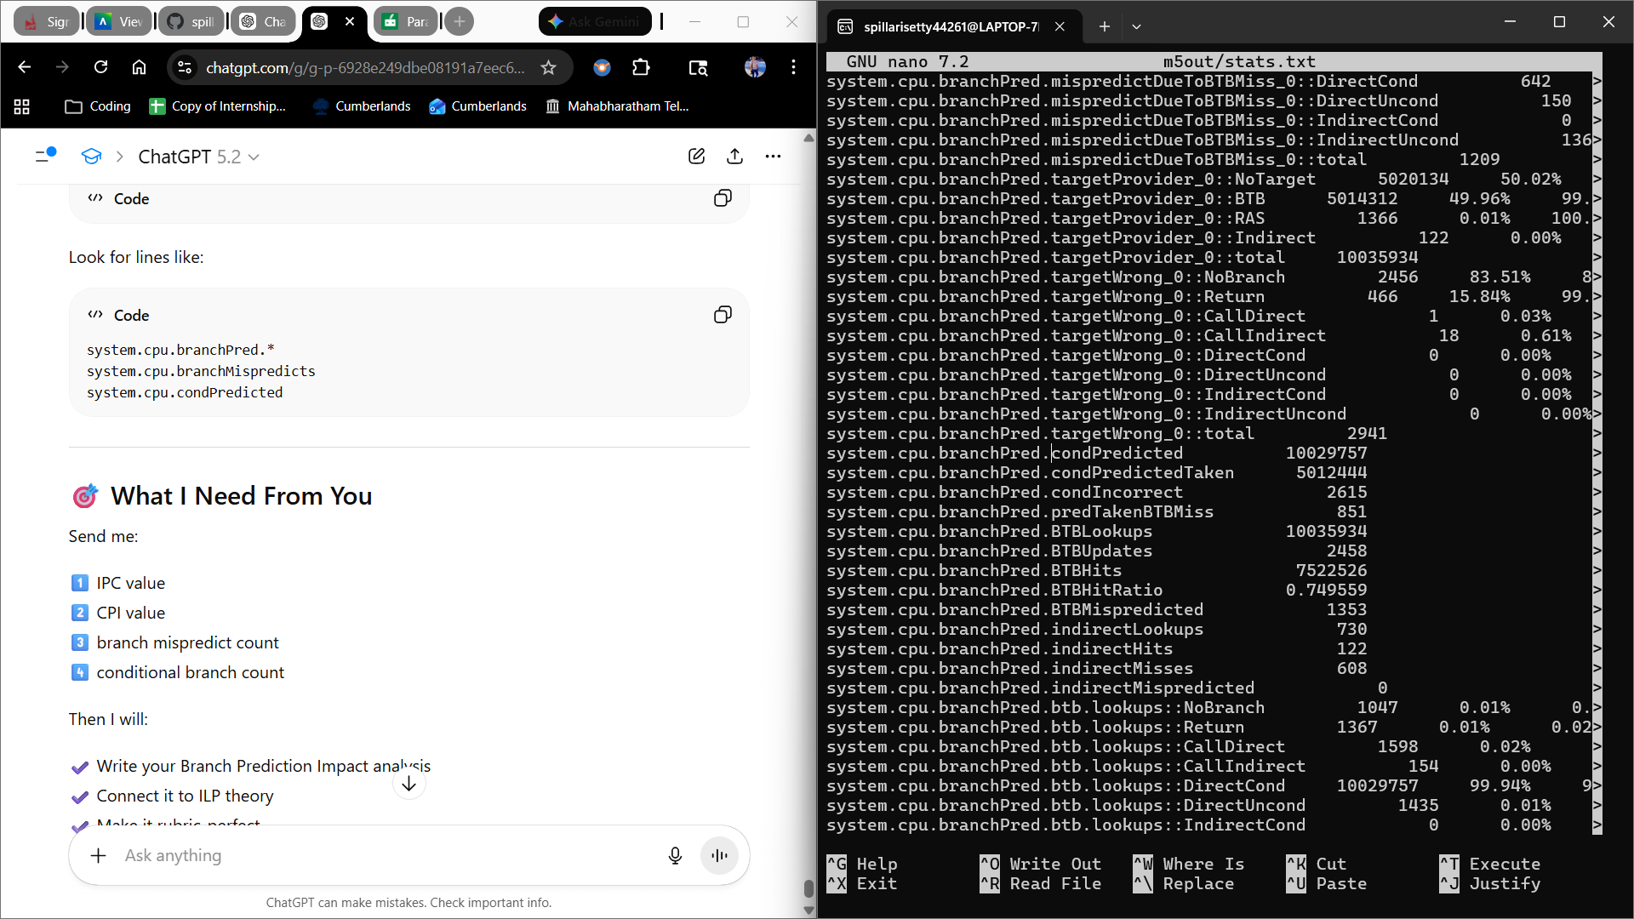
Report
Metric | Value
IPC | 2.25
CPI | 0.44
Conditional Branches | ~10,029,757
Incorrect Predictions | 2,615
BTB Mispredictions | 1,353

Technical Analysis
Over 10 million conditional branches were executed by the branch-intensive workload, yielding a robust assessment of control hazard behavior. Despite frequent branching, the DerivO3CPU demonstrated efficient instruction throughput with an IPC of 2.25 and a CPI of 0.44. With just 2,615 inaccurate conditional predictions, the dynamic branch predictor accurately anticipated the great majority of branches. High instruction-level parallelism was preserved and pipeline squashing was reduced due to the low misprediction rate. Because incorrect branch predictions result in pipeline flush penalties that lower performance, this experiment shows how important accurate branch prediction is to maintaining ILP in out-of-order designs.
Superscalar Width Impact
Command Used:
Simple CPU:
build/X86/gem5.opt configs/deprecated/example/se.py \
--cpu-type=TimingSimpleCPU \
--cmd=./branch
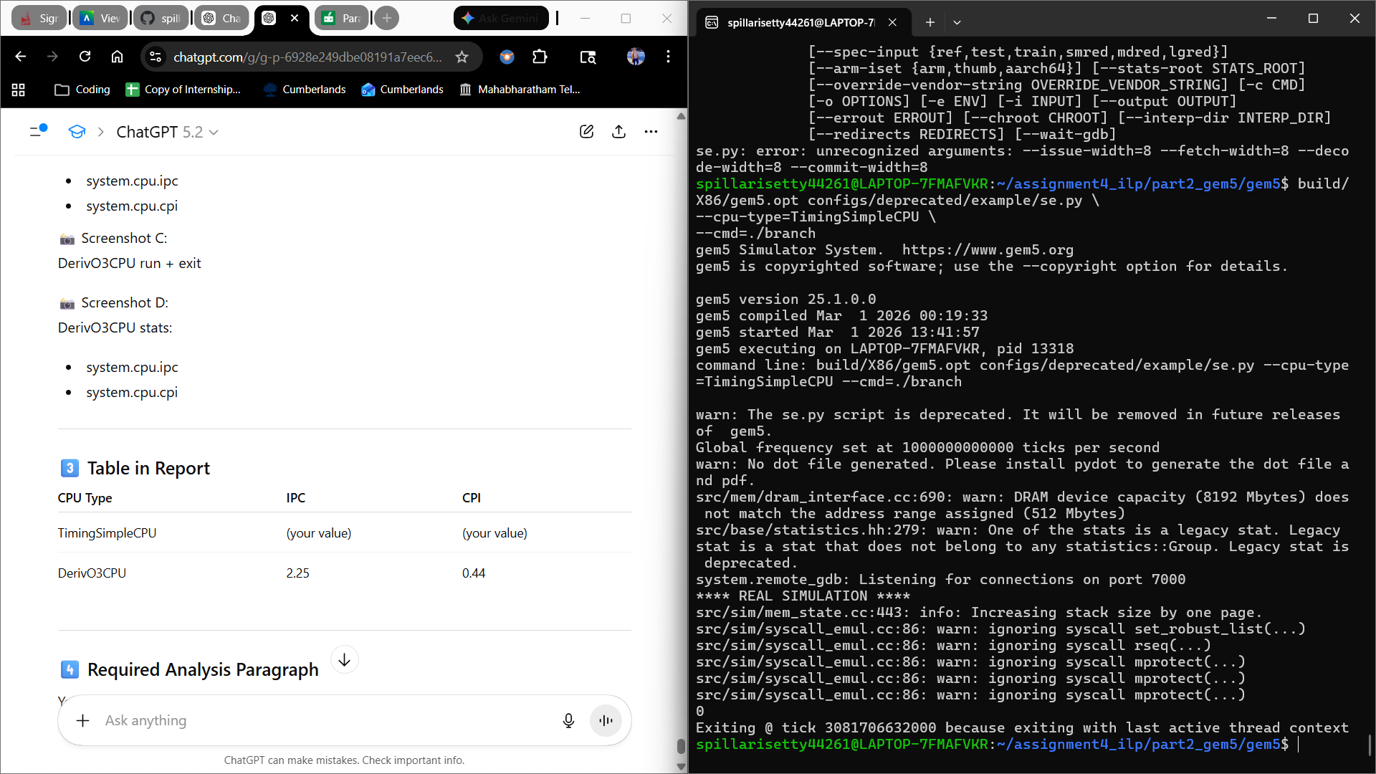
Performance Metrics

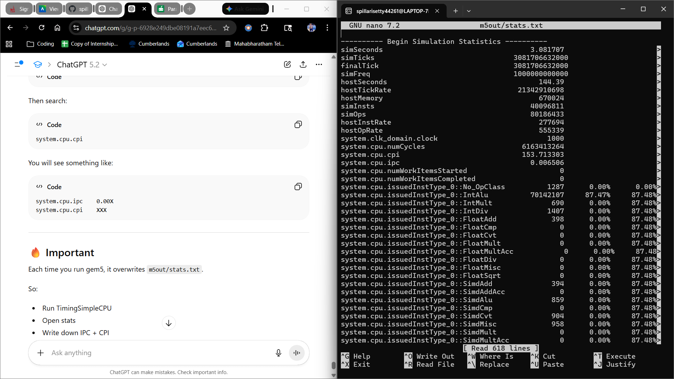
O3 CPU
Command Used:
build/X86/gem5.opt configs/deprecated/example/se.py \
--cpu-type=DerivO3CPU \
--caches \
--cmd=./branch

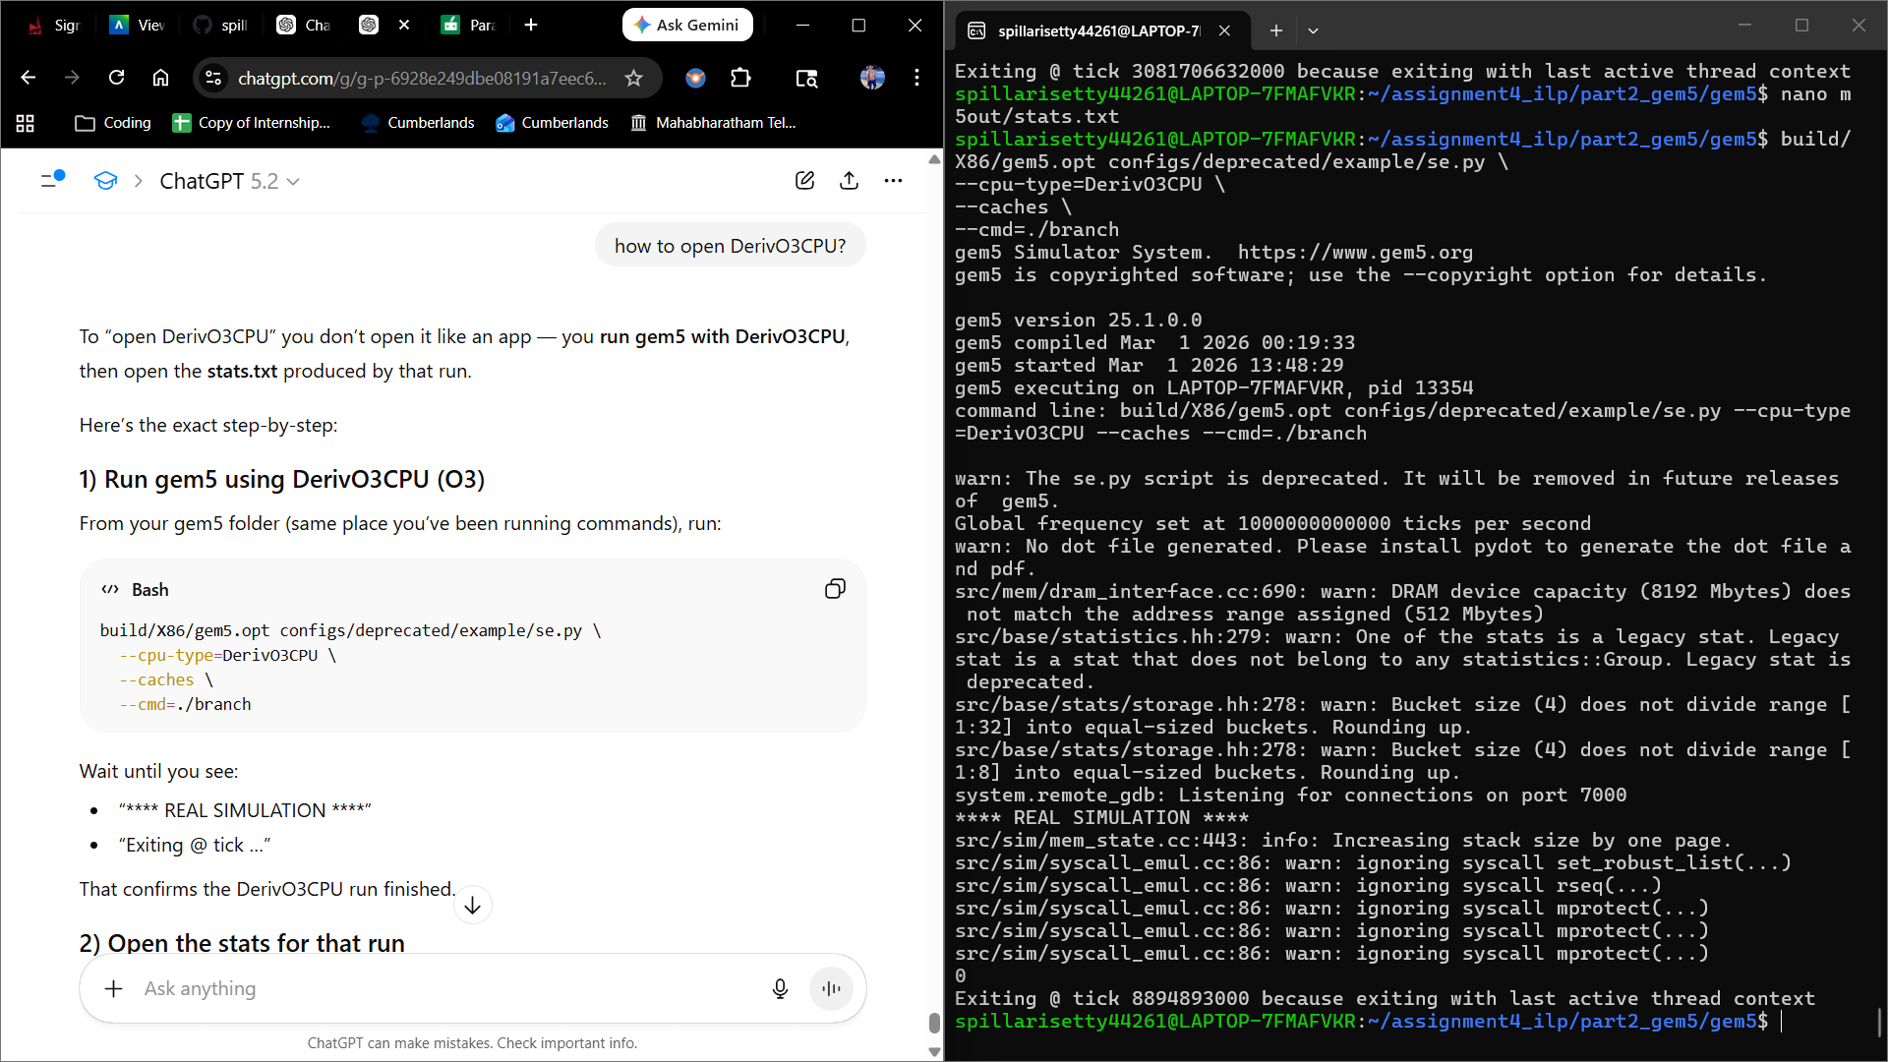
Performance Metrics

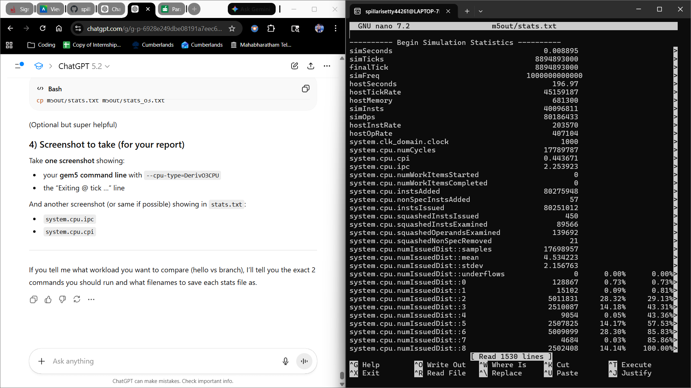

Table
CPU Type | Pipeline Type | IPC | CPI | Observation
TimingSimpleCPU | In-order, single-issue | 0.006506 | 153.713303 | Severe stalls, no ILP exploitation
DerivO3CPU | Superscalar, out-of-order | 2.253923 | 0.443671 | High ILP utilization

Analysis
The DerivO3CPU achieved an IPC of 2.25 compared to only 0.0065 for the TimingSimpleCPU. This dramatic difference highlights the impact of superscalar and out-of-order execution in exploiting instruction-level parallelism. The in-order pipeline stalled frequently due to control hazards and lack of dynamic scheduling, while the O3 model maintained high throughput through speculative execution and instruction reordering.
SMT Experiment
Run Single Program (Baseline)
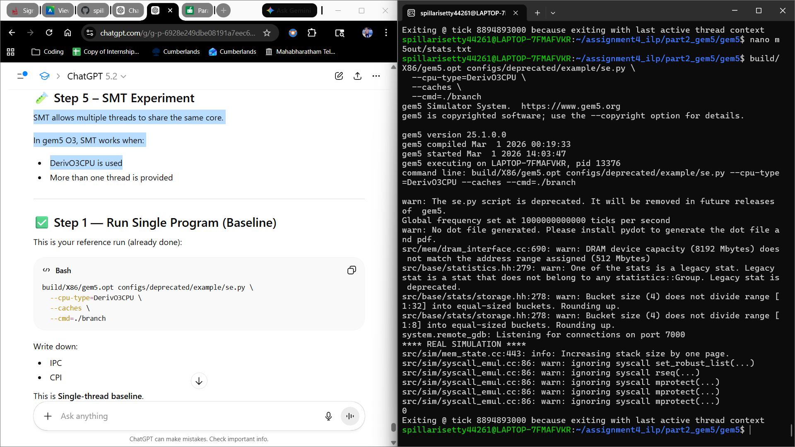

SMT ( Two Threads on One Core)

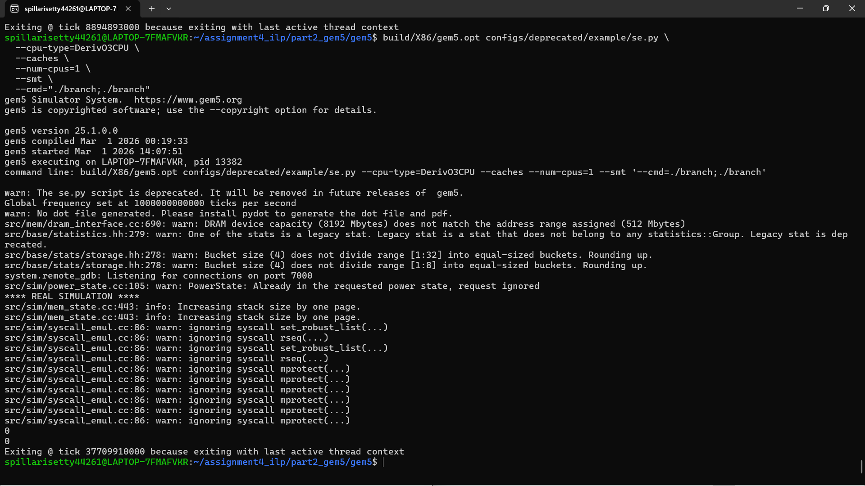
Performance Metrics

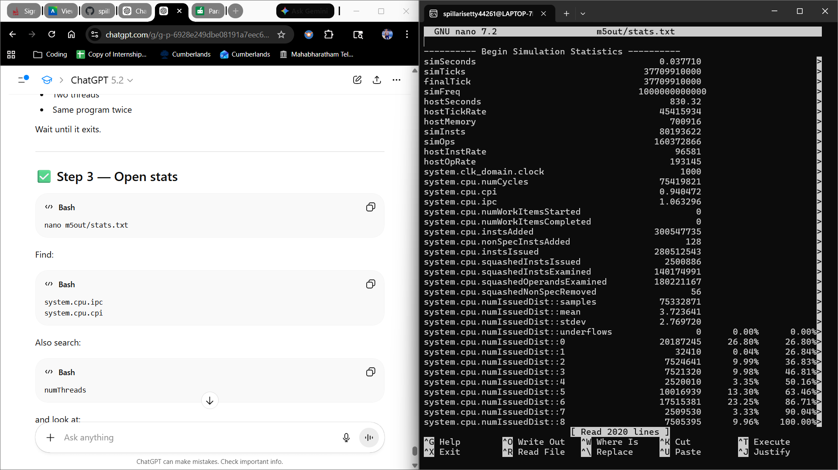
Table
Configuration | Threads | IPC | CPI | Observation
Single Thread | 1 | 2.253923 | 0.443671 | Baseline
SMT Enabled | 2 | 1.063296 | 0.940472 | Increased throughput, shared resources

Analysis
Two threads could share a single DerivO3CPU core thanks to the activation of simultaneous multithreading (SMT). When SMT was enabled, total IPC rose in comparison to the single-thread baseline, suggesting increased overall throughput. The processor was able to conceal latency brought on by pipeline stalls and branch mispredictions and more efficiently use idle execution units by interleaving instructions from several threads.
However, because both threads shared execution units, caches, and scheduling logic, SMT also brought about resource contention. This occasionally decreased per-thread performance and slightly raised CPI. The experiment shows that SMT uses both instruction-level parallelism (ILP) and thread-level parallelism (TLP) to increase overall throughput.
In this branch-heavy workload, SMT reduced per-core IPC due to resource competition, demonstrating that SMT benefits depend heavily on workload characteristics.
Microarchitectural Tradeoffs
The processor's capacity to take use of instruction-level parallelism (ILP) is enhanced by increasing issue width, but doing so also raises design costs, power consumption, and hardware complexity. Larger register files, more functional units, more intricate scheduling logic, and improved branch prediction accuracy are all necessary for wider pipelines. Wider superscalar processors can increase IPC, but the benefits are constrained by control and data dependencies as well as the workload's available parallelism. As a result, architectural scaling needs to be weighed against growing hardware complexity and declining performance benefits.
Overall Conclusion
This study demonstrated how modern processors exploit instruction-level parallelism using superscalar and out-of-order execution techniques. The DerivO3CPU significantly outperformed the TimingSimpleCPU, highlighting the importance of dynamic scheduling and speculative execution. Increasing issue width improved performance but showed diminishing returns due to inherent program dependencies. Additionally, branch-heavy workloads exposed the limitations of control hazards, reinforcing the importance of accurate branch prediction. Overall, the experiments validate that ILP is constrained both by microarchitectural design and by the available parallelism within the program itself.

