KARNATAK LAW SOCIETY’S

GOGTE INSTITUTE OF TECHNOLOGY

UDYAMBAG, BELGAUM-590008

(An Autonomous Institution under Visvesvaraya Technological University, Belgaum)

##### (APPROVED BY AICTE, NEW DELHI)



*Course Activity Report*

### Robotic Process Automation (UiPath)

*Submitted in the partial fulfillment for the academic requirement of* ***6th Semester B.E. in***

### COURSE CODE: 18CS64X

***Submitted by:***

|  |  |
| --- | --- |
| **NAME** | **USN** |
| Venkatesh Dhongadi | 2GI19CS175 |
| Aman Nadaf | 2GI19CS018 |
| Nagraj Sheeli | 2GI19CS075 |
| Revan Chonnad | 2GI19CS115 |

## GUIDE:

### Prof. Vidyadheesh Pandurangi

### 2021-2022

#### Karnatak Law Society’s

GOGTE INSTITUTE OF TECHNOLOGY

#### Udyambag Belagavi -590008 Karnataka, India.

##### Department of Computer Science and Engineering



Certificate

This is to certify that the Course Activity titled **“Data scraping and emails with attachment”** carried out by students **Venkatesh Dhongadi, Aman Nadaf, Revan Chonnad, Nagraj Sheeli** bearing **USNs: 2GI19CS175, 2GI19CS018, 2GI19CS115, 2GI19CS075** is submitted in partial fulfilment of the requirements for 6th semester B.E. in **Robotic Process Automation** (18CS64X), COMPUTER SCIENCE AND ENGINEERING ,Visvesvaraya Technological University, Belagavi. It is certified that all corrections/ suggestions indicated have been incorporated in the report. The course project report has been approved as it satisfies the academic requirements prescribed for the said degree.

Signature of the Faculty Member Signature of the HOD Date: 02-07-2022

**Declaration**

Team B4 the undersigned solemnly declare that the project - Report for COVID-19 is based on our own work carried out during the course of our study under the supervision of Prof. Vidyadheesh Pandurangi. The statements made and the conclusions drawn are the outcome of our research and work.

**Acknowledgement**

We as a team have taken efforts in this project. However, it would not have been possible without the kind support and help of our Professor and our college. I would like to extend my sincere thanks to all of them.

I am highly indebted to the Dept. of Computer Science for their guidance and constant supervision as well as for providing necessary information regarding the project & also for their support in completing the project.

I would like to express my gratitude towards our Prof. Vidyadheesh Pandurangi for his kind co-operation and encouragement which help me in completion of this project.

**Abstract**

This project is regarding a real time project in UiPath. Considering the recent disaster of COVID-19 and all the havoc and chaos being caused, this is a project that revolves around events of COVID-19. We will looking after data extraction from website of COVID-19 that provides statistics and the data maintained by Google Inc. We will be extracting data about various factors.

**Table of Contents**

* Introduction to RPA and UiPath software
* Problem Statement
* Packages and activities being used
* Workflow design
* Output
* Conclusion
* References

**Introduction to RPA & UiPath**

**RPA** is defined as an art of using software robots to interact with Software-as-a-Service applications and IT systems to automate the rule-based manual jobs associated with repetitive and transactional processes. The robot mimics the interactions of an employee with a system's user interface. The RPA services provide data security, enhanced business efficiency and effectiveness across various business applications without modifying available system and infrastructure. Robotic Process Automation can be termed as the breed of technology in the industries like Machine Learning, Automation Engineering and Artificial Intelligence. It can be considered as the low-risk process of performing business tasks in an automated manner than using the most valuable human resources on tasks that are repeated over the time. Further, RPA is for the non-technical businesspersons who are looking for the technology that do things for them rather than doing by themselves.

**UiPath** is a robotic process automation tool for large-scale end-to-end automation. For an accelerated business change, it provides solutions for businesses to automate routine office activities. It uses a variety of methods to transform tedious tasks into automated processes. It provides an open-source platform that promotes collaboration and automation of repetitive tasks. It is used in various fields such as banking, healthcare, finance, and many more.

**Problem Statement**

Automation process to prepare a COVID 19 Report.

The automation model should be capable of extracting all the necessary parameters and data from the website of COVID 19 for

1. Number of affected people
2. Number of recovered people
3. Number of deaths.

Extract the data mentioned in the above points and arrange it in a excel file.

Data in the excel sheet collected, has to be sent over email to the required recipients.

**Packages & Activities**

We begin the process by visiting the URL [Covid 19 website]

To open the URL, we use the ***Open Browser*** activity & provide the mentioned URL in the open browser.

Next we extract data. To extract data we use the ***Data Scraping***of UiPath which is used the extract the structured data from the website. (Since the data in the website is already very well structured)

We further setup the Data scraping by providing necessary details, like scraping the data from all the rows, spanning multiple pages, attaching browser and saving the extracted data in the ***DataTable.***

After completing this process we display a message using ***Message Box*** that gives a confirmation of data being extracted.

Next we work on the preparation of excel sheet. To work on excel activities we need to first create an excel sheet and then in the process flow choose

the ***Excel Application Scope*** and provide the path of our COVID-19 report excel sheet.

Provide the cell values and numbers and choose the option of *ExtractDataTable.*

After data is written to excel, display a message for the using ***Message Box***.

We now have the send an email about the statistics and data being collected.

From activities, under the email section we choose the ***Send SMTP Mail Message.***

Here we attach the COVID-19 file by providing the file path. Add the email Body, Subject and the list of recipients. Choose the port number 587 in the host, setup email ID and password for executing the emails. Bcc and Cc can also be optionally added.

Finally after all the tasks are completed. We need to close the browser. Therefore to finish the process we choose the ***Close Tab*** activity.

**Workflow Design - Flowchart**

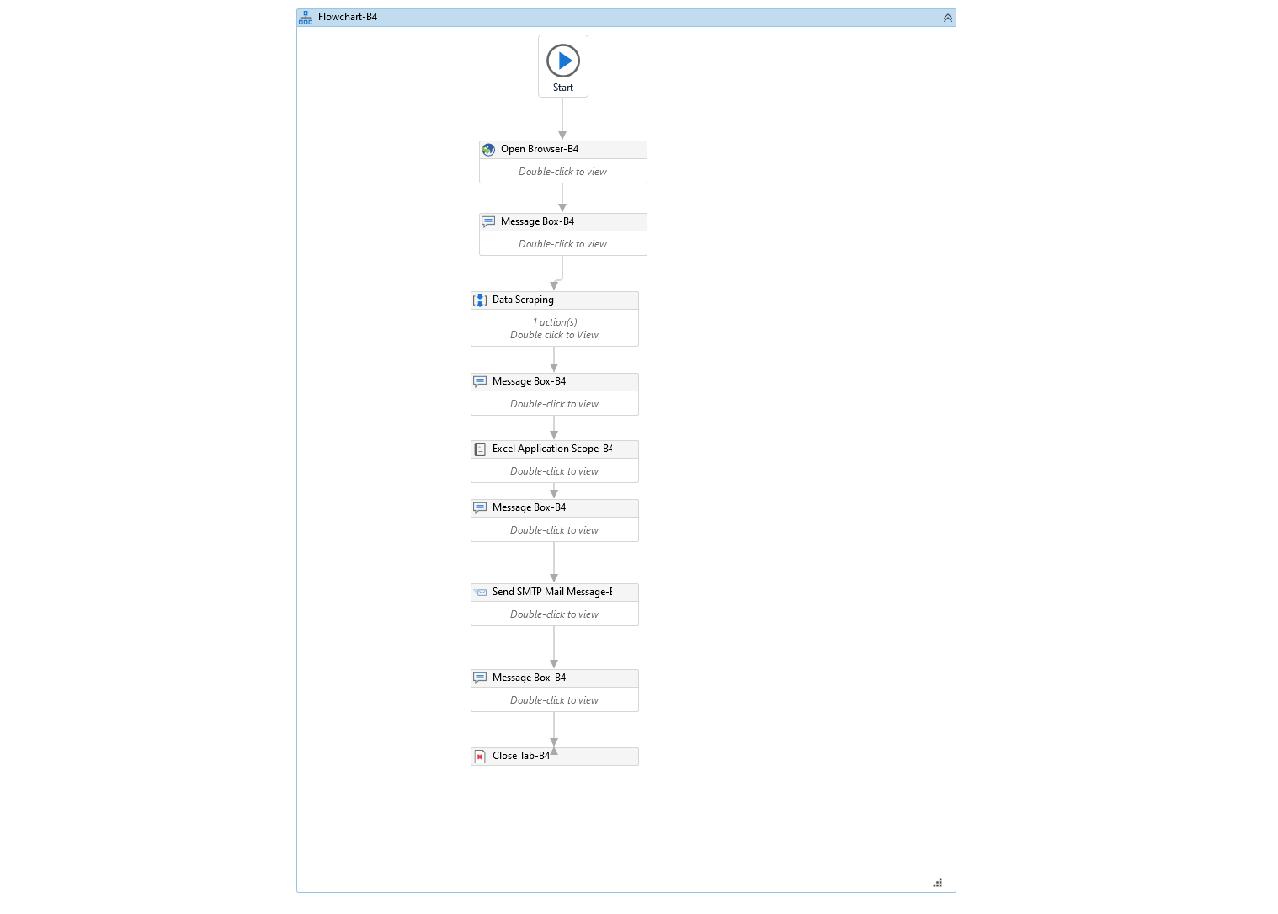

Fig. Design Workflow of the process

**Workflow Design – Open Browser**

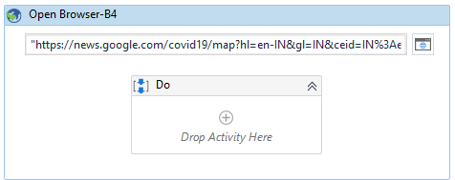

**Workflow Design – Data Scraping**

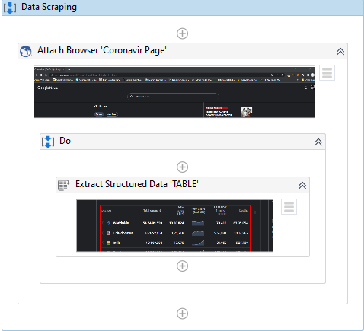

Fig. Data Scraping Process

**Workflow Design – Excel Application Scope**

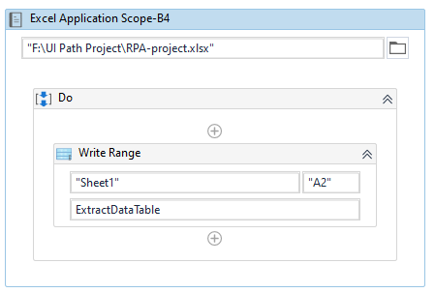

Fig. Data Scraping Process

**Workflow Design – SMTP Mail Message**

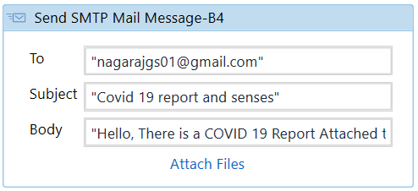

Fig. SMTP Mail Message Process

**Output**

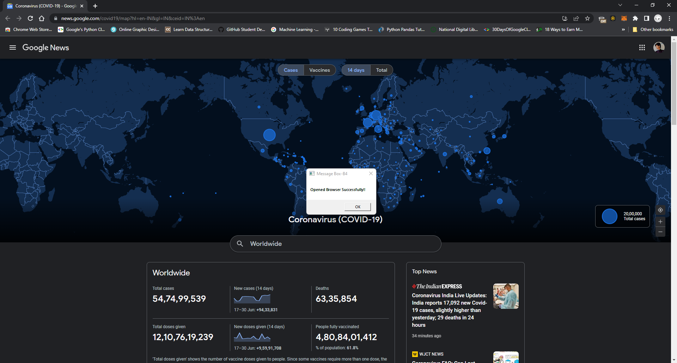

Fig. Successfully opened browser

**Output**

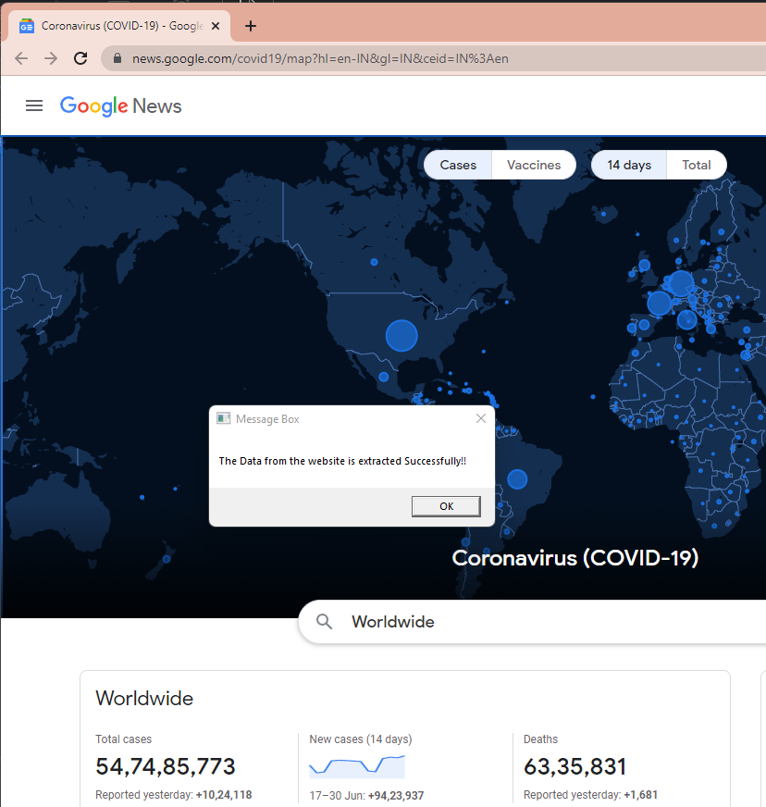

Fig. Successfully extracted data from the website

**Output**

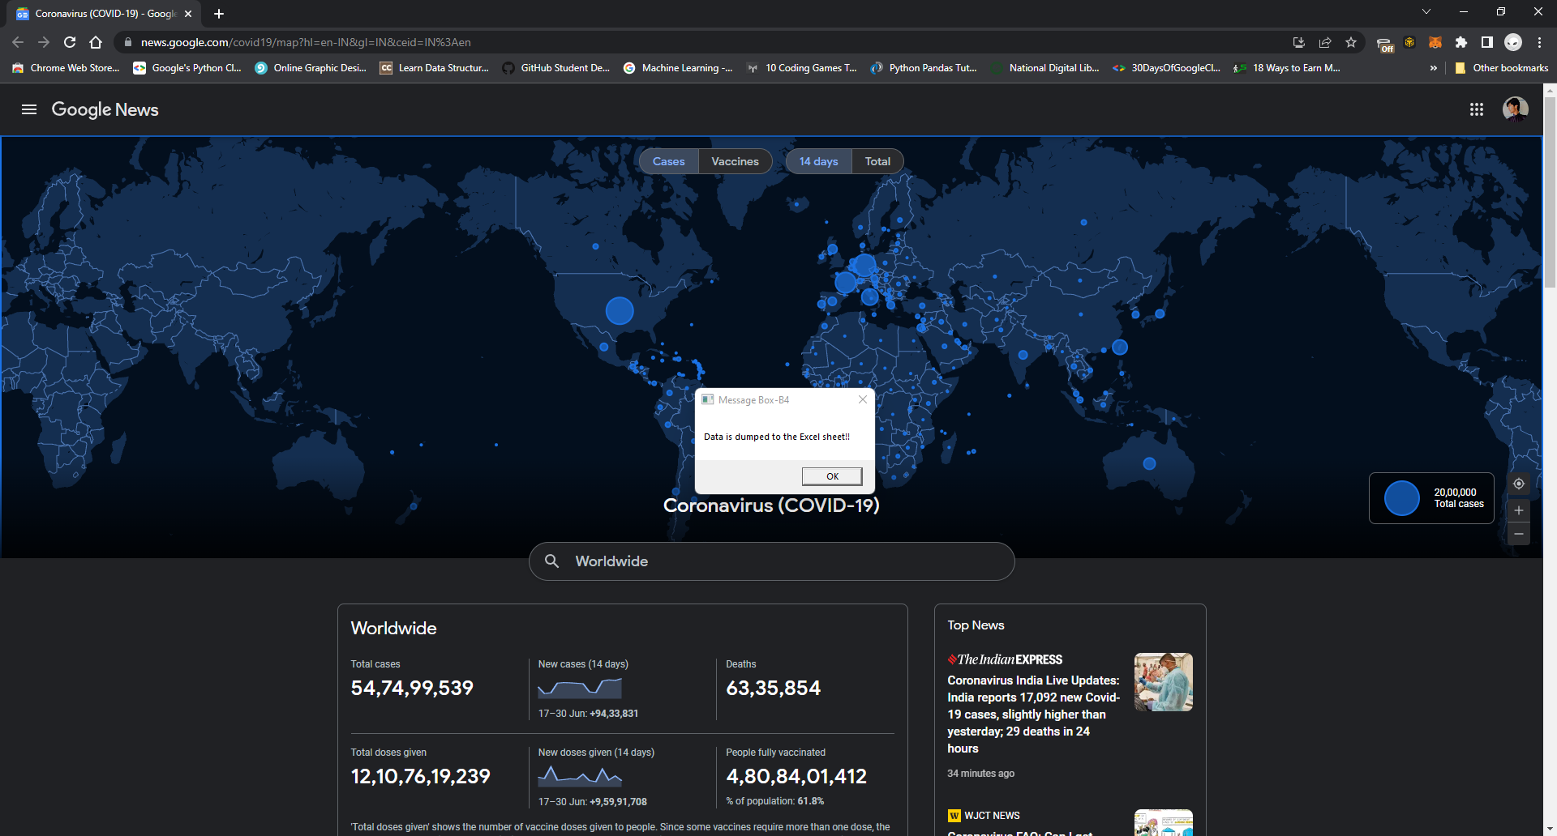

Fig. Successfully dumped data from the website to excel sheet

**Output**

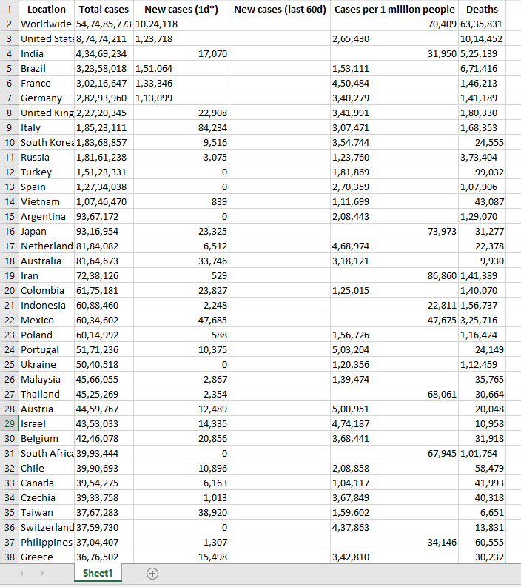

Fig. Data stored in excel sheet

**Output**

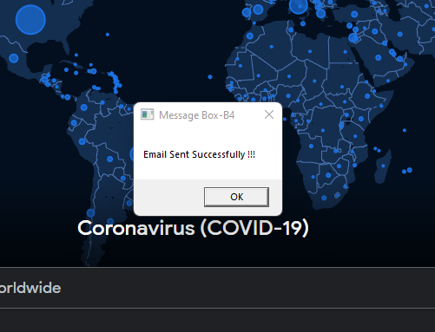

Fig. Email sent successfully

**Conclusion**

During the preparation of this project and report we were exposed to various activities and concepts which helped us improve our skills in UiPath. We were exposed to fundamentals of SMTP Mail servers, Data scraping from websites, working with excel sheets and working with process automations.

**References**

* [Covid 19 website] - [https://news.google.com/covid19/map](https://news.google.com/covid19/map?)
* Website – Covid 19 reports - <https://www.who.int/>
* Website - <https://academy.uipath.com/>
* Text Book - Robotic Process Automation: Guide to Building Software Robots, Automate Repetitive Tasks & Become an RPA Consultant

…Thank you…