S.E.E.R.

W.A.R.R.I.O.R.

  - User Guide: Machine Operator, Tradesman, and Supervision
  - 2012_1212
  - Guide version 5 (for Module version 2 [as of v-1.5.2-b])

Note: includes an intro to the plugin 'lactalis_bartender_labeling_system', as a general introduction to utilizing integration between WARRIOR and an external labeling system (which utilizes a labeling plugin built off of the WARRIOR labeling_system_plugin_template).

SUMMARY

WARRIOR is intended to be used as a natural part of daily operations, in conjunction with current machine operations. It is a method of tracking machine performance, downtime, and to identify the causes of common problems.

It is also a means of bringing label application control to the operator with as little aggravation as possible, and eliminating the need for a second control panel / screen when a single operator (or group of operators) is responsible for a single line running both O.E.E. / T.E.E.P. and label application.

You will be expected to use it, and to do so properly.

ACCESS

You have been provided or will be provided a unique username and password to access SEER. These are your own, and they are NOT to be shared and NOT to be used by anyone but you.

NAVIGATION AND MACHINE CONTROL

  - Navigate to your company's SEER homepage and select 'LOGIN' from the upper menu.


      - Enter your username / password combination, and click the 'Go' button.
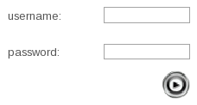
      - You should see a 'SUCCESSFUL LOGIN' notification. If you do not, or cannot login, please contact a System Administrator.
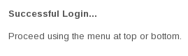
  - Now, select 'MACHINE CONTROL' from the upper menu.

      - Scroll down to the section titled 'WARRIOR'.
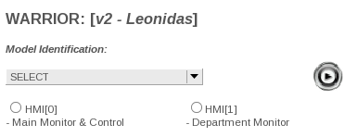
      - Select your 'DEPARTMENT' from the drop-down menu.
      - To view current department overall status, click the checkbox next to 'HMI[1] Department Monitor', and then click the 'Go' button.
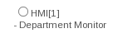
          - You will see a screen similar to the following, that will update at a regular interval.

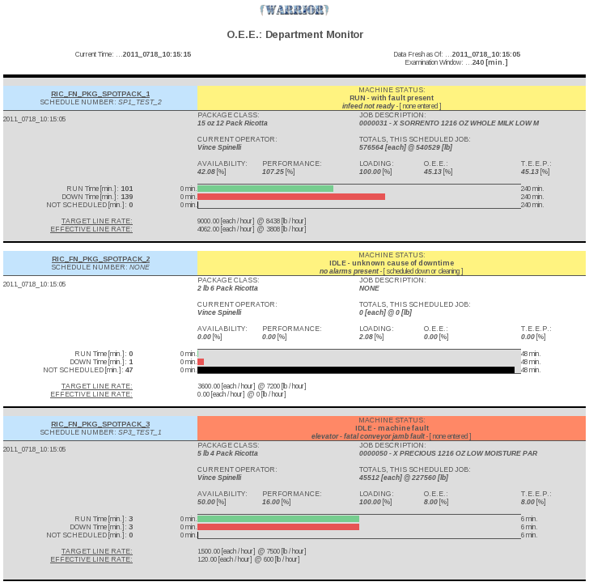

  - To control a machine's function, click the checkbox next to 'HMI[0] Main Monitor & Control', and then click the 'Go' button.
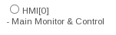
      - Now, select (from the drop-down) which machine within the department that you wish to control, and click the 'Go' button to launch the control console.

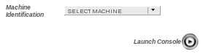
      - You will see a screen similar to the following, that will update at a regular interval, with controls at the bottom.

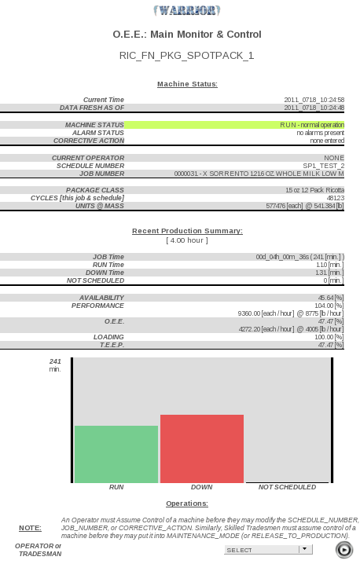

      - In order to make use of any controls, you must first ASSUME CONTROL of the machine, by selecting 'ASSUME CONTROL OF MACHINE' from the drop down menu titled 'OPERATOR or TRADESMAN', and then – of course – click the 'Go' button.
      - Once you've assumed control, the bottom portion of the screen will look similar to the following (note: the following screenshot includes the proprietary plugin 'lactalis_bartender_labeling_system', and thus the screen image will vary with other plugins).

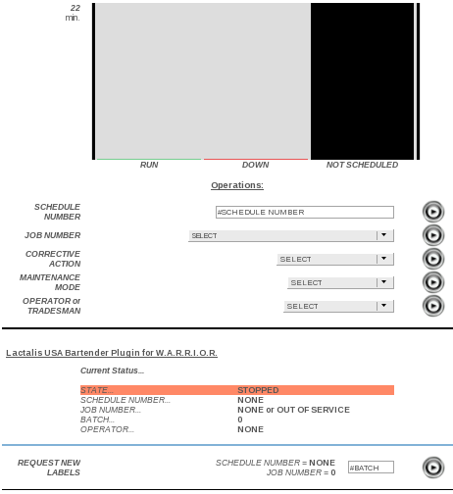
      - BE ADVISED: the following controls must be executed individually. You cannot type in a new schedule number, select a new job number, or any other combination at the same time. This is because each entry is bound to a different back-end component. For example... schedule numbers are bound to your SEER Server's Database, job numbers are bound to the individual machine's logic controller (typically a PLC), and any label_plugin (whether via the lactalis_bartender_labeling_system plugin, or otherwise) are bound to a 3rd party Labeling System Server or other device.

      - SCHEDULE NUMBER
      - You may now change or update the running 'SCHEDULE NUMBER' by typing in any combination of ALPHA-NUMERIC characters.
          - These include “0 – 9”, “a – z”(lowercase), “A – Z”(uppercase), as well as the dash (subtract sign) “-” and the underscore “_”.
          - Your input will be sanitized and converted to all uppercase letters and numbers, with disallowed characters removed automatically.
          - The only exception to this is the following:
              - “space” key.
              - “;” semicolon key.
              - These keys are not accepted, and they cannot be filtered out. If you enter a schedule number with either of these, your input will be completely rejected (in the case of space) or possibly mis-interpreted (in the case of semicolon). Simply put, do not use these two keys for the schedule number entry. If you happen to make a mistake and use one of them, simply re-entering a valid schedule number will rectify the problem. Regardless, you will know immediately, because the 'new' value that you input will NOT show up as the 'current' value.

      - JOB NUMBER
        - You may update the current running 'JOB NUMBER' by selecting the resource or product identification (loosely termed simply as 'JOB') number from the drop down, and clicking the 'Go' button.
        - If you utilize a labeling system plugin, that plugin should control automatic update of the job number list.
              - In the case of the lactalis_bartender_labeling_system plugin, the job list is updated automatically every few hours. When the update is triggered, the unlucky user who is using WARRIOR at the moment will encounter a 1 to 2 minute delay where the page appears to be frozen (but is not). This is due to the sheer size of the job (resource) list being worked on – smaller deployments will not see this. If the user refreshes the page, or presses the 'back' button (thinking that they have encountered a frozen page and wish to reload it), the plugin must be written in such a manner (and php.ini settings provided such that) the update will continue in the background, regardless. This is the default behavior using the sample php configuration provided with the help package... SEER_-_SERVER_BUILD_NOTES_-_FULL_KIT_-_RHEL_2011-05-20.

        - If you do NOT utilize a labeling system plugin, then System Administrators, Super Users, Managers, and Supervisors (access levels greater than or equal to '4') may add or modify 'JOB' numbers via the 'SETTINGS' tab on the upper menu. Only System Administrators and Super Users may remove or delete 'JOB' numbers via the same menu.
            - Note: when not using a labeling system plugin, if you have a large number of 'JOB' identification numbers, it is adviseable that a System Administrator make the initial entry via direct database dump through the console on your SEER server. Initial setup will be much less time consuming that way.

      - CORRECTIVE ACTION
        - Not all machine faults may be known. While every effort should be made by the Machine Controller (PLC) programmer to identify any and all machine faults, and have them auto-trigger, there may be instances where sensors are not in place, or the machine controller simply cannot diagnose the cause of machine downtime. For this purpose, WARRIOR uses an 'Idle Timeout' feature. After a predefined amount of time (the default is 2 minutes) where the machine has NOT cycled –and- no hard faults have been detected, the machine will identify itself as being in a state of “IDLE – UNKNOWN CAUSE OF DOWNTIME”.
        - If this should happen, you will see the 'CORRECTIVE_ACTION' entry field appear (below the 'JOB_NUMBER' field). Here you may select (from a drop down menu) a list of downtime causes.
            - You do not have to enter this corrective action immediately upon occurrence of downtime. Rather, tend to your machine, and prior to starting back up (prior to resuming running), enter the appropriate corrective action. As long as you do this a few moments before starting production (assuming your system admin is pulling data at a fast rate [such as every 15 seconds or better]), then that corrective action will be back-pushed onto the previous downtime instance.
                - Failure to enter a corrective action when machine state is identified as “IDLE – UNKNOWN CAUSE OF DOWNTIME” will result in all reports showing the downtime instance as being “UNEXPLAINED” in nature (synergistic / hybrid) and “NO ALARMS PRESENT / NO CORRECTIVE ACTION ENTERED (but still down)” in type (discrete).
            - For downtime instances where a fault is detected, the 'CORRECTIVE_ACTION' should be left blank, as the machine already knows why it is down.
      - Upon the machine resuming it's normal running state, the 'CORRECTIVE_ACTION' that you have entered (if any) will be automatically cleared by the machine controller.

      - MAINTENANCE MODE
        - This function is available ONLY to those personnel listed as being part of the Maintenance Department or with an access level of '6' (Skilled Trades).
        - Maintenance mode is useful for two things.
            - Most importantly, during normal operation, a machine may break down. Maintenance is called to diagnose and test the machine to determine and fix the problem. In doing so, they may be required to cycle the machine (empty or with bad product) several if not dozens of times (or more). To prevent these cycles from counting toward production totals, and to correctly categorize the machine's condition for reporting, maintenance personnel should log into SEER, assume control of the machine, and then place it in 'MAINTENANCE_MODE'.
            - Secondly, even if the machine is not running (scheduled down or otherwise), maintenance personnel should log in to ensure that the machine will not potentially resume production mode status reporting (for example, if it is 'faulted' with a 'CORRECTIVE_ACTION' of 'SCHEDULED_DOWN' – which would be overridden as soon as machine cycling resumed).
            - Upon completion of work, they should use the 'MAINTENANCE_MODE' drop down, and select 'Release to Production', and then use the 'OPERATOR_OR_TRADESMAN' input to 'ABANDON_MACHINE'. The normal machine operator can then log back in and re-assume control of the machine.

      - GOING ON BREAK (LUNCH or OTHER)
        - There are two ways to deal with an operator going on break (if and only if he is not being relieved during that break – basically, only if the machine is actually going to stop running because the operator is on break).
        - Method #1
            - taking the machine down, but instead of using a 'CORRECTIVE_ACTION' of “SCHEDULED_DOWN”, use “OPERATOR_ON_BREAK_OR_LUNCH”
(See the next section, titled “Machine Scheduled Stop / Scheduled Down” for instructions.)
        - Method #2
            - Ensure that there are no machine faults present (warnings are alright, but not faults), and simply stop feeding the machine production materials. After a few moments (default is 2 minutes) without having cycled, the machine will force a state of “IDLE – UNKNOWN CAUSE OF DOWNTIME”, where the operator may then update the 'CORRECTIVE_ACTION' to “OPERATOR_ON_BREAK_OR_LUNCH”.

      - MACHINE SCHEDULED STOP / SCHEDULED DOWN
        - If the machine has completed its scheduled work for the day, and it is to be down for a good while (such as for cleaning, or simply to be idle), then the last operator to use the machine should take the following steps...
            - [1] Update 'JOB_NUMBER' to “0 – None or Out of Service”
            - [2] Once the control screen has returned and the current job is listed as “0”, then you should enter a 'CORRECTIVE_ACTION' of “SCHEDULED_DOWN”.

      - OPERATOR BEING RELIEVED OR LEAVING FOR THE DAY
        - If an operator is leaving for the day (or after they have put a machine into a 'SCHEDULED STOP / SCHEDULED DOWN' condition), they must use the 'OPERATOR_OR_TRADESMAN' drop down and select 'ABANDON_MACHINE', prior to logging out of SEER.
        - If an operator is simply being relieved by another operator “on the fly” (so to speak), then it is acceptable (provided it is also acceptable within your company's operations, behavioral, and record keeping standards) to simply log out of seer whilst remaining in control of the machine. The relief operator then logs into SEER, navigates to the appropriate Machine Control page, and immediately uses the drop down to select 'ASSUME_CONTROL_OF_MACHINE'.

CONTROL OF LABELING APPLICATION PLUGINS

  - If using a labeling application plugin, there will be an additional control section, just below the (already discussed) controls of HMI[0]. Regardless of how your particular label plugin may work 'behind the scenes', the end effect is to push the 'SCHEDULE_NUMBER', 'JOB_NUMBER', 'OPERATOR_NAME', 'MACHINE_NAME' (or other identifier), and possibly additional information out to a 3rd party label application.
  - In order to do this, you must be sure to follow the previously discussed instructions with regard to 'ASSUMING CONTROL' of a machine, entering and updating the 'SCHEDULE_NUMBER', and entering and updating the 'JOB_NUMBER'.
  - You must be aware that simply updating these fields will not automatically update them with your label application. Rather, after updating, you must then use the additional controls to 'REQUEST' or 'CANCEL' labels with your external 3rd party application.

  - EXAMPLE WITH lactalis_bartender_labeling_system PLUGIN

      - this plugin, when active, should generate a control screen similar to the following...
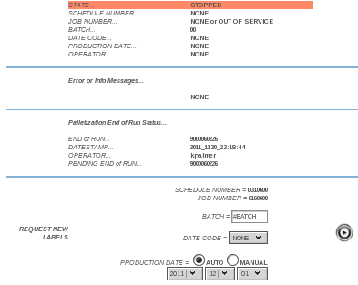

    - 'CURRENT_STATUS' readily identifies what the labeling system is using to generate labels for the machine. Obviously, when labels are turned off, or 'CANCELED', these fields are automatically set to 'NONE'.

    - REQUESTING LABELS

      - you can only request labels when the label plugin's 'CURRENT_STATUS' is 'STOPPED'. Otherwise, you must first 'CANCEL' labels (for whatever may be running), and then you will see the controls to 'REQUEST_NEW_LABELS'.
      - Be sure the 'SCHEDULE_NUMBER' and 'JOB_NUMBER' are accurate. If they are not, use the existing WARRIOR controls (higher up on the page) to change them appropriately.
      - Additionally, the labeling system needs to know the 'BATCH' number (we have given “lot”, “vat”, “series”, etc... the general name of 'BATCH'), 'DATE CODE', and 'PRODUCTION DATE'.
          - The 'BATCH' number must be a NUMERIC value up to 8 characters long (anything '00000000' through '99999999' is acceptable – letters and special characters are not allowed).
                - Letters and special characters are automatically removed from the input value.
                - Again, the “space” key and “;” (semicolon) are not accepted, and cannot be filtered out.
                - If you happen to make a mistake and use one of them, 'CANCELLING' labels, and then re-'REQUESTING' them (with a valid 'BATCH' number) should rectify the problem.
- The 'DATE CODE' type for production labeling is selected via drop down menu.
- The 'PRODUCTION DATE' (also called 'Pack Date' or 'Make Date') can either be manually defined (by clicking the 'MANUAL' checkbox, and then selecting the date via drop down menu), or automatically determined by the labeling system (by clicking the 'AUTO' checkbox – if 'AUTO' is clicked, whatever value is in the drop down menu will be ignored, and the labeling system will use a Production Date declared by the information contained in the master schedule for the job.

    - CHANGING BATCHES
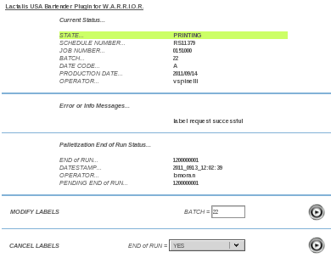

      - in order to change 'BATCH' (vat, lot, etc...), you must simply type in the new batch number, and press the 'Go' button on the 'Modify Labels' row.
      - Do –NOT-- cancel labels if you simply wish to modify the 'BATCH' !!!!

    - CANCELLING LABELS

      - you can 'CANCEL_LABELS' (stop label application) by pressing the 'CANCEL_LABELS' button at any time. You do NOT have to put the machine into a 'SCHEDULED_STOP' or 'SCHEDULED_DOWN' state. You can stop labels for any reason, at any time, at will.

      - When doing so, you must select an 'END OF RUN' option first.
          - 'YES' will log the LAST package to have been scanned as the 'End of Run Trigger' package. So, if you are utilizing automatic palletization, be sure that the last package did in fact go toward the auto-palletizer and not to the hand-pack station. If it did go to hand-pack, then take one away from the hand-pack station and make sure it goes to the auto-palletizer. Then you may select 'YES'.
          - 'NO' will stop production without sending an 'End of Run Trigger' to the auto-palletizer.
          - 'FORCE CANCEL' will force the cancellation of labels operation and give you the ability to request new labels, even if the Labeling System does not authorize this, or does not respond to the cancellation request properly. The intention of this function is to account for times when the Labeling System may have stopped, run into a problem, or for some other reason stopped labeling operations on its own. In such an event, SEER will remain running as if labeling operations were still active, and the only way to remedy the issue will be to 'FORCE CANCEL' labels. Be advised, this instruction will NOT send an 'End of Run Trigger' to the auto-palletizer.
          - 'FORCE CANCEL ALL' will not only force the cancellation of labels operation (like with 'FORCE CANCEL'), but it will also send a series of instructions to the Labeling System to stop / cancel auto-palletization. This command is only available to Administrators and Super Users. In the event that the Labeling System encounters a major error, or SEER has been restored via backup from catastrophic failure, then you may have to issue this command to more or less “clear everything out”. Proper procedure would be to make sure all actual production operation for the line has stopped – there are no more packages to be auto-palletized, and there are no more hand-pack packages. Issue a 'FORCE CANCEL ALL', and any pending or 'in limbo' operations on the Labeling System will be aborted. You may then resume normal operations by requesting new labels.

REPORTING AND ANALYTICS

  - Navigate to your company's SEER homepage and select 'LOGIN' from the upper menu.
      - Enter your username / password combination, and click the 'Go' button.
      - You should see a 'SUCCESSFUL LOGIN' notification. If you do not, or cannot login, please contact a System Administrator.
  - Now, select 'REPORTING' from the upper menu.
      - Scroll down to the section titled 'WARRIOR'.

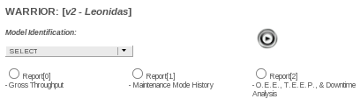

      - Select your 'DEPARTMENT' from the drop-down menu.
          - 'REPORT[0]' covers 'GROSS_THROUGHPUT', calculating the total mass, quantity, etc. of production during a given time period.
          - 'REPORT[1]' covers 'MAINTENANCE_MODE', detailing each instance a machine was placed into Maintenance mode during a given time period.
          - 'REPORT[2]' covers O.E.E., T.E.E.P., and Downtime Analysis. This is by far the most thorough analysis of machine fault and production codes, dividing machine time into 'RUN', 'DOWN' and 'SCHEDULED_DOWN' time. Then, downtime and scheduled downtime are broken down, individually, by what category each type of fault may fall into, plotting those faults by duration and frequency in a Pareto style. Further, faults themselves are broken down further into another set of Pareto charts. Lastly, depending on detail level chosen by the user, individual machine fault instances are shown – listing start / end datestamps, operator name, and other critical information.

    - Building a Report Ticket...

      - common to all WARRIOR reports is a request ticket similar to the following, requesting the 'START_DAY', 'START_MONTH', and 'START_YEAR', and then report duration in 'MONTHS' and 'DAYS'.

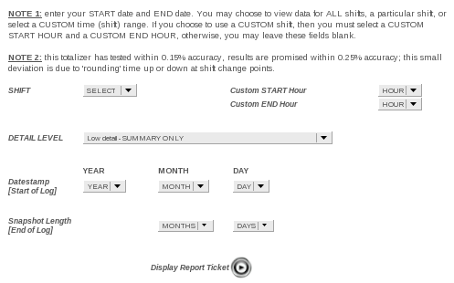
    - you may select any shift from the drop down menu, or choose 'CUSTOM' and enter your own custom 'START' and 'END' hours of the day (for abnormal shifts, or special reporting).

  - Recommendation for use...

      - MAINTENANCE / FAILURE
        - it is suggested that machines be analyzed from a maintenance / failure perspective over a one week to one month period using 'REPORT[2]'. Obviously, if certain topics peak one's interest, drilling down is logical. However starting with a one week or one month view of an entire department, with a detail level of “MEDIUM”, would be the best place to start.
      - PRODUCTION / PERFORMANCE
        - in regards to production and line performance, 'REPORT[2]' provides a nice global view, and the ability to see periods of time where the machine is not being utilized or under utilized.
        - However, 'REPORT[0]' provides a much better “day to day” or “week to week” performance metric to hold operators / department supervision to (when settings goals or benchmarking one group or shift against another – even when comparing one machine to another).
            - 'REPORT[0]' has a built-in shortcut next to every entry it displays.

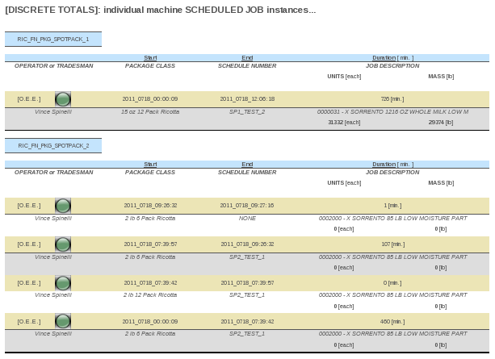
        - pressing the small, green button labeled 'OEE' to the left of each entry will jump to a streamlined version of 'REPORT[2]' which is focused solely on the machine, time period, and instance which is associated with the applicable 'REPORT[0]' entry.

