**CLIENT SIDE MODULE**

# CONTENTS

This module has the following files:

1. MODULE_CLIENT_SIDE.docx
2. MODULE_CLIENT_SIDE_MEDIA.zip

# INTRODUCTION

You are asked to develop a game called **Shooter** using HTML and CSS and develop client-side programming using JavaScript. Some media files are available to you in a zip file. You can create more media and modify anything in the media if you want. Your game needs to be developed in a tablet resolution (1000 x 600 pixels). In bigger resolution, the game must be centered in the screen both horizontally and vertically.

# DESCRIPTION OF PROJECTS AND TASKS

This is a module of 3 hours. You can create the layout using HTML/CSS and create the functionality of the game using JavaScript that allows the game to work correctly in different web browsers.

**Shooter** game screen should have meet these requirements below:

1. Player Name
2. Gameboard
3. Gun Type
4. Target
5. Total Score
6. Timer
7. Shoot History

## Design and Initial Layout

1. **Develop the initial markup (HTML + CSS) of your game application.** Overall screen must be within 1000 x 600 pixels and centered on the screen.
2. **You are free to decorate** the game screen design as long as it meets the requirements.
3. **The HTML and CSS** code must be valid in the W3C standards for HTML5 and CSS3 rules in accordance with the WCAG and standard ARIA (Accessible Rich Internet Applications Suite)

## Game Functionalities

1. **Show game welcome** in the center after pages are loaded.
2. **Players can go to the game** after filling the username field and click the “**Play Game**” button at the bottom of the welcome page.
3. **The “Play Game” button should be disabled** if the user did not input the username.
4. User must choose one from each option:
   1. one of three levels (easy, medium, hard).
   2. one of two guns to be used.
   3. one of three targets to be used.
5. **Game instructions should be shown** after the page is loaded.
6. **After clicking the “Instruction”** button, it shows game instructions.
7. **Users can close instructions** after clicking the **“X”** button.
8. **Show countdown for three seconds in the center of screen** after the user clicked the play button before the game started playing.
9. **When the game starts,** the timer will start with time according to level.
   1. ’30 seconds’ for easy level
   2. ‘20 seconds’ for medium level
   3. ‘15 seconds’ for hard level
10. **Add target** **randomly** every 3 seconds.
11. **The target will appear** with animation.
12. **When the game starts, there will be 3 random targets**
13. The pointer will appear in the center of the screen and move with the mouse
14. **gun** will move follow pointer motion.
15. **Player can shoot with click**
16. **Target will disappears** after being hit by the shoot.
17. **If the shot does not hit the target, the time will be reduced by 5 seconds**
18. **The score will be increased** if the player can shoot to target.
19. Players can change guns after pressing the space button
20. There is an animation when changing guns.
21. **Players can** **pause** the game.
22. Press **Esc** to open the **pause popup**. The game should be in a paused state when opening the popup.
23. Press **Esc** again to **continue** or click the “**continue”** button and the countdown should appear before the game continues.
24. **Game Over** when the timer time is up.
25. **Show popup after game over** to display the player username and scores, save match history button, and restart button.
26. **Match results should be saved in the local storage** after the player clicks the “**Save Score”** button.
27. **Players are able to** see the match history after clicking the Match History Button.
28. **Shoot history can be sorted** by score or last matches based on user choices.
29. **The game needs to work correctly** in Google Chrome.

# EXAMPLE

These following images are for example purposes only. You may design your own game layout.

**Welcome Screen**

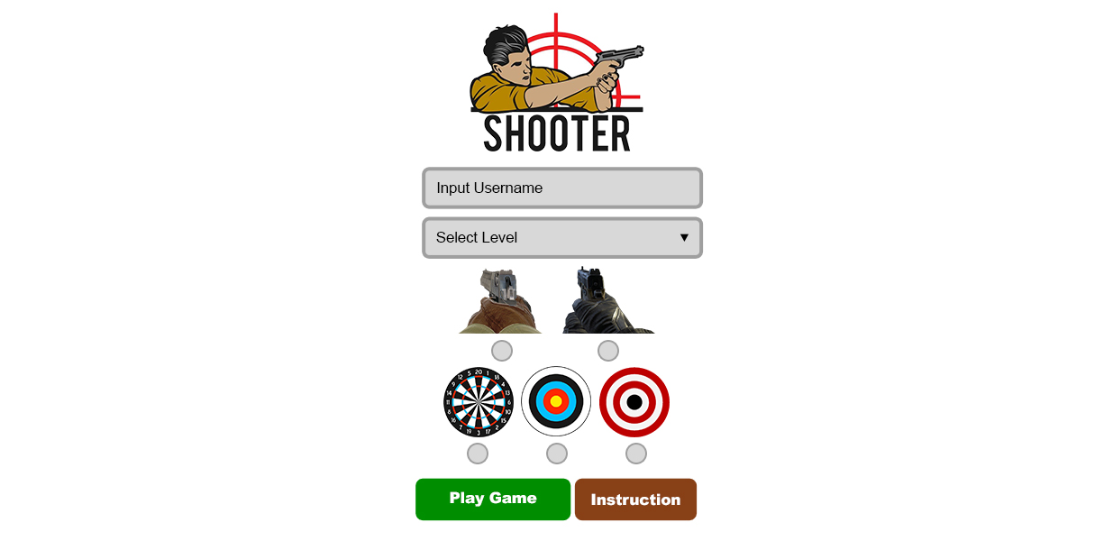

**Show Instruction**

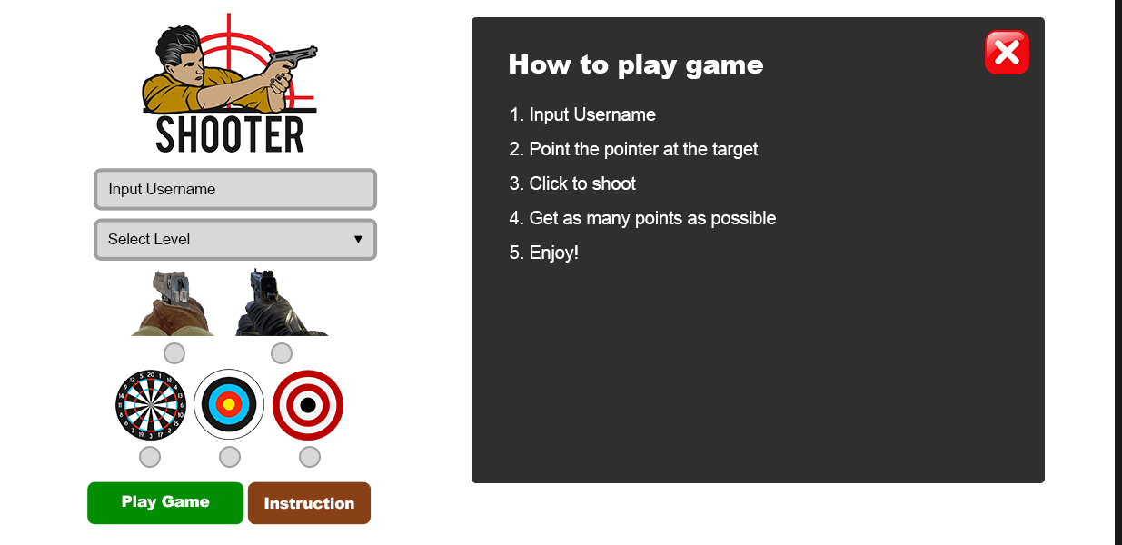

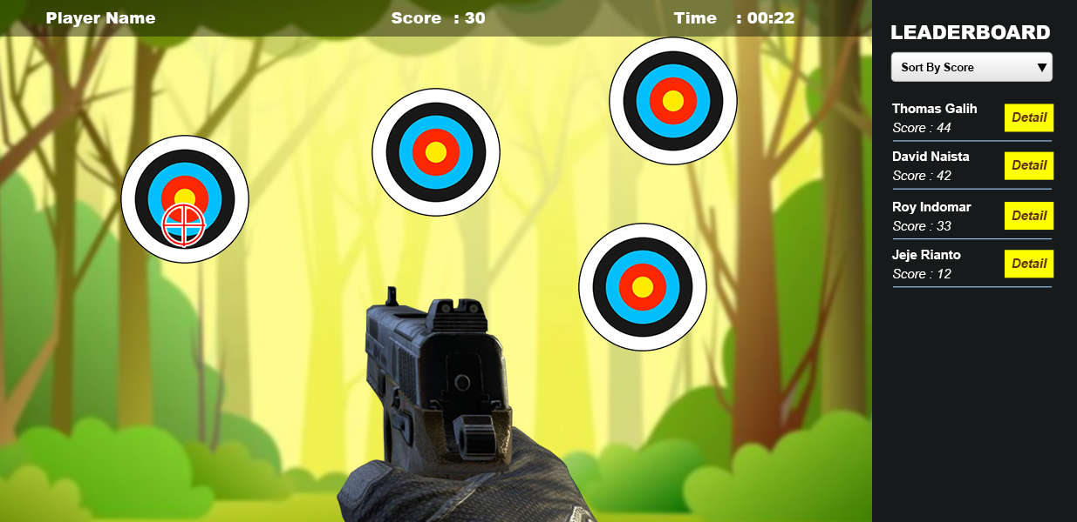

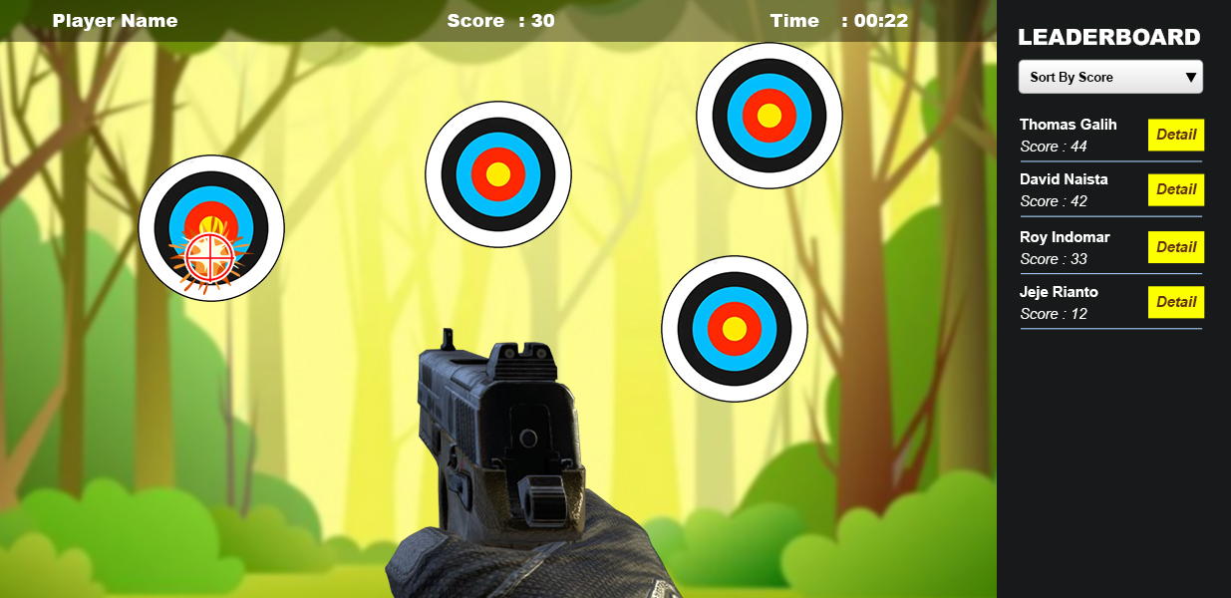

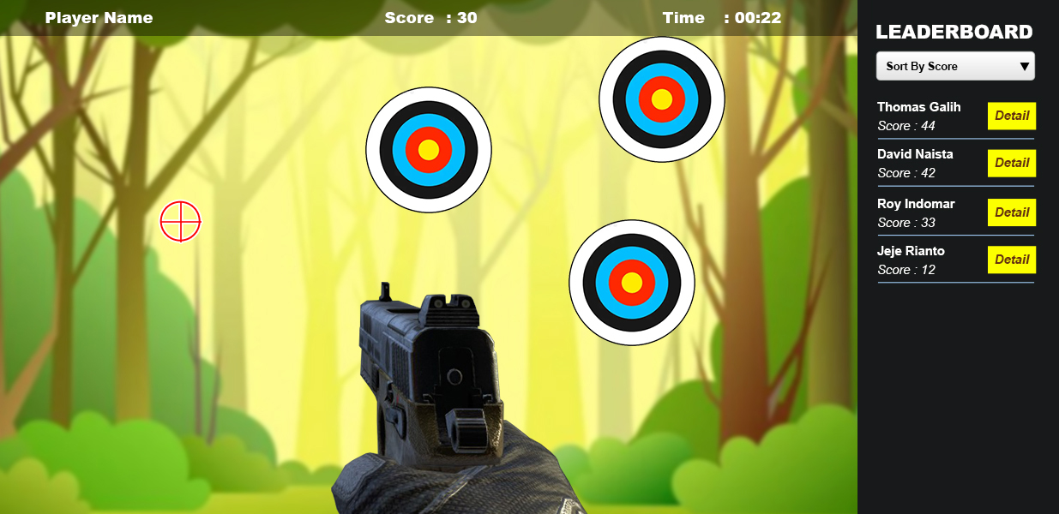

# INSTRUCTION FOR COMPETITORS

1. The media files are available in the ZIP file. You can modify the supplied files and create new media files to ensure the correct functionality and improve the application.
2. The entry file should be ‘**XX_CLIENT_SIDE/index.html’**
3. You should create additional images for each of the requested resolutions to highlight hidden elements, animations, interactions, or any additional information that will assist in the presentation of the game design.
4. Save the working game to the directory on the server named "**XX_CLIENT_SIDE**". Be sure that your main file is called **index.html**.
5. You are responsible for the time management in your development. If you finalize some tasks you can continue to other tasks.