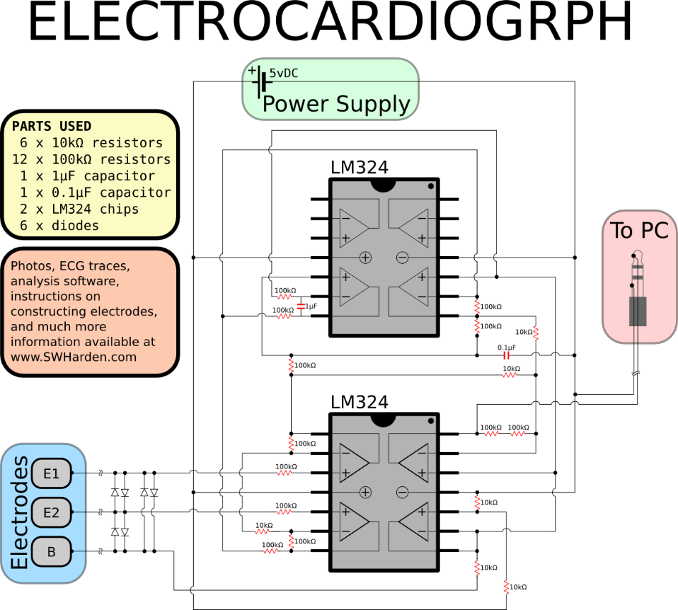

- (1) Instrumentation amplifier INA128  
- (1) Operational amplifier 741  
- (1) Arduino Uno  
- (1) 16x2 characters Liquid crystal display  
- (1) Voltage regulator 7805  
- (1) 8 ohms mini speaker  
- (1) Brigth LED (I use a 10 mm one)  
- (1) Diode 1N3064  
- (2) 9V Batteries with connectors  
-  Breadboard  
-  Jump wires  
Resistors :  
- (2) 100 ohms, 1/4W  
- (1) 470 ohms, 1/4W  
- (1) 1 kiloohms, 1/4W  
- (2) 10 kiloohms, 1/4W  
- (2) 100 kiloohms, 1/4W  
- (1) 1 Megaohms, 1/4W  
Capacitors :  
- (1) 10 nF  
- (1) 47 nF

<https://diyhacking.com/diy-ecg-build-electrocardiogram/>

<http://www.instructables.com/id/Electrocardiograph-Heart-Rate-Monitor/>

[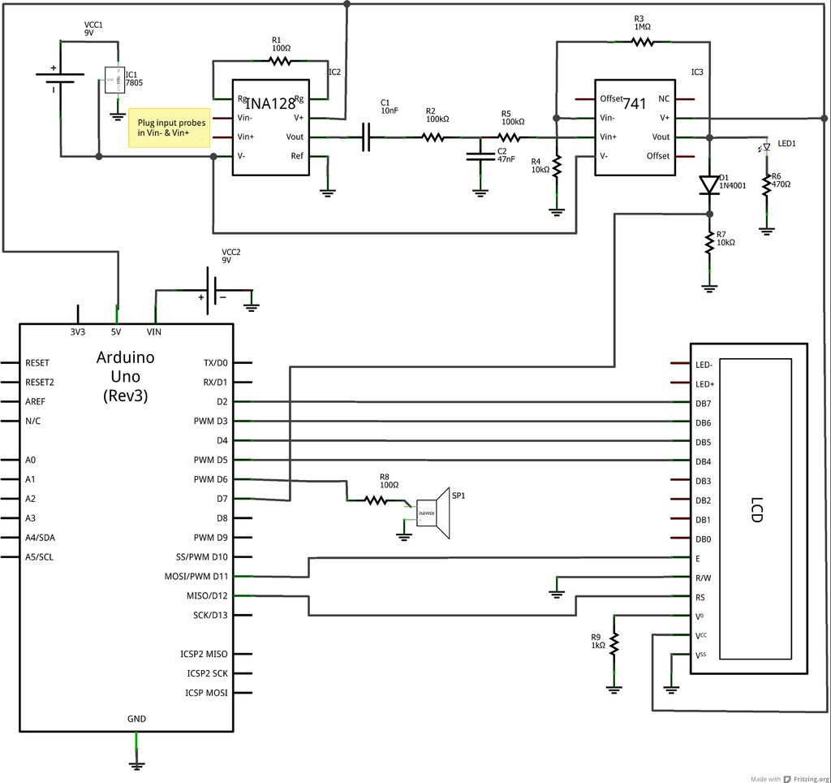](https://cdn.instructables.com/FAZ/QGW7/HOW0HQ7S/FAZQGW7HOW0HQ7S.LARGE.jpg)