Watch Data – Request Response Case

End Point: http://localhost:3000/api/v1/admin

Data:

email:berat

password:1234

Success:

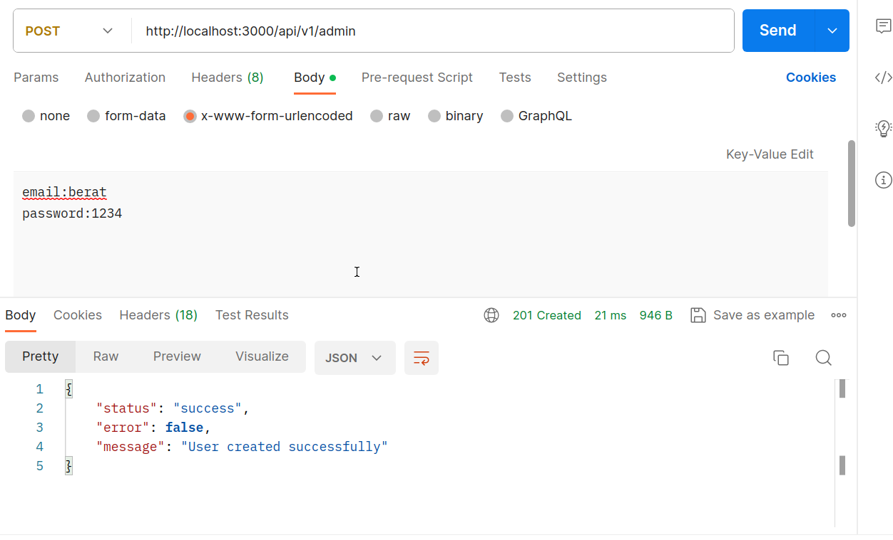

Fail:

