**SOFTWARE DESIGN**

**FunixSwap**

**1. Architecture**

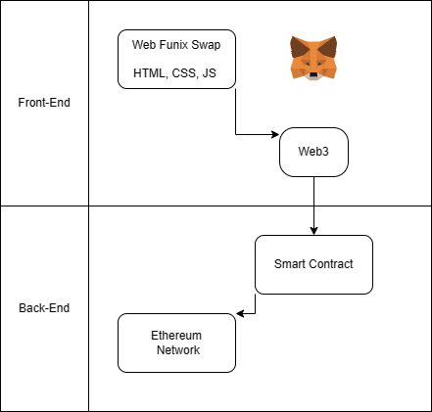

**2. Class Design**

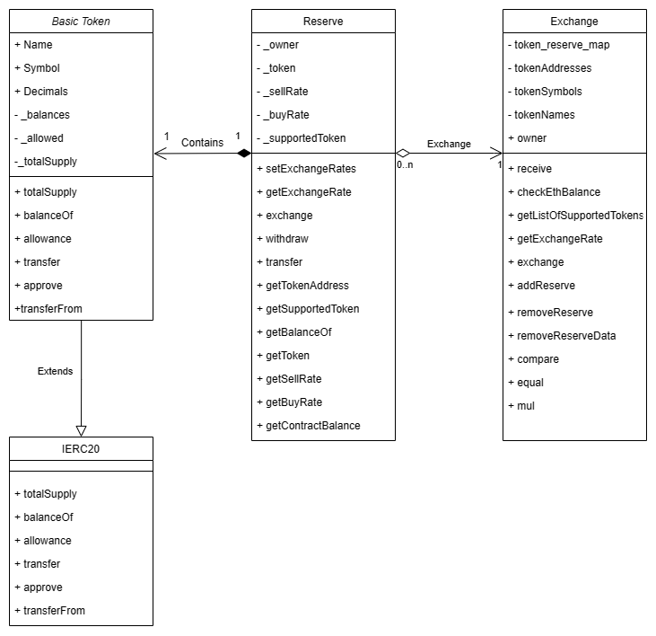

**3. Functional Design**

**A. Reserve**

|  |  |
| --- | --- |
| Function name | setExchangeRates |
| Function purpose | Set exchange rate for reserve’s token |
| Parameters | Uint256, Uint256 |
| Return type | Not return |

|  |  |
| --- | --- |
| Function name | getExchangeRate |
| Function purpose | Return the buyRate, sellRate of reserve’s token |
| Parameters | Bool, Uint256 |
| Return type | Uint256 |

|  |  |
| --- | --- |
| Function name | exchange |
| Function purpose | Convert (Buy/ Sell) from ETH to Reserve token |
| Parameters | Bool, Uint256 |
| Return type | Bool |

|  |  |
| --- | --- |
| Function name | withDraw |
| Function purpose | Owner can withDraw Token and ETH from Reserve contract |
| Parameters | No parameters |
| Return type | Not return |

|  |  |
| --- | --- |
| Function name | transfer |
| Function purpose | Contract can transfer amount of ETH to other address |
| Parameters | Address, uint |
| Return type | Not return |

|  |  |
| --- | --- |
| Function name | getTokenAddress |
| Function purpose | Get address of reserve’s token |
| Parameters | No parameter |
| Return type | address |

|  |  |
| --- | --- |
| Function name | getSupportedToken |
| Function purpose | Get reserve’s supported token name |
| Parameters | No parameter |
| Return type | string |

|  |  |
| --- | --- |
| Function name | getBalanceOf |
| Function purpose | Get token’s balance of input address |
| Parameters | address |
| Return type | unit |

|  |  |
| --- | --- |
| Function name | getTokenAddress |
| Function purpose | Get address of reserve’s token |
| Parameters | No parameter |
| Return type | address |

|  |  |
| --- | --- |
| Function name | getToken |
| Function purpose | Get object token of reserve |
| Parameters | No parameter |
| Return type | BasicToken |

|  |  |
| --- | --- |
| Function name | getSellRate |
| Function purpose | Get reserve’s token sell rate |
| Parameters | No parameter |
| Return type | unit |

|  |  |
| --- | --- |
| Function name | getBuyRate |
| Function purpose | Get reserve’s token buy rate |
| Parameters | No parameter |
| Return type | Uint |

|  |  |
| --- | --- |
| Function name | getContractBalance |
| Function purpose | Get reserve contract ETH value |
| Parameters | No parameter |
| Return type | uint |

**B. Exchange**

|  |  |
| --- | --- |
| Function name | receive |
| Function purpose | Receive ETH sent by other addresses |
| Parameters | No parameter |
| Return type | Not return |

|  |  |
| --- | --- |
| Function name | checkEthBalance |
| Function purpose | Get contract current ETH amount |
| Parameters | No parameter |
| Return type | Uint256 |

|  |  |
| --- | --- |
| Function name | getListOfSupportedTokens |
| Function purpose | Get list of supported token |
| Parameters | No parameter |
| Return type | Address[] |

|  |  |
| --- | --- |
| Function name | getExchaneRate |
| Function purpose | Get exchange rate from token A to token B by. X amount of token A to Y amount of token B. |
| Parameters | Address, address, unit256 |
| Return type | Uint256 |

|  |  |
| --- | --- |
| Function name | exchange |
| Function purpose | Exchange token A to token B |
| Parameters | Address, address, amount |
| Return type | Uint256 |

|  |  |
| --- | --- |
| Function name | addReserve |
| Function purpose | Add new reserve to contract |
| Parameters | Reserve |
| Return type | Not return |

|  |  |
| --- | --- |
| Function name | removeReserve |
| Function purpose | Remove reserve from contract |
| Parameters | address |
| Return type | Not return |

|  |  |
| --- | --- |
| Function name | removeReserveData |
| Function purpose | Remove reserve data from contract |
| Parameters | Uint256 |
| Return type | Not return |

|  |  |
| --- | --- |
| Function name | compare |
| Function purpose | Compare 2 string |
| Parameters | string, string |
| Return type | int |

|  |  |
| --- | --- |
| Function name | equal |
| Function purpose | Check if 2 string are equal |
| Parameters | string, string |
| Return type | bool |

|  |  |
| --- | --- |
| Function name | mul |
| Function purpose | Get reserve contract ETH value |
| Parameters | No parameter |
| Return type | uint |