**SOFTWARE REQUIREMENTS SPECIFICATION**

**1. Product overview**

* Product name: FunixSwap – A decentralized exchange for swapping tokens.
* Product description:
* FunixSwap is a trading platform for user to trade Token, transfer token from one Token to others.

//*TODO*: *Briefly describe* *the* *main* *functionality of the product.*

* The benefit to users:
* Fast transfer, secure and easy to use.

// *TODO: specify* w*ho is the key user that the product is targeting. How is it beneficial to the key user? Which user’s problem will be solved by using the product?*

* Actors:
* Client – Token trader, transfer
* Token owner

|  |  |  |
| --- | --- | --- |
| *No.* | *Actor* | *Description* |
| *1.* | Client | *Token traders, metamask users* |
| *2.* | Token owner | *Token contract owner* |

**2. Functional Specifications**

**2.1. Use Cases Diagram**

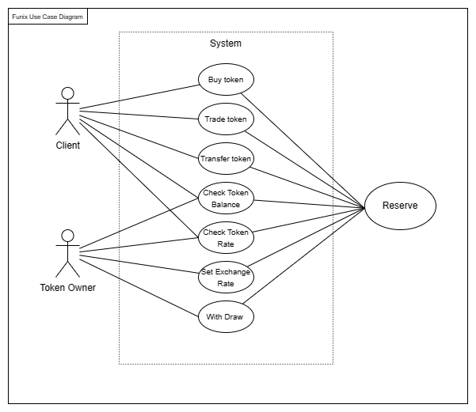

**2.2. Use Cases Specifications**

**2.2.1**

|  |  |
| --- | --- |
| **ID:** | **UC.1** |
| **Title:** | Buy token |
| **Description:** | Client can use ETH to buy tokens from selected drop down. After press the Swap button on UI to trade from ETH to selected token with the amount displayed on the screen. |
| **Primary Actor:** | Client |
| **Post-conditions:** | Success Guarantees:  The X amount of ETH transfer to Reserve contract and Y amount of token A transfer to user wallet.  FunixSwap will display a success message to prompt client that the trade has come through. |
| **Preconditions:** | Client has enough ETH. |
| **Trigger:** | Client press the Swap button and confirm the amount of ETH trade to X number of selected tokens. |
| **Main  Success Scenario:** | FunixSwap will display the UI the user. User change to the swap tab.  User choose the token to buy  User enter the amount of selected token to buy. FunixSwap will display the amount of ETH required to trade.  User press the swap button.  FunixSwap will display the confirm box. If user select accept, go to 6.1. Else user press Cancel, go to 6.2.  FunixSwap will swap X ETH from user wallet to Y amount of selected tokens  FunixSwap will close the confirm box. |
| **Extensions:** | 1. Display 2. FunixSwap gets all the tokens its support, the rate of the default token. 3. Calculate token rate 4. After client enter X amount of token to the input box. FunixSwap will calculate the amount of the received token at the moments. 5. Cancel and swap 6. After client the press button, FunixSwap will show all the information about the trade. 7. If confirmed FunixSwap will send a trade to the Reserve contract 8. Time out 9. After user not using FunixSwap for 5 minutes. It will disconnect from Metamask, Keystore, … |

**2.2.2**

|  |  |
| --- | --- |
| **ID:** | **UC.2** |
| **Title:** | Trade Token |
| **Description:** | Client can use ETH to buy tokens from selected drop down. After press the Swap button on UI to trade from Token A to Token B with the amount displayed on the screen. |
| **Primary Actor:** | Client |
| **Post-conditions:** | Success Guarantees:  The X amount of Token A transfer away and Y amount of selected token transfer to user’s wallet.  FunixSwap will display a success message to prompt client that the trade has come through. |
| **Preconditions:** | * Client has enough Token A. |
| **Trigger:** | Client press the Swap button and confirm the amount of token A trade to X number of destination tokens. |
| **Main  Success Scenario:** | FunixSwap will display the UI the user. User change to the swap tab.  User choose the token to buy  User enter the amount of selected token to buy. FunixSwap will display the amount of original token required to trade.  User press the swap button.  FunixSwap will display the confirm box. If user select accept, go to 6.1. Else user presses cancel, go to 6.2.  FunixSwap will swap X token A from user wallet to Y amount of destination tokens  FunixSwap will close the confirm box. |
| **Extensions:** | 1. Display 2. FunixSwap gets all the tokens its support, the rate of the default token. 3. Calculate token rate 4. After client enter X amount of token A to the input box. FunixSwap will calculate the amount B of the received token at the moments. 5. Cancel and swap 6. After client the press button, FunixSwap will show all the information about the trade. 7. If confirmed FunixSwap will send a trade to the Exchange contract 8. Time out 9. After user not using FunixSwap for 5 minutes. It will disconnect from Metamask, Keystore, … |

**2.2.3**

|  |  |
| --- | --- |
| **ID:** | **UC.3** |
| **Title:** | Transfer token |
| **Description:** | Client can switch to transfer tab, send selected token from dropdown to input address. |
| **Primary Actor:** | Client |
| **Post-conditions:** | Success Guarantees:  The X amount of Token A is transfer to inputted address’s wallet.  FunixSwap will display a success message to prompt client that the trade has come through. |
| **Preconditions:** | Client has enough Token A.  Inputted address exists. |
| **Trigger:** | Client press the transfer button and confirm the amount of token A to send to inputted address’s wallet. |
| **Main  Success Scenario:** | FunixSwap will display the UI the user. User change to the transfer tab.  User choose the token to transfer.  User enter the amount of selected token to buy. FunixSwap will display the amount of original token required to trade.  User press the swap button.  FunixSwap will display the confirm box. If user select accept, go to 6.1. Else user presses cancel, go to 6.2.  FunixSwap will swap X token A from user wallet to Y amount of destination tokens  FunixSwap will close the confirm box. |
| **Extensions:** | 1. Display 2. FunixSwap gets all the tokens its support, the rate of the default token. 3. Calculate token rate 4. After client enter X amount of token A to the input box. FunixSwap will calculate the amount B of the received token at the moments. 5. Cancel and swap 6. After client the press button, FunixSwap will show all the information about the trade. 7. If confirmed FunixSwap will send a trade to the Exchange contract 8. Time out 9. After user not using FunixSwap for 5 minutes. It will disconnect from Metamask, Keystore, … |

**2.2.4**

|  |  |
| --- | --- |
| **ID:** | **UC.4** |
| **Title:** | Check token blances |
| **Description:** | Client can view current balances of selected token |
| **Primary Actor:** | Client |
| **Post-conditions:** | Success Guarantees:  After client logged in with metamask, the selected token will have a balances line under the selected token |
| **Preconditions:** | Client logged in |
| **Trigger:** | Client log in to the FunixSwap |
| **Main  Success Scenario:** | FunixSwap will display the UI balances. User change to token to view other balances |
| **Extensions:** | 1. Display 2. FunixSwap gets all the tokens its support, display the current user balances 3. Time out 4. After user not using FunixSwap for 5 minutes. It will disconnect from Metamask, Keystore, … |

**2.2.5**

|  |  |
| --- | --- |
| **ID:** | **UC.5** |
| **Title:** | Check token rate |
| **Description:** | Client can open transfer tab. The rate will be displayed under the destination token with the combination of 2 selected token. |
| **Primary Actor:** | Client |
| **Post-conditions:** | Success Guarantees:  The X amount of Token A is transfer to inputted address’s wallet.  FunixSwap will display a success message to prompt client that the trade has come through. |
| **Preconditions:** | Client select from token and destination token. FunixSwap will display the rate of 2 token. |
| **Trigger:** | Client will choose 2 token and FunixSwap. |
| **Main  Success Scenario:** | FunixSwap will display the UI the rate.  User choose the token to transfer.  User enter the amount of selected token to buy. FunixSwap will display the amount of original token required to trade.  User press the swap button.  FunixSwap will display the confirm box. If user select accept, go to 6.1. Else user presses cancel, go to 6.2.  FunixSwap will swap X token A from user wallet to Y amount of destination tokens  FunixSwap will close the confirm box. |
| **Extensions:** | 1. Display 2. FunixSwap gets all the tokens its support, the rate of the default token. 3. Time out 4. After user not using FunixSwap for 5 minutes. It will disconnect from Metamask, Keystore, … |

**2.2.6**

|  |  |
| --- | --- |
| **ID:** | **UC.6** |
| **Title:** | Set exchange rate |
| **Description:** | Owner can set exchange rate |
| **Primary Actor:** | Owner |
| **Post-conditions:** | Success Guarantees:  Owner can set sell/ buy rate for specific token |
| **Preconditions:** | Owner is the master owner of the Reserve contract |
| **Trigger:** | Owner set the sell/ buy rate of the token |
| **Main  Success Scenario:** | Owner updated the sell/ buy rate successfully. |
| **Extensions:** | 1. Time out 2. After user not using FunixSwap for 5 minutes. It will disconnect from Metamask, Keystore, … |

**2.2.7**

|  |  |
| --- | --- |
| **ID:** | **UC.7** |
| **Title:** | Width Draw |
| **Description:** | Owner can width draw ETH from the Reserve contract |
| **Primary Actor:** | Owner |
| **Post-conditions:** | Reserve transfers all its ETH token to owner balances |
| **Preconditions:** | Owner is the owner of Reserve Contract |
| **Trigger:** | - |
| **Main  Success Scenario:** | Reserve will transfer all of its ETH to owner balances |
| **Extensions:** | 1. Time out 2. After user not using FunixSwap for 5 minutes. It will disconnect from Metamask, Keystore, … |

**3. Non-Functional Requirements**

* Web browser coverage: Chrome, Firefox.
* Number of user can access exchange at the same time: 200.

**4. Product Upgrades**

- The below functions will be added to the product soon:

+) Support Android OS and  iOS.