Haoyi Li

haoyi.sg@gmail.com (617) 378 2565 333 Harrison Street

<http://www.github.com/lihaoyi> San Francisco, CA 94105

Education Massachusetts Institute of Technology Cambridge, MA

* Bachelor of Science degree in Computer Science, GPA 4.8/5.0 Sep 2010 – Jun 2013

Work Dropbox San Francisco, CA

Software Engineer Aug 2013 – Present

* Worked on two-account login for web, two-account pairing flow
* Set up selenium testing infrastructure to run UI tests against major portions of the website
* Sped up home page on the Dropbox website by 6x
* Removed the size limit from uploading files through the website
* Prototyped new sharing features and peripheral capabilities like Account Photos

 Dropbox San Francisco, CA

Software Engineer Intern, API Team May 2012 – Aug 2012

* Built, documented and launched infrastructure to allow API apps to upload large files to Dropbox
* Wrote unit tests and set up a continuous integration server for the Dropbox client SDKs

# Facebook Palo Alto, CA

Software Engineer Intern, Messaging Team May 2011 – Aug 2011

* Built an extensible attachment framework for Facebook Messages

# Singapore Armed Forces Singapore

Platoon Commander, 35th Battalion Singapore Combat Engineers ­Jan 2008 – Nov 2009

* Managed the platoon’s discipline and wellbeing during training, as well as coordination and performance during combined arms field exercises

Activities Scala-JS

Core contributor Aug 2013 – Present

* Worked on ScalaJS (<http://www.scala-js.org/>) a Scala to Javascript cross-compiler that allows you to run Scala applications, which previously required a JVM, as Javascript in any browser
* Built several web applications, games and libraries using ScalaJS, proving out the platform and helping to attract a community and contributors
* Fixed several bugs uncovered in the course of my work and reported countless others
* Played a role in the architecture and design of the platform based on my experience with it
* Presented at the SF Scala meetup group (<http://vimeo.com/87845442>)

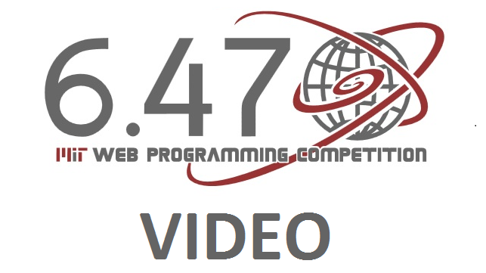 MIT Web Programming Competition ­­ Cambridge, MA

Front End Developer, 4th Place January 2011

* Developed Mojo, a website that uses statistical analysis to help users discover games they enjoy

Projects [Scalatags](http://www.github.com/lihaoyi/scalatags) – Fast, safe, cross-platform HTML generation in Scala

## [Scala.Rx](http://www.github.com/lihaoyi/scala.rx) – Cross-platform change Propagation/FRP library for Scala

## [Scala-Js-Fiddle](http://www.github.com/lihaoyi/scala-js-fiddle) – Compose, run and publish Scala-JS code right in the browser

## [Metascala](http://www.github.com/lihaoyi/metascala) – The worlds smallest DIY JVM in 3000 lines of Scala

## [MacroPy](https://www.github.com/lihaoyi/macropy) – Macros for Python, from string-transforms to hygienic quasiquotes

Awards 38th International Physics Olympiad – Gold Medalist July 2007, Isfahan, Iran

## 8th Asian Physics Olympiad – Gold Medalist May 2007, Shanghai, China