**API testing tool:** Postman

**Database:** Postgresql

**Programming Language:** Python

**Request and response format:** JSON

**Viewset List**

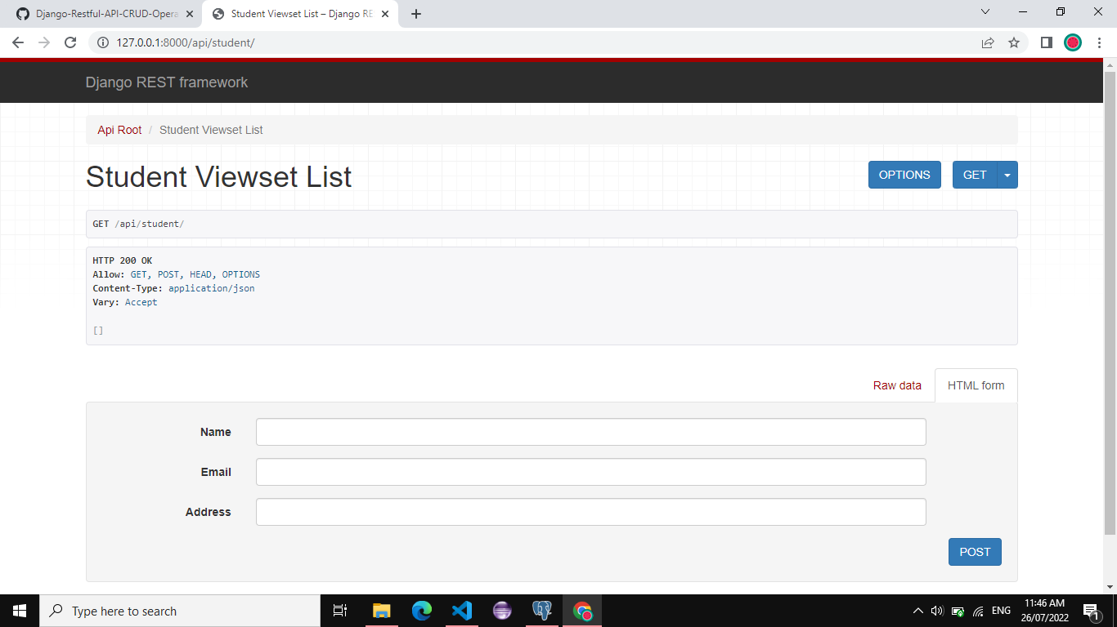

1. **Register Student API:**

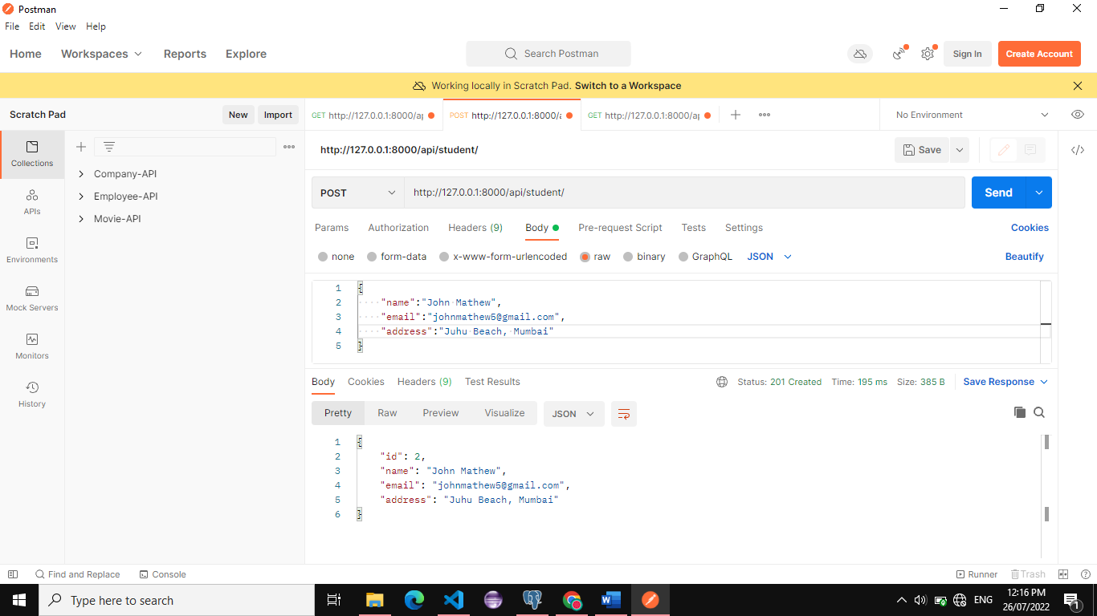

1. **Get all registered Student’s API:**

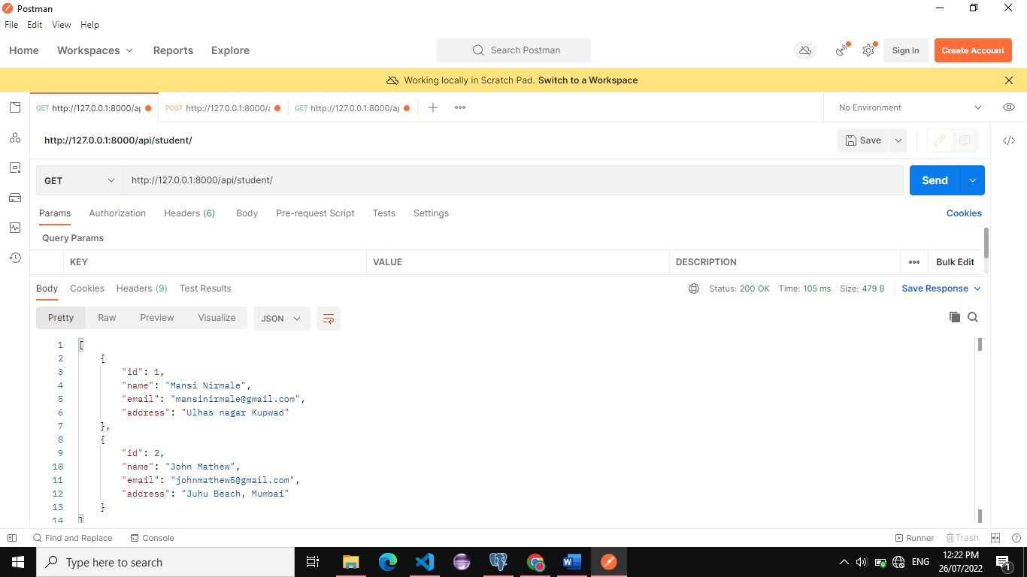

1. **Get Student by id API:**

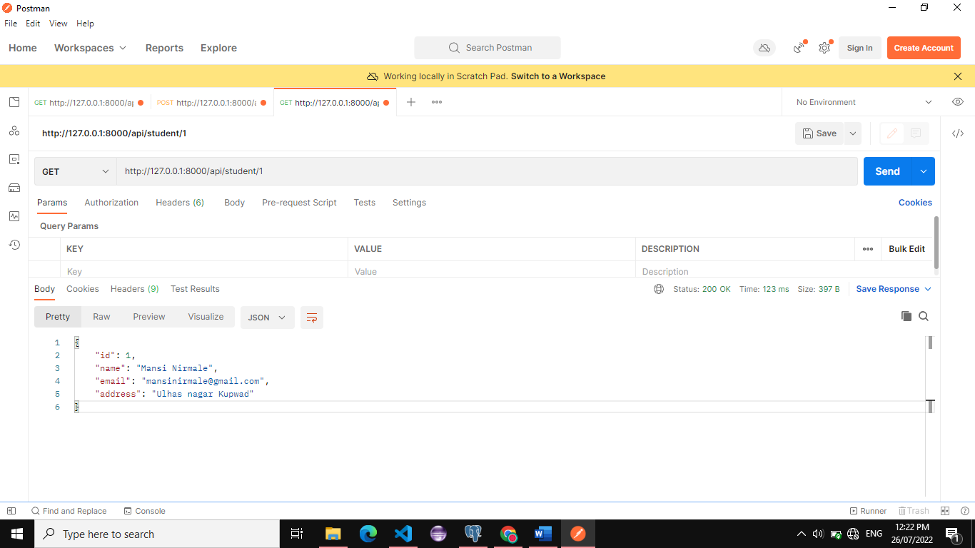

**Postgresql Database:**

