HIGH LEVEL DOCUMENT
OmniBridge Retail Integration Platform
Client
Meridian Retail Group
Prepared by
IBM Consulting
Document Reference: HLD-OMNIBRIDGE-2026-001
Version 1.0 | Draft
July 10, 2026
SAMPLE / ILLUSTRATIVE DOCUMENT — FICTIONAL PROJECT FOR DEMONSTRATION PURPOSES ONLY

1. Purpose & Scope
This High-Level Document (HLD) describes the architecture of OmniBridge, the integration platform connecting Meridian Retail Group's client channels to Oracle Middleware and the Enterprise MDM Hub. It covers system components, technology stack, integration points, data flow, and non-functional characteristics at an architectural level. Detailed design (APIs, schemas, sequence-level logic) is covered in the accompanying Low-Level Document (LLD).

2. System Overview
OmniBridge is a Node.js backend service acting as the integration and orchestration layer for Meridian's retail operations. It sits between client-facing channels (web, mobile, in-store POS) and two upstream/downstream enterprise systems: Oracle Middleware (for ERP order orchestration) and an Enterprise MDM Hub (for customer, product, and store master data).
OmniBridge uses MongoDB as its primary operational data store for transactional and cached reference data, favoring a document model given the variability of order line-item structures and the read-heavy nature of product/customer lookups.

3. Architecture Diagram
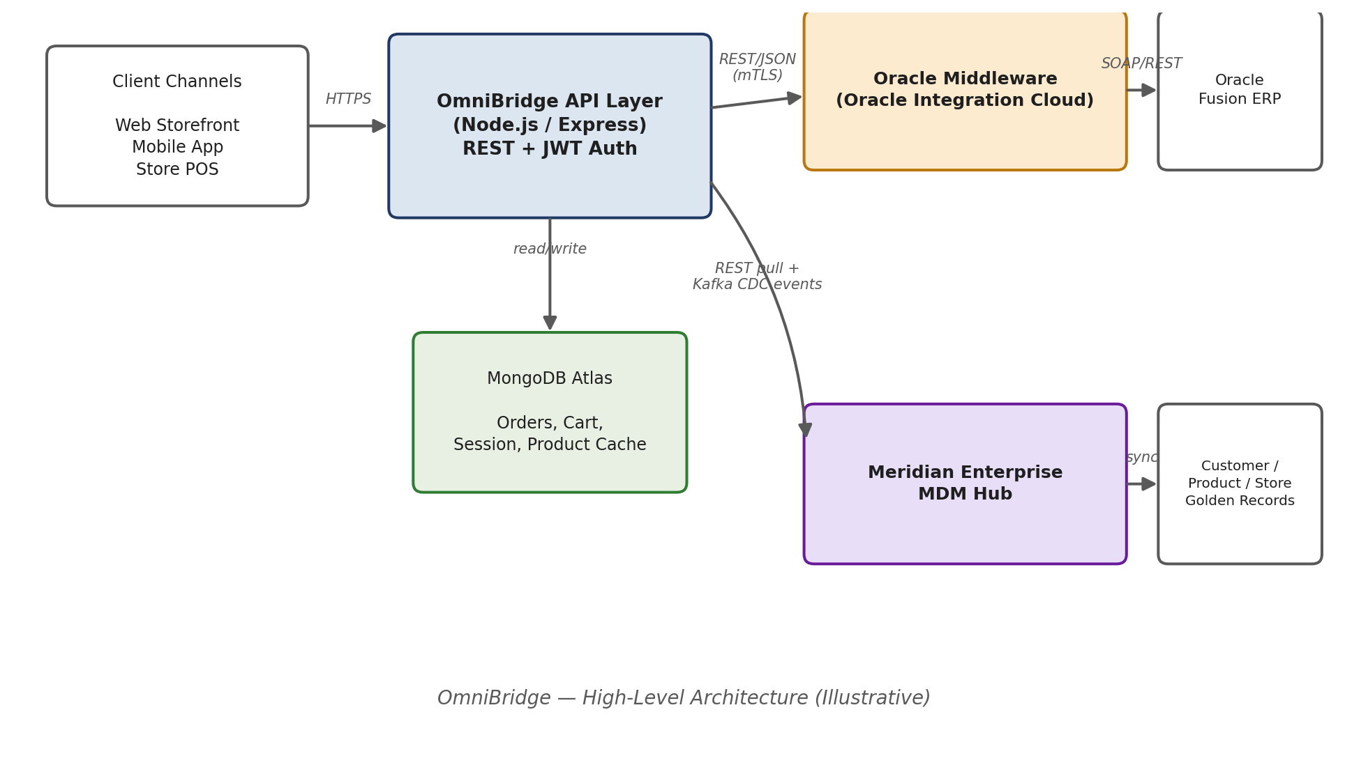

4. Component Overview
Component | Responsibility
Client Channels | Web storefront, mobile app, and store POS — consumers of OmniBridge's REST APIs. Outside this project's build scope, but integration contracts are defined here.
OmniBridge API Layer | Node.js/Express service exposing REST APIs for order management, product/customer lookups, and status queries. Handles authentication (JWT), request validation, and orchestration logic.
MongoDB Atlas | Primary data store. Holds Orders, Cart/Session state, and a read-optimized cache of Product and Customer data sourced from the MDM Hub.
Oracle Middleware (OIC) | Receives order orchestration requests from OmniBridge and coordinates with Oracle Fusion ERP for inventory allocation, payment capture, and fulfillment. Returns synchronous acknowledgements and asynchronous status callbacks.
Enterprise MDM Hub | System of record for Customer, Product, and Store master data. Publishes golden records to OmniBridge via REST (on-demand) and Kafka-based CDC events (near-real-time sync).

5. Technology Stack
Layer | Technology
Backend Runtime | Node.js (LTS), Express.js
Database | MongoDB Atlas (replica set, 3 nodes)
Messaging | Kafka (consumed for MDM CDC events)
Middleware Integration | Oracle Integration Cloud — REST/JSON primary, SOAP for legacy ERP status endpoints
Authentication | JWT-based bearer tokens; mutual TLS for service-to-service calls to Oracle Middleware and MDM Hub
Hosting | Containerized deployment (Kubernetes), illustrative cloud-agnostic setup
Monitoring | Centralized logging and metrics (illustrative — e.g., ELK / Prometheus-Grafana stack)

6. Data Flow (High-Level)

6.1 Order Placement Flow
- Client channel submits order request to OmniBridge API Layer over HTTPS.
- OmniBridge persists the order in MongoDB with status Received (write-ahead, before downstream calls).
- OmniBridge calls Oracle Middleware (REST/JSON, mTLS) to initiate ERP-side order orchestration.
- Oracle Middleware returns a synchronous acknowledgement; asynchronous status updates follow via callback/webhook.
- OmniBridge updates order status in MongoDB as callbacks are received and triggers customer notifications.

6.2 Master Data Sync Flow
- Enterprise MDM Hub publishes a CDC event when a Customer, Product, or Store golden record changes.
- OmniBridge consumes the event from Kafka and updates the corresponding MongoDB cache document.
- On a cache miss, OmniBridge falls back to a direct REST pull from the MDM Hub.

7. Integration Points

7.1 Oracle Middleware
- Protocol: REST/JSON (primary), SOAP (legacy ERP status queries).
- Security: Mutual TLS between OmniBridge and Oracle Integration Cloud; service account credentials managed per the PAM Document.
- Pattern: Synchronous request/acknowledgement for order submission; asynchronous callback for status updates.

7.2 Enterprise MDM Hub
- Protocol: REST (on-demand pull), Kafka (CDC event stream for near-real-time sync).
- Security: OAuth2 client-credentials flow for REST calls; TLS-encrypted Kafka topics with consumer-group-level access control.
- Pattern: Event-driven cache refresh, with REST fallback on cache miss.

8. Non-Functional Requirements
Category | Requirement
Availability | 99.9% for order-submission path; OmniBridge must accept and queue orders even if Oracle Middleware or MDM Hub is briefly unreachable.
Performance | P95 order-submission response time under 800ms; P95 product/customer lookup under 200ms (cache hit).
Scalability | Stateless API layer, horizontally scalable behind a load balancer; MongoDB sharded by order date range if volume requires.
Security | TLS 1.2+ everywhere; least-privilege service accounts; secrets managed via a central vault (see PAM Document).
Resilience | Retry with exponential backoff for transient Oracle Middleware/MDM Hub failures; dead-letter queue for failed CDC event processing.
Observability | Structured logging with correlation IDs across OmniBridge, Oracle Middleware calls, and MDM Hub calls for end-to-end traceability.

9. Deployment Architecture (Illustrative)
OmniBridge is deployed as a set of containerized, horizontally-scalable service instances behind a load balancer / API gateway. MongoDB Atlas runs as a managed 3-node replica set. Outbound connectivity to Oracle Middleware and the MDM Hub is routed through a dedicated network segment with restricted egress rules, consistent with the access boundaries defined in the PAM Document.

10. Assumptions & Constraints
- Oracle Middleware and the MDM Hub are external systems; this project delivers OmniBridge and its integration contracts, not changes to those systems.
- Network connectivity (VPN/direct connect) between Meridian's environment and Oracle Middleware/MDM Hub is established prior to integration testing.
- MongoDB is used as an operational/cache store, not as the system of record for master data — the MDM Hub retains that role.

