Design Specification –
Order Entry (Prototype #1)

Indicator Manager
The indicator manager is where users can access existing indicators (either pre-entered into the program, or created by them). They would be able to find indicators using the search function and use them within the order workspace widget or the quote board widget (still to come). The Indicator Manager should function almost identically to the ‘Order Manager’ as described in the order entry Design Specification, including most properties and menus.
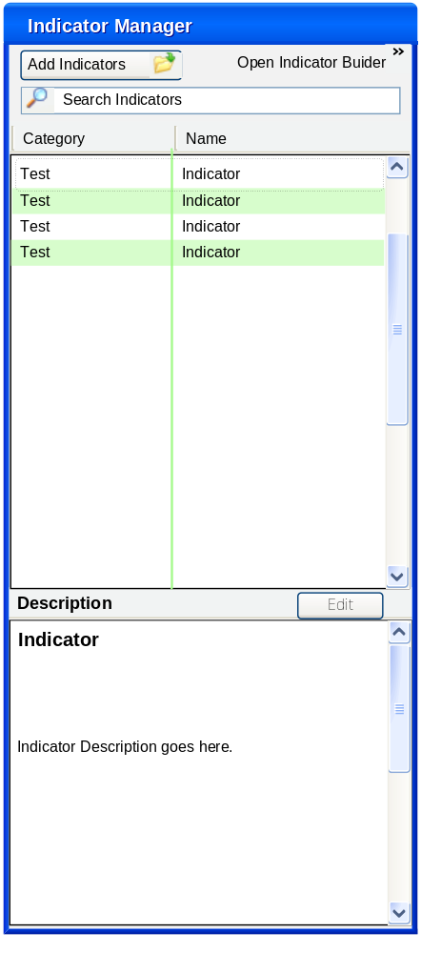

Indicator Builder
The main difference between indicators and orders are the way they are originally constructed by the user. Indicators are developed in their own ‘Indicator Builder’ which expands to the right of the indicator manager. This is intended to operate similarly to Microsoft’s Equation Editor, in that it allows users to enter mathematical functions with as natural formatting as possible http://en.wikipedia.org/wiki/Microsoft_Equation_Editor).
Users would combine pre-existing indicators from the list in the indicator manager with operators available in the indicator builder. Users also have the option of adding conditional formatting to their indicators using the ‘if’ and ‘else’ operators along with the formatting options.
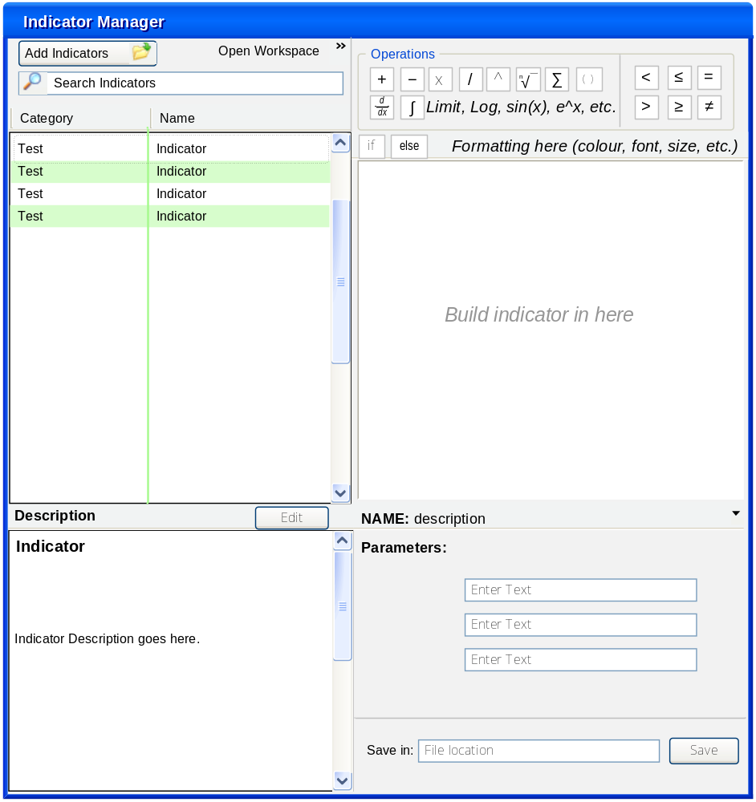
The main challenge with creating operators this way is how parameters are created. Basically, each time an indicator involving a parameter (i.e. ‘symbol’) that must be assigned, a field could be added in the ‘parameter section at the bottom of the indicator builder. Users could then fill this out and save the indicator, or they could fill the parameters in later within the order workspace or the quote board.
For example, the VWAP formula as written in Wikipedia is shown below:

Formula
The VWAP is calculated using the following formula:
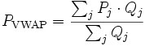
where:
P_{VWAP} = Volume Weighted Average Price
P_{j} = price of trade j
Q_{j} = quantity of trade j
j = each individual trade that takes place over the defined period of time, excluding cross trades and basket cross trades.

In this case, P and Q would likely be existing indicators. Time period and symbol would become parameters for the user to define.

Indicators and Orders
When indicators are required for building orders, they can be dragged and dropped into the order workspace in the same way as existing order types. Indicators would then appear in a similar manner to order types, with their parameters expanding below and some indication of ‘slots’ available for interaction with other orders/indicators.
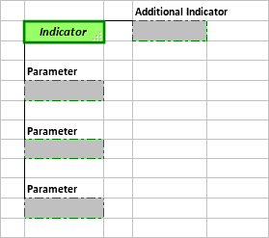

Indicators and Quote Board
The quote board widget could be used to both build and run the quote board. Users could enter both symbols and indicators into a grid and then ‘start’ the quote board to view live market data.
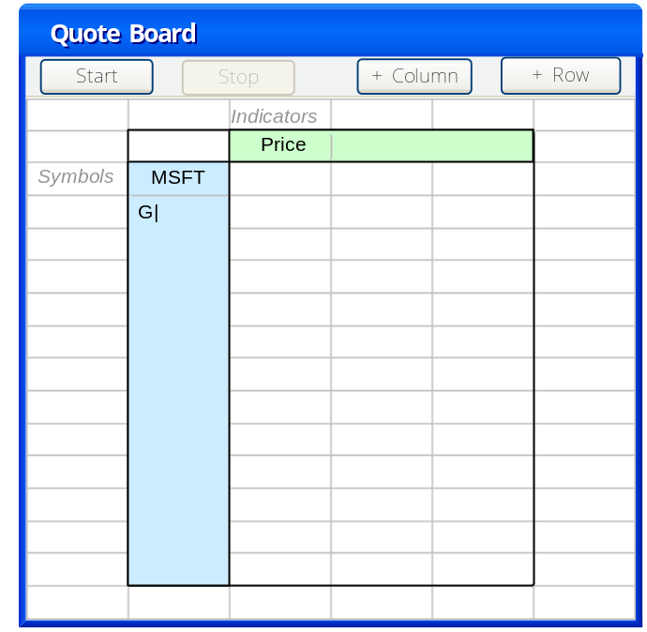
Symbols could be entered through a pop-up menu and indicators could be dragged and dropped into the top cell of each column. Users could adjust the size of the quote board by adding columns and rows.
