Level 2 – aggregated data feature
Option 1: data minimizes to one line per price level
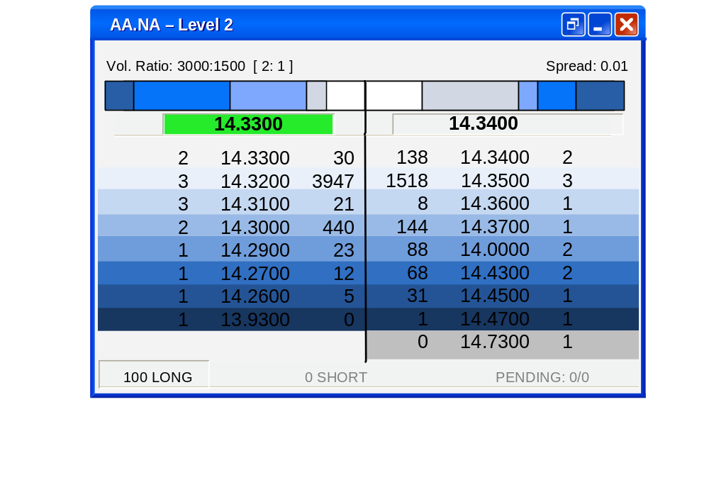

Option 2: Additional aggregated feature can be added to the widget
