Design Specification –
Log-in (Prototype #1)

Requirements Document – Log-in

Product Characteristic | Functional Requirements | Constraints | Performance Metrics
Functional | Verify user’s identity  Direct new users to basic information about Avalon | Works within Data and Environmental Requirements  Screen space  Must fit into a ‘grid’ design | Need some…
Reliable | Resistant to crashes, bugs, etc.  Communicate impossible entries/ potential sources of error
Robust | Handle random/ illogical/ impossible entries by users  Fast (no lag)  Secure (hard to break into)
Feasible/ “Program-able” | Kamal can build it | Must use multiple windows (doesn’t work within one big window) | Kamal  Time spent on implementation?
Usable/ Safe | System status is visible  Functioning is consistent and predictable  Display and controls are standardized  Clear error messages  Allows error remediation  Aesthetic and minimalist design (no unnecessary information)  Clear documentation available  Documentation is easy to find  Easy to use  Fast to use  Requires minimal training/ explanation  Default display options minimize eye strain (reduce glare, optimal contrast, etc.)  Provides clear and accurate information and system status to minimize stress/ uncertainty | Constrained by human limitations (info processing speed, visual system, anatomy, etc.)  Users may be from various backgrounds/ cultures  Constrained by the speed of the market/ nature of the task | Meets Nielsen’s heuristics (and improves from previous system) as measured by expert evaluation  Effective: success on test tasks; pathways or #of clicks  Efficient: time to complete test tasks ; pathways or # of clicks  Safe: eye strain?  Useful: meets requirements , user evaluation (do they think any functions are missing? User preference ratings)  Learnable/Memorable: if you train, will they still know how to use it a few days later?  Reduce error messages sent (compared to current software)  Integrates data from multiple sources to reduce the amount displayed on the screen
Marketable | Appeals to investors/ traders  Provides new functionality  Solves problems with existing systems | ? | ?

Data Requirements:
- Program transmits data from stock market, to user, back to stock market
- Data from program: prices, bids, offers (level 2); sales completed through the day (time and sales);
  - Provide information necessary for users to monitor the status of their pending orders and current positions
  - Provide list of all saved orders
  - Provide data necessary to make decisions about future orders
- List all available order types in one place
- Compatible with custom order types created by users; able to recognize and open ‘order’ files
- Data entered by user: type of order, conditions for order (price, etc.), location of order (what market, what stock), signal to cancel
- Data provided to market: bids/offers made by user; any cancellations
- All data displayed must be accurate

Environmental Requirements/Context of Use:
- Phsyical: For use on a trading floor (like in Swift trade), or in the users home or office
  - Trading floor: noisy (tv, squawk, other traders making sounds); cool temperature; crowded space; two monitors
  - Users home or office: probably quiet, private, with more space; less data from squawk, other traders, tv; more interruptions possible (phone, doorbell, family, etc.).
  - Design for use on one monitor; second monitor would be needed for charts, etc.
- Social: independent use; risk may be monitored by someone else (for example, the floor supervisors using brokerware)
- Organization: user support available on the trading floor, but not at home; online manual; training available through swift trade; provide some kind of tutorials built in?
- Technical: runs quickly on basic personal computer, requires internet access to get data (?), blocks the outward transmission of proprietary data about the market and/or software

User Requirements:
- Users will be used to seeing data presented in formats used by major trading software available on the market
- Users will be computer literate

Use Cases – Log-in

- Existing user logs in
User Intention | System Responsibility
Open Avalon from windows
 | Display ‘log-in’ widget with ‘username’ field highlighted
Enter username
Move to password field (press ‘tab’ or left click on ‘password’ area)
 | Highlight ‘password’ field
Enter password
Log-in (press ‘enter’ or left click on ‘log-in’ button)
 | Display ‘processing’ indicator
 | Log-in
 | Close Log-in widget
 | Display Avalon toolbar

- New user
User Intention | System Responsibility
Open Avalon from windows
 | Display ‘log-in’ widget with ‘username’ field highlighted
Note that you must talk to your branch manager to obtain log-in information

- User can’t remember username/password
User Intention | System Responsibility
Open Avalon form windows
 | Display ‘log-in’ widget with ‘username’ field highlighted
Hover mouse over the ‘?’ symbol to the right of the username field
 | Display more information about the format of the username and how to recover a forgotten username
Move to the ‘password’ field (press ‘tab’ or left click on the ‘password’ area)
 | Highlight ‘password’ field
Hover mouse over the ‘?’ symbol to the right of the password field
 | Display more information about the format of the password and how to recover a forgotten password

- User enters wrong username/password
User Intention | System Responsibility
Open Avalon from windows
 | Display ‘log-in’ widget with ‘username’ field highlighted
Enter username
Move to password field (press ‘tab’ or left click on ‘password’ area)
 | Highlight ‘password’ field
Enter password
Log-in (press ‘enter’ or left click on ‘log-in’ button)
 | Display ‘processing’ indicator
 | Display error message ‘you have entered the wrong username/password…’
 | Highlight username or password field

- User logs in with ‘remember me’ function
User Intention | System Responsibility
User opens Avalon from windows
 | Display ‘log-in’ widget with username and password fields completed
 | Highlight ‘Log-in’ button
User clicks enter to proceed
User clicks ‘remember me on this computer’ box to clear log-in information
 | Display ‘log-in’ widget with no username or password
 | Highlight the ‘username’ field
User proceeds with log-in

- Abort Log-in
User Intention | System Responsibility
User Logs in (presses enter/clicks on ‘log-in’ button
 | User displays ‘processing’ indicator and enabled ‘cancel’ button
User clicks ‘cancel’ while the system is processing the log-in information
 | Cancel log-in
 | Close log-in widget

Interface Design – Log-in

Main Window
The basic log-in widget for Avalon is shown below. This will appear when the user first opens Avalon from their operating system.
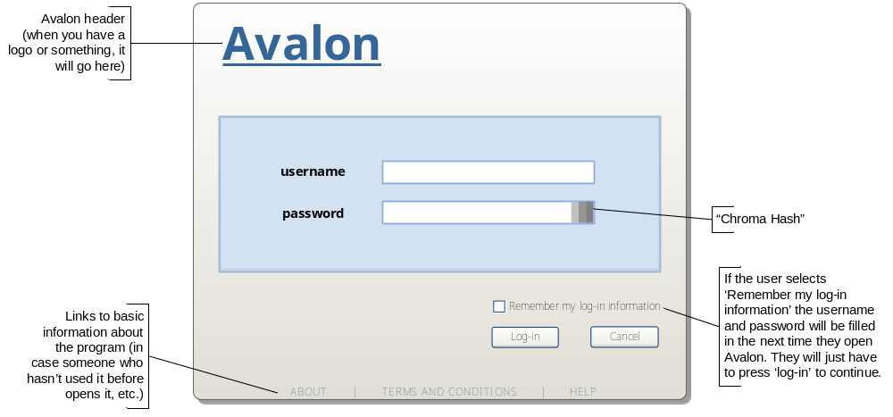

Typically, the default setting for the log-in widget should be set so the username field is immediately activated when the program is opened (see below). This allows users to immediately start typing their information into the widget.

Details
Size: 134mm wide, 108 mm tall
Border: grey (RGB 104), 1px, rounded corners (radius 2mm)
Shadow: grey (RGB 154), offset 1.2mm from main shape on x and y axis
Background: gradient white (RGB 255) to grey (RGB 220)
Title: MS Reference Sans Serif, 36pt, bold, underline, R: 51 G: 102 B: 153
Username/password box size: 120mm wide, 42mm tall
Username/password box colour: R: 210 G: 226 B: 242
Username/password box border: double border (2px, each pixel a different colour), outside = R: 157 G: 183 B: 206, inside= R: 192 G: 211 B: 241
Username/password titles: MS Reference Sans Serif, 10pt, bold, black
Username/password textbox size: 58mm wide, 6mm tall
Username/password textbox border: 2px, R: 137, G: 173, B: 228
Username/password textbox font: Arial, 10pt, black (RGB 0)
Space between username/password title and textbox: 10mm
Remember me, log-in and cancel button font: Tahoma, 8pt, black (RGB 0)
About/terms and conditions/help font: MS Reference Sans Serif, 8pt, R: 51 G: 102 B: 153

Logging In

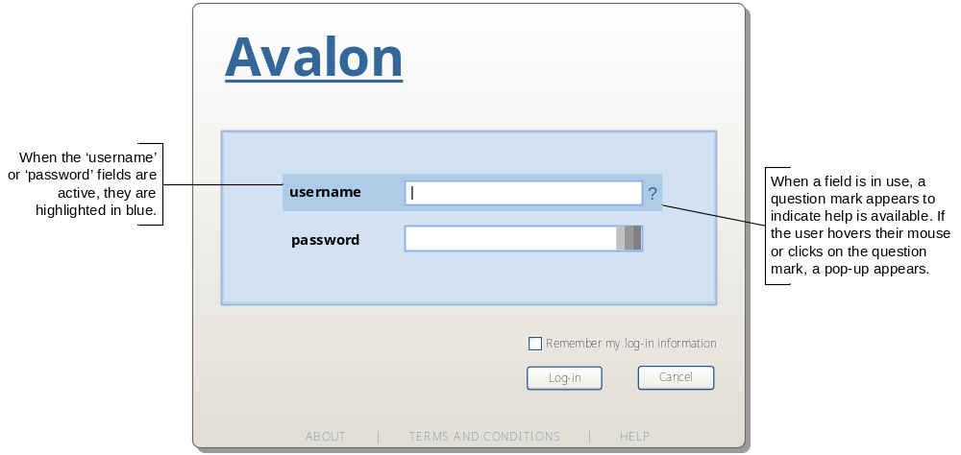
Users log-in by entering a username and password in the text fields provided. If the user is unsure of their username and/or password, they can hover over the question mark symbol to the right of the textbox to view more information (number of characters, are symbols acceptable, etc.)
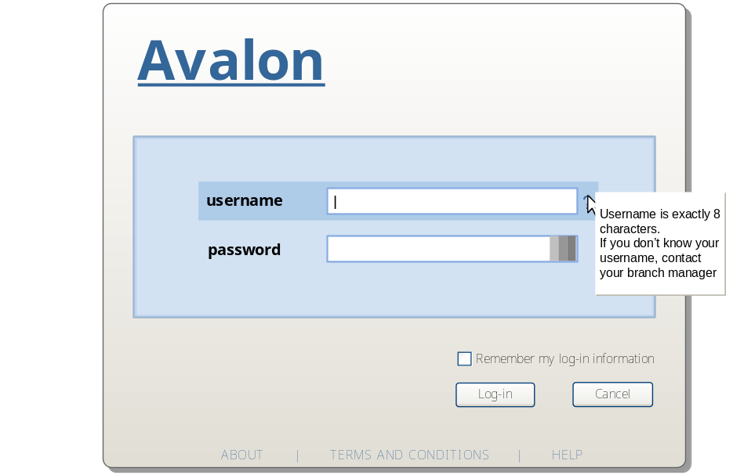
Once the user has entered their username and password, they indicate they are ready to log-in by pressing ‘enter’ or clicking on the ‘log-in’ button. While system is logging in, the log-in widget should remain visible until log-in is complete. During any processing time by the system, an indicator bar should be displayed showing that the system is working, not idle. This should be an indicator of movement, not really a process bar: ˚̊˚̊˚̊˚˚˚ ˚˚̊˚̊˚̊˚˚ ˚˚˚̊˚̊˚̊˚ ˚˚˚˚̊˚̊˚̊ ˚̊˚˚˚˚̊˚̊ ˚̊˚̊˚˚˚˚̊ ˚̊˚̊˚̊˚˚˚
In addition, during the log-in process, all fields and options should be disabled except for the ‘Cancel’ button. This allows users to cancel their log-in and close the program before it finishes opening if they change their mind (see below).
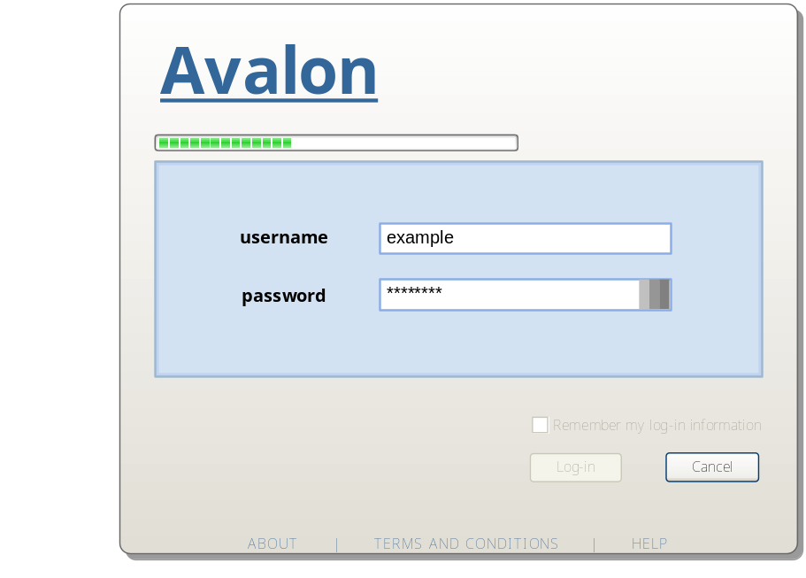

Details
Highlight box: 92mm wide, 9mm tall, R: 174 G: 203 B: 232
Question mark: Arial, 12pt, R: 51 G: 102 B: 153
Mouse-over box: 30mm wide, 25mm tall, grey (RGB 234)
Mouse-over box border: 1px, left & top – white (RGB 255), right & bottom – grey (RGB 104)
Mouse-over box font: Arial, 8pt, black (RGB 0)
“Processing” bar: 71mm wide, 3.3mm tall, border – 2px, RGB 104, squares – R: 0 G: 223 B: 0

Error Messages
If an error occurs during the log-in process, an error message will be displayed within the log-in window. Error messages appear within an inset box in the top portion of the window, between the title and the log-in box. The example provided is for an incorrect password, but most errors could be addressed in a similar way.
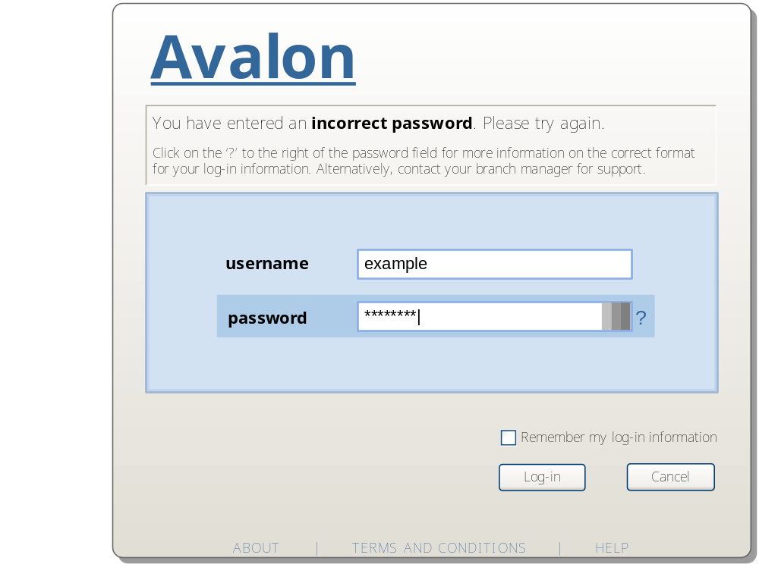

Details
Border: 1px, left border & top border – RGB 104, right border & bottom border – RGB 255
Font: Tahoma, Top line = 10pt, bottom lines = 8pt

