

User Guide

Prepared by: William Morgan,
Mark Wolfendale , Mariano Odio & Andres Navarro

Table of contents

1. Introduction 5
2. Traderware Windows 6
2.1. Status Window 6
2.2. Tool Bar 6
2.2.1. Logout 6
2.2.2. Level 2 6
2.2.3. Time and Sales 6
2.2.4. Market Minder 7
2.2.5. Order Log 7
2.2.6. Blotter 7
2.2.7. Ticker 7
2.2.8. User Options Menu 7
2.2.9. Save Layout 7
2.2.10. Lock Keyboard 7
2.2.11. Basket Order 7
2.2.12. Scanner 8
2.2.12.1. Market orders (RN: 6.70) 8
2.2.13. Conditional Orders 9
2.2.14 Stock Tracker 10
2.2.14.1. Alerts (RN: 6.70) 10
2.2.15. Imbalance Locator (6.70.58) 10
2.3. Level 2 12
2.3.1. Information Displayed 13
2.3.2. Level 2 Options Window 14
2.3.3. Columns 17
2.3.3.1. Type 17
2.3.3.2. MMID 17
2.3.3.3. LRP (RN:6.70) 18
2.3.3.4. Price 18
2.3.3.5. Size 18
2.3.3.6. Tick 18
2.3.3.7. Time 19
2.3.3.8. Change 19
2.3.4. View 20
2.3.5. Colors 22
2.3.6. Fonts 23
2.4. Time and Sales (TAS) 24
2.4.1. Options 25
2.4.2. Columns 26
2.4.2.1. Sub Market Identifiers (RN:6.70 27
2.4.3. NIDS Feed 27
2.5. Colors 27
2.6. Order Log 28
2.6.1. OL Options 29
2.6.2. Columns 31
2.6.3. Colors 31
2.7. Blotter 32
2.7.1. Open Position 33
2.7.1.1. Options 33
Scroll Bars 34
Grid Lines 35
Show Seconds 35
2.7.1.2. Columns 36
Available Columns 36
2.7.1.3. Colors 38
2.7.2. Summary 39
2.7.3. Trade List 40
2.7.3.1. Columns 41
2.7.4. Symbol Info 42
2.8. Ticker 42
2.9. User Options Menu 44
2.9.1. Keyboard 45
2.9.1.1. Convert to SS 45
2.9.1.2. Price Adjustment 45
2.9.2. Key Shave 46
2.9.3. Default Shares 46
2.9.4. Required Confirmations 47
2.9.5. Exchange Defaults 47
2.9.6. Misc 48
2.9.7. Hot Keys 49
2.10. Basket Order 50
2.11. Liquidity Search 51
2.12. Conditional Orders 54
2.13. Stock Tracker 55
2.13.1. Columns 56
3. Order Types 57
3.1. Basic Concepts 57
3.1.1. Adding / Removing Liquidity 57
3.2. Standard Order Types 57
3.2.1. Limit Order 57
3.2.2. Market Order 57
3.2.3. IOC 57
3.2.4. FOK 57
3.2.5. Load 58
3.3. Order Attributes 58
3.3.1. Hidden Order 58
3.3.2. Reserve Order 58
3.3.3. Routed Order 58
3.3.4. Pass-Through Orders 58
3.3.5. Post Only 58
3.3.6. T.I.F. 58
3.3.7. Pegged Order 58
3.3.8. NASDAQ Cross Orders 59
3.4. Cancel Orders 59
3.5 Order on TW by Gateway/ECN 59
3.5.1. Merril Lynch Direct Market Access (ISI) 59
3.5.2. NASDAQ 60
3.5.3. RASH 61
3.5.4. NYSE Arca (Arca PO+ TW: 6.76.00) 62
3.5.5. Direct Edge 63
3.5.6. BATS (Better Alternative trading System) 65
BATS Dark and BATS Peg orders - (RN:6.72.00) 65
3.5.7. NYFIX Millenium 66
Millennium NIX orders - (RN:6.70.53) 66
NYFIX stealth orders - (RN:6.75.00) 66
3.5.8. Bloomberg (BBRG) 66
3.5.9. AUTO 67
3.5.10. TRACK (Track data securities) 67
3.5.11. UBS ( Union Bank of Switzerland ) 67
3.5.12. Edge trade ( EDGE ) 68
3.5.13. Crossfinder+ ( CSD ) (TW: 6.70.00) 68
3.5.14. ISE ( International Securities Exchange ) (TW: 6.70.00) 69
3.5.15. GETCO (RN: 6.70.48) 70
3.5.16. OES (RN:6.71.00) 71
3.5.17. Morgan Stanley (RN:6.72.00) 71
3.5.17. Piper Jaffray (RN:6.74.00) 72
3.5.18. Sungard (RN:6.74.00) 74
3.5.19. Instinet (RN: 6.76.00) 74
3.5.20. Bank of America “BOFA” (RN: 6.77.00) 75
4. Recently added to TW 76
4.1. Quotes (RN:6.70.00) 76
4.2. Cancellation options (RN:6.70.00) 77
4.3. ATS: Omega (RN:6.70.00) 77
4.4. MTF/ECN: CHI-X (Euronext) - (RN:670.55) 78
4.5. Markets: Xetra and Milan (RN:6.70.58) 78
4.6. Stop Orders - (RN:6.73.00) 78
4.7. Trailing Stop Orders 79
4.8. User options Window: 79
4.9. Order entry, and examples 81
4.10. Using Stops and Trailing stops as a Stop-loss order. 82
4.11. Using Stop orders for entering a new trade 83
4.12. Tracking Swift Stop/Trailing Stop orders in the Order log 83

Introduction

At the centre of the ProsperPro system, Traderware provides Swifttrade’s access to the market. The well organized and simple interface allows traders to quickly and effectively analyse the markets and place orders.

Although Traderware’s many features may appear daunting, understanding how to use them makes trading easier and more profitable. Once you understand the feature of Traderware, understanding all of the order types and their relation to the market will enhance your trading ability.

As with all ProsperPro applications, Head Office personnel will happily assist you with any questions or problems.

William D. Morgan
Business Analyst
swiftTRADE

Traderware Windows
For simplicity’s sake, I have organized this manual by the windows in traderware.

Status Window

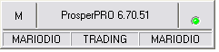

This window displays the version of Traderware, the trader’s username, his trading status, the active currency account, the messaging system, and the quote status of any stocks his is trading.

“M” will flash with a red dot when HO has an urgent message for traders.

When a percentage appears above the status indicator this indicates the percentage which is being used of the buffer, TW’s buffer can hold up to 2 seconds of messages. A 50% means a 1 second delay; to avoid the buffer getting filled, reduce the amount of symbols viewed in your office.

Tool Bar
The tool bar allows a trader to open most of TW’s windows as well as perform some basic system tasks. Below, is a list of each function.
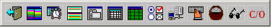

Logout
This button allows the trader to logout out of TW. Before logging the trader off, the system will warn the trader of any open positions.

Level 2
Pressing this button opens a new level 2 window (see 2.3). You may have a maximum of 8 level 2 windows open.

Time and Sales
This opens a time and sales window. (see 2.4)

Market Minder
This opens a market minder window (currently unavailable)

Order Log
This opens an order log window (see 2.6). A trader may only have one order log open at a time.

Blotter
This opens a window which lets the trader select which account they wish to use. A trader may have only one blotter open for each currency. (see 2.7)

Ticker
This opens the ticker window (see 2.8)

User Options Menu
Click this to open the user options menu (2.9)

Save Layout
This saves the trader’s layout to the server. The server stores data on the configuration of each window, but not on the screen layouts.

Lock Keyboard
This feature allows a trader to lock his keyboard. When activated, TW will prevent the trader from using the keyboard. They may unlock the keyboard by clicking on this button and entering the password used to login.

Basket Order
To open a Basket Order window, click the basket icon on the tool bar. The Basket Order window contains up to ten customizable lists of orders. Each Basket Order (list of orders) can simultaneously send unlimited individual orders to any number of securities using all available order types.
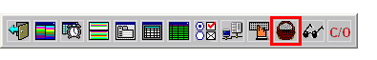

Scanner
To open a Liquidity Search window, click the sun glasses on the Tool Bar. The Liquidity Search window contains up to ten customizable search lists. Each Liquidity Search sequentially sends unlimited individual orders to any number of securities using all available order types, sequentially.
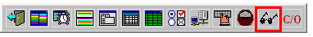

2.2.12.1. Market orders (RN: 6.70)
TW scanner now supports using market orders.
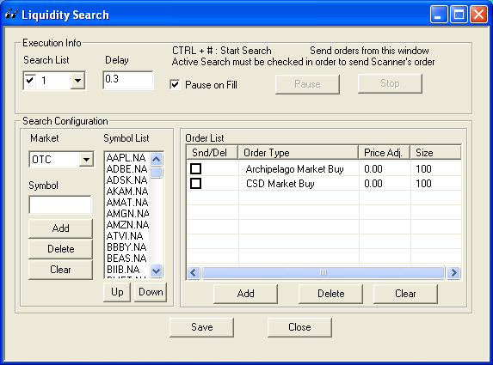

2.2.12.2. Multiple instances
TW now allows repeated symbols in the scanner list as well as user defined order. This features allows for a symbol or several symbols to be scanned several times during a single scan.
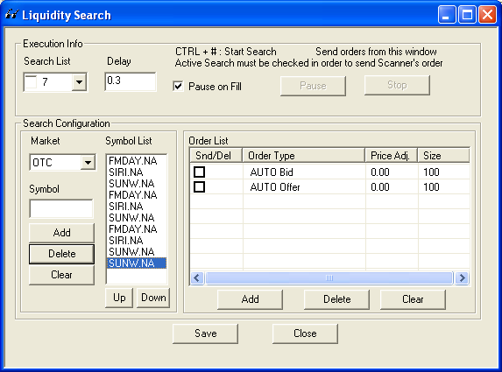

2.2.12.3. Checked orders
TW will now only scan for orders that are checked in the order list. This allows for users to turn on or off the orders without having to edit the order list.
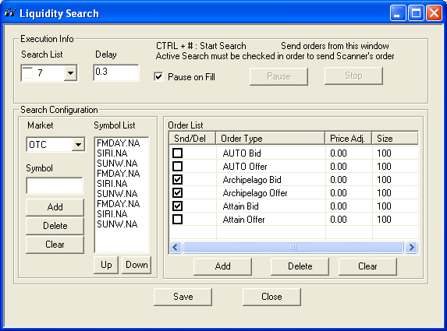

2.2.13. Conditional Orders
TW can create conditional orders that allow traders to automatically submit or cancel orders only if the specified criteria(s) are met.
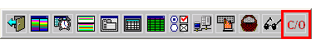

Stock Tracker
Traders can create a list of stocks to track in real-time customizing the various columns for tracking.

2.2.14.1. Alerts (RN: 6.70)
TW supports user defined alerts on the stock tracker window.
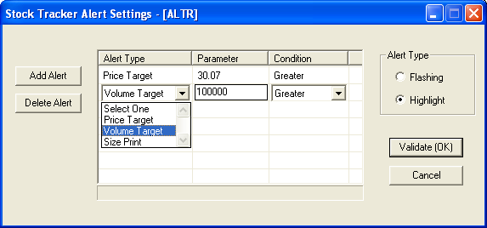

The alerts can be set up using a Price target, Volume target or a Size print; with a user defined value and condition for the alert.
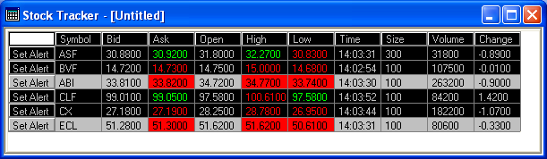

Once the alert parameters are meet, the symbol is going to change to inverse colors permanently [highlight] or switch and switch back repeatedly [flashing]

2.2.15. Imbalance Locator (6.70.58)

Imbalance Locator for the closing cross on the NYSE, NASDAQ and TSX; which you will be able to take advantage of with the Imbalance Only Orders. You can see in the screen capture below where the Imbalance locator is found.

In the window below you right click and get the window on the lower right where you select the markets and the minimum size.

Imbalance Locator Window

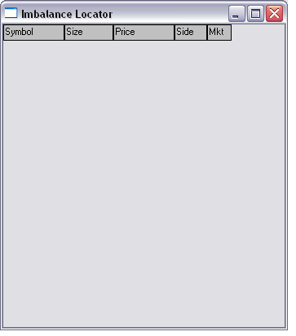

Configuration Window

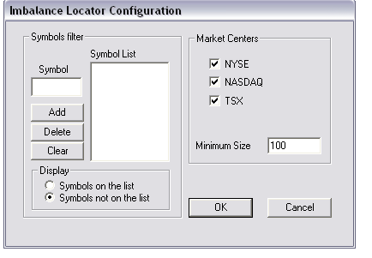

If the imbalance Locator is not showing any symbols go to the Configuration Window and click on Symbols not on the list.

Level 2

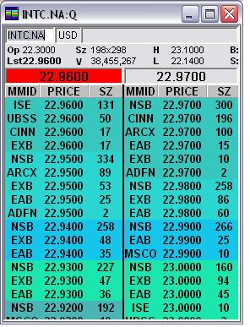

This window displays quotes and other relevant information for one stock. This window must be active in order for a trader to place an order.

Information Displayed

The level 2 displays the following information:
CSCO.NA:Q (symbol.region:market): symbol – the stock’s ticker symbol; region – NA for North America, LO for London; market – Q for NASDAQ, N for NYSE, A for AMEX, H for CME, O for LSE.
Directly below that line you may enter the stock symbol you wish to trade.
USD: the currency in which the stock trades. For non-USD securities, TW displays the conversion rate to USD beside the currency.
OP: The opening price of the security. This value comes from the first print of the day recorded by our servers.
CH: The change in the stocks price from the previous close. (Not Available “Removed on V:6.70”)
Sz: The size, or number of shares on the level bid and offer.
H: The highest print of the day recorded on the server.
B: The trader’s default share size, less any long position or the number of shares currently held short. If the trader attempts to buy, TW will use his value as the share size, unless the trader specifies a different value.
Cl: The previous day’s closing price. This price should always have a value of 0.000 as the servers reset every night. (Not Available “Removed on V:6.70”)
Lst: The most recent print in the stock.
L: The lowest recorded price of the day.
S: The trader’s default share size, less any short position or the number of shares currently held long. If the trader attempts to sell, TW will use his value as the share size, unless the trader specifies a different value.

22.9600, 22.9700 (Level 1 Price): The level 1 displays the best bid and offer price on the controlling market.

For a description of the values in the columns, see 2.3.3

Level 2 Options Window

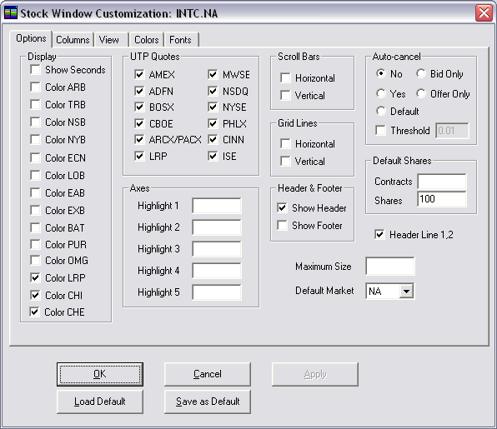

To Display this window, right click anywhere on the level 2 screen.

As with all ProsperPro windows, by clicking “Save as Default” the trader may save the settings of this window to the server. Clicking load default pulls those settings from the server.

Maximum Size allows a trader to restrict the number of shares he/she wishes to trade of any one stock. Traders can use this feature to prevent themselves from buying or shorting an excessive amount of share accidentally. Once a trader has set a maximum size, TW will block the trader from placing orders exceeding that size.

In the Display area of this menu, you may choose to have TW colour specific book feeds and ECNs. To set the colours, see section 2.3.6.

Grid Settings: you may choose to have scroll bars on your level 2, display the header, and grid line. If you enter a Market Maker or ECN’s 4 letter id into either of the text boxes labelled Axe MM1 or 2, TW will colour that Market Maker or ECN a specific colour as set in the “Colors” tab (see section 2.3.6).

If the trader has chosen to display the Tick column (see section 2.3.4), he may select the format to use under Tick Format.

The Order Edits section allows the trader to select whether they want the bid/offer options to appear at the top or bottom of the level 2 screen.

The Header section allows the trader to adjust what TW displays in the top of the level 2. Generally, “Controls” is the only item that a trader should check off.

In the upper right corner, under Default Shares the trader may make the same adjustments as he can make in the user options menu (see section 2.10.3).

The UTP Quotes section allows trader to choose which quotes they wish to see. Not all quotes apply to all markets.

The auto cancel feature under Auto-cancel cancels any parallel orders in a security once the trader has one order filled. This means, if a trader has set his default share size to 500, and has multiple bids on a stock, once he has 500 shares long, TW will cancel his remaining bids. If the trader has selected “No” TW will not cancel the bids as described above. Selecting the Default value tells TW to look to the default settings in the user options menu 2.10.6.

Also under Auto-cancel, traders may select to auto-cancel all orders that fall within a pre-defined “Threshold.” If a trader selects a threshold value of 0.02, TW will cancel all bids and offers that come within 0.02 of the level one price. Traders have the option of Auto-cancelling their bids or offers separately.

Default Market Settings: Traders may set the default market for a Level 2 window. This will allow the trader to type in a stock’s symbol without the need to add the “.TO”,”.LO” or other extensions.

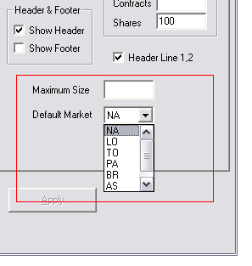

Columns

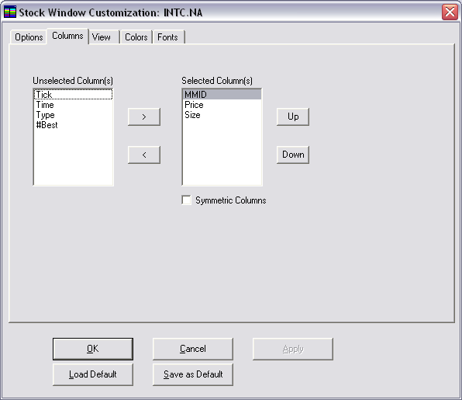

This tab allows a trader to determine which column TW displays on the level 2 screen. TW will display the columns under “Selected Column(s)”. Traders can also make their Level 2 columns symmetrical.

Type

This column displays whether the value in the MMID column is an ECN or a Book.

MMID

Market Maker Identification displays the short name of the market maker or ECN quoted.

LRP (RN:6.70)

NYSE liquidity replenishment points, it can be displayed with a differentiated color.
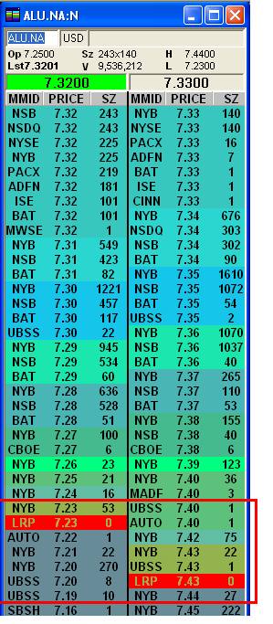

Price

This displays the price of the quoted limit order.

Size

Size indicates the number of shares, in hundreds, or contracts, bid or offer at that level through that MMID.

Tick

Tick indicates whether the bid or offer displayed constitutes an uptick or downtick.

Time

The Time column displays the time at which the oldest bid on that level was entered.

Change

This indicates the difference between the limit price displayed and the close from the previous day.

View

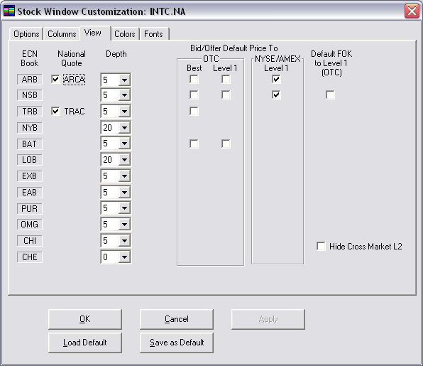

In this screen the trader may adjust the ECNs displayed on the Level 2 and how orders interact with those ECNs.

The first column indicates the ECN.
ARB – Arca
NSB – NASDAQ Anonymous Book
TRB – Trac
NYB – New York Book
BAT – Better Alternative Trading System
LOB – London Stock Exchange
EXB – Edge X Book
EAB – Edge A Book
PUR – Pure Book
OMG – Omega Book
CHI – Chi-X Canada Book
CHE – Chi-X Europe Book

In the second column, the trader may choose to display the national quote for that ECN on the Level 2. The trade may only choose those ECNs with a national quote.

In the third column the trader may choose to set the depth of the book feed from that ECN.

The “bid offer default price to” area allows the trader to specify the price at which they wish their bids and offers to default. The trader may have different settings for those ECNs on NYSE and OTC.

Under “Default FOK to level 1” the trader may decide to set their default price for FOK orders to the level 1 price.

Colors

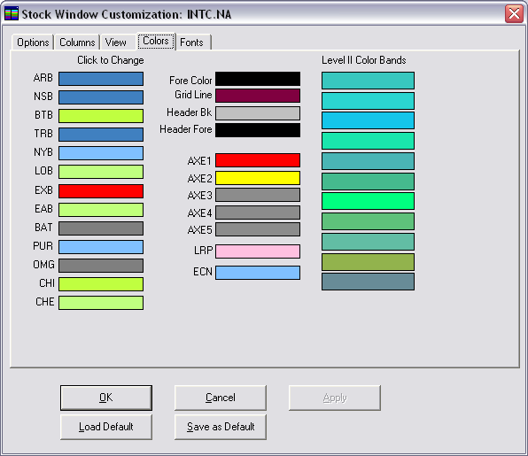

In this area the trader may set his level 2 colours. Clicking on each colour brings up a colour pallet from which the trader may choose the colour they wish to use.

The area in the upper left allows the trader to set the foreground, gridline, header background, and heard foreground. Below that, the trader may set the colours for each ECN book.

In the center area of the window, the trader may set the colours for the Axes he chose in 2.3.2. Below that, he may set the colour for any ECNs’ national quote he has chosen to colour.

The right area of the window allows the trader to set the colour for the different price levels on the level 2.

Fonts

The notes for this window apply to all other ProsperPro windows.

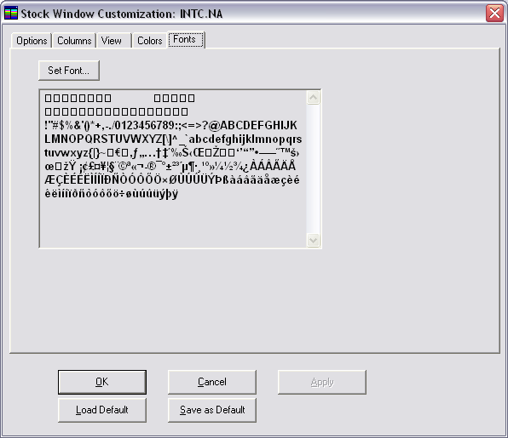

This window allows the trader to set any font they wish for the level 2 screen. They may also choose the size and features of that font.

Time and Sales (TAS)

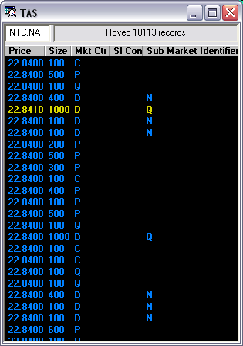

A time and sales displays every print on a security.

Options

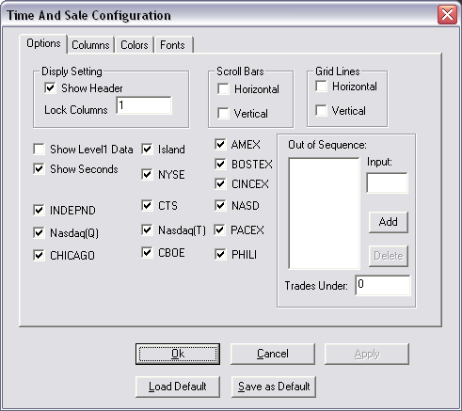

This window allows the trader to adjust various settings for the TAS.

In the upper left area, “Display Setting,” the trader may choose to display the header on the TAS.

The two areas to the right allow the trader to display scroll bars and grid lines on the TAS.

The lower left section of the screen allows traders to choose to display Level1 data and whether they wish to see seconds in the “Time” column. The remaining check boxes in this area allow the trader to choose to display prints from specific exchanges.

In the “Out of Sequence” area of the screen, traders may choose to have the TAS not display prints with specific sales conditions. To add a sales condition (not display prints with this condition), type the single letter into the “Input” area and press “Add.” To remove a sales condition, click on the letter and press “Delete.”

In the lower right area, “Trades Under,” traders may choose to have the TAS not display prints with quantities lower than the desired size.

Columns

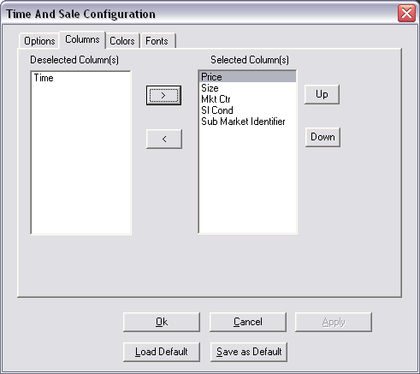

The columns tab allows a trader to select which columns the TAS displays. To move a column from the selected area to the deselected area or vice versa, double-click on the column title or click on the column title and press the directional arrow.

Time: The time the print was executed
Price: The price at which the print was executed
Size: The number of shares or contracts traded
Mkt Ctr: (Market Center) The location the trade took place
Sl Cond: (Sales Condition) The code letter of any sales condition attached to the trade. If blank, the trade did not have a special condition. (For values of these conditions, see the training manual.)
Type: This will not have any value.
Sub Market Identifiers: NASDAQ submarket identifiers. This feature will help traders identifier different submarkets that print under the D market center.
2.4.2.1. Sub Market Identifiers (RN:6.70
- The submarket id includes the following NASDAQ departments:
UTP Participant Name | UTP Market Center ID | Sub-Market Center ID | Department Name
FINRA Alternative Display Facility (ADF) | D | (space) | FINRA Market Operations
FINRA/NASDAQ Trade Reporting Facility | D | Q | NASDAQ MarketWatch
FINRA/BSE Trade Reporting Facility | D | B | BSE Operations
FINRA/NSX Trade Reporting Facility | D | C | NSX Control Room
FINRA/NYSE TRF | D | P | NYSE Arca Data Integrity

    - NIDS Feed

TW can view indices traded on NASDAQ. Traders will be able to see TAS for the indices but not level 2. Please remember when entering indices you must enter “$” then the symbol, for example $NDX. For a list of the NASDAQ indices please view the following link http://www.nasdaqtrader.com/content/productsservices/dataproducts/realtimeindexes/indexsymbols.pdf

Colors

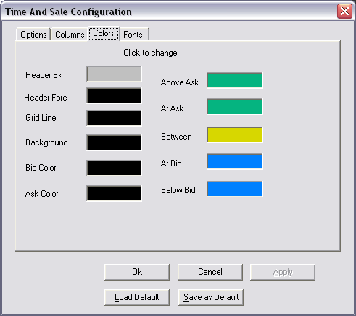

In this window, the trader may select the colours with which he wishes the TAS to represent certain trades.

Header Bk: (Background) The header background.
Header Fore: (Foreground) The header foreground.
Grid Line: Any grid lines displayed on the TAS.
Background: The background of the body of the TAS.
Bid colour: The bid price.
Ask colour: The ask price
Above Ask: A trade executed above the level 1 ask price.
At Ask: A trade executed at the level 1 ask price.
Between: A trade executed between the level 1 bid and ask price.
At Bid: A trade executed at the level 1 bid price.
Below bid: A trade executed below the level 1 bid price.

Order Log

The order log displays all pending, executed, rejected, and cancelled orders.

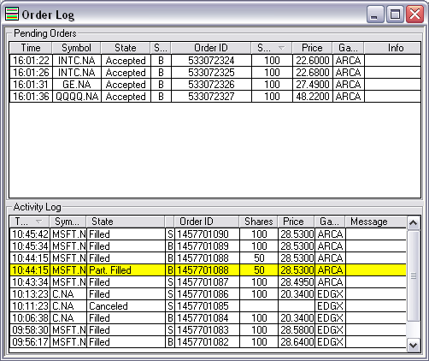

The “Pending Orders” area of the screen displays all orders the trader has placed that have not been executed or cancelled.

The Info column indicates a hidden or a pass-through order. The State column indicates that the order is pending or accepted by its destination.

The “Activity Log” contains all orders that have been executed, rejected, or cancelled.

OL Options

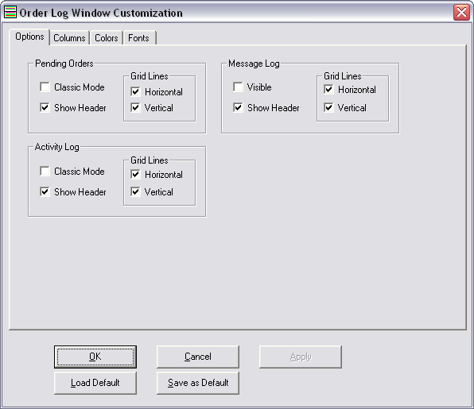

This window allows the trader to choose display settings for his order log. In both areas, the trader can select “Classic Mode,” “Show Header,” and any grid lines they wish. Classic mode appears below for the same OL above.

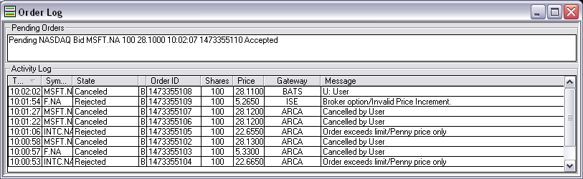

Columns

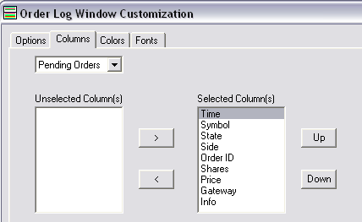

In this tab, the trader chooses which columns the OL will display in the “Pending Orders” (PO) and the “Activity Log” (AL) which he chooses in the upper left corner. This applies only to non-classic mode.

Time: The time at which the trader entered the order (PO) or at which the order was executed or cancelled (AL).
Symbol: The symbol for this order.
Gateway: The gateway used for the order.
Side: B – Buy, S – Sell, T – Short Sell
Order ID: The order number
Shares: The number of shares unexecuted (PO); the number of shares in this order (OL).
Price: The limit price of the order.
Info: Any special message or error message for this order.
State: PO: Pending– waiting for acknowledgement of the order, Accepted– the order now resides in the queue at the specified price; OL: Cancelled, Filled, Rejected, Partially Filled

Colors

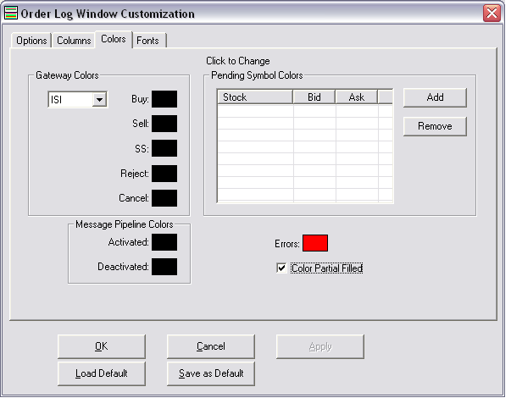

This allows a trader to specify colours that the OL will display for specific orders.

The “Gateway Colors” area allows the trader to specify colours used on specific gateways for specific orders.

The Symbol colours window (above) allows traders to set bids and offers for different symbols to differing colours.

Blotter

The blotter has three windows displaying information regarding the trader’s day.

Open Position

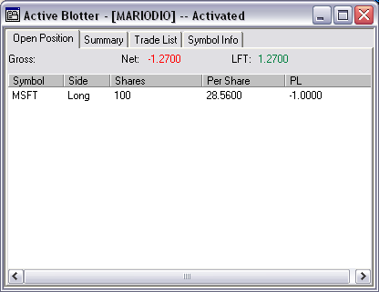

This window displays any open positions the trader has. If the trader chooses, the blotter can display the trader’s realized gross and unrealized net.

Options

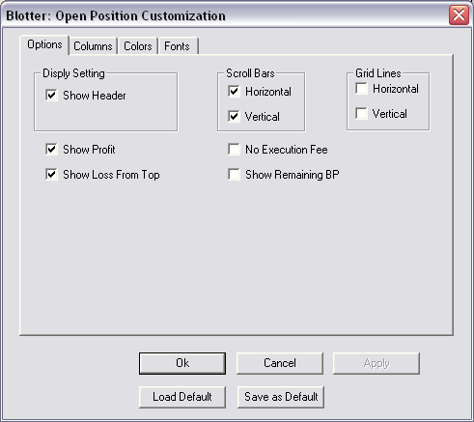

Show Header – when this function is activated, each column in the Blotter: Open Position Tab window will be labeled with a heading. Left click on the box to the left of this function to activate or deactivate.
Lock Columns - the value that is selected is the number of columns, starting from the left, that will remain "locked" or visible at all times, regardless of where you move the horizontal scroll bar.

Scroll Bars
Horizontal – when this function is activated, a horizontal scroll bar will appear at the bottom of the Blotter: Open Position Tab window. Left click on the box to the left of this function to activate or deactivate.
Vertical – when this function is activated, a vertical scroll bar will appear on the right side of the Blotter: Open Position Tab window. Left click on the box to the left of this function to activate or deactivate.

Grid Lines
Horizontal - when this function is activated, horizontal grid lines will appear within the Blotter: Open Position Tab window. Left click on the box to the left of this function to activate or deactivate.
Vertical - when this function is activated, vertical grid lines will appear within the Blotter: Open Position Tab window. Left click on the box to the left of this function to activate or deactivate.
Loss Set Point
These two fields are related to the color setting for Level I loss and Level II loss in Color Tab. User can set up the Level1 Loss (The First level of Loss for a position which will be colored) and Level2 Loss (The Second level of Loss for a position which will be colored)
Example:
When the loss value is over 0.10, the position will show red color if the color setting for level I loss is red
When the loss value is over 0.12, the position will show blue color if the color setting for level II loss is blue.

Show Seconds
When this function is activated, the seconds will appear in the time column (along with the hour and minutes). Left click on the box to the left of this function to activate or deactivate.
Show Profit
When this function is activated, the value of Net and Gross will be show on the Open Position Tab
Show Loss From Top
When this function is activated, the difference between the highest Net of the day and the current net will be displayed on the Open Position Tab.
Show Remaining BP
When this function is activated, the currently available buying power will be displayed on the Open Position Tab. This is measured by subtracting any bids in the Order Log from the traders’ total buying power.
No Execution Fee
When this function is activated, all values exclude execution fees.

Columns

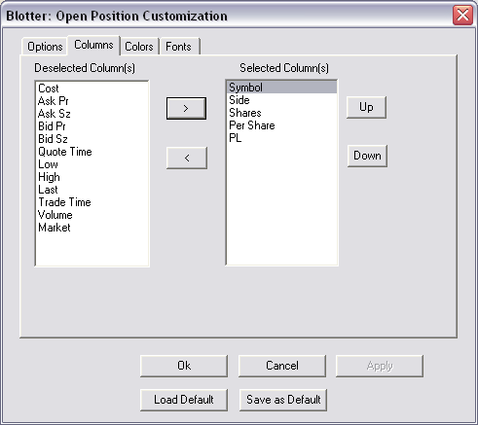

In this window, the trader may choose which columns to display in the open position window. He/she may move them between the two windows in the same method as the TAS columns (see 2.4.2).

Available Columns
Symbol – stock symbol
Side – B=bought, SS=short sold, S= sold
Shares – number of shares bought or sold
Cost – cost of the trade
Per Share – cost of the trade per share
PL – profit/loss
Ask Pr – current market price at the ask for specified stock
Ask Sz – number of shares at the ask price for a specified stock
Bid Pr – current market price at the bid for specified stock
Bid Sz – number of shares at the bid price for a specified stock
Quote Time –the time the specific quote was posted for a specific stock
Open – price stock opened current day at
Close – price stock closed at on previous day
Last - price of the last transaction in specified stock
Change – difference between Close and Last
Pct Change – percentage difference between Close and Last
Low – lowest transaction price intraday
High – highest transaction price intraday
Trade Time – time of transaction
Volume – number of shares traded intraday
Pullback Low – the difference between the current lowest price of the stock and the current ask price
Pullback High – the difference between the current highest price of the stock and the current bid price

Colors

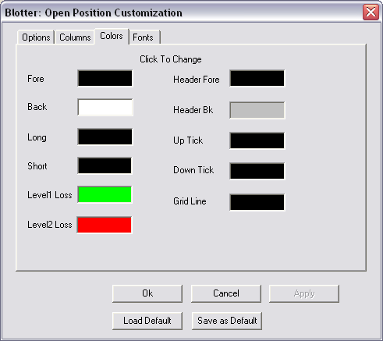

To change the color of any of the following items, left click on the color bar to the right of the item. A color palette appears. Select a color by left clicking on it and then click OK. More colors are available by clicking Define Custom Colors.
Fore - text color of the displayed open positions
Back - background color of the displayed open positions
Long – text color of the long position
Short – text color of the short position
Level 1 Loss – the text color of first level loss
Level 2 Loss – the text color of second level loss
Header Fore - text color of the column header
Header Bk - background color of the column header
Up Tick - Text color of the stock symbol when the stock is on an up tick
Down Tick - Text color of the stock symbol when the stock is on a down
Tick
Grid Line - color of the vertical and horizontal grid lines

Summary

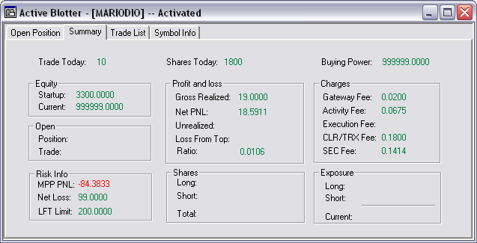

This tab of the blotter displays the summary of the traders day.

Trade Today: the number of single trades the trader executed
Shares Today: The total number of shares the trader traded
Buying Power: The trader’s buying power
Equity
Startup: The trader’s initial buying power
Current: The trader’s buying power, less the current exposure
Open
Position: The number of current positions
Risk info
MPP PNL: The trader’s current MPP is displayed in the currency of the blotter
Net Loss: The maximum net loss allowed by RW
LFT Limit: The maximum loss from top allowed by RW
Profit and loss
Gross Realized: The realized gross profit/loss
Net PNL: The total unrealized net profit/loss
Unrealized: The unrealized net profit/loss
Loss From Top: The unrealized loss from top
Ratio: The gross realized divided by the Shares Today

Shares
Long: The total shares currently held long
Short: The total shares currently held short
Total: The total shares current held
Charges
Gateway Fee: All charges directly relating to using gateways (ECNs) to trade
Activity Fee: The NASD activity fee
Execution Fee: The Swifttrade execution fee
Clearing Fee: Fees related to clearing.
SEC Fee: The total SEC paid by the trader
Exposure
Long: The value of all long positions
Short: The value of all short positions
Current: The value of all positions currently held
Symbol Information
Symbol: The symbol traded
Market: The market in which the symbol trades
Gross Pl: The realized gross on the symbol
Charges: All charges relating to trading of the symbol
Net Pl: The realized net from the symbol.

Trade List

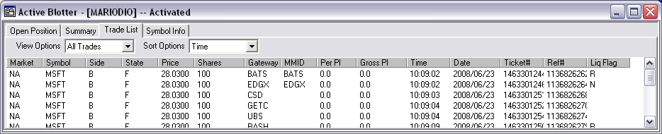

The trade list displays all of the trader’s executed trades for the day.

Columns

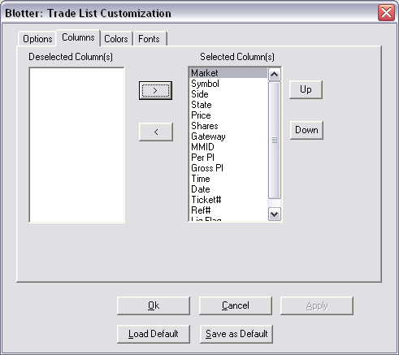
In this window, the trader may choose which columns to display in the trade list. He may move them between the two windows in the same method as the TAS columns (see 2.4.2).

Market: The region of the trade (NA – North America, LO – London)
Symbol: The symbol traded
Side: B – Buy, S – Sell, SS – Short Sell
State: F – Filled, PF – Partially Filled
Price: The price at which the trade executed
Shares: The number of shares traded
Gateway: The gateway/ECN used to execute the trades
MMID: The Market Maker ID with which the trader executed the trades (this may be blank if the trade was not against a market maker)
Per Pl: The gross profit/loss per share
Gross Pl: The total gross profit/loss on the trade
Time: The time the trade was executed
Date: The date on which the trade was executed
Ticket#: The trade’s order number
Ref#: The trade’s sequence number

Symbol Info

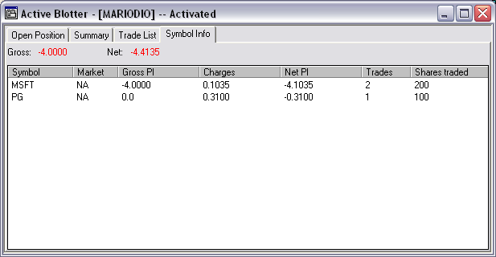

In this window, the trader may view a summary separated by symbol. They can arrange information by double clicking the column either alphabetically or highest to lowest as appropriate.

Ticker

The Ticker is a special Time and Sales that allows the info from multiple stocks to be displayed in the same window. This window can filter trades above, trades below, Level 2 size change, prints from specific Market Makers, specific sales conditions and specific market centers.

Traders can add the bid/ask size column to their ticker window. This can be done in the Ticker Window Customization and selecting the “Add Bid/Ask Size columns”. Traders can see the size of the different stocks they have added to their Ticker without having to flip to different stocks every time.

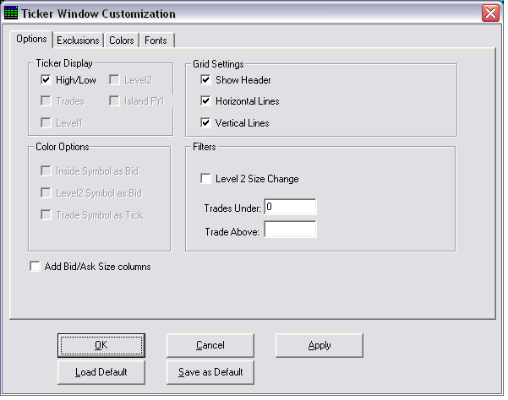

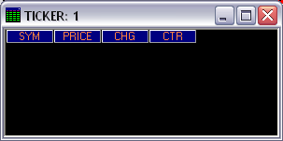

User Options Menu

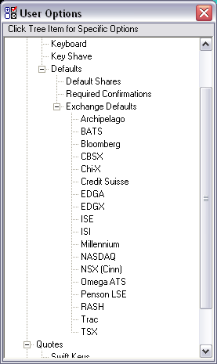

The user options menu gives traders access to multiple sub-windows. Other than the windows note below, traders may also click on Layouts, Save to save their layout to the server. This has the same functionality as 2.2.9. At the bottom of the menu, traders may change their password by clicking on “Change Password.”

Keyboard

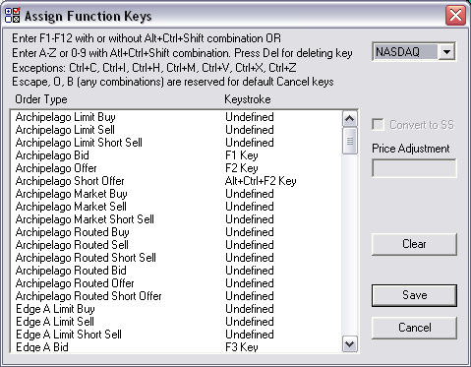

This menu allows the trader to assign each order type a specific key. Each order may have only one key or combination of keys (CTRL and/or ALT and/or SHIFT and a number, letter or function key) assigned. Conversely, each key or combination of keys may have only one order assigned.

For an explanation of order types, see section 3.

Convert to SS

This option only applies to offers and sells. If a trader selects this option on an order, when the trader has no long positions in the stock, TW will convert all offers and sells to short offers and sells respectively.

Price Adjustment

Setting a price adjustment on limit orders allows the trader to adjust the limit price to help ensure execution. On buy orders, a positive price adjustment increases the limit price of the order. On sell orders, a positive price adjustment decreases the limit price of the order.

Key Shave
The Key Shave window allows the trader to set their manual price adjustment for bids and offers. The arrows in the center of the window refer to the arrows on the keyboard. Pressing up or right adjusts the price higher by the specified amount. Pressing down or left adjusts the price lower by the specified amount. Using the upper left drop down box, a trader may select stocks or CME futures.
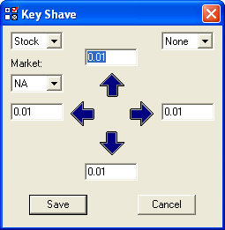

Default Shares

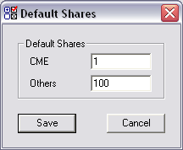

In this window, a trader may set the number of shares he wishes to buy and sell in a single order. The CME window allows the trader to set the contract default and “Others” allows the trader to set the share default for all other markets.

Required Confirmations

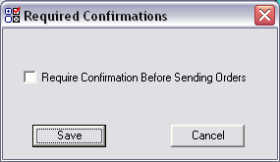

If a trader selects “Require Confirmation Before Sending Orders” TW will ask the trader to confirm all orders normally executed with a single keystroke.

Exchange Defaults

Every gateway/exchange has different combinations of features that traders may use to trade. Section three explains the effect of those features on orders.

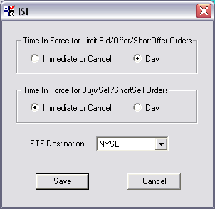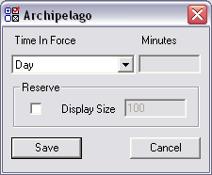

Misc

The miscellaneous options menu contains multiple features described below.

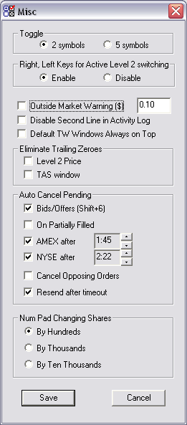

Toggle: This allows the trader to choose the number of symbols that are retained by the Level 2 for toggling with the PageUp key.
Disable Left/Right Arrow Keys: Traders can disable the left and right arrow keys for the purpose of changing the active stock window. This option is in the User option menu under the misc settings.
Outside Market Warning ($): This will warn the trader if the order being sent is beyond the Level 1 price. The threshold is adjustable and measured in dollars. This means that in the above example, TW will warn the trader if a bid order is sent 10 cents higher tthan the best offer of if an offer is sent 10 cents below the best bid.
Disable Second Line in Activity Log: This allows the trader to remove the second line from the “classic view” in the Activity Log of the OL.
Deafault TW Windows Always on Top: This defaults all new TW windows to Always on Top.
Eliminating Trailing Zeroes: This area allows a trader to remove the additional zeros that trail price on the Level 2 and TAS
Auto Cancel Pending, Bids/Offers: This sets the default value for the level 2 auto-cancel as described in 2.3.2.
Auto Cancel Pending, AMEX/ NYSE after: This function allows traders to set an auto-cancel time for all orders going to the NYSE or AMEX specialist.
On Partially Filled: With this feature activated, TW will send a cancel on all orders of the same price and side of a partially filled order.
Cancel Opposing Orders: With this feature activated, TW will send a cancel on all opposing orders at a locked or crossed price when the trader places a new order. TW will place the new order in the order log with the status “waiting” until the opposing orders cancel.
Resend After Timeout: This option instructs TW to send a new order at the same price for the same size as soon as the expiry time has been reached. (Listed only)
Num Pad Changing Shares: If a trader wishes to change his default share size quickly, he may press CTRL + 0-9 on the number pad. If the trader chooses “By Hundreds” then presses CTRL + 1-9 will adjust his shares size from 100-900 shares and pressing zero increases the share size to 1000. Setting the value to “By Thousands” or “By Ten Thousands” increases those values appropriately.

2.9.7. Hot Keys

TW has hot keys to switch the default share size increment between 100, 1000 or 10000 without having to access the User Options menu. This will save traders valuable seconds when adjusting share size. To change the default share size, please refer below:

“Ctrl” and “/” on the number pad will set the default share increment to 100

“Ctrl” and “*” on the number pad will set the default share increment to 1000

“Ctrl” and “-” on the number pad will set the default share increment to 10000

“Shift” and “2” on level 2 – RASH and NASDAQ will set to display

“Shift” and “3” on level 2 – RASH and NASDAQ will set to do not display

Basket Order

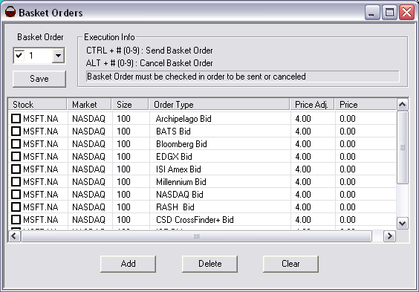

To create a list of orders for the first Basket Order, select a number in the Basket Order scroll down menu. Do not check the box next to the number yet.

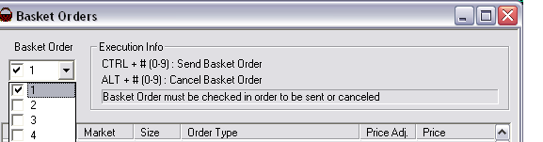

To add an order to the list, click Add. This will allow you to select the Stock, Market, Share Size, Order Type and Price Adjustment for the first order in the list. You must select the correct market to ensure the correct orders get sent.

You can add unlimited orders to this list. To delete an order from the list, check the box next to the stock symbol. Clicking delete will remove all checked orders. Clicking clear will delete all orders in the list. After you have entered all of the orders you wish in the list, click save.

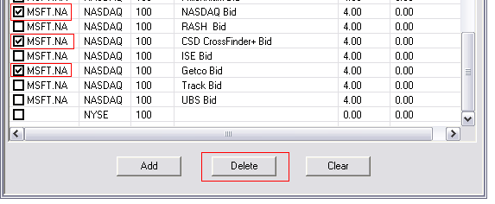

To activate the list, check the box next to the number of the Basket Order list. To ensure fast quotes do not activate any lists unless you are using them. Activating a list forces Prosper Pro to receive quotes from all the symbols in the list.

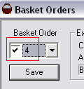

You may now send the Basket Order. In this example, pressing “CTRL” and “4” while in the Basket Order window, sends each order in Basket Order 4 simultaneously. Pressing “Alt” and “4” after the orders have been sent will cancel any of the unfilled orders from that list.

Liquidity Search

Each list has two components – the symbol list and the order list. The symbol list can contain any number of symbols from one market. The order list can contain up to 10 orders for the market specified. When sent the search starts with the first symbol in the symbol list by sending and canceling each order in the order list. Between each order, the search tool waits the specified delay time. When the search has gone through the order list, it moves to the next symbol in the symbol list.

To create a list a Liquidity Search, select a number in the Liquidity Search scroll down menu. You do not have to check the box at this stage.

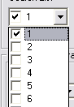

To add a symbol to the Symbol List, choose the market type for your search then type your symbol in the text entry box and click Add.

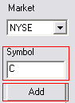

To delete a symbol from the list, highlight the symbol in the Symbol List and click Delete.

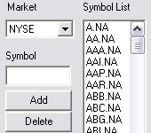

To add an order to the Order List, click on Add in the Order List area. You may now select an order type by clicking the space under Order Type and choosing from the drop down menu. Input the desired price adjustment and share size in the following columns. Please note: a negative price adjustment moves bids/buys lower and move offers/sells higher – it moves the order away from the level 1 price.

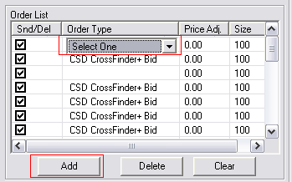

To delete an order, check the box next to the order and click delete.

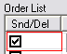

To change the delay between orders sent, Adjust the value in the delay section. This number has minimum value of 0. 3 and is in seconds.

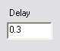

If you wish the Liquidity Search tool to stop sending orders if an order is filled, check the box marked “Pause on Fill”.

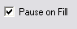

When you have completed the list and all the settings, click save.

To activate the list, check the box next to the number of the Search List. To ensure fast quotes do not activate any lists unless you are using them. Activating a list forces Prosper Pro to receive quotes from all the symbols in the list.

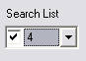

You may now begin the Liquidity Search. In this example, pressing “CTRL” and “4” will start liquidity search number 4. To pause or stop the search, you may click Pause or click Stop. To resume a paused search you may click Resume.

Conditional Orders

When trader presses Add button, TW will display the following window:

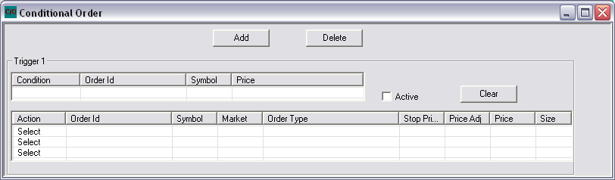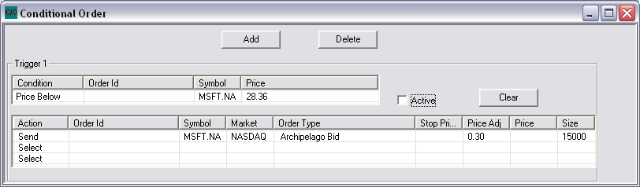

In the trigger condition field you will have the following options:
Order Fills – an order’s status changes to “Filled”
Order Partial Fills – an order’s status is changed to “Partially Filled”
Price Below – the price drops below a specified point
Price Above – the price rises above a specified point

As well in the field you need to fill in an order ID or a symbol and price.

In the action field a trader is limited to three actions per condition.

In the action column the trader has two options. First the trader can send an order if the trigger conditions or met or cancel and order if the trigger conditions are met.

If the trader chooses to send an order if the trigger condition(s) are met then the trader would also have to set the market (OTC, NYSE, AMEX, LSE, TSX and CME), symbol, size as well as one of the price fields.

If the trader chooses to cancel an order if the trigger condition(s) are met then the trader would have to enter the order ID number.

Example:

In this case the trigger condition was set to send an order on Arca at $28.66 when MSFT price rose above $28.36.

2.13. Stock Tracker

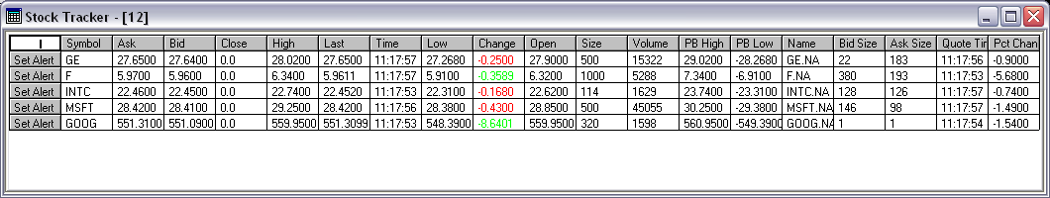

Columns

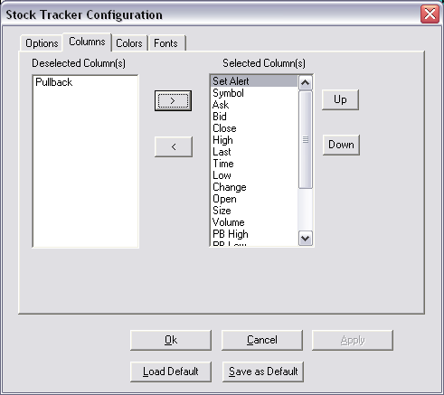

In this window the user may select which columns they want to display in the Stock Tracker. Columns shown will be the items that have been moved into the “Selected Column(s)” from the “Deselected Column(s)”.

Symbol: The symbol that is being tracked
Ask: The current ask price of the stock
Bid: The current bid price of the stock
High: The high of the day on the stock
Low: The low of the day on the stock
Last: The last traded price
Time: The time of the print in the TAS
Change: The change in the price from the opening price
Open: The opening price
Close: The closing price
Size: The size of the last print in the TAS
Volume: Up-to-date daily volume
PB High: Pullback from the day high
PB Low: Pullback from the day low
Bid Size: The current bid size
Ask Size: The current ask size
Quote Time: The time of the last print in the TAS
Pct Change: The percentage change of the stock from the opening price
Name: The name of the stock

Order Types

Basic Concepts

Adding / Removing Liquidity

Adding liquidity means that an order arrived at the market center before the order against which it was executed. Simply put, the order arrived first. Generally, a trader can tell if the order arrived first if they see the order on the level 2 screen; that means the order added liquidity to the market. An order that removes liquidity acts against an order that added liquidity.

Standard Order Types
In order to understand the orders available to them, traders must first understand the basic order types listed below.

Limit Order

An order to buy or sell at a specified price or better

Market Order

An order to buy or sell with no specified price; these orders will be filled at the “best” available price

IOC

Immediate or Cancel – a limit order with an instruction to fill it immediately, or cancel the order

FOK

Fill or Kill – the same function as an IOC, except that FOK orders carry an “All or None” condition requiring that the order get a single fill without any partial fills.

Load

ISI Load – one key that allows a Stop, Limit Stop, or a Limit or Better order to be sent to the NYSE or Amex specialist.

Order Attributes

Hidden Order

An order not displayed to anyone; these orders have the lowest line priority

Reserve Order

An order where only a portion of the order displays, the remainder, held in reserve cannot be seen; these orders have the 2nd lowest line priority

Routed Order

An order that the ECN will send to a gateway outside of its own book; these orders should route to the national best bid best offer unless otherwise specified

Pass-Through Orders

A type of routed order; these orders generally go to the NYSE or AMEX specialist; they skim the ECN’s book for any shares, then route to the specialist; they will not route to a price worse then the national best bid best offer

Post Only

An order that can only post to the book; it will not remove liquidity

T.I.F.

Time In Force – the length of time the trade can remain active

    - Pegged Order

Pegged orders will allow traders to have their orders follow the NBBO. If the NBBO moves so will your order until you are filled. Orders will be placed at the NBBO with no price adjustment.

NASDAQ Cross Orders

NASDAQ has created an order where traders can now participate in the opening, closing on intraday crosses.

Opening Cross – limit-on-open (LOO) orders allow investors to specifically request an execution at the opening price. Accepted between 7:00 a.m. and 9:29 a.m. Eastern Time (ET).

Closing Cross – limit-on-close (LOC) orders allow investors to specifically request an execution at the closing price. On-Close Orders are accepted between 7:00 a.m. and 3:50 p.m. Eastern time (ET).

Intraday Cross – Intraday Crosses will occur at 10:45 a.m., 12:45 p.m. and 2:45 p.m. Eastern Time (ET). The crosses will occur at a random point in time during the minute beginning at each of these times.

Cancel Orders

TW has many types of cancel orders as discussed below.

Cancel Oldest Pending Order: cancels the oldest pending order on that stock
Cancel Most Recent Order: cancels the most recent order on that stock
Cancel All Orders: cancels all orders on that stock
Cancel Closest Bid: cancels the bid closest to the level 1 price on that stock
Cancel Closest Offer: cancels the offer closest to the level 1 price on that stock
Cancel All Bids: cancels all bids on that stock
Cancel All Offers: cancels all offers on that stock
Cancel Newest Bid: cancels the newest bid on that stock
Cancel Newest Offer: cancels the newest offer on that stock
Mass Cancel: cancels all orders in the Order Log

Order on TW by Gateway/ECN

    - Merril Lynch Direct Market Access (ISI)

ML DMA (ISI) acts as a gateway to the market - they route orders directly to the specialist book with no internal matches. ISI do not quote on the level 2.
Orders available in TW:
-ISI Limit Bid / Offer / Short Offer
-ISI Limit Buy / Sell / Short Sell
-ISI Market Buy / Sell / Short Sell
-ISI Market Buy at Open
-ISI Market Short Sell at Open
-ISI Buy on Close
-ISI Short Sell on Close
-ISI Bid on Open
-ISI Offer on Open
-ISI Short Offer On Open
-ISI Limit Buy Plus
-ISI Limit Sell Minus
-ISI Load
-ISI Bid to AMEX
-ISI Offer to AMEX
-ISI Short Offer to AMEX
-ISI Amex Limit Buy/Sell/Short Sell
-ISI Amex Bid/Offer/Short Offer
-ISI Amex Market Buy/Sell/Short Sell

    - NASDAQ

NASDAQ single book acts as a ECN some of its features included being allowed to send hidden orders as well as sending IOC Limit Buy/Sell/Short Sell orders.
It quotes on Lvl2 ( MPID ) NSDQ/ NSB and is available on NYSE, AMEX and NASDAQ markets.
Orders Available on TW:
-NASDAQ Bid / Offer / Short Offer
-NASDAQ IOC Limit Buy/Sell/Short Sell
-NASDAQ Cross Bid/Offer/Short Offer

Intraday Crosses
NASDAQ cross Bid/offer/Short Offer are limit orders that will be executed at the mid-point of the NBBO. All executions are anonymous. The crosses take place at 10:45am, 12:45pm, and 2:45pm Eastern Time. This can occur anytime during the minutes specified above. Orders can be entered anytime during the day, and the order will participate in the closest intraday cross. Only round lots will be accepted, mixed lots and odd lots will be rejected.

The amount of available shares for execution during the cross are divided up among all the intraday cross orders. The larger share sized orders will have more shares allocated to the order. For intraday cross orders, all marketable orders are treated as the same price. Short sale orders will be excepted and executed when possible, considering applicable short sale rules and approved exemptions. For a locked NBBO, the cross will be executed at the locked price. Should a crossed market situation occur, NASDAQ will wait for the quote to uncross before executing at the mid-point. If the quote remains crossed for 5 minutes from when the cross should have occurred, then the cross will be cancelled. A one sided market will be treated the same as a crossed market.

    - RASH

Rash acts like a gateway. Rash quotes on LVL2 as NSDQ/NSB if sitting on NASDAQ book.
Orders Available on TW:
-RASH Bid / Offer / Short Offer
-RASH Buy / Sell / Short Sell
-RASH Pegged Bid / Offer / Short Offer
Pegged orders prices the order relative to the current market price. A pegged bid will move up to the new Level 1 bid price if the stock moves up, and a pegged offer/short offer will move the offer price down to the new Level 1 offer price if the stock goes down.
-RASH SCAN Bid / Offer / Short Offer
The order will sweep the NASDAQ book at a price equal to or better than the NBBO; it will then route to other markets. If shares remain unexecuted after routing, they are posted on the NASDAQ book. After the order is posted, it will not route out again.
-RASH DOT Bid / Offer / Short Offer
DOTA
This order type attempts to execute against the NASDAQ book before routing to other market centers. If the order is routed to the NYSe or AMEX, it will remain at the exchange until executed or cancelled.
DOTM
RASH DOTM orders first tries to execute against the NASDAQ book then routes to an accessible market center. If the order is not fully executed, it will then post on the NASDAQ book. This order will route to resolve any lock or cross after it posts to NSB. If the order is routed to the NYSE or AMEX at any time, it will remain at the exchange until executed or cancelled.
DOTI
Attempts to execute against orders in the NASDAQ book at a price equal to or better than the NBBO and then route to the NYSE or AMEX where the order will remain unitil bein executed or cancelled.
DOTP
This order type attempts to execute against the NASDAQ book before routing to other market centers if the order is marketable. Any remaining shares will post on the NASDAQ book for a set period of time (3 seconds), after which the order will be routed to the NYSE or AMEX. If the order is routed to the NYSE or AMEX, it will remain at the exchange until it is executed or cancelled.
DOTN
This order type attempts to execute against the NASDAQ book, then posts at the NYSE or AMEX.

-RASH MOPP orders:
This order type is designed to route the minimum amount of shares required to comply with regulation NMS:
If an order that could lock the market is sent by the trader, RASH MOPP will route the displayed size to the ECN that’s locking and post the remaining shares.
Fees: MOPP orders that execute on destinations other than NASDAQ including ETF’s that execute on NYSE: $0.0035 per share.
MOPP orders on non-ETF’s that execute on the NYSE: $0.0009 per share
Volume on MOPP orders that executes on destinations other than NASDAQ does not count for the INET bonus.

-RASH Midpoint Peg:
Is a pegged order that executes at the midpoint between the Bid and the Ask
Primary: Peg an order to the same side of the NBBO
Market Peg: Peg an order to the opposite side of the NBBO
Mid-Point Peg: Peg an order to the middle of the NBBO

    - NYSE Arca (Arca PO+ TW: 6.76.00)

Arca acts like a ECN. It quotes on lvl2 ( MPID ) as ARCX/ PACX / ARB.
Orders Available on TW ( NYSE / AMEX / NASDAQ):
-ARCA Limit Buy / Sell / Short Sell
-ARCA Bid / Offer / Short Offer
-ARCA Market Buy / Sell / Short Sell
-ARCA Routed Bid / Offer / Short Offer
-ARCA Routed Buy / Sell / Short Sell
-ARCA Auction Only Bid / Offer / Short Offer

Orders Available on TW ( NYSE):
-ARCA PO Plus Bid / Offer / Short Offer
-ARCA PO Plus Buy / Sell / Short Sell
Arca PO+ allows users to route to the NYSE during all of the trading sessions. Arca PO+ order can be entered as an Immediate-or-Cancel (IOC) order, or as a Day Order that will remain open until the order is either executed or cancelled. Additionally, Arca PO+ order type supports reserve orders. This order will not route out, it will sit on the NYSE.
Fee for removing liquidity from the NYSE is of $0.0008 per share
Free to add liquidity to the NYSE

    - Direct Edge

Direct Edge ECN has two gateways. Each gateway has its own MPID and fee schedule. EDGX offers the classic rebate pricing model, giving liquidity suppliers high rebates. EDGA is free to take liquidity and free to supply it. EDGX(EXB) and EDGA (EAB) quote on lvl2 and are available on NYSE , NASDAQ and AMEX markets.
EDGA orders available on TW:
-Edga Bid / Offer / Short Offer
-Edga Limit Buy / Sell / Short Sell

EDGX order available on TW:
-EDGX Bid / Offer / Short Offer
-EDGX Routed Bid / Offer / Short Offer
-EDGX Routed Buy/ Sell/ Short Sell

Routing strategies:
All routing strategies are valid for both EDGA & EDGX
ROUT Strategy: EDGX/A Book→ELPs→Visible Market
1. Non-marketable orders are posted on the ECN book and quoted as EDGX/A on ADF.
2. Marketable orders:
a. Interact with posted liquidity on EDGX/A’s book.
b. Interact with Enhanced Liquidity Providers.
c. Interact with quotes of market centers that are displayed in level 2 montage at the inside.
3. Repeat the process again every 100 ms.

ROUX Strategy: EDGX/A Book→Visible Market
1. Non-marketable orders are posted on the ECN book and quoted as EDGX/A on ADF.
2. Marketable orders
a. Interact with posted liquidity on EDGX/A’s book.
b. Interact with quotes of market centers that are displayed in level 2 montage at the inside.
3. Repeat the process again every 100 ms or till the order is filled or cancelled.

ROUZ Strategy: EDGX/A Book→ELPs
1. Non-marketable orders with Day Time In Force are posted on the ECN book and quoted as EDGX/A on ADF.
2. Marketable orders
a. Interact with posted liquidity on EDGX/A’s book.
b. Interact with Enhanced Liquidity Providers.
3. Unexecuted quantity of the order with Day Time in Force is posted on the ECN book and quoted as EDGX/A on ADF.

Exchange Listed and ETF Stocks Routing Strategies
ROUT Strategy: EDGX/A Book→ELPs→Visible Market
1. Non-marketable orders are posted on the ECN book and quoted as EDGX/A on NASDAQ.
2. Marketable orders:
a. Interact with posted liquidity on EDGX/A’s book.
b. Interact with Enhanced Liquidity Providers.
c. Send orders to the primary exchange for its quoted size.
d. Interact with quotes of ECNs and NASDAQ that are displayed in level 2 montage at the inside.
e. Repeat the process again every 150 ms until all liquidity on the ECNs and NASDAQ is exhausted.
f. Send orders to regional exchanges via ITS for their quoted size
3. Post unexecuted shares as EDGX/A on NASDAQ.

ROUX Strategy: EDGX/A Book→Visible Market
1. Non-marketable orders are posted on the ECN book and quoted as EDGX/A on NASDAQ.
2. Marketable orders:
a. Interact with posted liquidity on EDGX/A’s book.
b. Send order to the primary exchange for its quoted size.
c. Interact with quotes of ECNs and NASDAQ that are displayed in level 2 montage at the inside.
d. Repeat the process again every 150 ms until all liquidity on the ECNs and NASDAQ is exhausted.
e. Send orders to regional exchanges via ITS for their quoted size.
3. Post unexecuted shares as EDGX/A on NASDAQ.

RDOT Strategy: EDGX/A Book→ELPs→Primary Exchange
1. Non-marketable orders are quoted on the primary exchange.
2. Marketable orders:
a. Interact with posted liquidity on EDGX/A’s book.
b. Interact with Enhanced Liquidity Providers.
c. Send order to the primary exchange.

RDOX Strategy: EDGX/A Book→Primary Exchange
1. Non-marketable orders are quoted on the primary exchange.
3. Marketable orders:
a. Interact with posted liquidity on EDGX/A’s book.
b. Send order to the primary exchange as non routable order.

ROUZ Strategy: EDGX/A Book→ELPs
1. Non-marketable orders with Day Time In Force are posted on the ECN book and quoted as EDGX/A on NASDAQ.
2. Marketable orders
a. Interact with posted liquidity on EDGX/A’s book.
b. Interact with Enhanced Liquidity Providers.
3. Unexecuted quantity of the order with Day Time in Force is posted on the ECN book and quoted as EDGX/A on NASDAQ.

    - BATS (Better Alternative trading System)

Bats quotes on the NYSE, NASDAQ and AMEX markets. BATS features include a "Post only" option that prevents orders from removing liquidity. In addition with BATS you have the option of displaying your order or not.

Orders Available on TW:
-BATS Bid / Offer / Short Offer
-BATS Limit Buy / Sell / Short Sell
-BATS Dark Bid / Offer / Short Offer
-BATS Dark Buy / Sell / Short Sell
-BATS Peg Bid / Offer / Short Offer
-BATS Peg Limit Buy / Sell / Short Sell
-BATS Pass Through Bid / Offer / Short Offer
-BATS Pass Through Limit Buy / Sell / Short Sell

BATS Dark and BATS Peg orders - (RN:6.72.00)
They both have Bid/Offer/Short Offer and Limit Buy/Sell/Short Sell. There are also new routing options for BATS. The new options available are Routing to the NYSE, to the AMEX and routing To All. The BATS Pegged orders will not display, they are all hidden orders.
The Dark Liquidity Providers available through BATS are GETCO, Liquidity Ping, A Citi Company, Liquidnet H20 and Knight Link. BATS dark routes to these liquidity providers before accessing the BATS book.

    - NYFIX Millenium

MILN works as a dark book, which will allow traders to take advantage of off book liquidity.
MILN Pass Through orders will first search the dark book for any liquidty then will post on the NYB until filled or canceled.

Orders available in TW:
-Millenium Bid / Offer / Short Offer
-Millenium Market Buy / Sell / Short Sell
-Millenium Pass Through Bid / Offer /Short Offer

-Millenium Pass Through Buy /Sell / Short Sell
-Millenium Market Buy / Sell / Short Sell
-Millenium NIX Bid / Offer / Short Offer
-Millenium NIX Buy / Sell / Short Sell

Millennium NIX orders - (RN:6.70.53)
Available for all NA Markets, NIX orders have the choice of routing to Dark or All. It routes to numerous dark pools, at this time they do not disclose the pools they route to but it gives access to more dark venues.

NYFIX orders available in TW:
-NYFIX Stealth Bid / Offer / Short Offer
-NYFIX Stealth Buy / Sell / Short Sell

NYFIX stealth orders - (RN:6.75.00)
NYFIX Stealth is a Dark router available on the NYSE, NASDAQ and AMEX. What Stealth does is that it automates dark pool liquidity search in Millennium and other ATSs on the market, including pools not open to other, non-neutral providers. A smart strategy for working orders in the harder-to-trade names over a period of time.

3.5.8. Bloomberg (BBRG)

BBRG features include a "Reserve" option that allows traders to not show the full size of their order. It’s MPID on lvl2 is BTRD.

Orders available in TW:
-Bloomberg Bid / Offer / Short Offer
-Bloomberg Market Buy / Sell / Short Sell
-Bloomberg Limit Buy / Sell / Short Sell

3.5.9. AUTO

AUTO works as a dark book and black box trading system. This will allow traders to take advantage of off book liquidity.

Orders available in TW:
-AUTO Bid / Offer / Short Offer
-AUTO Buy / Sell / Short Sell

3.5.10. TRACK (Track data securities)

Track features include a "Post only" option that prevents orders from removing liquidity. In addition with Track you will also be able to place reserve orders.

Orders available in TW:
-Track Bid / Offer / Short Offer
-Track Limit Buy / Sell / Short Sell
-Track Market Buy / Sell / Short Sell

    - UBS ( Union Bank of Switzerland )

UBS is available on NYSE, NASDAQ and AMEX, UBS orders on NYSE listed symbols will first access UBS's dark liquidity pool. If the order, or a portion of the order can be filled, it will execute against this pool. The remainder will be routed to the NYSE. For NASDAQ listed symbols, UBS will access its dark liquidity, then route to the best displayed price.

Orders available in TW:
-UBS Bid/Offer/Short Offer
-UBS FOK Buy/Sell/Short Sell

3.5.12. Edge trade ( EDGE )
Edge Trade is a Dark Router is available on NYSE, AMEX and NASDAQ. They have over 200 customers and connect to several Dark books.
Edge Trade ensure that their orders "hit" all liquidity sources simultaneously, without any destination preference logic to impede a best execution.

Orders available in TW:
-Edge Trade Bid / Offer / Short Offer
-Edge Trade Buy / Sell / Short Sell
-Edge Trade Pegged Bid / Offer / Short Offer
-Edge Trade Pegged Buy / Sell / Short Sell

3.5.13. Crossfinder+ ( CSD ) (TW: 6.70.00)
This ECN offers trading in NASDAQ, NYSE and AMEX.
CSD is a dark book, and it also routes orders to: ISE, FLOW, ARCA, NASDAQ, BATS, EDGA, EDGX, BIDS, Instinet CBX, Instinet IDX, Lehman LCX, LEVEL, ISE Midpoint, Knight Match, Knight Link, Lava Dark book, Citadel, ATD, BNY Cross, CrossFinder Retail Network, BNY Vert-X, Fidelity CrossStream, NYFIX Millennium, Pulse Blockcross and Liquidnet H2O.
Fees:
CSD charges
$0.0025 per share.

Order available on TW:
-CSD Limit Bid / offer / short offer
-CSD Limit Buy / sell / short sell
-CSD Market Buy / Market Sell / Market short sell

CSD offers 2 execution styles, neutral and aggressive.
The neutral execution style will execute orders at the midpoint, or better.
The aggressive execution style will execute bids at the ask, or better; and offers at the bid or better.

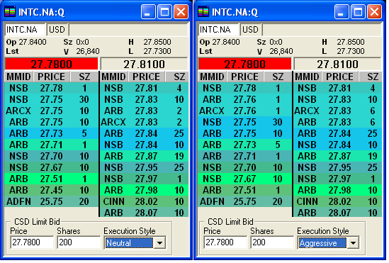

3.5.14. ISE ( International Securities Exchange ) (TW: 6.70.00)
The ISE Stock Exchange is the only dual structure platform that integrates a dark pool with a fully displayed stock market. On one platform, traders have the best of both worlds -complete order protection and continuous price improvement.
ISE acts like a ECN and offers trading in NASDAQ and NYSE.

Order available in TW:
-ISE Bid / Offer / Short Offer
-ISE MPM Bid / Offer / Short Offer
-ISE SOI Bid / Offer

Mid Point Match [MPM] Orders:
A Limit Order, If not immediately executed Standard MPM orders reside in the MPM order book. All orders are executed at the midpoint of the NBBO, with limit orders providing a boundary prie outside of which the order cannot be executed.

Solicitation of Interest [SOI] Orders:
A special MPM order type unique to ISE, unlike a regular MPM the ticker symbol of an SOI order is broadcast to inform market participants that the order is present.
For viewing SOI indications of interest, you must check “visible” on the Order Log Window Customization.
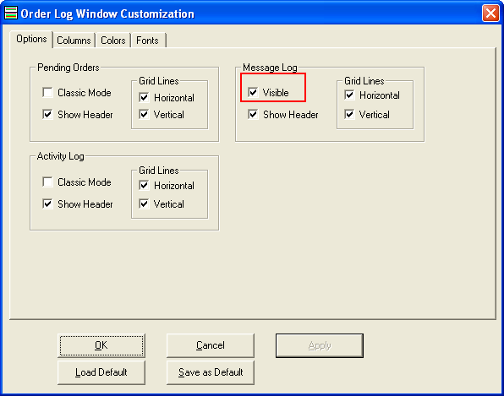
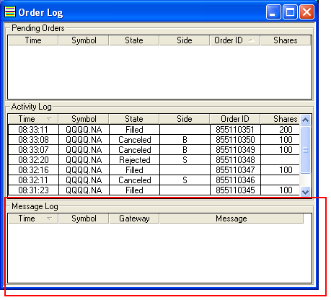

3.5.15. GETCO (RN: 6.70.48)

GETCO acts as a dark pool with both customer and proprietary orders with which we will interact. GETCO, also known as Wedbush Morgan, provides more liquidity to the US markets than any other firm.
Currently GETCO will not charge for executions (FREE). It prints in Time and sales as “D”.
Orders available on TW:
-Getco Bid / Offer / Short Offer
-Getco Buy / Sell / Short Sell
-Getco Market Buy / Sell / Short Sell

OES (RN:6.71.00)

OES is a Dark Book Router, it is available for NYSE, NASDAQ and AMEX listed symbols.
All OES are Immediate or Cancel. OES uses undisplayed, anonymous indications of interest to create order matches and executions between multiple, independent dark pools, exponentially increasing crossing. It creates new liquidity and enables higher fill rates by anonymously aggregating buyers and sellers who are fragmented across various dark pools.
This Dark book router goes to 13 different dark pools and 11 others will be added in the near future. The Fee for the use of OES Marketplace is 0.0015 per share apart from what the venue is charging.

Orders available in TW:
-OES Dark Bid / Offer / Short Offer
-OES Dark Limit Buy / Sell / Short Sell
-OES Dark Market Buy / Sell / Short Sell

3.5.17. Morgan Stanley (RN:6.72.00)
Morgan Stanley is available on NYSE, NASDAQ and AMEX symbols. The fees for this Gateway will be $0.002 per share.

Orders available in TW:
-MS Night Vision Limit Bid / Offer / Short Offer
-MS Night Vision Limit Buy / Sell / Short Sell
-MS Night Vision Market Buy / Sell / Short Sell
-MS Sort DMA Limit Bid / Offer / Short Offer
-MS Sort DMA Limit Buy / Sell / Short Sell
-MS Sort DMA Market Buy / Sell Short Sell
-MS Sort PP Limit Bid / Offer / Short Offer
-MS Sort PP Limit Buy / Sell / Short Sell
-MS Sort PP Market Buy / Sell Short Sell

Sort DMA:
SORT DMA allows us to reach the Morgan Stanley Smart Order Router during market hours .
Marketable orders are executed price level by price level with quotes allowed to refresh at the inside before SORT moves further into the book.
The order is optimally broken up and executed against multiple liquidity pools based on price, current and historical liquidity, speed and stability

SORT PP:
Its like SORT DMA for Premarket and postmarket

Night Vision:
[Dark router] “What Night vision does is fragment the order to sources of only dark liquidity through an aggregation of dark pools. The Smart Order Routing Technology (SORT) has fragmented markets in a single, unified view. SORT will send orders to liquidity pools helping to achieve best execution using the MS BXS limit order program. An important rule about the Nightvision orders is that they block IOC orders and the orders must remain in the pool for a required resting time of 10 seconds before they can be canceled.

3.5.17. Piper Jaffray (RN:6.74.00)

This Dark Router is available on the NYSE, NASDAQ and AMEX.
The fee for Piper Jaffray is $0.004 per share.
The Piper Jaffray orders are the following.

PJC BEVWAP | Bid/Offer/ Short Offer | Market Buy /Sell /Short Sell | Limit Buy/ Sell/ Short Sell
PJC ESP | Bid/Offer/ Short Offer | Limit Buy/ Sell/ Short Sell | Market Buy /Sell /Short Sell
PJC INLINE | Bid/Offer/ Short Offer | Limit Buy/ Sell/ Short Sell | Market Buy /Sell /Short Sell
PJC TWAP | Bid/Offer/ Short Offer | Limit Buy/ Sell/ Short Sell | Market Buy /Sell /Short Sell
PJC VTRACK | Bid/Offer/ Short Offer | Limit Buy/ Sell/ Short Sell | Market Buy /Sell /Short Sell
PJC FUSION | Bid/Offer/ Short Offer | Limit Buy/ Sell/ Short Sell | Market Buy /Sell /Short Sell
PJC HORNET | Bid/Offer/ Short Offer | Limit Buy/ Sell/ Short Sell

Details on order types:

Weighted Average Price Orders
Piper Jaffray utilizes the price predictive engine to effectively manage spread costs for optimal timing and routing to track VWAP, minimize market impact and prevent market participants from detecting trading intent.
• Best Efforts Volume Weighted Average Price (beVWAP)
• Time Weighted Average Price (TWAP)

ESP (Execution through Statistical Prediction)
Piper Jaffray employs a short-term, predictive market model that formulates expectations of the price and volume of a given stock in the next one to three minutes. ESP orders can be tagged Aggressive, Normal or Passive.
For example, a passive ESP order will typically trade on “strong” trading signals only for orders less than 3% of ADV in liquid names. When an order exceeds 10% of the interval volume, the algorithm typically is forced to trade on “weaker” signals so the order can be completed.
Example: Buy 50,000 INTL; let the model do the work

INLINE
INLINE is appropriate for trade strategies focused on implementation shortfall/arrival price, and for stocks/ baskets with high alpha decay. By default, orders are typically executed “in line” with 15% to 20% of volume depending on the amplitude of the trading signal generated by the Piper Jaffray price predictive engine. In addition, you have the flexibility to specify target participation levels, and to assign a price limit. Note that variance from volume goals may be +/- 5% of any specified target percentage.

Volume Tracker [VTRACK]
This order participates strictly using the specified target percent and smoothes volume spikes to avoid undue market impact following a large print.
Example: Buy 50,000 JNJ, be 20% of volume

Fusion
Fusion is Piper Jaffray’s dark router. Fusion allows customers to intelligently work an order in an algorithm while “smart-searching” for block liquidity. Fusion can be accessed as both an order type and an order qualifier. You can use Fusion as an order type when the sole intent is to anonymously access a growing list of dark liquidity pools and crossing networks. Fusion can be used as an order qualifier to simultaneously execute an order using a Piper Jaffray algorithm while seeking crosses on the balance of the order.

Hornet
Hornet represents PJC’s most aggressive order type. It’s designed to capture as many shares as possible without posting the order. Use Hornet if you’re looking to get a fill quickly and you don’t care where you get the shares. Upon receipt of the order, Hornet takes all liquidity at the inside market and then uses hidden/discretionary orders to capture reposts at the previous inside market or better.

At each price level, Hornet attempts to fill the order and, before moving to the next price level, it continuously pings for hidden liquidity between the spread.

3.5.18. Sungard (RN:6.74.00)
Sungard is a Dark router. We include 1 order type and a total of 9 new orders to Trader ware. Sungard is $0.002 per share.
Order available in TW:
-SUN Dark PING Limit Bid / Offer / Short Offer
-SUN Dark PING Limit Buy / Sell / Short Sell
-SUN Dark PING Market Buy / Sell / Short Sell

3.5.19. Instinet (RN: 6.76.00)

You will be able to find two different order types with Instinet, Nighthawk and Instinet Dark.
Nighthawk:
Nighthawk is a stealth liquidity aggregation algorithm that simultaneously accesses most major pools of dark liquidity, including Liquidnet H20, NYFIX Millennium, Pipeline and Instinet’s various sources of upstairs liquidity. There are several execution styles available for Nighthawk they are Normal, Passive, Aggressive and Super Aggressive.
There are also available different Limit Types such as Last, AVG, VWAP, REL, STR, MKT and QUOTE.
Orders Available on TW:
-INST Limit Bid / Offer / Short Offer

Instinet Dark:
Instinet dark is a dark pool designed to allow institutions to trade confidentially with natural counterparties. There’s no public quote, so the traders can exhaust liquidity on either side of the spread without moving the market.
Orders Available on TW:
-INST Dark Bid / Offer / Short Offer
-INST Dark Buy / Sell / Short Sell
-INST Dark Peg Bid / Offer / Short Offer

3.5.20. Bank of America “BOFA” (RN: 6.77.00)

BOFA adds 12 new order types to TW:
-Limit Bid/Offer/Short Offer and Buy/Sell/Short Sell
-Market Bid/Offer/Short Offer and Buy/Sell/Short Sell
-On Open Bid/Offer/Short Offer
-On Close Bid/Offer/Short Offer
-On Open: with the On Open you can specify the amount of the order you want to trade at the open.
-On Close: with the On Close you can specify the amount of the order you want to trade at the close.
Value
>1 | Number of shares to trade
0<and<1 | Fraction of shares (e.g. 0.05)
0 | Do not trade at Open/Close
None | Defaulted automatically

There are 2 different routing options DMA and CUST.
Direct Market Access: Routes to all visible and dark pools. When receiving an order for the first time in the stock that day, it will send the whole order to NASDAQ. If the router has seen activity in that name previously, it will split the order into child orders based on a liquidity profile for that stock. The profile is calculated based on historical and real-time data. If we see a large dma order get sent for the first time, we typically cancel it at NASDAQ so the order gets split out to other venues.
Custom: Limited to dark-only venues. When receiving an order, it will initially split it evenly between the dark-only venues. Then as we get fills, it will re-allocate more shares to the dark venue(s) providing the most fills. Currently there are no individual stock profiles.
It also provides 3 different Execution Modes Neutral, Passive and Aggressive.

The Exchanges that can be routed to with DMA and CUST are listed below
DMA
AMEX
ARCA
AUTO
BATS
BIDS
BLOK
CHX
EBXL
EDGA
EDGX
INET
ITGI
LQNT
NYFX
NYSE
PULX
SHAW
NITE
CUST
Dark Pool | MPID
BIDS | BIDS
LeveL ATS | EBXL
ITG Posit | ITGI
NYFX Millenium | NYFX
Pulse | PULX
ATD | AUTO
LiquidNet | LQNT
DE Shaw | SHAW

Recently added to TW

4.1. Quotes (RN:6.70.00)
TW supports quotes from Bats book
TW supports quotes from Omega book on the TSX.

4.2. Cancellation options (RN:6.70.00)
TW supports canceling the orders furthermost from level 1
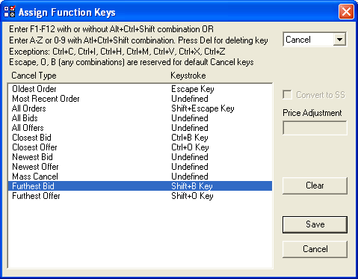

4.3. ATS: Omega (RN:6.70.00)

TW supports trading with the Omega gateway. This ECN offers trading in the Toronto Stock Exchange [TSX]

Fees:

Omega charges:
CND 0.0039 per share for removing liquidity.
CND -0.0036 per share for adding liquidity.

TW provides the following Omega orders:

Omega Limit Bid
Omega Limit Offer
Omega Limit Short Offer
Omega Limit Buy
Omega Limit Sell
Omega Limit Short Sell

4.4. MTF/ECN: CHI-X (Euronext) - (RN:670.55)
The advantages that this ECN has are Pegged orders and Reserve for Euronext.
The Fees for this new ECN are the following:

Gateway fee: -€0.00002 x shares x price / €0.00003 x shares x price
Clearing fee: €0.2 per fill + €0.000015 x shares x price
Execution fee: € 0.07 / trade

4.5. Markets: Xetra and Milan (RN:6.70.58)

The new release of Traderware provides access to two new markets, Xetra and Milan. In order to be able to execute in these markets a new order has been added, CAI Cheuvreux, Limit and Market Bid/Offer-Buy/Sell, LOC and MOC Buy/Sell.

The fees are the following:

Borsa Italiana-Milan:
Gateway €0.32 per fill
Clearing €0.28 per fill
Execution €0.07 per trade

Deutsche Börse-Xetra:
Gateway €0.6 per fill
Clearing €0.70 per fill
Execution €0.07 per trade

4.6. Stop Orders - (RN:6.73.00)
Swift Stop orders are available now. A stop order is an order to buy or sell once the price reaches a price the user has specified, this price is known as the stop price. Once this price is reached the Swift Stop sends a user defined limit or market order to execute the Buy or Sell. This order allows users to buy once the market has gone up beyond a certain price, or to sell once the market has gone down beyond a certain price. For this orders to execute you must have the Level 2 and Time and Sales open for the stock. The order rests in TW, it is not sent to the market until the Stop Price is triggered. In the case that TW is restarted the order is lost.

4.7. Trailing Stop Orders
Trailing Stop orders can control the LFT in a specific position. When entering the order the user will set the LFT allowed for this position, the order will adjust itself maintaining itself within the range the user has selected. This order allows users to define an order that is going to buy when the market goes up 5, 10 or 15 cents; or to sell after the market drops 3 cents. For this orders to execute you must have the Level 2 and Time and Sales open for the stock. The order rests in TW, it is not sent to the market until the Stop Price is triggered. In the case that TW is restarted the order is lost.
For example: User punches in at 96.00 and selects and LFT of 0.25 so the trailing stop order will be at 95.75, if the stock were to move to 96.10 then the trailing stop order will be set to 95.85 maintaining an LFT of 0.25.

4.8. User options Window:
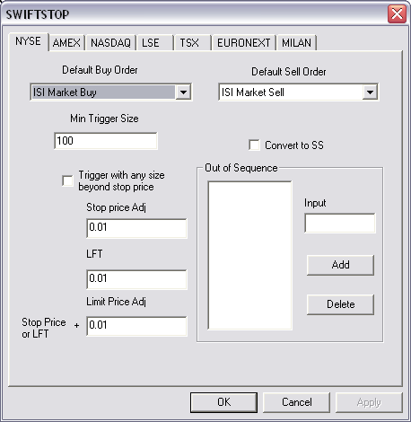
Market tabs:
The market tabs allow you to set up defaults for each independent market where we trade. Initially, only US markets are available, other markets will be added in future releases.
Order options:
Default Buy Order:
Allows you to specify what order is SWIFTSTOP going to use for buying on the selected Market.
Default Sell Order:
Allows you to specify what order is SWIFTSTOP going to use for selling on the selected Market.
Convert to SS:
Allows offers to be converted to short offers if trader is flat at the time of sending the order.
Triggers:
Stop orders are triggered from information on the TAS window. In order to avoid false triggers a few options are provided.
Out of sequence:
Allows you to define what SL conditions you consider to be out of sequence [Z,H,G, etc…]
Adding the out of sequence characters is as simple as putting the character in the input field and pressing the Add button.
To remove a character, select it from the Out of Sequence list and press Delete.
Min Trigger Size:
This feature allows you to specify the minimum order size for a trigger to execute. This is useful if you want your stop to trigger only with large prints.
Trigger with any size beyond stop price:
This option complements the Min Trigger Size. It allows you to specify whether you want to screen for the minimum size even when the TAS is printing at prices beyond your stop price.
Price Options:
Stop Price adjust:
This option is used for Stop orders [not with the Trailing Stop Orders. The stop price is the price after which the order becomes active.
The Stop Price Adjust feature allows you to set a price adjust for the Stop price to load above/below current market price when you open the order edit box [on the level 2 window].
LFT:
This feature is used only for the Trailing Stop orders. LFT allows you to specify how many you’re going to allow the market to go against your order in any given time.
By setting up LFT you decide what the default is going to be for this value every time you open the order edit box [on the level 2 window].
Limit Price Adjust:
The limit price on a stop order is the price at which the order is sent to the market once the stop price has been passed.
By setting up a limit price adjust, you are able to define how much beyond the stop price you want your Limit price to be loaded by default when you open the order edit box [on the level 2 window].
If you define a market order on your Default Buy/Sell orders, then Limit price has no effect on your order.

4.9. Order entry, and examples
Both the Stop and Trailing stop order can be used to stop losses or for starting new positions. It is easier to understand the functionality of these orders by considering their role as a stop-loss order first.

Oder Edit Box for Swift Stop

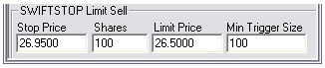

Order Edit Box for Trailing Stop

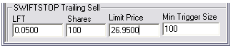

4.10. Using Stops and Trailing stops as a Stop-loss order.
Let us say a trader is long 5000 shares of MSFT at 27.00. The trader does not want to take more than a 5 cents loss on the trade. The trader puts a Swift Stop Sell order at a stop price of 26.95 with a limit price of 26.85.
Let’s suppose that MSFT goes up to 27.10 and then comes back down to 26.95, then TW is going to send a limit sell order at a price of 26.85 [that order will execute at the best available price, not necessarily 26.85]. The trader is out of his trade at 26.95 with a 0.05 loser.

Let us take the same trader with a 5000 share long position on MSFT, but let’s suppose that he didn’t use a Swift Stop order, but rather a Swift Trailing Stop order.

The trader is long 5000 shares at 27.00, and he does not want to risk more than 0.05 on the trade. So he sets a Swift Trailing Stop Sell with a 0.05 LFT and a limit price of 26.85. At this moment the Trailing stop will sell the shares once the stock reaches 26.95

Let us suppose that MSFT goes up to 27.10. At this moment the Trailing stop has adjusted the stop price, it will no longer wait for MSFT to go down to 26.95 in order to execute, but it will execute the order once it losses 0.05 from the best price so far [25.70]. So once again, MSFT heads back down to 26.95; but the Trailing stop sells the shares once MSFT trades at 25.70, sending a limit order at the price of 26.85, so the trader gets out of his trade at a 0.05 profit.

In both cases the Stop order prevents the trade from exceeding the maximum risk that the trader wants on the trade, but with the trailing stop it also helps the trader lock into profits when the market moves on his favor before moving against him.

4.11. Using Stop orders for entering a new trade
Now that we understand how these orders work, let us suppose our trader is not long 5000 shares of MSFT, but flat.
He sees the stock and determines that 26.95 is a support level and if the stock breaks that level it will probably continue going down from there.
So he sets up a Swift Stop order with a Stop price of 26.94 and a limit price of 26.85. Again let’s say that MSFT goes up to 27.10 and then starts heading down from there, once MSFT prints at 26.94 our trader gets a short position at that price [or a bit lower if there’s slippage].

Let us suppose another trader is also watching the move on MSFT but he thinks that 25.70 is a mayor resistance. He thinks that if the stock drops more than 5 cents after trading at that price, it would be a sign of weakness and a sell signal. So once the stock is trading at 25.70 he puts a Swift Trailing Stop Sell with a 0.10 LFT.
As MSFT goes up to 27.10 his stop gets adjusted all the way to 27.00, once the stock starts going down he gets a short position at 27.00 by sending a limit order at 26.85
Comment on Limit price
Since stop orders are used for limiting losses when the market is moving against you, or for entering breakout trades, using an aggressive limit order is a good idea. Since you do not want your order to just sit there, but you want to it to get you the shares now, before the stock has made a mayor move in the direction of your order.

4.12. Tracking Swift Stop/Trailing Stop orders in the Order log
Below is the Order log, which includes now a section for tracking Swift Stop Orders.
Note: To cancel these orders you will need to cancel selecting the orders in the log. In the current implementation you will not be able to cancel orders directly from the Level 2 window. However, since Swift Stop orders rest in TW before the stop price is triggered, you will be able to cancel many stop orders by selecting them, without experiencing delay.
