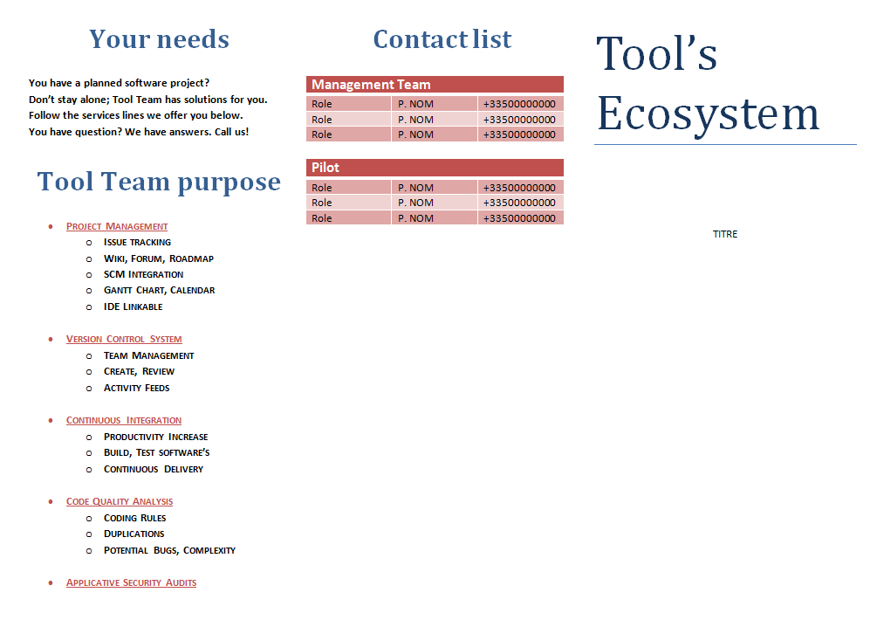

## Installation

Git provides desktop and command line tools. The desktop tool includes graphical user interface to help users into most common usage

**Git for Windows**

<https://tortoisegit.org/download>

**Git for Mac**

<https://www.sourcetreeapp.com>

**Git for all platforms**

<http://git-scm.com>

## Configuration

Configure user information for all local repositories

|  |
| --- |
| $ git config --global user.name “[name]” |
| Sets the name you want attached to your commits transactions |
| $ git config --global user.emal “[email address]” |
| Sets the email you want attached to your commits transactions |

## Create repositories

Start a new repository or obtain one from an existing URL

|  |
| --- |
| $ git init [project-name] |
| Creates a new local repository with the specified name |
| $ git clone [url] |
| Downloads a project and its entire version history |

## Make changes

Review, edits and craft a commit transaction

|  |
| --- |
| $ git status |
| Lists all new or modified files to be commited |
| $ git diff |
| Shows file differences not yet staged |
| $ git add [file] |
| Snapshots the file in preparation for versionning |
| $ git diff --staged |
| Shows file differences between staging and the last file version |
| $ git reset [file] |
| Unstages the file, but preserve its contents |
| $ git commit -m “[descriptive message]” |
| Record file snapshots permanently in version history |

## Group changes

Name a series of commits and combine completed efforts

|  |
| --- |
| $ git branch |
| List all local branches in the current repository |
| $ git branch [branch-name] |
| Creates a new branch |
| $ git checkout [branch-name] |
| Switches to the specified branch and updates the directory |
| $ git merge [branch] |
| Combines the specified branch’s history into the current branch |
| $ git branch -d [branch-name] |
| Deletes the specified branch |

## Refactor filenames

Relocate and remove versioned files

|  |
| --- |
| $ git rm [file] |
| Deletes the file from the working directory and stages the deletion |
| $ git rm --cached [file] |
| Removes the file from git VCS but preserves the file locally |
| $ git mv [file-original] [file-renamed] |
| Changes the file name and prepares it for commit |

## Suppress tracking

Exclude temporary files and paths

|  |
| --- |
| *.log  build/  temp-* |
| A text file names .gitignore suppresses accidental versionning of files and path matching the specified patterns |

## Save fragments

Shelve and restore incomplete changes

|  |
| --- |
| $ git stash |
| Temporarily stores all modified tracked files |
| $ git stash pop |
| Restores the most recently stashed files |
| $ git stash list |
| Lists all stashed changesets |
| $ git statsh drop |
| Discard the most recently stashed changesets |

## Review history

Browse and inspect the evolution of project files

|  |
| --- |
| $ git log |
| Lists version history for the current branch |
| $ git log --follow [file] |
| List version history for a file, including renames |
| $ git diff [first-branch]…[second-branch] |
| Shows content differences between two branches |
| $ git show [commit] |
| Outputs metadata and content changes of the specified commit |

## Redo commits

Erase mistakes and craft replacement history

|  |
| --- |
| $ git reset [commit] |
| Undoes all commits after [commit], preserving changes locally |
| $ git reset --hard [commit] |
| Discards all history and changes back to the specified commit |

## Synchronize changes

Register a repository bookmark and exchange version history

|  |
| --- |
| $ git fetch [bookmark] |
| Downloads all history from the repository bookmark |
| $ git merge [bookmark]/[branch] |
| Combines bookmark’s branch into current local branch |
| $ git push [alias] [branch] |
| Uploads all local branch commit to git remote server |
| $ git pull |
| Downloads bookmark history and incorporates changes |