《机器学习基础》实验报告

年级、专业、班级 |  | 计算机科学与技术2020级 |  |  | 姓名 | 黄昊
实验题目 | 对数几率回归算法实践
实验时间 | 2022/09/25 |  | 实验地点 | 线上进行
实验成绩 |  |  | 实验性质 | □验证性 □设计性 □综合性
教师评价：
□算法/实验过程正确； □源程序/实验内容提交 □程序结构/实验步骤合理；
□实验结果正确； □语法、语义正确； □报告规范；
其他：
评价教师签名：
一、实验目的
掌握线性模型、对率回归算法原理。
二、实验项目内容
1. 理解对率回归算法原理。
2. 编程实现对数几率回归算法。
3. 将算法应用于西瓜数据集、鸢尾花数据集分类问题。

三、实验过程或算法（源程序）
1）实验过程
①西瓜数据集
本实验选择的是教材上西瓜数据集3.0的数据。该数据的处理难点在于有非数值型数据。因此，本实验首先进行数据预处理，将非数值型数据用独热编码进行转换，之后再进行模型的训练。对率回归算法的参数更新采用梯度下降法，训练次数为1000，学习率为0.3。该实验的过程如下图所示：
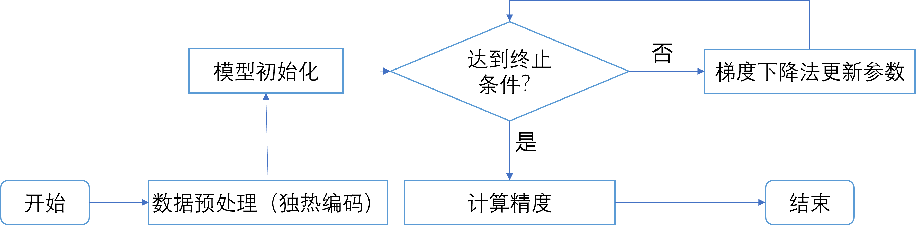
考虑到样本量较少，因此未进行训练集和验证集的划分，仅计算了训练时的准确率。
②鸢尾花数据集
鸢尾花数据集为三分类问题，不能直接使用Logistics分类器进行分类，需要利用OvO策略对原问题拆分为三个二分类任务。具体来说，针对不同的类别，产生三个数据集，每个数据集选择一类作为正例，同时选择另外一类作为反例，然后分别送入三个对应的二分类器进行训练。在验证阶段，三个分类器同时对一个样本进行预测，按照投票原则产生预测结果。具体流程如下图所示：
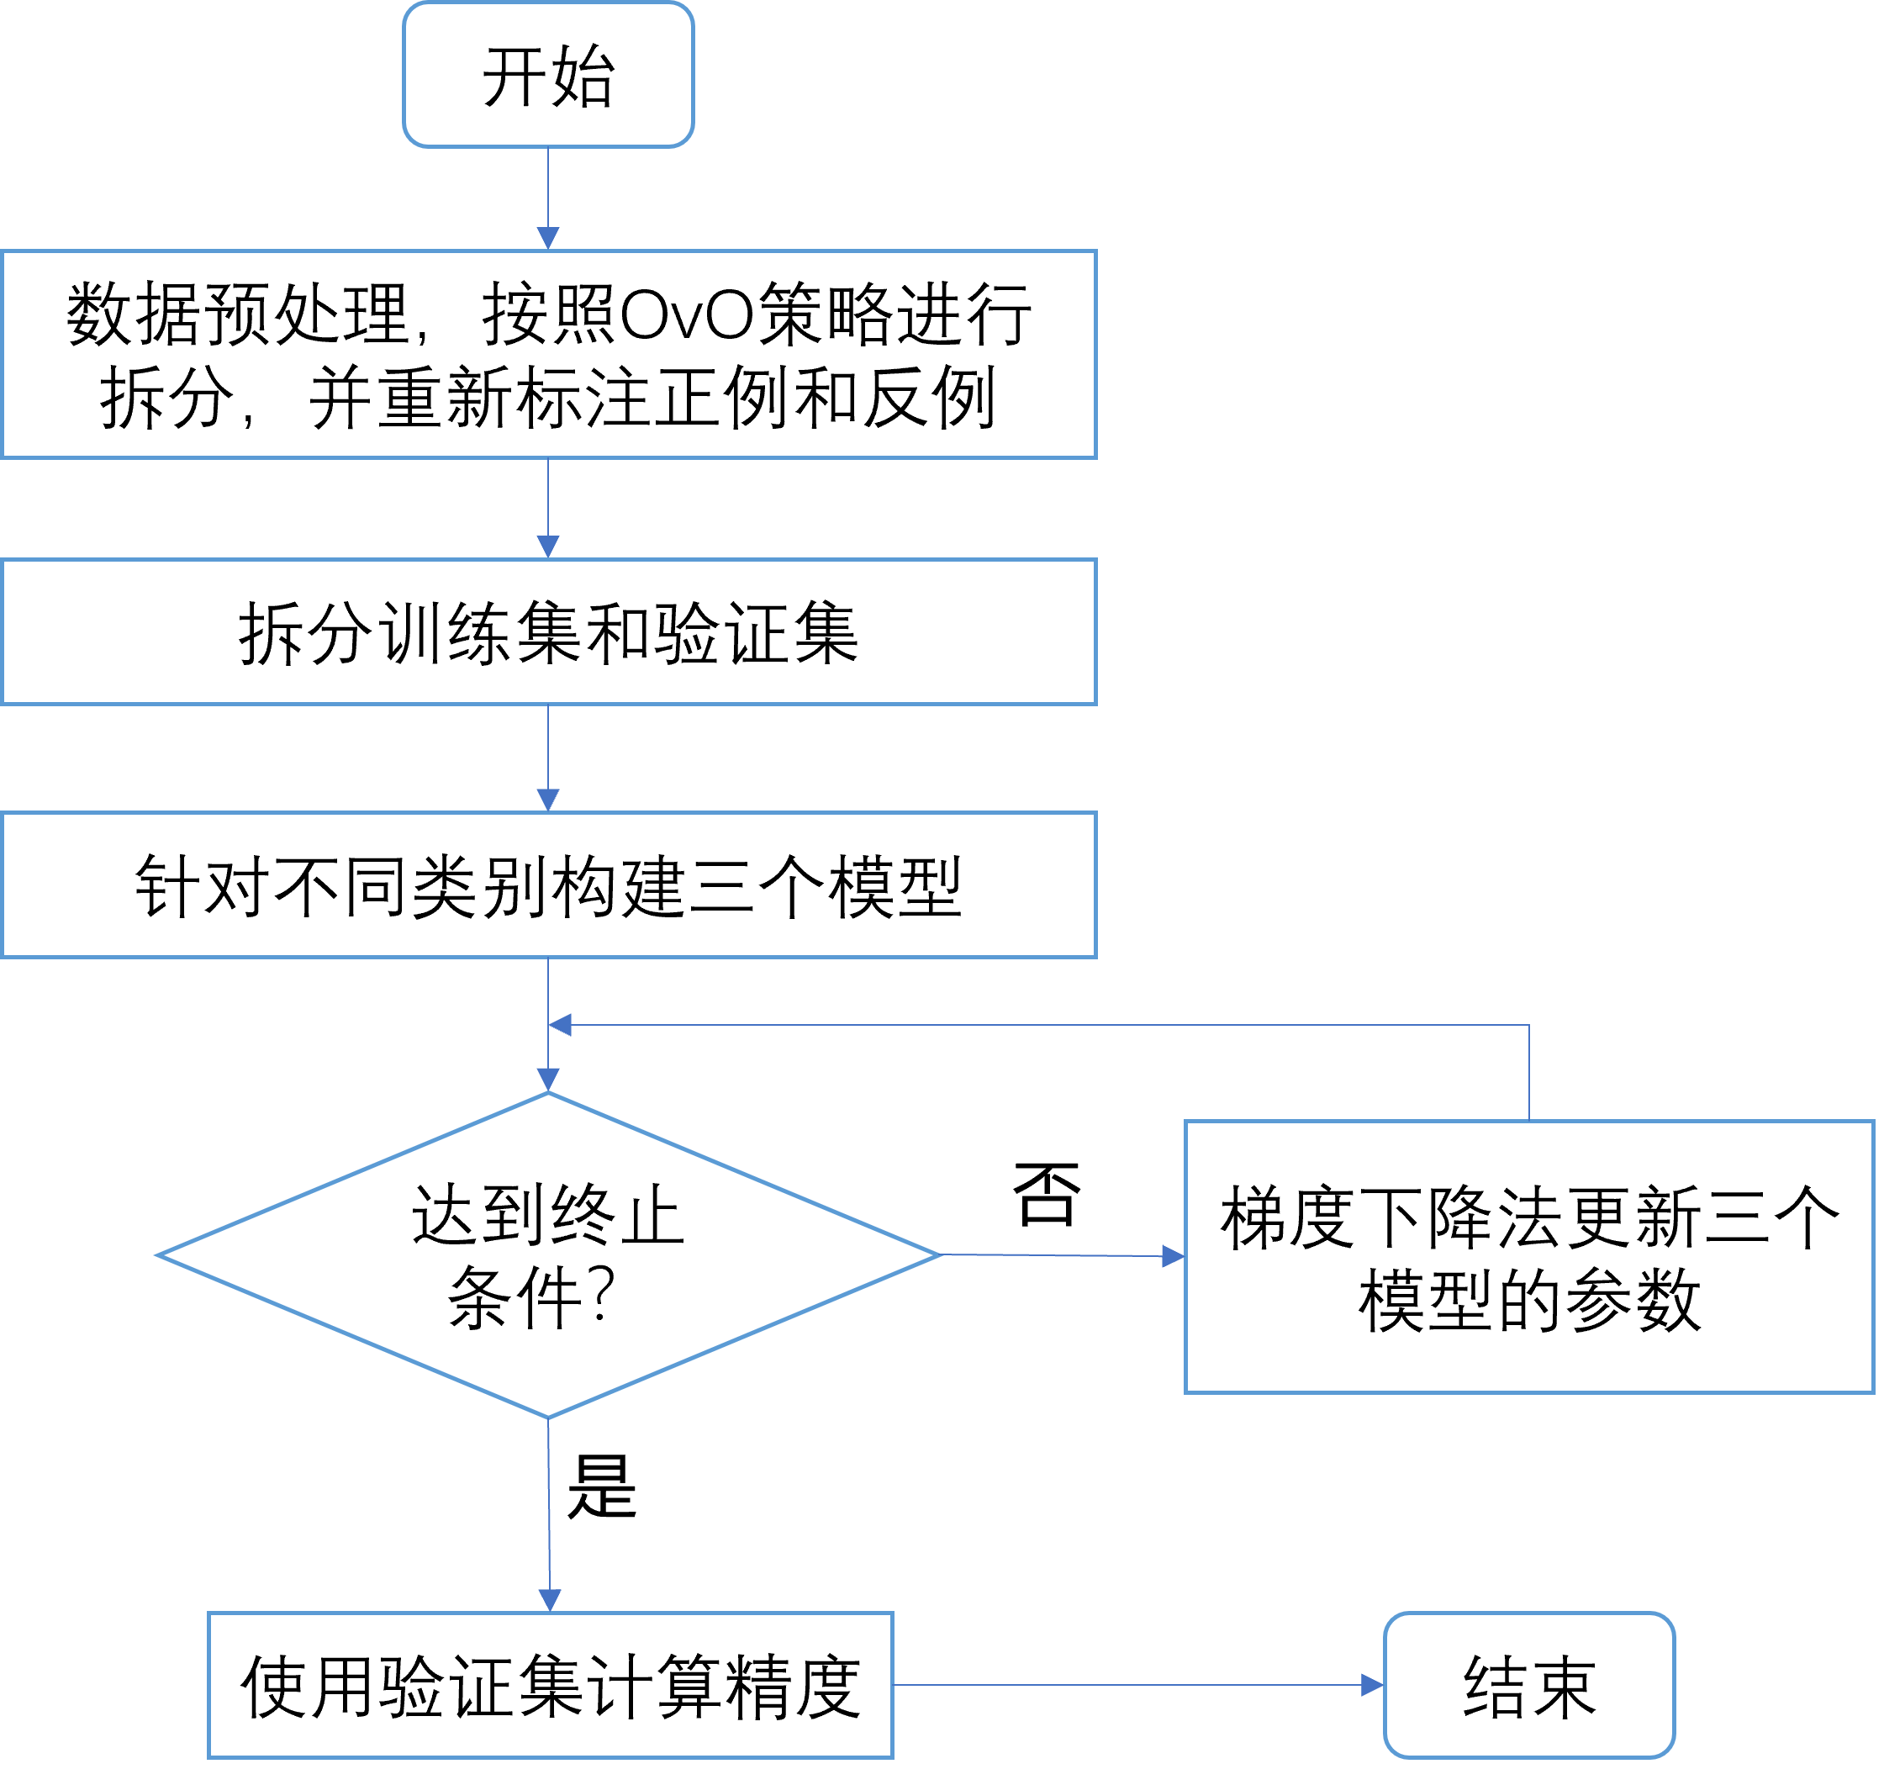
2）源代码
①代码说明
代码结构为：
─lab1_logistic
│ logistic.py
│ __main__.py
├─utils
│
└─Data.py
其中：
- logistic.py实现了本实验要求的Logistic分类器，为本实验的核心代码，详情见②源代码；
- __main__.py为整个程序的入口，实例化分类器，并实现了对西瓜数据集、鸢尾花数据集的分类，也为本实验的核心代码，详情见②源代码部分。
- utils/Data.py实现了对数据集的封装，并实现了对数据的预处理，如独热编码的转化。由于数据预处理是必需过程，但又不是本实验的核心内容，因此具体实现不放入源代码中，具体实现详见附件。
②源代码
- logistic.py
'''
1. 理解对率回归算法原理。
2. 编程实现对数几率回归算法。
3. 将算法应用于西瓜数据集、鸢尾花数据集分类问题。
'''
import numpy as np
from logging import warning

class Logistic:
def __init__(self, feature: np.array, label: np.array) -> None:
self.__feature = feature.astype('float')
self.__label = label.astype('float')
self.__sample_num, self.__input_size = feature.data.shape
self.__beta = np.random.rand(self.__input_size + 1, 1) * 10 - 5 # 将常数项 b 直接纳入里面

def getPositiveProb(self, x: np.ndarray):
x_extend = np.concatenate((x.reshape(self.__input_size, 1), np.ones((1, 1))),axis=0)
expX = self.__beta.T.dot(x_extend)
if expX > 0: # 防止数值溢出
ans = 1 / (1 + np.exp(-expX))
else:
ans = np.exp(expX) / (1 + np.exp(expX))
return ans

def getNegativeProb(self, x: np.ndarray):
x_extend = np.concatenate((x.reshape(self.__input_size, 1), np.ones((1, 1))),axis=0)
expX = self.__beta.T.dot(x_extend)
if expX < 0: # 防止数值溢出
ans = 1 / (1 + np.exp(expX))
else:
ans = np.exp(-expX) / (1 + np.exp(-expX))
return ans

def getLogit(self, x: np.ndarray):
x_extend = np.concatenate((x.reshape(self.__input_size, 1), np.ones((1, 1))),axis=0)
ans = self.__beta.T.dot(x_extend)
return ans

def optimize(self, iter_num = 100, lr = 1, method = "gd"):
'''
注意feature是一整批送进来的
'''
if not method in ["gd","newton"]:
warn_str = "不存在 "+method+" 迭代算法，默认使用梯度下降法，学习率为: "+str(lr)
warning(warn_str)
for epoch in range(1, iter_num + 1):
self.__step(lr, method)

def __step(self, lr = 1, method = "gd"):
if method == "newton":
val_2d = self.__getMLEValue_2d()
try:
inv_2d = np.linalg.inv(val_2d)
except np.linalg.LinAlgError: # 奇异矩阵无逆矩阵，使用伪逆代替
inv_2d = np.linalg.pinv(val_2d)
delta = inv_2d.dot(self.__getMLEValue_1d()) * lr
self.__beta = self.__beta - delta
else:
delta = lr * self.__getMLEValue_1d()
self.__beta -= delta

def __getMLEValue(self): # 极大似然函数
ans = 0
for x, y in zip(self.__feature, self.__label):
x_extend = np.concatenate((x.reshape(self.__input_size, 1), np.ones((1, 1))),axis=0)
ans += -y * self.__beta.T * x_extend + np.log(1 + np.exp(self.__beta.T * x_extend))
return ans

def __getMLEValue_1d(self): # 极大似然函数的一阶导数
ans = 0
for x, y in zip(self.__feature, self.__label):
x_extend = np.concatenate((x.reshape(self.__input_size, 1), np.ones((1, 1))),axis=0)
ans += - x_extend * (y - self.getPositiveProb(x))
return ans

def __getMLEValue_2d(self): # 极大似然函数的二阶导数
ans = 0
for x, y in zip(self.__feature, self.__label):
x_extend = np.concatenate((x.reshape(self.__input_size, 1), np.ones((1, 1))),axis=0)
prob_1 = self.getPositiveProb(x)
ans += - x_extend.dot(x_extend.T) * prob_1 * (1 - prob_1)
return ans

def eval(self, feature: np.array, label: np.array):
tot = len(label)
acc = 0
for X, y in zip(feature, label):
pred = 1 if self.getLogit(X) > 0 else 0
# print(pred, y)
if int(pred) == int(y):
acc += 1
return acc / tot

def getBeta(self):
return self.__beta

def pred(self, feature: np.array):
_pred = 1 if self.getLogit(feature) > 0 else 0
return _pred

- __main__.py
'''
代码在src的上级目录，在命令行输入：
python -m lab1_logistic
即可运行
'''

from lab1_logistic.logistic import Logistic
from lab1_logistic.utils.Data import DataClass, DataSet, DataSpliter
import numpy as np
from sklearn.datasets import load_iris
import logging

if __name__ == "__main__":
logging.disable(logging.WARNING) # 禁用 DataSet 定义的 Logging

# 西瓜数据集
ITER_NUM = 1000
feature=[["青绿","蜷缩","浊响","清晰","凹陷","硬滑",0.697,0.46],
["乌黑","蜷缩","沉闷","清晰","凹陷","硬滑",0.774,0.376],
["乌黑","蜷缩","浊响","清晰","凹陷","硬滑",0.634,0.264],
["青绿","蜷缩","沉闷","清晰","凹陷","硬滑",0.608,0.318],
["浅白","蜷缩","浊响","清晰","凹陷","硬滑",0.556,0.215],
["青绿","稍蜷","浊响","清晰","稍凹","软粘",0.403,0.237],
["乌黑","稍蜷","浊响","稍糊","稍凹","软粘",0.481,0.149],
["乌黑","稍蜷","浊响","清晰","稍凹","硬滑",0.437,0.211],
["乌黑","稍蜷","沉闷","稍糊","稍凹","硬滑",0.666,0.091],
["青绿","硬挺","清脆","清晰","平坦","软粘",0.243,0.267],
["浅白","硬挺","清脆","模糊","平坦","硬滑",0.245,0.057],
["浅白","蜷缩","浊响","模糊","平坦","软粘",0.343,0.099],
["青绿","稍蜷","浊响","稍糊","凹陷","硬滑",0.639,0.161],
["浅白","稍蜷","沉闷","稍糊","凹陷","硬滑",0.657,0.198],
["乌黑","稍蜷","浊响","清晰","稍凹","软粘",0.36,0.37],
["浅白","蜷缩","浊响","模糊","平坦","硬滑",0.593,0.042],
["青绿","蜷缩","沉闷","稍糊","稍凹","硬滑",0.719,0.103]]
label=[1,1,1,1,1,1,1,1,0,0,0,0,0,0,0,0,0]
feature_title=["色泽","根蒂","敲声","纹理","脐部","触感","密度","含糖率"]

feature = np.array(feature, dtype=object)
label = np.array(label, dtype=object)
dataset_watermelon = DataSet(feature,label,feature_title,labelConvert=False)
feature_watermelon, label_watermelon = dataset_watermelon.getFeatureAndLabel(is_converted = True)
title_watermelon = dataset_watermelon.getTitle(is_converted=True)
attrNum = len(title_watermelon)
model_watermelon = Logistic(feature_watermelon, label_watermelon)
model_watermelon.optimize(lr = 0.3, iter_num = ITER_NUM, method="gd")
acc = model_watermelon.eval(feature_watermelon, label_watermelon)
print("西瓜数据集上的训练轮数为：{:d}，分类正确率为：{:.2%}".format(ITER_NUM, acc))

# 鸢尾花数据集
ITER_NUM = 1000
dataset_iris = load_iris()
feature_iris = dataset_iris.data
label_iris = dataset_iris.target
labelName_iris = dataset_iris.target_names
title_iris = ["sepal length in cm", "sepal width in cm", "petal length in cm", "petal width in cm"]
dataset_iris = DataSet(feature_iris, label_iris, title_iris)
feature_iris, label_iris = dataset_iris.getFeatureAndLabel()
trainFeatureSet, trainLabelSet, testFeatureSet, testLabelSet = DataSpliter.trainAndTestSetSpliter_bareData(feature_iris, label_iris, is_shuffle = True, trainRatio = 0.7)
indexOfLabel0_1 = abs(trainLabelSet.reshape(len(trainLabelSet,)) - 0.5) < 0.5 + 1e-6
indexOfLabel0_2 = abs(trainLabelSet.reshape(len(trainLabelSet,)) - 1) > 1 - 1e-6
indexOfLabel1_2 = abs(trainLabelSet.reshape(len(trainLabelSet,)) - 1.5) < 0.5 + 1e-6
trainLabelSet0_1 = trainLabelSet[indexOfLabel0_1]
trainLabelSet0_2 = trainLabelSet[indexOfLabel0_2]
trainLabelSet1_2 = trainLabelSet[indexOfLabel1_2]
trainFeatureSet0_1 = trainFeatureSet[indexOfLabel0_1]
trainFeatureSet0_2 = trainFeatureSet[indexOfLabel0_2]
trainFeatureSet1_2 = trainFeatureSet[indexOfLabel1_2]
mapping_0 = {0:1, 1:0, 2:0} # 0 作为正例
mapping_1 = {0:0, 1:1, 2:0} # 1 作为正例
mapping_2 = {0:0, 1:0, 2:1} # 2 作为正例
def convertMapping(label, mapping): # 标记正反例
for idx, val in enumerate(label):
val = int(val)
label[idx] = mapping[val]
return label

trainLabelSet0_1 = convertMapping(trainLabelSet0_1, mapping_1) # 将 0 转成 0（反例），1 转成 1（正例）
trainLabelSet0_2 = convertMapping(trainLabelSet0_2, mapping_2) # 将 0 转成 0（反例），2 转成 1（正例）
trainLabelSet1_2 = convertMapping(trainLabelSet1_2, mapping_2) # 将 1 转成 0（反例），2 转成 1（正例）
# OvO多分类策略
model_iris_0_1 = Logistic(trainFeatureSet0_1, trainLabelSet0_1)
model_iris_0_2 = Logistic(trainFeatureSet0_2, trainLabelSet0_2)
model_iris_1_2 = Logistic(trainFeatureSet1_2, trainLabelSet1_2)
# 模型训练
OvR_LR = 0.05
model_iris_0_1.optimize(iter_num = ITER_NUM, lr = OvR_LR, method = "gd")
model_iris_0_2.optimize(iter_num = ITER_NUM, lr = OvR_LR, method = "gd")
model_iris_1_2.optimize(iter_num = ITER_NUM, lr = OvR_LR, method = "gd")
# 获取训练集准确率
acc_0 = model_iris_0_1.eval(trainFeatureSet, trainLabelSet0_1)
acc_1 = model_iris_0_2.eval(trainFeatureSet, trainLabelSet0_2)
acc_2 = model_iris_1_2.eval(trainFeatureSet, trainLabelSet1_2)
acc_search = [(acc_0, 0), (acc_1, 1), (acc_2, 2)]
acc_search.sort(key = lambda x: x[0], reverse = True) # 按照准确率从大到小排列，后续扫描从准确率大的开始比对
# 开始进行预测
acc = 0
tot = len(testLabelSet)
modelLst = [model_iris_0_1, model_iris_0_2, model_iris_1_2]
for X, y in zip(testFeatureSet, testLabelSet):
y = int(y)
pred = [md.pred(X) for md in modelLst]
pred[0] = 0 if pred[0] == 0 else 1 # 从0-1表示的正反例 转换回类别，对应代码在77-79行
pred[1] = 0 if pred[1] == 0 else 2
pred[2] = 1 if pred[2] == 0 else 2
rec = [0, 0, 0]
for i in pred:
rec[i] += 1
if np.argmax(rec) == y:
acc += 1
print("鸢尾花数据集上的训练轮数为：{:d}，训练集上的分类正确率为：{:.2%}".format(ITER_NUM, acc / tot))

四、实验结果及分析
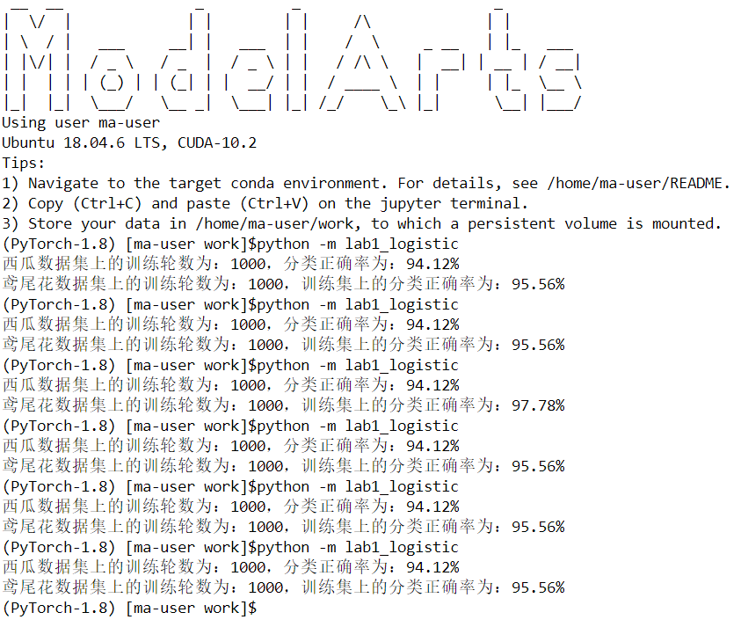
本实验基于华为的ModelArts平台，对数据集进行了多次实验，部分结果如上图所示。对于西瓜数据集，训练集分类准确率大多在90%以上，效果良好，但有过拟合的风险。鸢尾花数据集的结果稳定在90%以上，大多数在95%以上，效果良好。

