《机器学习基础》实验报告

年级、专业、班级 |  | 20计算机科学与技术（卓越）01 |  |  | 姓名 | 黄昊
实验题目 | BP算法实践
实验时间 | 2022/10/30 |  | 实验地点 | DS1421
实验成绩 |  |  | 实验性质 | □验证性 √设计性 □综合性
教师评价：
□算法/实验过程正确； □源程序/实验内容提交 □程序结构/实验步骤合理；
□实验结果正确； □语法、语义正确； □报告规范；
其他：
评价教师签名：
一、实验目的
掌握BP算法原理并编程实践。
二、实验项目内容
1.理解并描述BP算法原理。
2.编程实践，将算法应用于合适的分类数据集 (如鸢尾花、UCI数据集、Kaggle数据集)，要求算法至少用于两个数据集。
三、实验过程或算法（源程序）
（一）BP算法原理
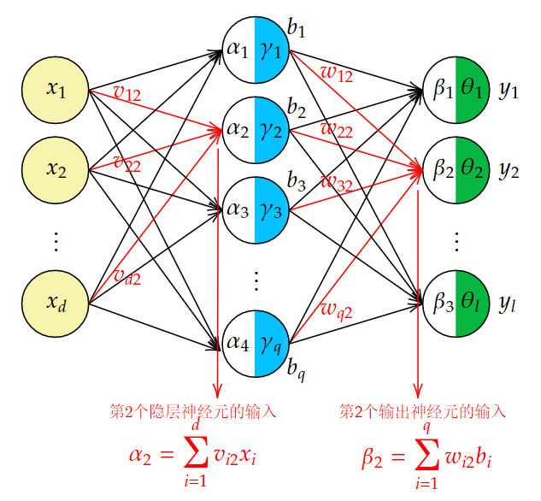
图1 全连接网络拓扑图
BP算法的本质是链式法则+动态规划。由于前向传播的过程中，最终结果的计算从前向后，这就导致了反向传播计算梯度的时候需要从后向前计算梯度，因为层数靠前的参数在求梯度的时候，根据链式法则，可以依靠层数靠后的参数的梯度。以均方损失函数为例，本实验的所有参数的梯度如下式所示：
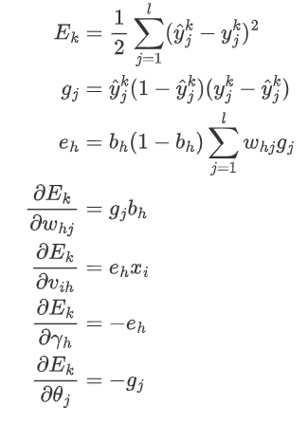
（二）编程实践
本次实验采用了图一的网络拓扑结构，设置了单隐藏层，并选取了鸢尾花数据集和UCI数据集中的红酒数据集进行试验。
（三）源代码
本次实验提交的代码的结构如下所示：
lab2_bpnetwork
- utils
- - Data.py
- MLP.py
- main.ipynb
其中：
- Data.py 实现了DataClass，DataSet，DataSpliter等类的实现，用于数据预处理，由于非本实验核心内容，故不附在本实验报告中
- MLP.py为本实验核心代码，将在后面附出
- main.ipynb实例化了MLP类，并对鸢尾花数据集和红酒数据集进行了实验。结果详见main.md。

MLP.py
from logging import warning
import numpy as np
from scipy.special import expit
from math import exp

class MLP(object):
def __init__(self, n_input: int, n_hidden: int, n_output: int, loss_func = "MSELoss"):
self.__n_input = n_input
self.__n_hidden = n_hidden
self.__n_output = n_output
self.__layer_1 = np.random.uniform(-1, 1, size=(n_input, n_hidden)) # weights between hidden layer and output layer
self.__layer_2 = np.random.uniform(-1, 1, size=(n_hidden, n_output)) # weights between input layer and hidden layer
self.__bias_1 = np.random.uniform(-1, 1, size=(n_hidden)) # bias in hidden layer
self.__bias_2 = np.random.uniform(-1, 1, size=(n_output)) # bias in output layer
self.__hidden_output = np.zeros(shape = (1, n_hidden)) # record middle output for backward propagation
self.__loss_func = loss_func
self.__loss_train_rec = []

def __sigmoid(self, x):
return expit(x) # sigmoid function, import scipy to avoid the annoying numerical precision problem which is not the focus of this experiement.

def __onehotConvert(self, label_set):
sampleNum = label_set.data.shape
s = set()
for i in label_set:
s.add(i)
classNum = len(s)
newSet = np.zeros(shape = (0, classNum))
for i in label_set:
l = np.zeros(shape = (1, classNum))
l[0][i] = 1
newSet = np.concatenate((newSet, l), axis = 0)
return newSet

def __lrDecay(self, lr_0, epoch, maxEpoch, decay = "None"):
if decay == "none":
return lr_0
elif decay == "linear":
return lr_0 * (maxEpoch - epoch) / maxEpoch
else:
warning("No such decay method: {:s}, use default method.".format(decay))
return lr_0

def optimize(self, feature_set, label_set, epochNum = 100, lr = 0.01, decay = "none", printMsg = False):
self.__loss_train_rec = []
label_set = self.__onehotConvert(label_set)
for epoch in range(1, epochNum + 1):
loss = 0
if epoch % 1000 == 0 and printMsg == True:
print(" + 当前是第 {:d} 次迭代".format(epoch))
lr_e = self.__lrDecay(lr, epoch, epochNum, decay)
for X, y in zip(feature_set, label_set):
loss += self.__step(X, y, lr_e)
self.__loss_train_rec.append(loss)
loss = 0
for X, y in zip(feature_set, label_set):
loss += self.MSELoss(X, y)
self.__loss_train_rec.append(loss)

def __step(self, feature: np.array, label: np.array, lr = 0.01):
output = self.__forward(feature)
loss = self.MSELoss(feature, label, output)
self.__backPropagate(feature, label, output, lr)
return loss

def __forward(self, feature: np.ndarray):
# note that feature is a single feature
feature = feature.reshape(1, self.__n_input)
output = feature.dot(self.__layer_1)
output += self.__bias_1
output = self.__sigmoid(output)
self.__hidden_output += output
output = output.dot(self.__layer_2)
output += self.__bias_2
output = self.__sigmoid(output)
return output.reshape(self.__n_output)

def __backPropagate(self, feature: np.ndarray, label: np.ndarray, output: np.ndarray, lr = 0.01):
# note that feature is a single feature, label is the same.
# the param need update: bias_1, bias_2, layer_1, layer_2
# note that label here should be one-hot vector, which shall be processed in DataSet class

# adjust the shape of input
output = output.reshape(1, self.__n_output)
feature = feature.reshape(self.__n_input, 1) # shape: n_input * 1
label = label.reshape(1, self.__n_output)
# backward propagantion!
d_g = output * (1 - output) * (label - output) # gradient for middle varaible: shape: 1 * n_output
d_e = self.__hidden_output * (1 - self.__hidden_output) * d_g.dot(self.__layer_2.T) # gradient for middle varaible: shape: 1 * n_hidden
d_b2 = - d_g.reshape(self.__n_output) # gradient for bias_2: shape: n_output
d_w2 = self.__hidden_output.T.dot(d_g) # gradient for weight in layer_2: shape: n_hidden * n_output
d_b1 = - d_e.reshape(self.__n_hidden) # gradient for bias_1: shape: n_hidden
d_w1 = feature.dot(d_e) # gradient for weight in layer_1: shape: n_input * n_hidden
# update parameters
self.__bias_1 += lr * d_b1
self.__bias_2 += lr * d_b2
self.__layer_1 += lr * d_w1
self.__layer_2 += lr * d_w2
# clear accumulate
self.__hidden_output = np.zeros(shape=(1, self.__n_hidden))

def MSELoss(self, feature, label, y_hat = None):
# note that feature is a single feature
if y_hat is None:
return np.sum((label - self.__forward(feature)) ** 2)
else:
return np.sum((label - y_hat) ** 2)

def pred(self, feature):
return np.argmax(self.__forward(feature))

def eval(self, feature_set, label_set):
# evaluation function, return the accuracy
acc = 0
tot = len(label_set)
for X, y in zip(feature_set, label_set):
y_hat = self.pred(X)
acc = acc + 1 if y_hat == y else acc
return acc / tot

def getTrainLoss(self):
return self.__loss_train_rec

四、实验结果及分析
本实验依托ModelArts平台进行。实验结果如下：
（一）鸢尾花数据集
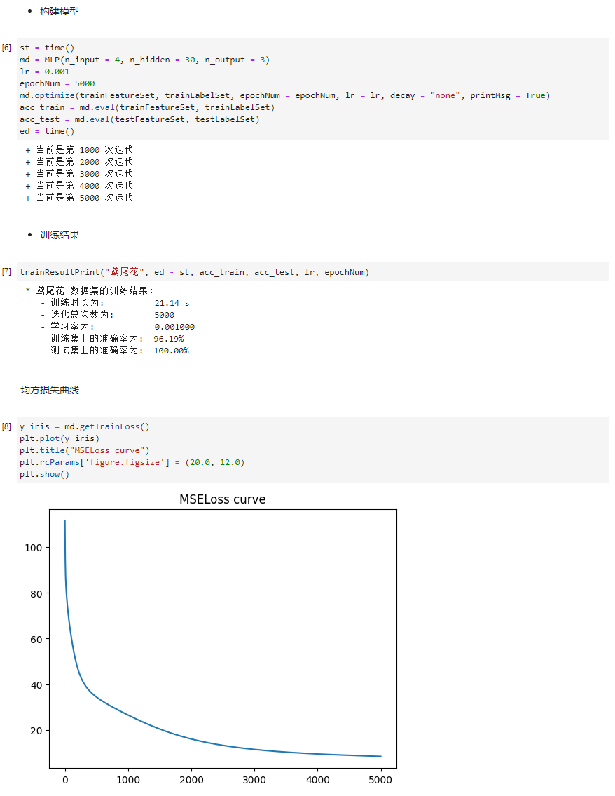
图2 鸢尾花数据集结果
鸢尾花数据集训练了5000次，学习率为0.001，最后测试集上的准确率达100.0%，损失曲线平滑，说明算法收敛，表现良好。
（二）红酒数据集（UCI数据集）
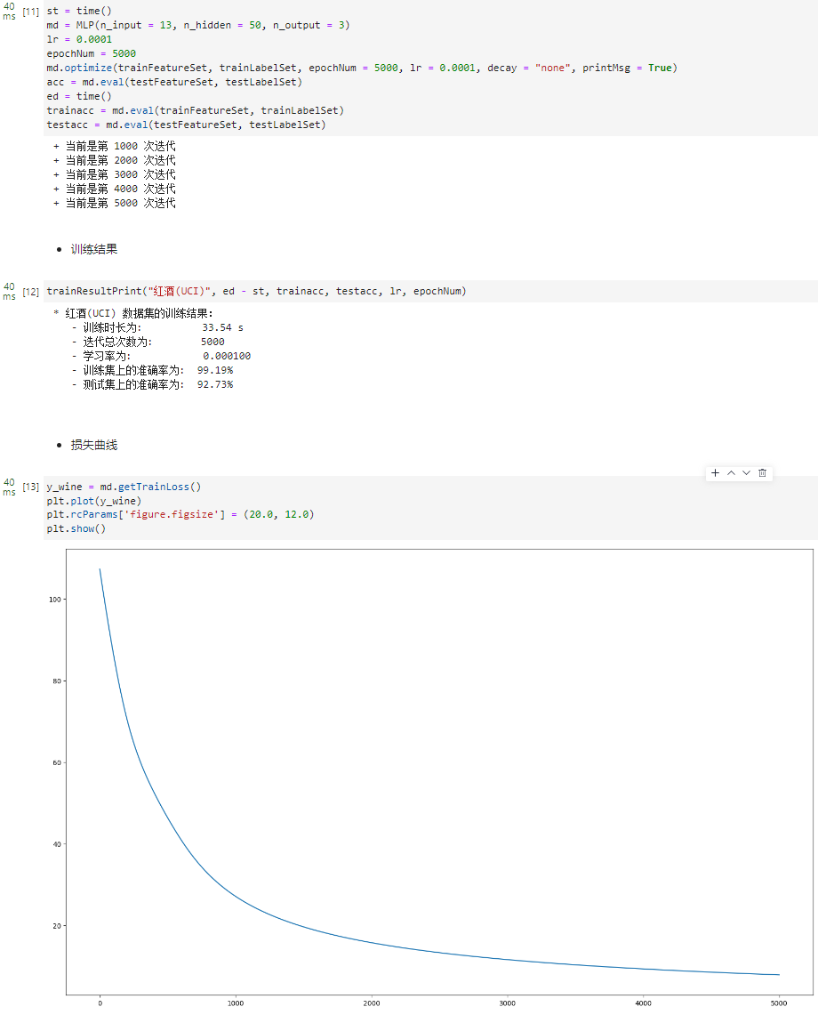
图3 红酒数据集结果
红酒数据集首先进行了归一化的预处理，然后训练了5000次，学习率为0.0001，最后测试集上的准确率达92.73%，损失曲线平滑，说明算法收敛，表现良好。

