***Do not write italics, those are just comments to help you write the notes better ;)***

START OF NOTES

A Letter to God

— G.L. Fuentes

# Learning Objectives

Students will be able to:

* critically analyze the theme and characters.
* develop inference and vocabulary

***ENSURE C and D in the objectives are SMALL LETTERS***

# Author's Note

**Gregorio López y Fuentes (1897 - 1966)** was a Mexican novelist, poet, and journalist. He was born on November 17, 1895, on a ranch in the Huasteca region of Veracruz.

He began writing at the age of fifteen, just as the Mexican Revolution broke out.

# Theme analysis:

* The theme of the story is the faith of people in God and their expectation that God will help them in times of need. It covers how people can have so much faith in their spiritual deities
* The story also shows how there are still gem-like people in the world that will readily help people in need regardless of their own problems or struggles.

# Learn ing Points *STRICTLY IN POINTS AND NOT AS A PARAGRAPH*

* In a rural village, Lencho, a hardworking farmer, eagerly awaited rain to nourish his cornfield.
* When the rain arrived, it brought hailstorms and ruined Lencho's crops.
* Distraught over his loss, Lencho turned to his unwavering faith in God, believing in divine providence.
* Lencho wrote a heartfelt letter to God, pleading for assistance in the form of 100 pesos.
* The postman and his master were touched by Lencho's faith and decided to contribute from their own salaries.
* They collected 70 pesos and sent it to Lencho.
* Lencho's faith remained unshaken, but upon realizing he had only received 70 pesos, he wrote another letter requesting the remaining 30 pesos.

# Activity 1

Fill out the Money Order form given below..

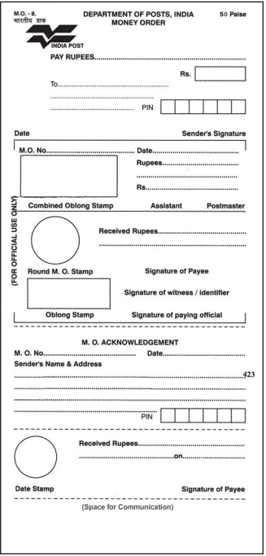

(*Use your imagination in this one and if you can’t get an indian address just use* [*this*](https://www.bestrandoms.com/random-address-in-in?quantity=1))

# Activity 2

Match the names in the box with their descriptions below, and fill in the blanks. You may use a dictionary to help you.

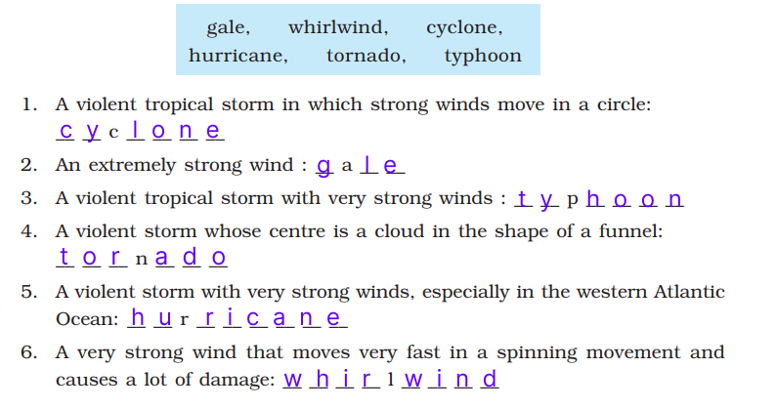

*(Yes you need to write the names and not just questions.)*

# Activity 3

Make a character sketch of the main characters in the story

**Lencho:**

Lencho was a simple, religious farmer who had faith in God. When facing starvation after losing his crops, he wrote a letter to God for help. Lencho was strong, knowledgeable about the weather, and literate, but ironically, he called his helpers "a bunch of crooks" near the end of the chapter.

**Postmaster**:

The Postmaster was a kind, generous, helpful, amiable and God-fearing man. He received a letter from Lencho which was written to God asking for 100 pesos, so that he could sow his fields again. The postman felt sympathetic towards Lencho. He gave up a part of his salary and asked all other employees to help and he managed to collect 70 pesos. He did so in order to preserve the man's faith in God.

# Extended Activity

**Currencies from around the world**  *← this is the title of the activity*Find 20 currencies from around the world and list them below, also compare them against the US Dollar.

*For this one, you need to write it down, sorry but limits of google docs :(*...