***Do not write italics, those are just comments to help you write the notes better ;)***

START OF NOTES

Electricity

# Ohm's Law

It states that at a constant temperature, potential difference across a conductor is directly proportional to the current passing through the conductor.

$V ∝ I$

$(Potential Diff) (Current)$

If $(V)$ is the potential difference and $(I)$ is the current passing through the conductor then:

$V = (R)I$

Here $(R)$ is a constant called the resistance of the conductor.

# Resistance (R)

It is the ability of a conductor to oppose the flow of current. The unit of resistance is ohm ($Ω$)

If resistance is more, current is less

If resistance is less, current is high

# Resistor

Anything that opposes the flow of current is called a Resistor, the circuit symbol of resistor is the following…

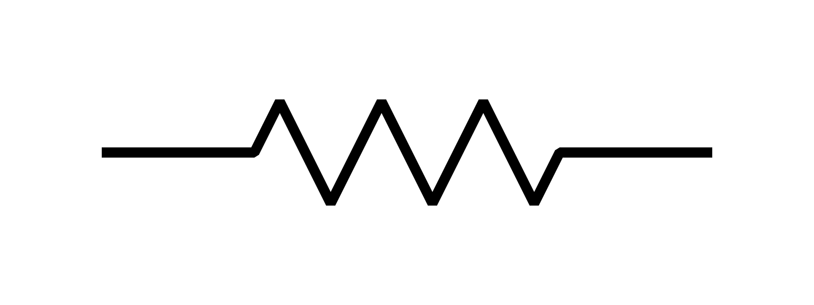

*Circuit Symbol of Resistor Circuit Symbols of Variable Resistor*

*Mark the names if you want, not required*

# 

# Factors affecting the resistance of a conductor



= Length of the conductor

$R$ = Resistance of the conductor

- (1)

- (2)

From 1 and 2 we get…

$R ∝ \frac{L}{A} →R = (⍴)\frac{L}{A} ;$ Rho -> Resistivity of a conductor

$⍴ = \frac{RL}{A}$

Unit of Rho = Ohm

# Potential difference ($V$) at a point

It is the work done to move a unit positive charge from infinity to a point.

$Potential (v) = \frac{work}{charge}$

Or, $v = \frac{W}{I}$

$Unit = volt (v)$

# Potential difference at 2 points



A B

It is the work done to move a unit positive charge from one point to another.

The device for measuring the potential difference of a conductor is called a **voltmeter**.