

**INDIAN EXCELLENT Pvt. SCHOOL, SHARJAH**

P.O. Box: 40194, Tel: 06 5249249 E-Mail: [info@iessharjah.com](mailto:info@iessharjah.com), www.iessharjah.com

(Affiliated to C.B.S.E Delhi & Approved by Ministry of Education, UAE)

|  |  |  |
| --- | --- | --- |
| **Worksheet [2024-2025]** | **Date:** |  |

|  |  |  |  |
| --- | --- | --- | --- |
| **Subject:** | **PHYSICS** | **Topic:** | **ELECTRICITY** |
| **Name of the Student:** |  | **Class/Div** | **X A and B** |

**WORKSHEET-4**

**ELECTRICITY**

1. The current flowing through a resistor connected in an electrical circuit and the potential difference developed across its ends are shown in the given ammeter and voltmeter. The voltage and the current across the given resistor are respectively

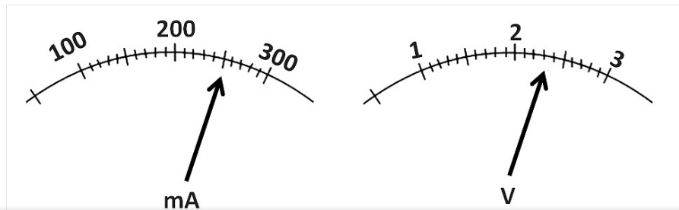

2.Two resistors 2 ohm and 4 ohm are given. When it is connected to a battery in series will have

* + - * 1. Same current flowing thorough them when connected in parallel
        2. Same current flowing through them when connected in series
        3. Same potential difference across them when connected in series
        4. Different potential difference across them when connected in parallel

3.A cylindrical conductor of length l and uniform area of cross section A has resistance R. Another conductor of length 2l and resistance R of the same material has area of cross section

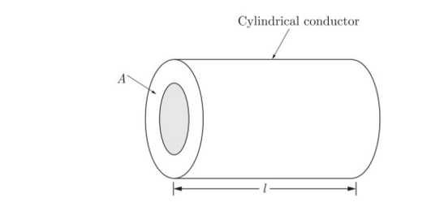

* + - * 1. A/2 (b)3A/2 (c)2A (d)3A

1. Find out the following in the electric circuit given in figure:
2. Effective resistance of two 8ohm resistors in the combination.
3. Current flowing through 4 Ohm resistor
4. Potential difference across 4ohm resistance
5. Power dissipated in 4ohm r3sistor
6. Difference in ammeter reading, if any.

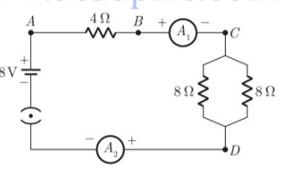

1. A piece of wire of resistance R is cut into three equal parts. These parts are then connected in parallel. If the equivalent resistance of this parallel combination is R1, what is the value of the ratio R1: R?
2. In an electrical circuit two resistors of 2Ω and 4Ω respectively are connected in series to a 6V battery as shown in the figure. The heat dissipated by the 4Ω resistor in 5s will be
3. 5J (b)10J (c)20J (d)30J

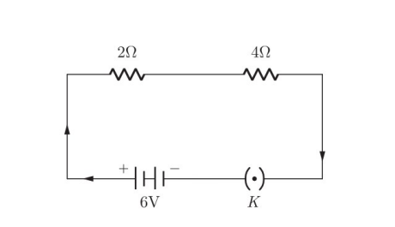

1. What is the maximum resistance which can be made using five resistors each of 1/5Ω.

(a)1/5Ω (b)10Ω (c)5Ω (d)1Ω

1. V-I graph for the two wires A and B are shown in the figure. if we connect both wires one by one to the same battery which of the two will produce more heat per unit time?

(a)A (b)B (c)Both A and B (d)None of these

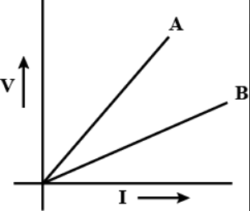

1. In the following circuits, heat produced in the resistor or combination of resistors connected to 12V battery will be

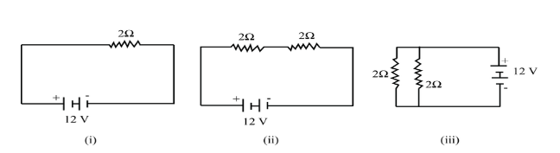

1. Same in all cases (b) minimum in case(i)

(c ) maximum in case (ii) (d) maximum in case (iii)

1. What would be the reading of ammeter and voltmeter in the given circuit.

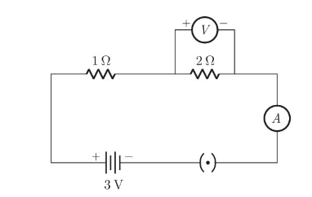

11.(a)What is meant by the statement, The resistance of a conductor is one ohm?

(b) Define electric power. Write an expression relating electric power, potential difference and resistance.

(c) How many 132Ω resistors in parallel are required to carry 5A on a 220V line?